DBSE&DBS
Roll No: 2520030087
Name: P. Anudeep
Query-1:
Query-2:
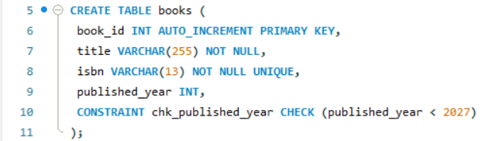
Query-3:
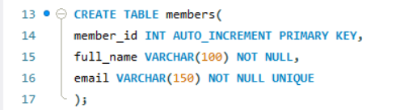
Query-4:
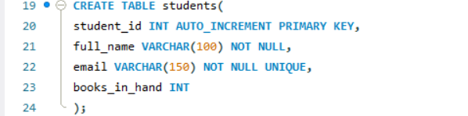
Query-5:
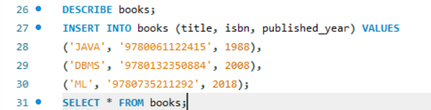
Books2:

Query-6:
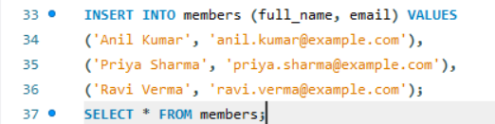
Members3:

Query-7:
