WEEK-1

Step 1 Database Setup
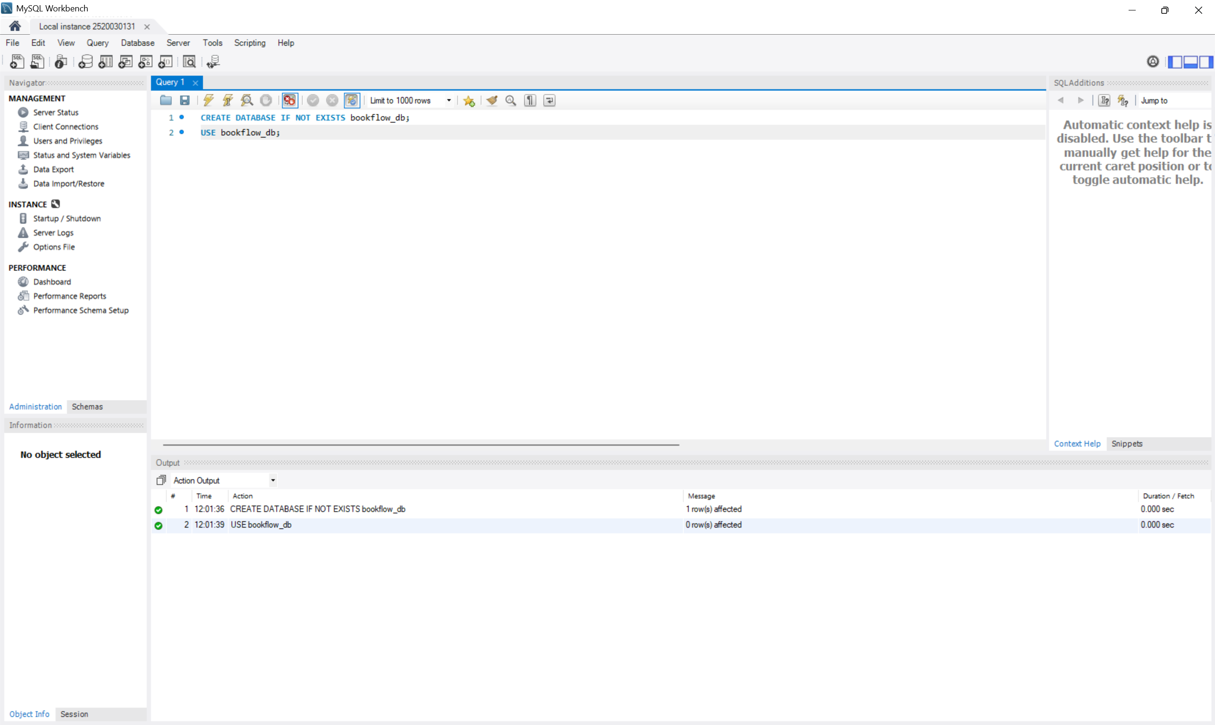

Step 2 Table Creation (DDL) with Constraints
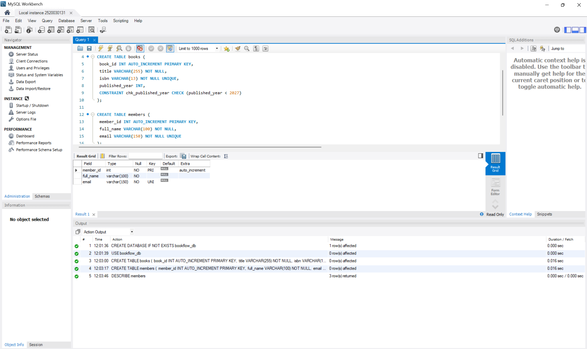
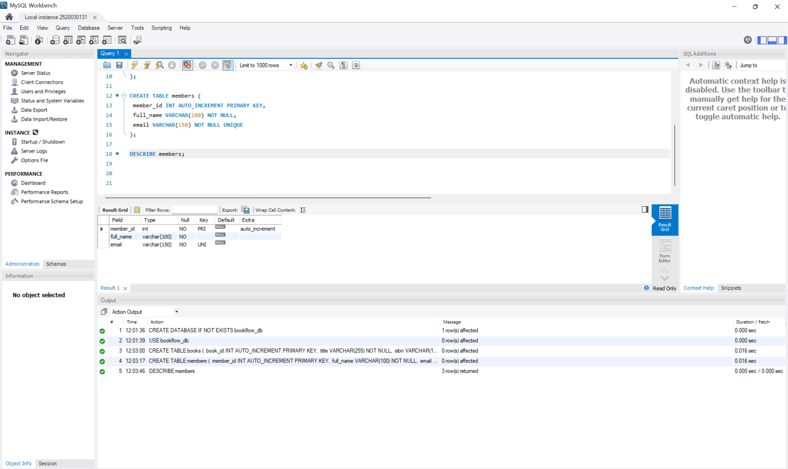

Step 3 Initial Seeding (Valid Data)
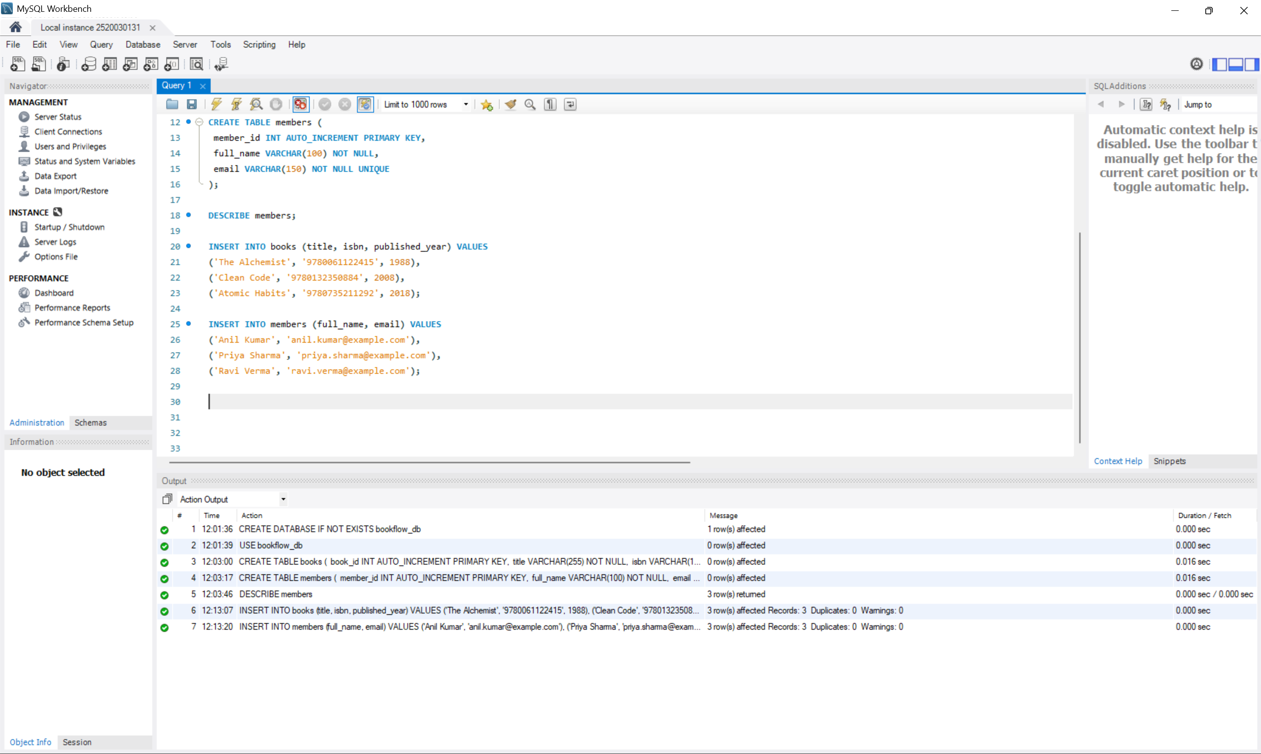

Step 4 Constraint Tests (These MUST Fail)
