WEEK-2

Step 1 — Create Database
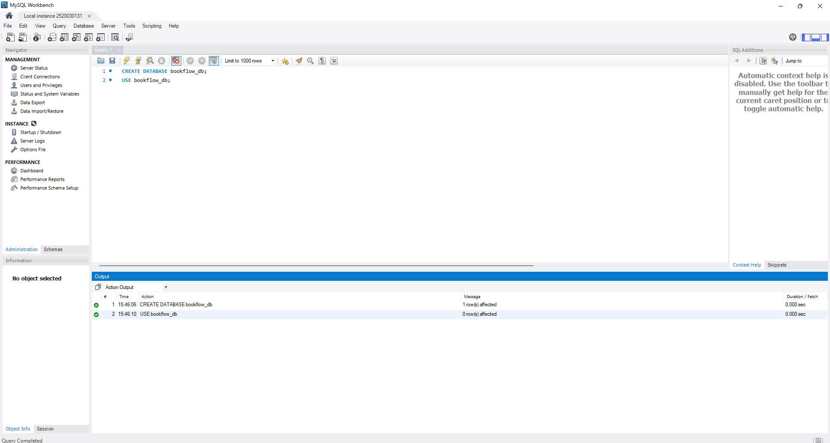

Step 2 — Create Books Table (DDL + Constraints
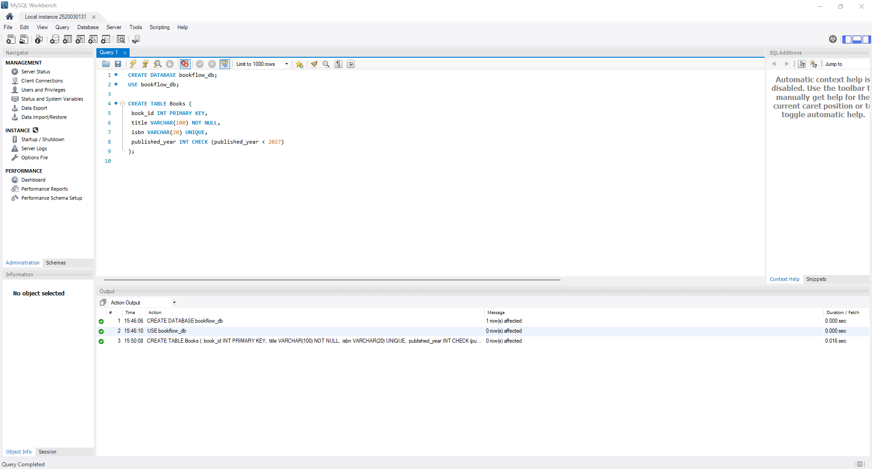

Step 3 & 4 — Insert Books and Display
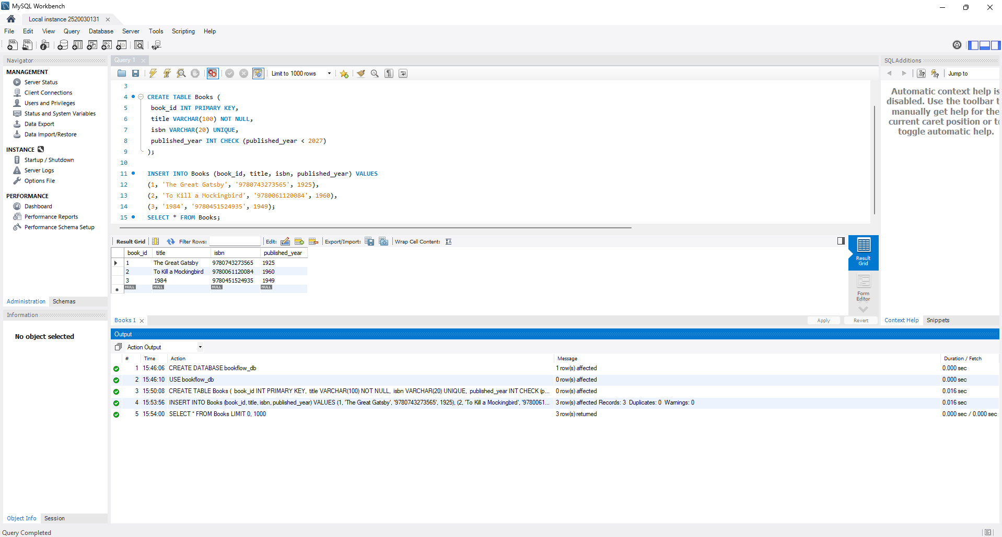

Step 5, 6 & 7 — Members Table: Create, Insert, Display
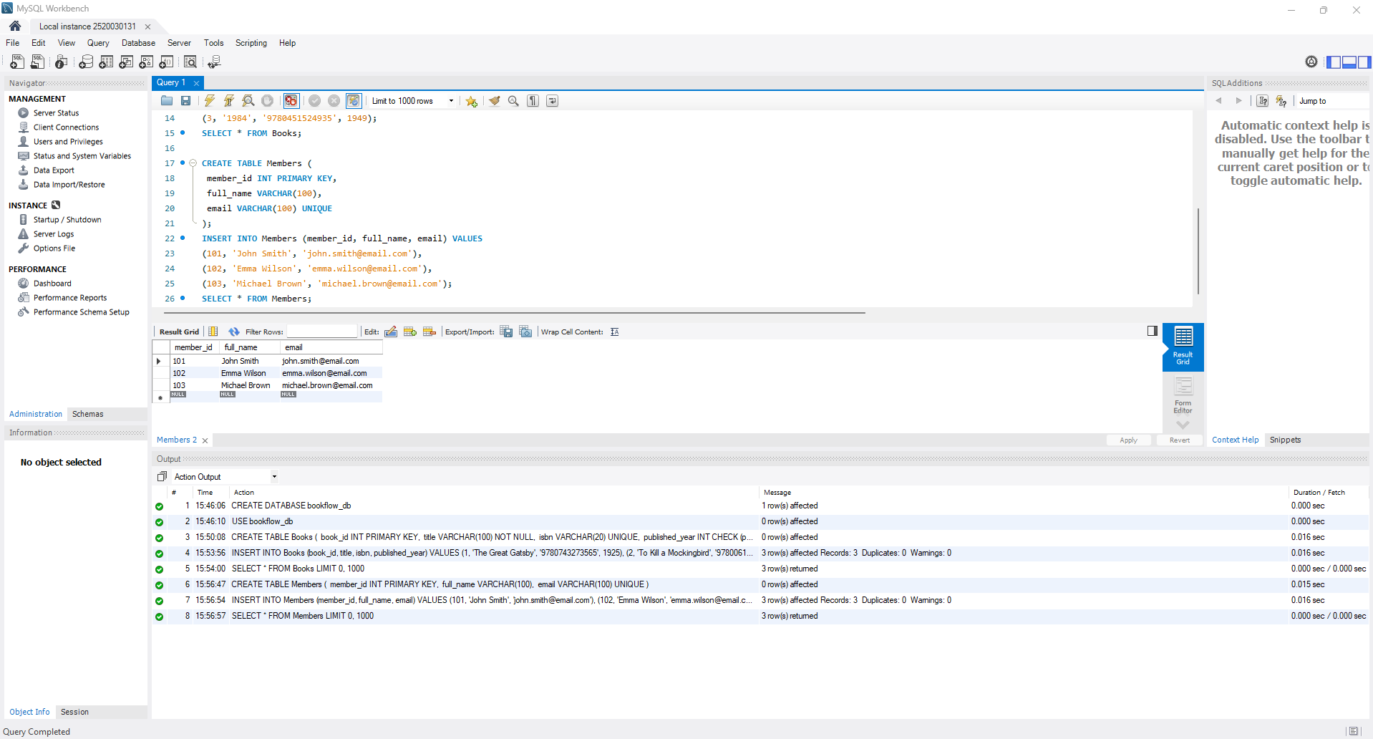

Step 8 — Create Loans Table (FOREIGN KEYS)
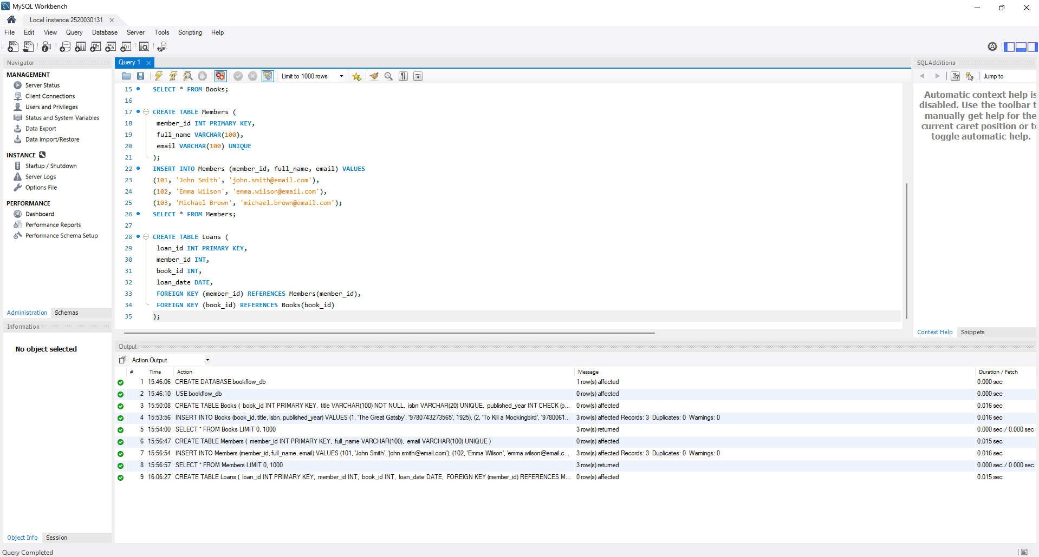

Step 9 & 10 — Insert 10 Loans and Display
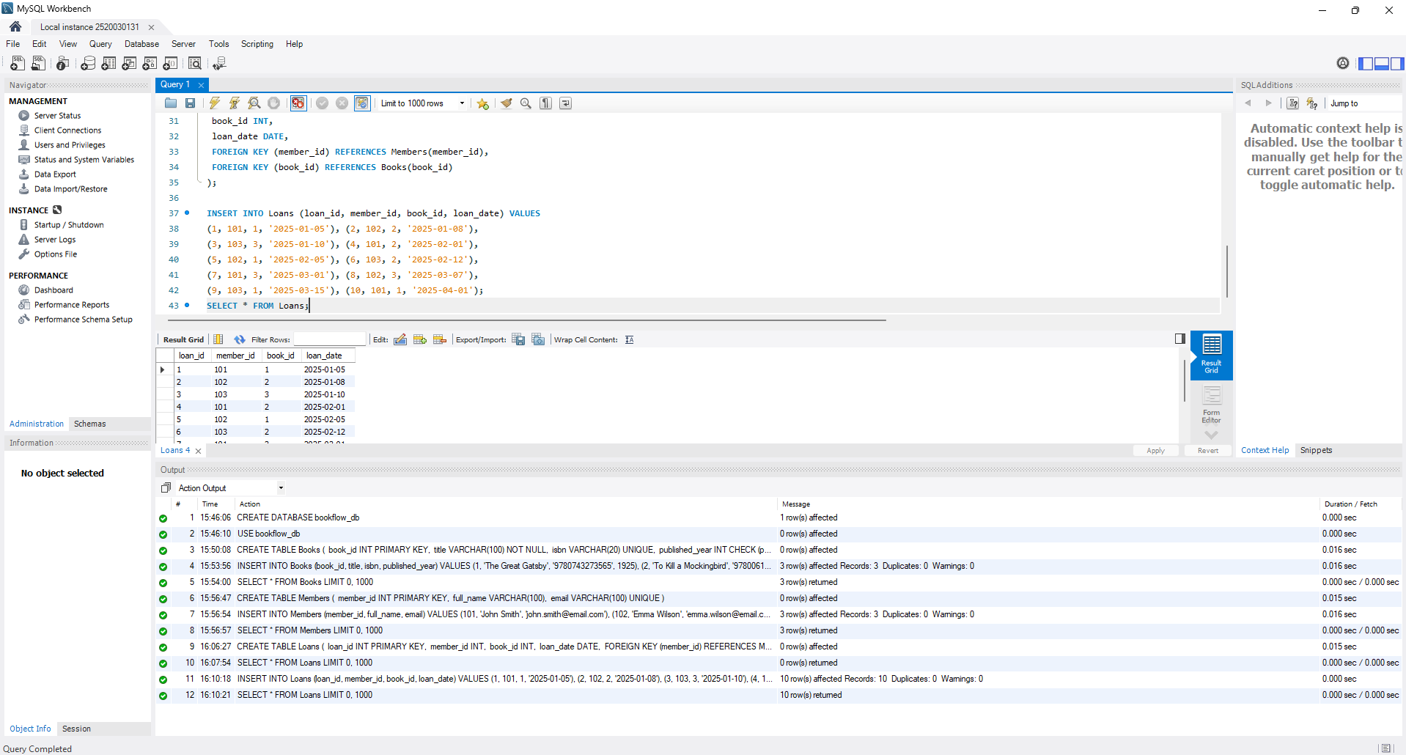

Step 11 — JOIN Query (Who Borrowed What)
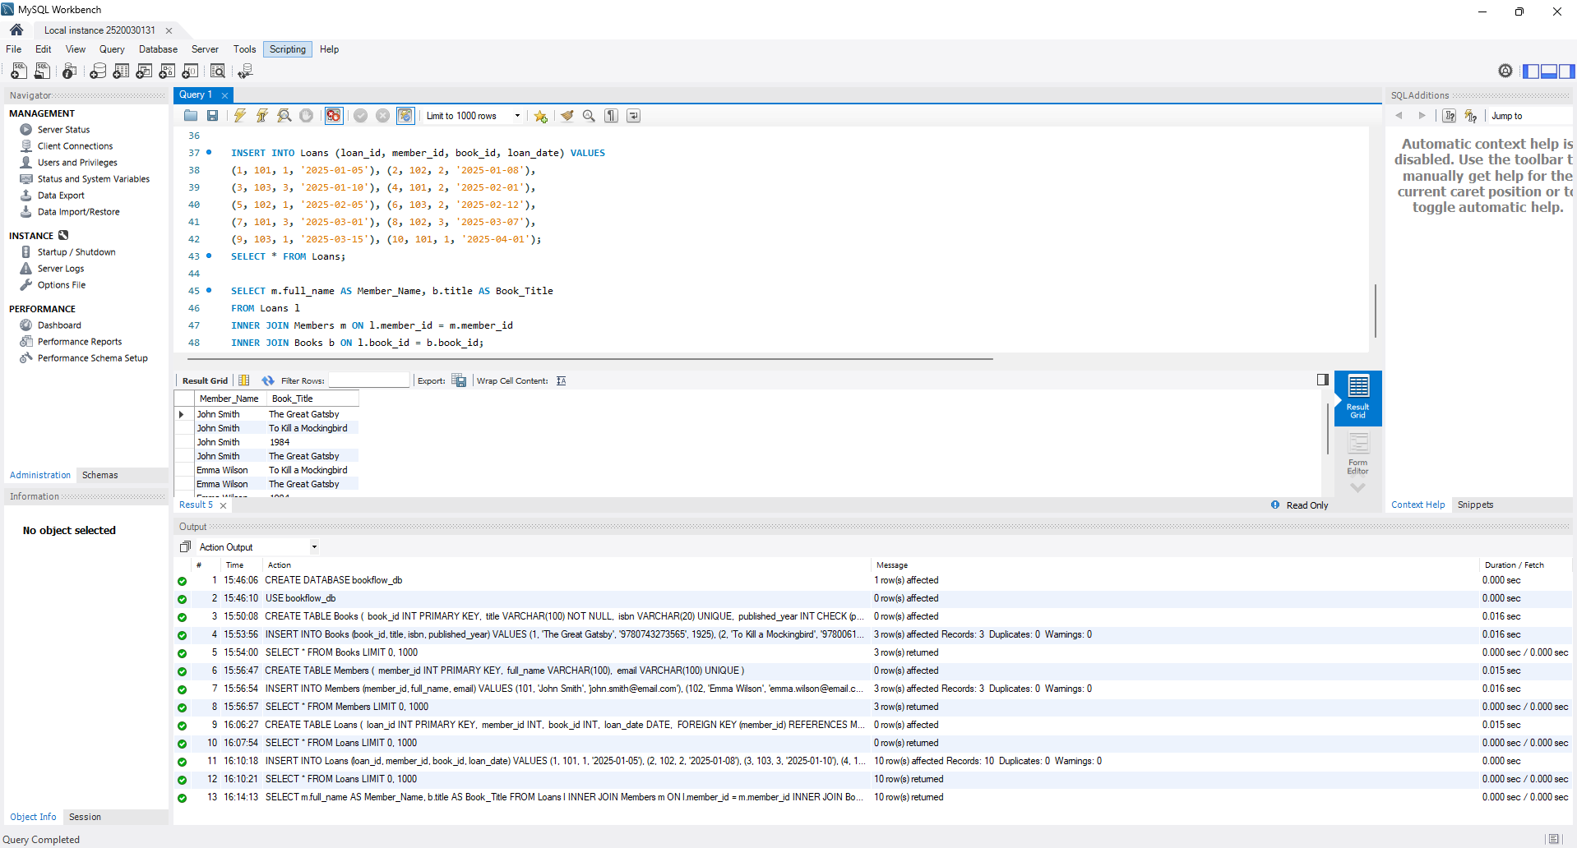

Step 12 — GROUP BY Query (Books per Year)
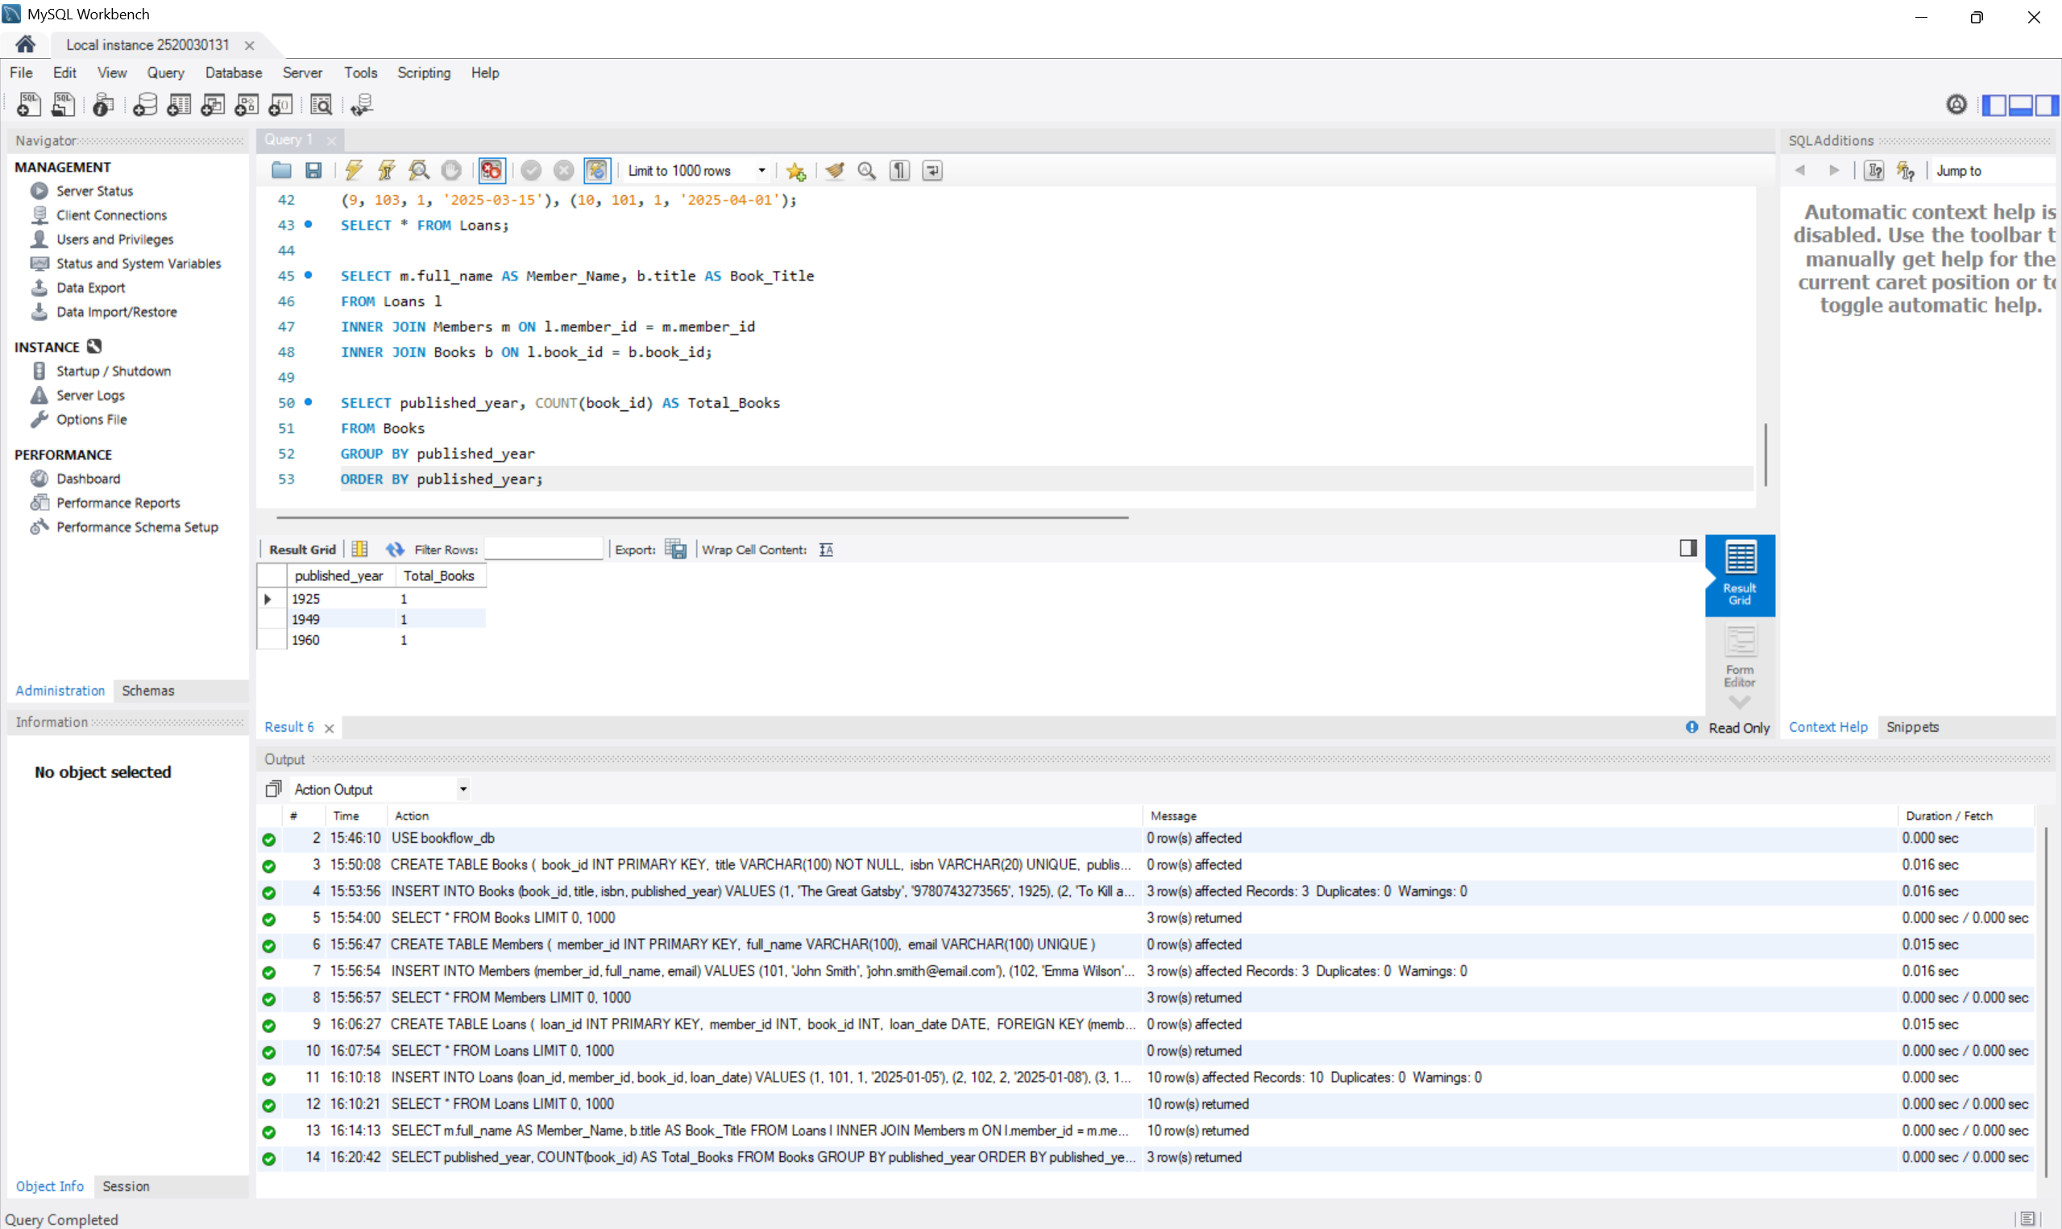

Step 13–16 — Donation via TRANSACTION (Atomicity)
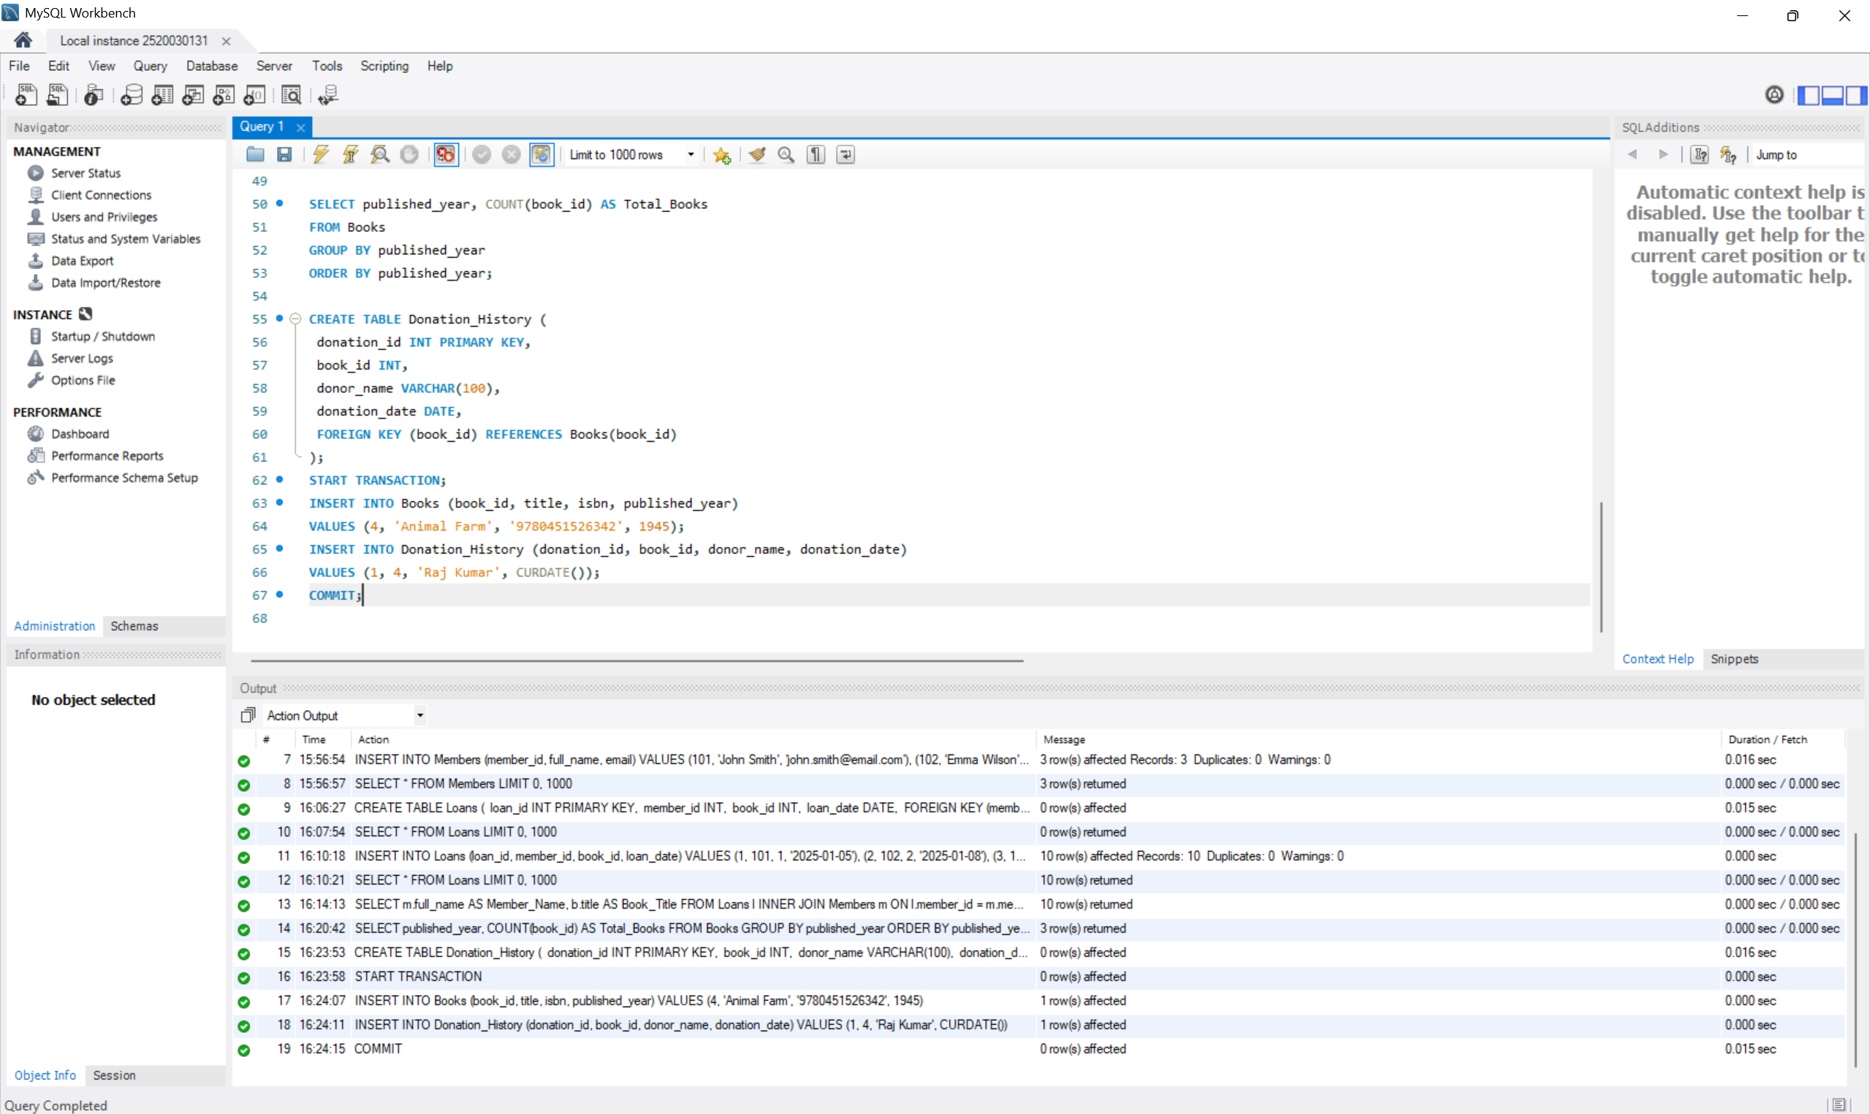

Step 17 & 18 — Index on ISBN + Fast Search
