Software Engineering
Lab-4
Name: Ajay Aditya Sethumadhavan Srn: PES2UG23CS037
Section: A
Overview of working code:
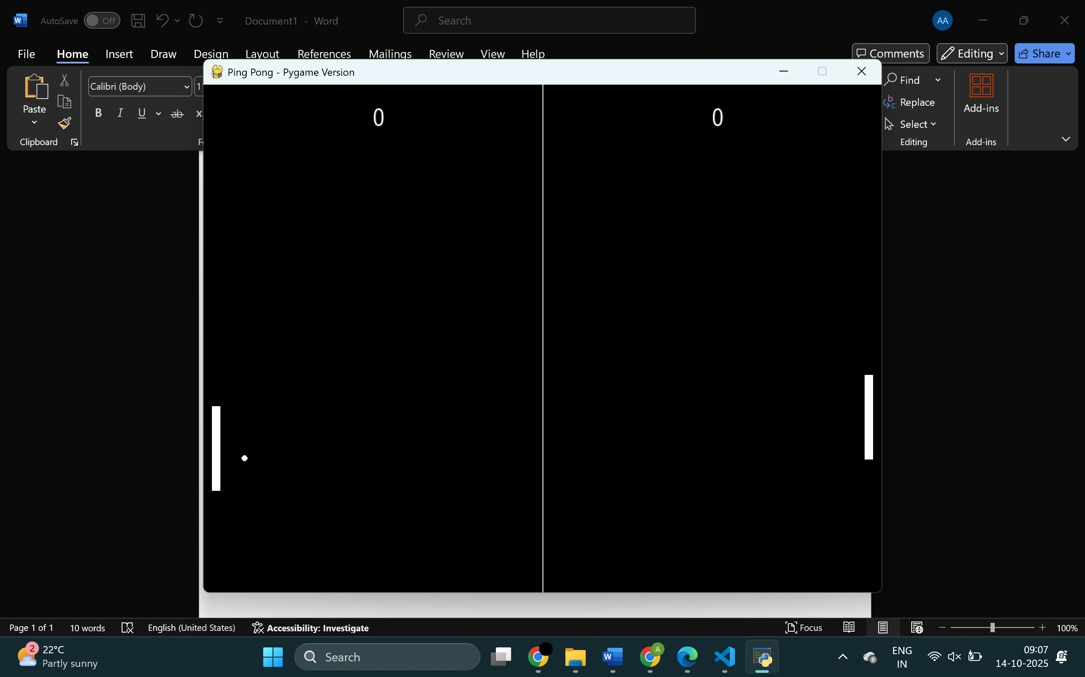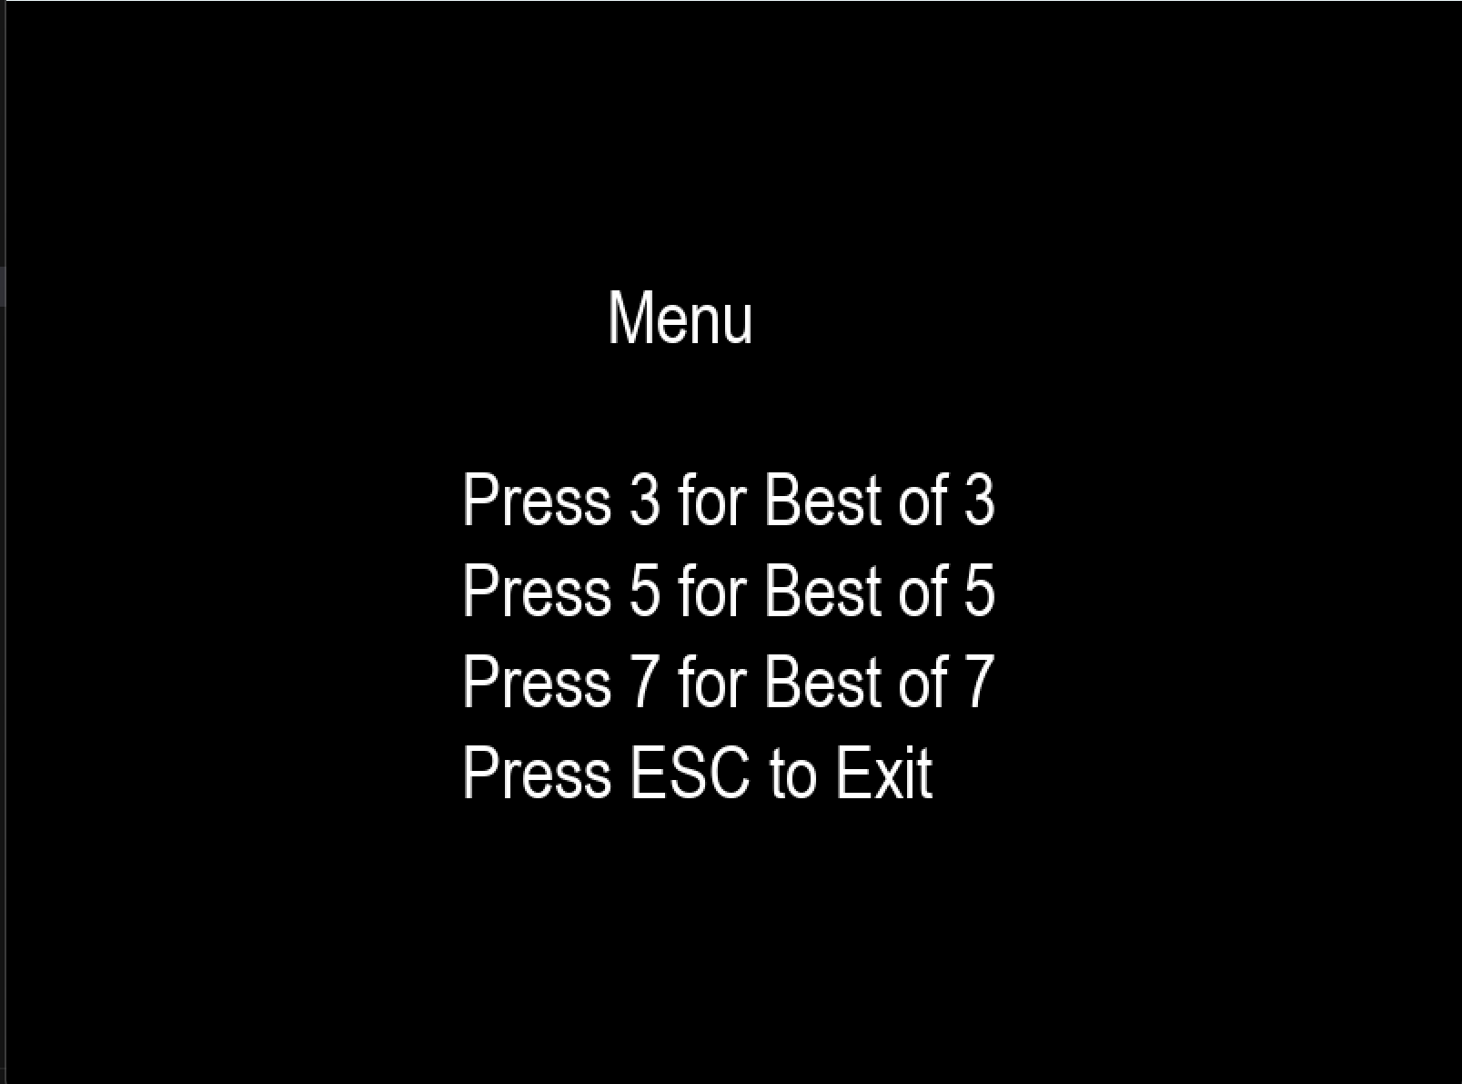
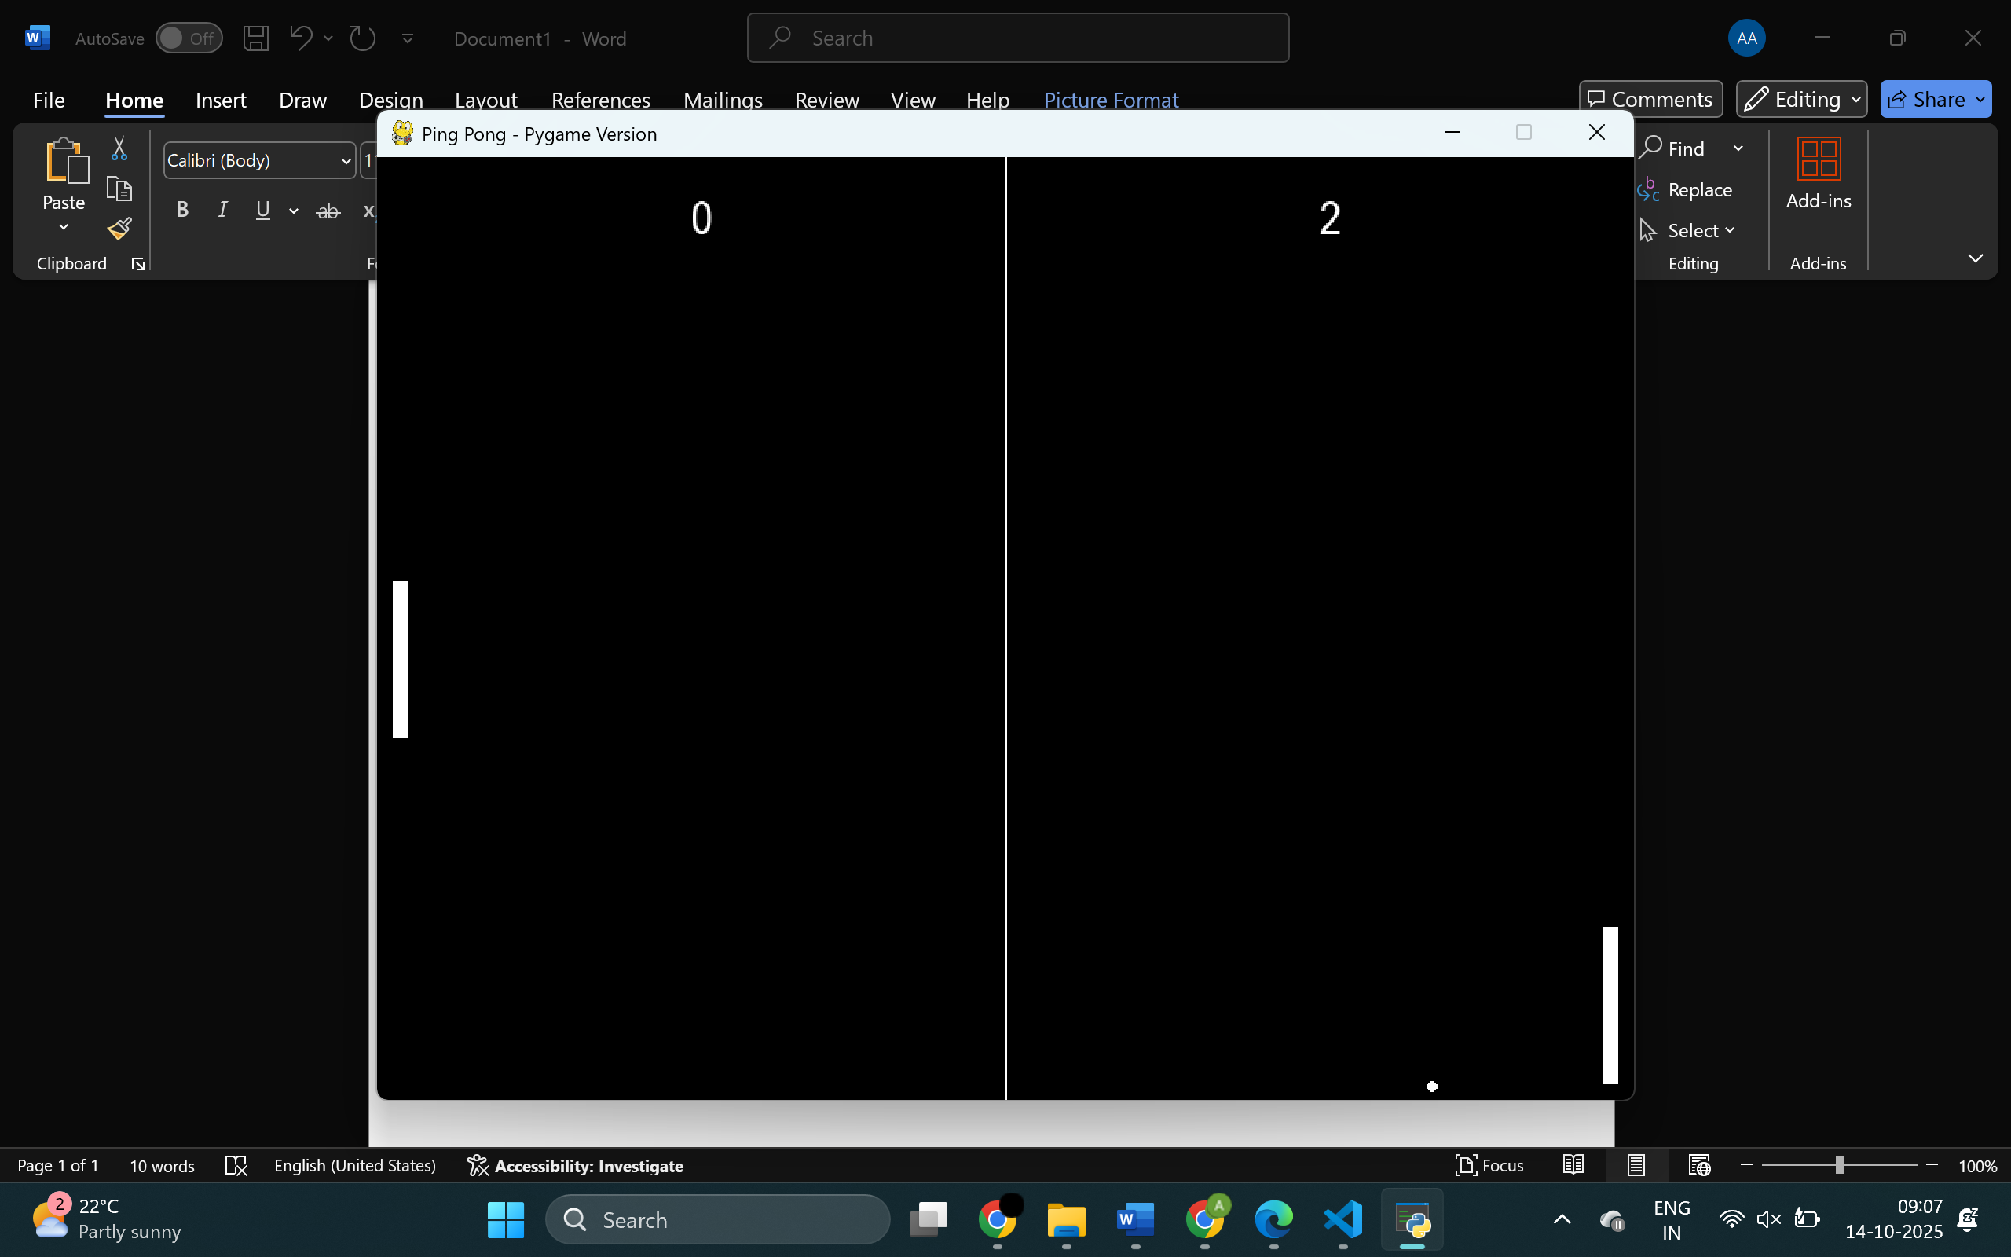
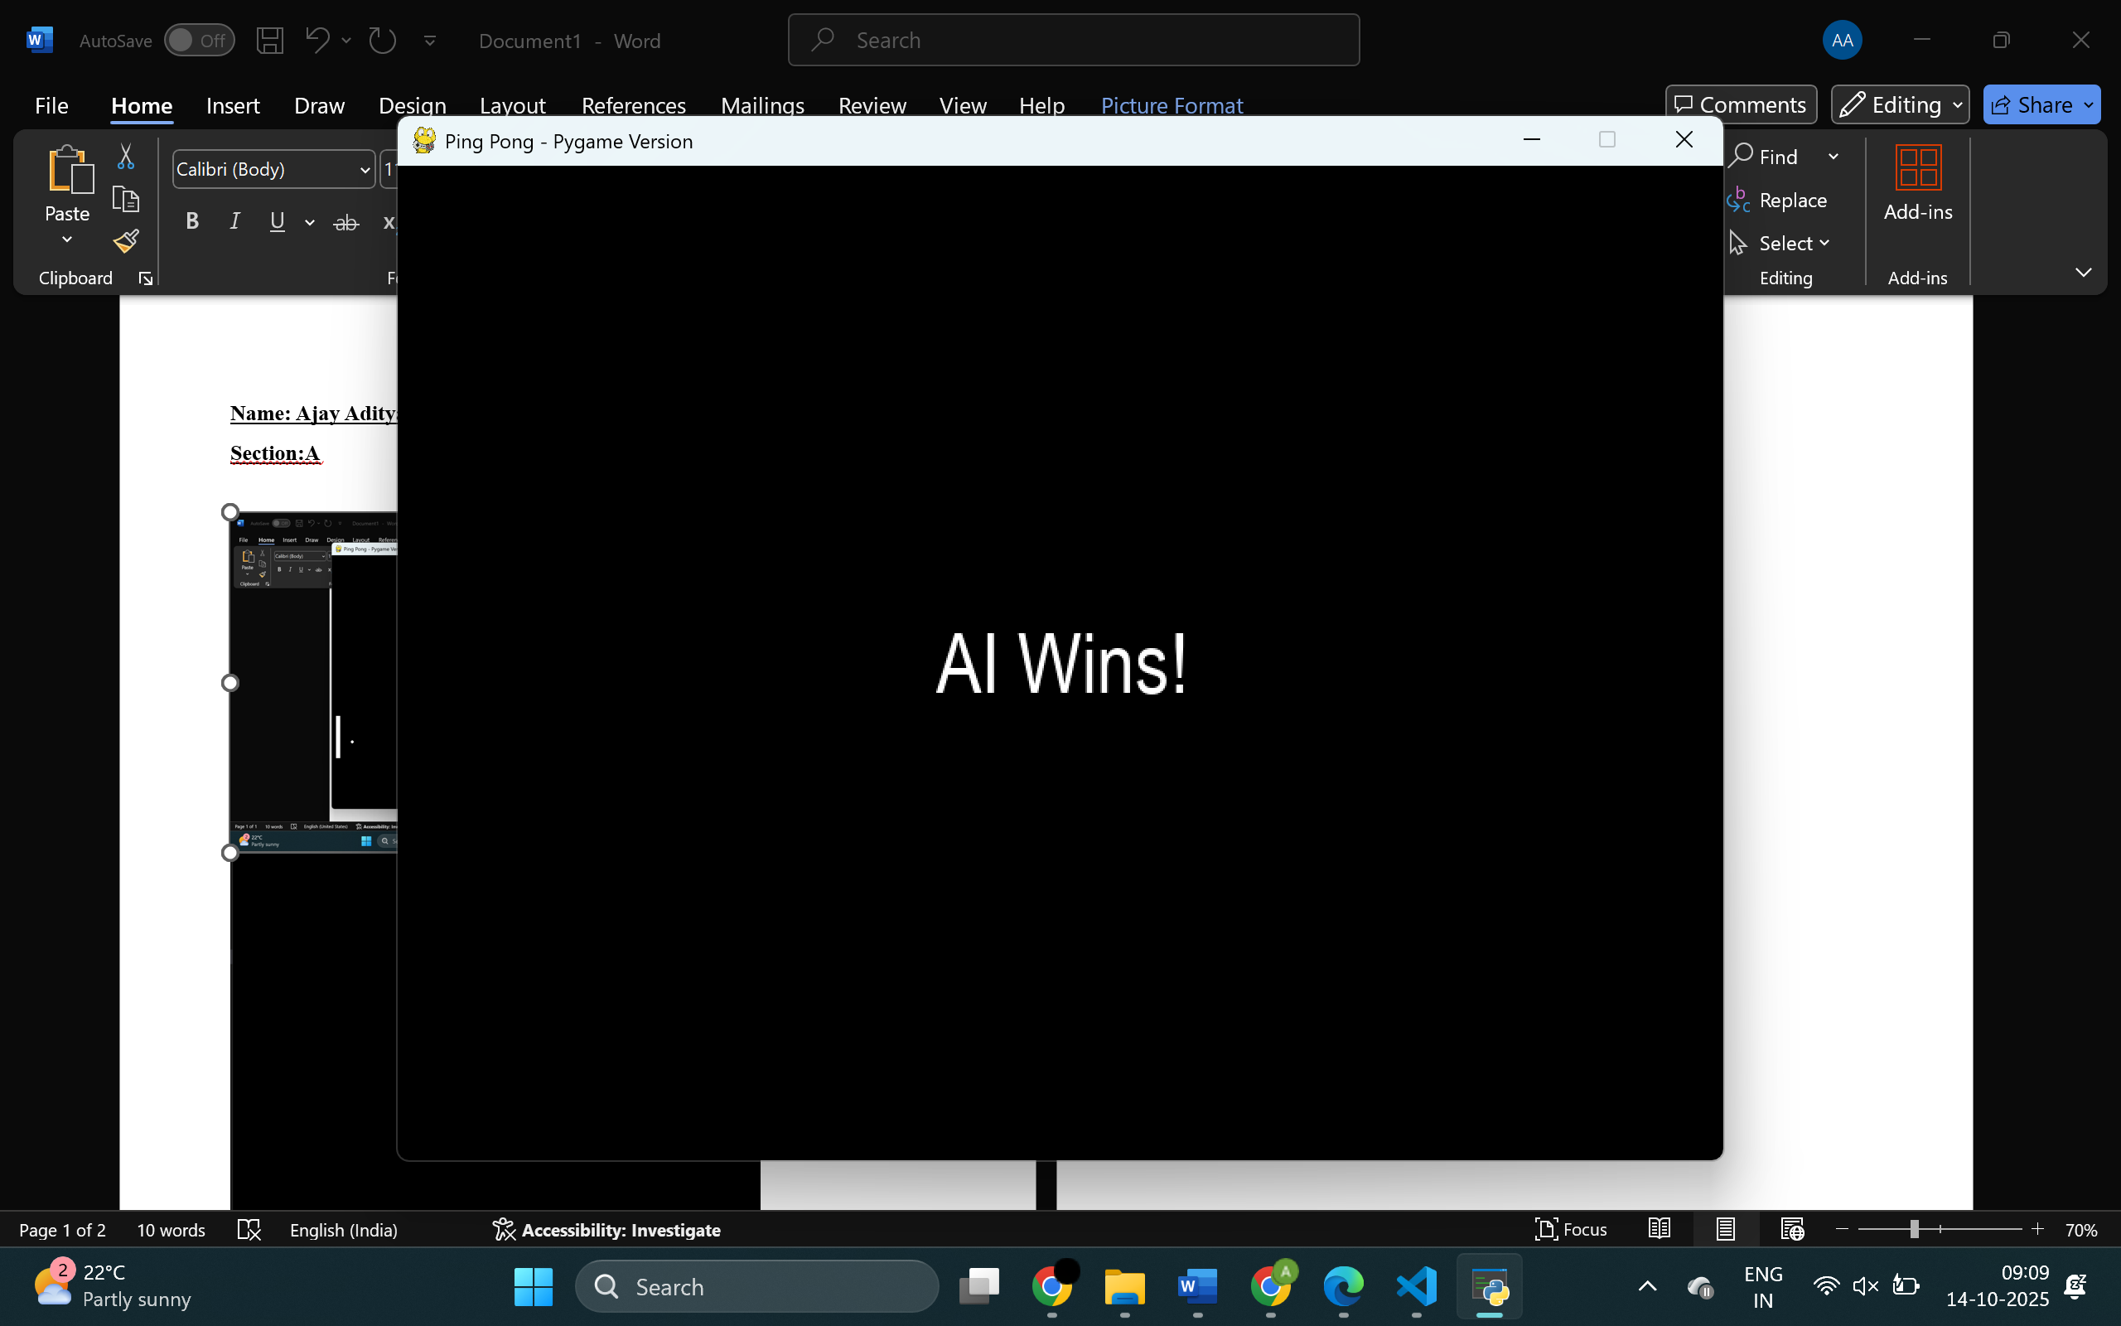
Pushing into git-repo:
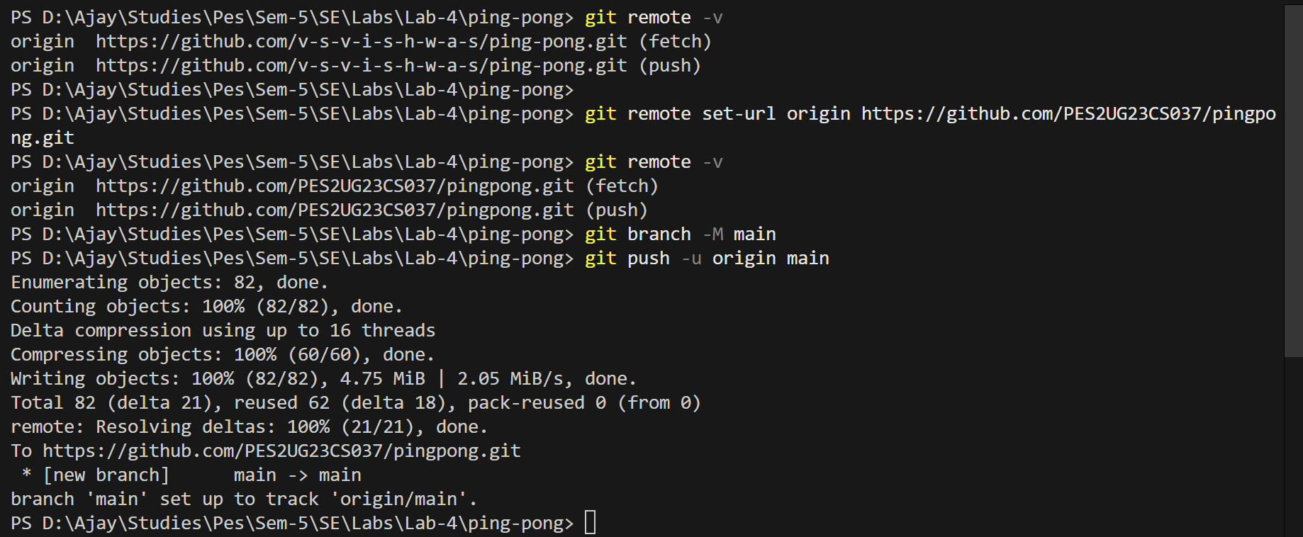

Chatgpt Prompt:
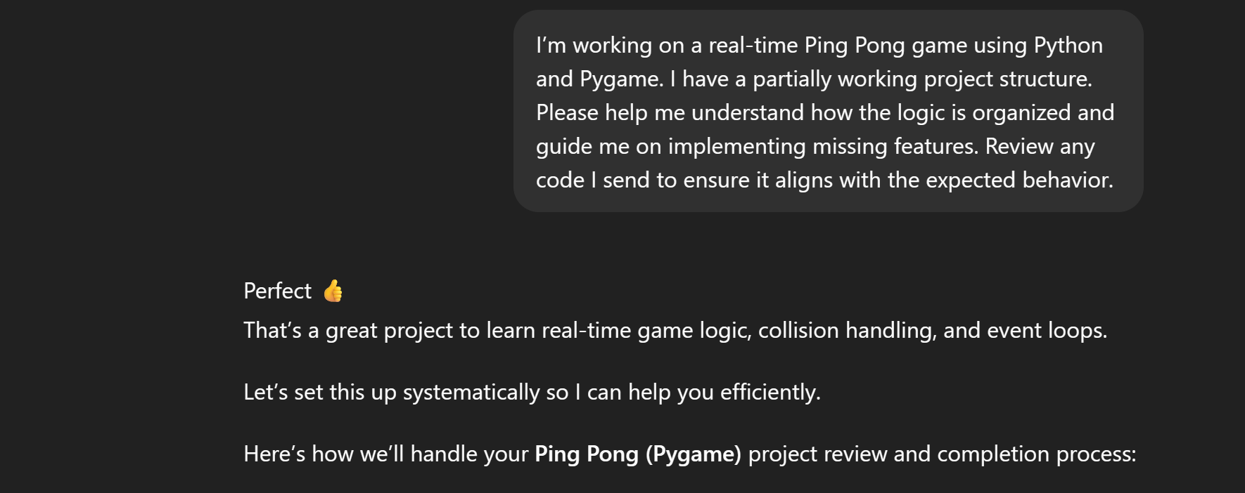
Task 1:
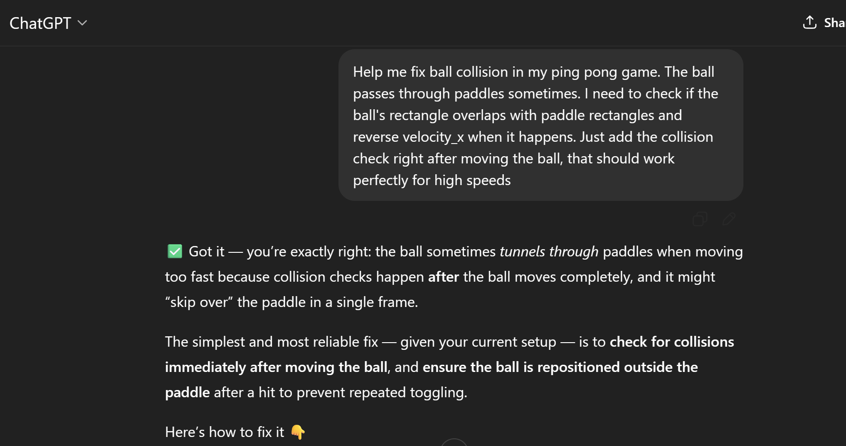
Task 2:
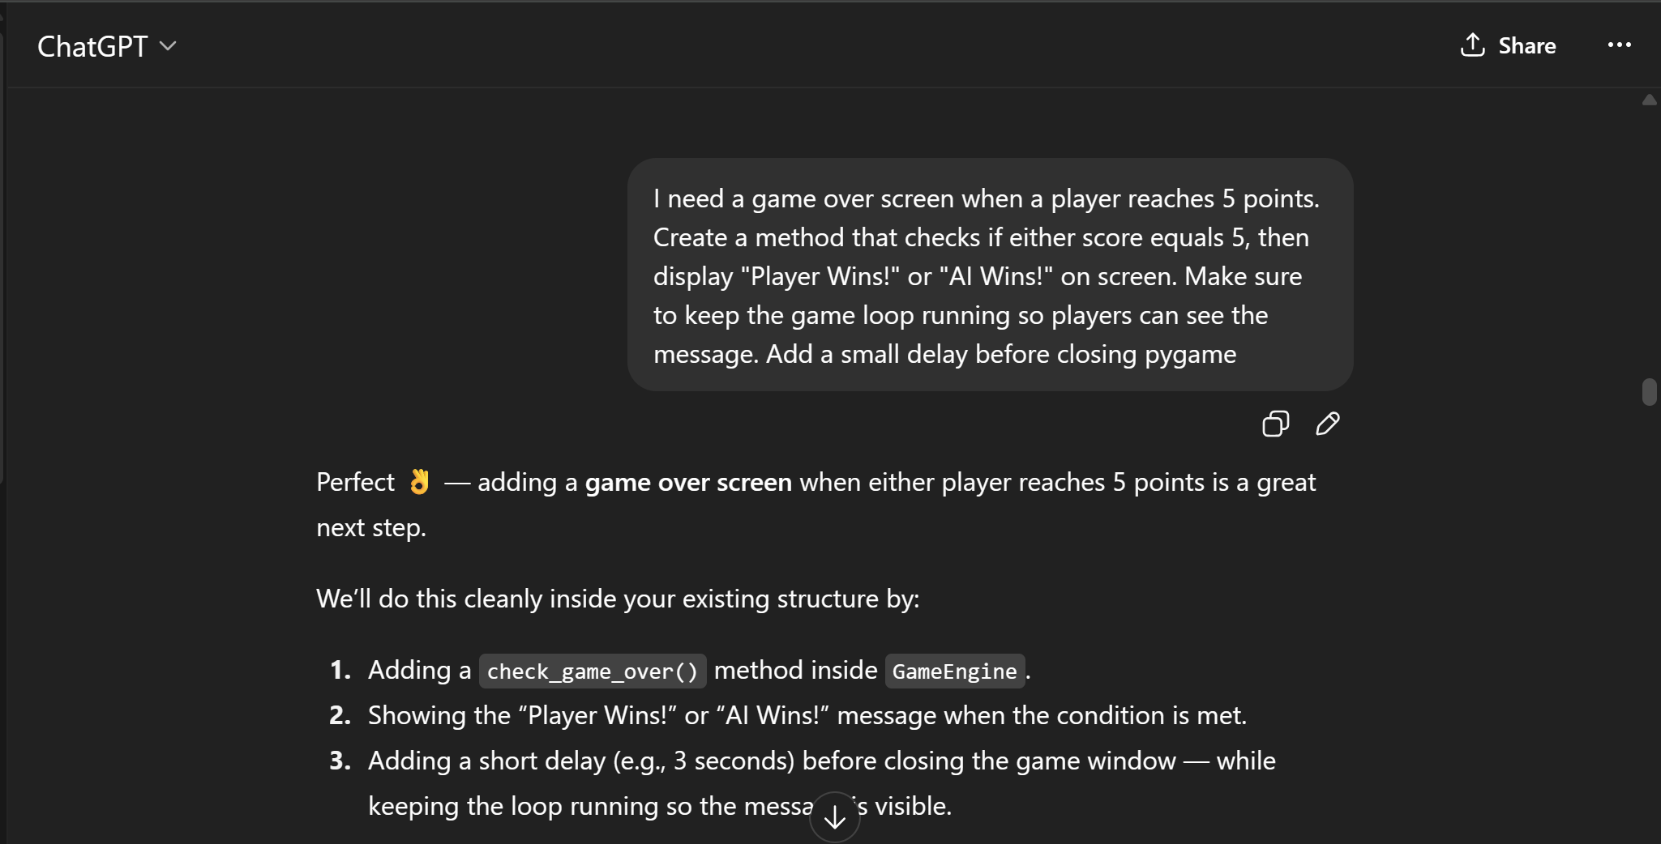
Task 3:
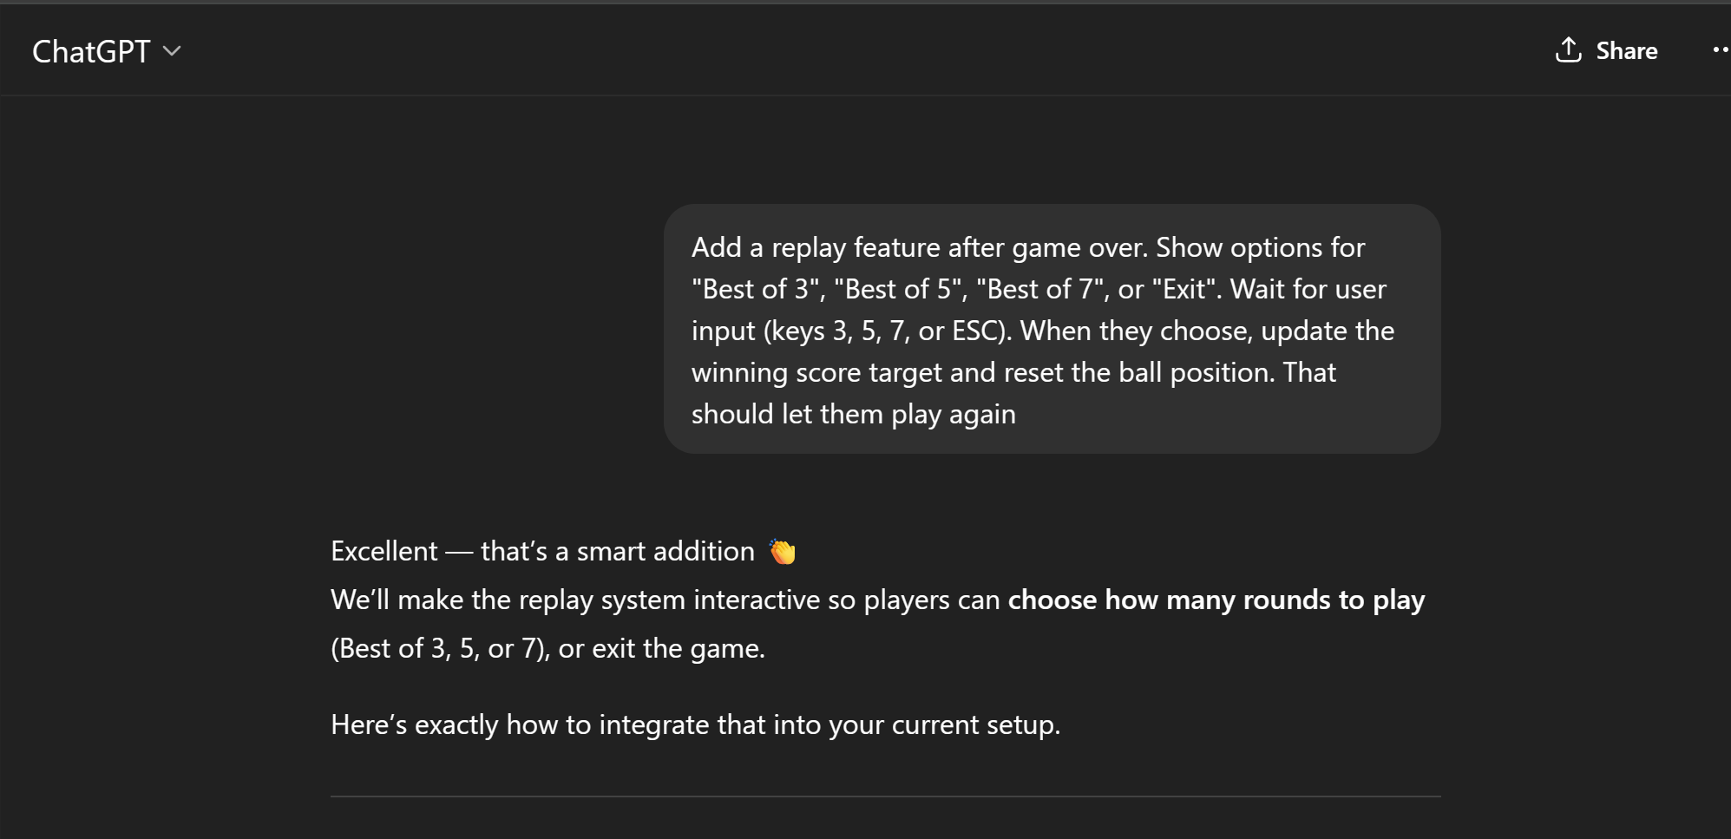
Task 4:
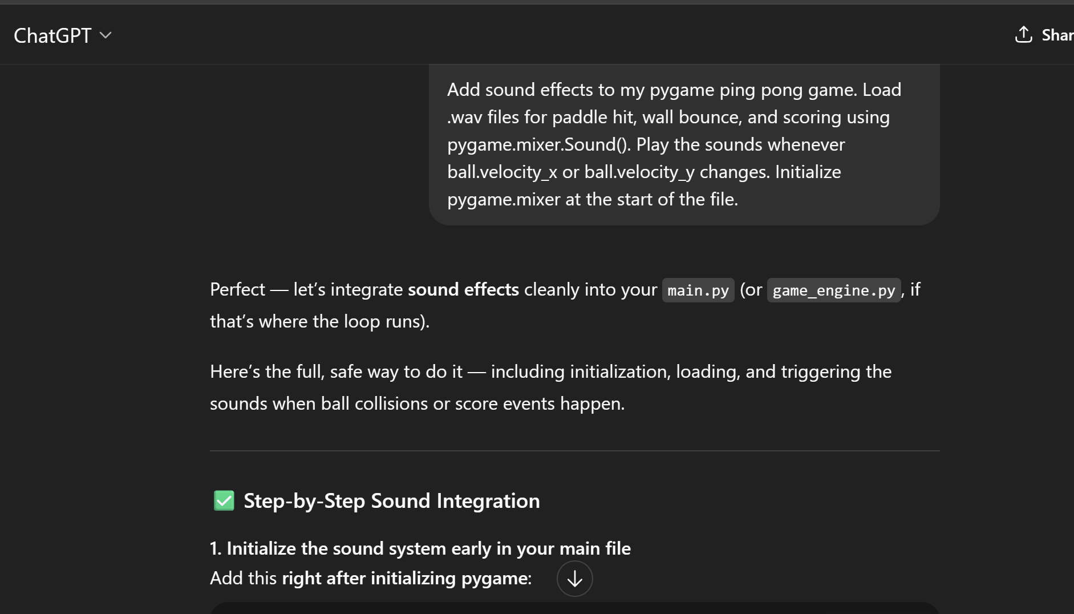

LLM Link: https://chatgpt.com/share/68edc9ce-9330-8006-8b40-697f987226a1
GIT link: https://github.com/PES2UG23CS037/pingpong

