**Index**

**1. Introduction**

1.1 Introduction to Existing System

1.2 Problems in Existing System

1.3 Need for Improvement

1.4 Objectives

1.5 Problem Statement

**2. Literature Survey**

2.1 Introduction

2.2 Research Paper- I

2.3 Research Paper- II

2.4 Research Paper- III

2.5 System – I

2.6 System - II

**3. Proposed System**

3.1 Dataset

3.2 Concept Involved

3.3 Block Diagram

3.4 Steps of Implementation

**4. References**

**1. Introduction**

Next Word Prediction is referred to as Language Modelling. It is a application of Natural Language Processing (NLP) where we aim to predict the most probable word that should follow a given sequence of words so that people do not have to type the following word, but rather can select a word from the suggested ones.

Predicting the next word in a sequence can reduce the count of number of letters typed made by the user. Imagine you’re typing a sentence, and your smartphone or computer suggests the next word you’re likely to type. That’s next-word prediction!

**1.1 Introduction to Existing System**

Next-word prediction has practical applications in various areas and some of the existing systems that utilize the concept of **next word prediction** are listed below:

1. **Auto-Completion Systems**: Auto-completion systems, commonly found in search engines, messaging apps, and code editors, which predict the next word or phrase based on the context provided by the user. These systems enhance user experience by offering relevant suggestions as the user types. This feature can improve typing speed and accuracy.

2. **Speech Recognition Systems**: Predicting the next word is crucial for accurate transcription in speech recognition. Voice assistants (e.g., Siri, Google Assistant) use context to anticipate the user’s intended words. Similar model architectures as auto-completion systems.

3. **Machine Translation**: Next word prediction is essential for translating sentences between languages. Context-aware models generate coherent and accurate translations. Predicting the next word helps improve translation quality.

4. **Mobile Keyboards**: Keyboard applications on smartphones often incorporate next word prediction to suggest the next word as users type, making texting faster and more convenient. Popular examples include Gboard by Google, Apple's default keyboard.

**1.2 Problems in Existing System**

Certainly the challenges associated with existing systems that utilize the concept of next-word prediction:

1. **Context Sensitivity**: Existing systems may struggle to understand the context of the text accurately, leading to predictions that are not relevant to the user’s intended meaning. These systems often rely on immediate preceding words without considering the broader context of the conversation or document.
2. **Limited Vocabulary**: Some systems may have a restricted vocabulary, resulting in predictions that lack diversity and are unable to suggest less common or specialized words. Expanding the vocabulary to handle a wide range of terms is essential for improving prediction quality.
3. **Ambiguity**: Words in natural language often have multiple meanings, and existing systems may struggle to determine the intended meaning of a word based on the context. This ambiguity can lead to incorrect predictions, especially when a word has several possible interpretations.
4. **Grammar and Syntax**: Next-word prediction systems may produce predictions that violate grammar rules or syntactic structures. Suggestions that are grammatically incorrect or awkwardly phrased can negatively impact user experience.
5. **Overfitting to Training Data**: Systems may become overfitted to the training data, leading to predictions that are too specific or repetitive. Generalizing well to new or unseen text is crucial for robust performance.
6. **Lack of Personalization**: Next-word prediction systems often do not take into account the individual preferences, writing style, or language variations of the user. Personalizing suggestions based on user-specific patterns remains a challenge.
7. **Performance Degradation with Noise**: The performance of existing systems may degrade in the presence of noise or errors in the input text. Noise can lead to less accurate predictions, affecting overall system reliability.
8. **Privacy Concerns**: Some next-word prediction systems may raise privacy concerns. They may need to process and store large amounts of user data to improve prediction accuracy. Balancing prediction quality with privacy and security considerations is essential.

Addressing these challenges is crucial for enhancing the effectiveness and usability of next-word prediction systems in various NLP applications .[While next-word prediction systems have made significant strides, addressing these challenges remains essential for improving user experience and communication in natural language processing applications](https://www.geeksforgeeks.org/next-word-prediction-with-deep-learning-in-nlp/).

**1.3 Need for Improvement**Improvements in existing systems that utilize next word prediction can address several key needs:

1. **Enhanced Context Understanding**: Systems need to better understand the context of the conversation or text to provide more accurate predictions. This involves analysing not only the immediate preceding words but also the broader context of the conversation or document.
2. **Increased Vocabulary and Language Variability**: Systems should be trained on a more extensive vocabulary and a diverse range of language styles and variations to generate more relevant and appropriate predictions across different contexts and domains.
3. **Dealing with Ambiguity and Polysemy**: Improved methods for disambiguating between words with multiple meanings can help systems provide more accurate predictions by selecting the most contextually appropriate word.
4. **Personalization and Adaptation**: Systems should be able to adapt to individual users' preferences, writing styles, and language usage patterns to provide more personalized and relevant predictions.
5. **Long-Term Dependency Handling**: Enhancements in capturing and modeling long-term dependencies in text can help systems generate predictions that are more consistent and coherent with the overall context of the conversation or document.
6. **Multilingual Support**: Systems should support multiple languages and be able to switch seamlessly between them to cater to users who communicate in different languages.
7. **Real-Time Feedback Integration**: Integrating mechanisms for users to provide real-time feedback on the accuracy and relevance of predictions can help improve the system over time through iterative learning and refinement.
8. **Ethical and Responsible AI**: Systems should be developed and deployed with considerations for ethical and responsible AI practices, including transparency, fairness, and accountability, to ensure that they benefit users while minimizing potential harm or biases.

Existing next word prediction systems have some shortcomings. They often struggle to understand context, may not know enough words or language styles, rely too heavily on patterns, sometimes get word meanings wrong, lack personalization, and can't handle long conversations well. Improvements are needed in these areas to make the systems more accurate and helpful for users.

**1.4 Objectives:**

**Learning Objective:**

1. Understand NLP Concepts: Gain insights into NLP tasks, including next-word prediction.

2. Explore Deep Learning Techniques: Learn about recurrent neural networks (RNNs), Long Short-Term Memory (LSTM), and Gated Recurrent Unit (GRU) architectures.

3. Word Embeddings: Comprehend the concept of word embeddings and their role in capturing semantic and contextual information.

**Deep Learning Objective:**

4. Model Architecture: Construct an effective next-word prediction system using RNNs, LSTMs, or GRUs.

5. Sequential Dependencies: Leverage deep learning architectures to capture sequential dependencies in input text.

6. Precise Predictions: Achieve accurate predictions of the next word by considering context and hidden states.

**Social Objective:**

7. Enhance User Experience: Provide relevant and coherent word suggestions for auto-completion systems.

8. Efficient Communication: Improve typing speed and accuracy, aiding in coherent and efficient communication.

**Performance Analysis Objective:**

9. Evaluate Model Performance: Assess the accuracy and efficiency of the next-word prediction model.

10. Fine-Tuning: Optimize hyperparameters and fine-tune the model for better results.

11. User Satisfaction: Measure user satisfaction through improved auto-completion experiences.

**1.5 Problem Statement**

Given a sequence of words (context) within a sentence, our objective is to predict the most likely next word. This predictive skill is crucial for applications such as text auto-completion, speech recognition, and machine translation. Given a sequence of words, our model aims to predict the most likely word to follow. Our task involves designing an effective deep learning model that accurately predicts the next word based on the preceding context. We will leverage recurrent neural networks (RNNs) and their variants (such as LSTM and GRU) to capture sequential dependencies in input text. By developing an effective next-word prediction model, we can enhance user experience and improve various NLP applications.

**2. Literature Survey**

In recent years, deep learning techniques have revolutionized Natural Language Processing (NLP), particularly in the domain of next-word prediction. Researchers explore architectures like Recurrent Neural Networks (RNNs), Long Short-Term Memory (LSTM), and Gated Recurrent Unit (GRU) to capture context and dependencies within text. Accurate predictions enhance user experience by suggesting relevant words, streamlining typing, and empowering NLP applications. Challenges include language-specific nuances, dataset availability, and practical constraints. Future directions involve multilingual models, fine-tuning, and broader application beyond restrictions.

Research Paper related to **Next Word Prediction**:

[1] *S. S. Kulkarni*, *S. S. Kulkarni* “**Next word prediction for phonetic typing by grouping language models**”

Description : This paper presents a language model-based framework for instant messaging. The framework predicts the probable next word given a set of current words, aiming to enhance the efficiency of instant messaging by suggesting relevant words to users. The goal is to facilitate faster typing and assist individuals with reduced typing speed.

Link : <https://ieeexplore.ieee.org/document/7477536>

[2] **Next Word Prediction with Deep Learning Models**” by *Erdem Yörük, Mehmet Fatih Amasyalı, and Mehmet Hakan* Karaata “

Description : Next word prediction has been a trending topic in Natural Language Processing (NLP) over the last decade. Previously, Support Vector Machines and Markov models were used for this task. However, with advancements in technology, NLP models have shifted to deep learning algorithms such as Recurrent Neural Networks (RNNs) and Long Short-Term Memory Networks (LSTMs). While much research has focused on English, this study explores next word prediction using a Turkish dataset. The corpus includes sports articles and comments related to football, basketball, volleyball, and tennis. The goal is to identify the most successful model for Turkish next word prediction, considering the unique characteristics of the Turkish language

Link: <https://link.springer.com/chapter/10.1007/978-3-031-09753-9_38>

[3] “**An Approach for Next-Word Prediction for Ukrainian Language Text Input**” by *Olena Kovalchuk, Oleksandr Kovalchuk, and Volodymyr Kovalchuk*

Description: This work focuses on developing a predictive system for Ukrainian language text input. The study employs machine learning algorithms, including Markov chains and LSTM (Long Short-Term Memory), to improve the correctness of next word predictions. By training a recurrent neural network-based language model, the authors aim to enhance the quality of suggested next words in Ukrainian text.

Link: <https://downloads.hindawi.com/journals/wcmc/2021/5886119.pdf>

[4] “**Next Word Prediction**” by Keerthana N., Harikrishnan S., Konsaha Buji M., and Jona J. B.

Description : Writing long sentences can be tedious, but text prediction within keyboard technology has made it easier. Next Word Prediction, also known as Language Modeling, aims to predict the word that comes next. It’s a crucial task in human language technology with various applications. The study explores Long Short-Term Memory (LSTM) models, which can understand past text and predict words, aiding users in constructing sentences. The approach involves letter-to-letter prediction, where letters combine to form words

Link : <https://ijcrt.org/papers/IJCRT2112562.pdf>

[5] **“A Comprehensive Review and Evaluation on Text Predictive and Next Word Prediction Systems”**

This comprehensive review evaluates various techniques for text prediction and next word prediction systems. It discusses different approaches and their effectiveness. While the paper does not focus on specific research papers, it provides a broader perspective on the field

Link - <https://arxiv.org/abs/2201.10623>

# [6] “ **Prediction of Next Words Using Sequence Generators and Deep Learning Techniques**” by *P. Sunitha Devi, Chepuri Sai Tejaswini, Modem Keerthana, Manusree Cheruvu & Minati Srinivas*

Description: In this paper, the authors explore the fascinating concept of next word prediction using deep learning techniques. The authors employ **recurrent neural networks (RNNs)** for predicting the next word—a neural application. While standard RNNs can handle certain issues, teaching them to learn long-term temporal dependencies can be challenging. To address this, **LSTM (Long Short-Term Memory) networks** are applied. By advancing existing technology, the authors aspire to anticipate the next words that best fit a given statement, ultimately creating a user-friendly application.

Link : <https://link.springer.com/chapter/10.1007/978-981-99-1588-0_16>

Some of the github respositories link :

[7] <https://github.com/topics/next-word-prediction>

[8] <https://github.com/MichiganDataScienceTeam/next-word-predictor>

[9] <https://github.com/AyomiUpeksha/Next-Word-Prediction>

[10] <https://github.com/topics/next-word-prediction?l=html>

[11] <https://github.com/Mrunali0205/Next-Word-Prediction-Model-using-Pythonh>

**3. Proposed System**

**3.1 Block Diagram**

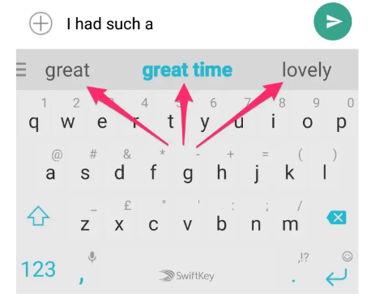

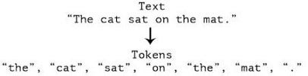

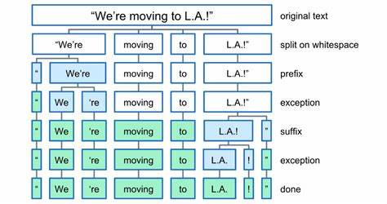

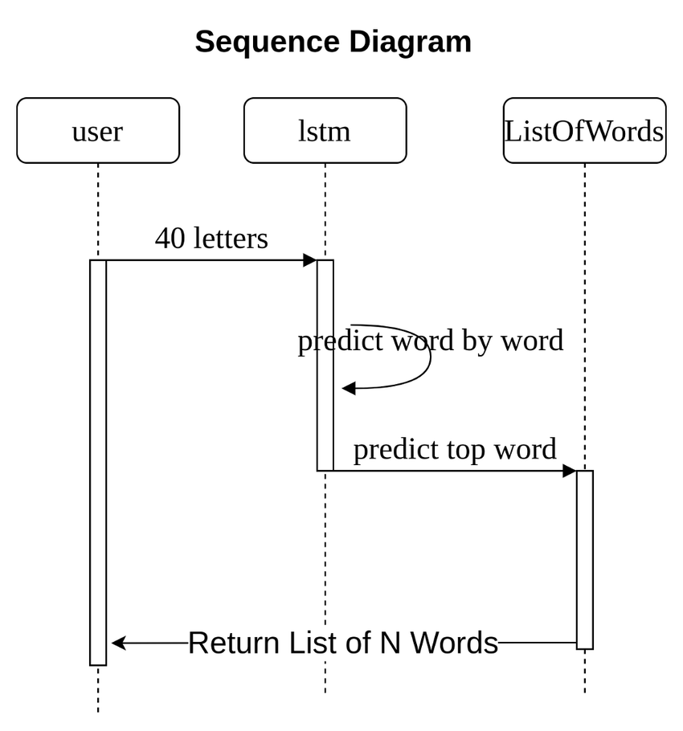

**3.2 Dataset**

In this project, we've used a dataset called the "Project Gutenberg Book Corpus for Next Word Prediction." We created this dataset ourselves by gathering lots of books from Project Gutenberg, a website with free books. Each book in our dataset is kept together, and we also included details like the book's title, author, and when it was published. Our dataset has various kinds of books, from different times and genres, like novels, poems, and more. We picked these books to make sure we have a wide variety of writing styles and topics.

In our Next Word Prediction project, we're using our dataset as the starting point to teach machine learning models how to guess the next word in a sentence. We're taking advantage of how language follows a sequence - one word comes after another. We're using techniques like recurrent neural networks (RNNs) or transformers to help us analyse the patterns in the words. We feed our dataset into these models, letting them learn from the thousands of words they see. As they learn, it will start to understand how words are used together and what word might come next based on what came before. It's like when you read a sentence and can guess what the next word might be because of the words you've already read.

Once our models are trained with our dataset, they get really good at guessing the next word in a sentence. They will learn the patterns and connections between words, so it can make smart guesses about what word should come next based on the words it have seen before. Our goal is to make a model that can predict the next word accurately and quickly, making it easier for people to write and understand text in various applications.

**3.3 Concept Involved**

Here are some key concepts that will be involved in creating a Next Word Prediction project:

1. **Natural Language Processing (NLP)**:
   * **Easy Term**: NLP is all about teaching computers to understand and work with human language, like English or Spanish.
2. **Text Preprocessing**:
   * **Easy Term**: Before teaching a computer to predict words, we need to clean up the text by removing things like punctuation and converting all words to lowercase.
3. **Tokenization**:
   * **Easy Term**: Tokenization means splitting up a sentence into individual words or "tokens" so the computer can understand them better.
4. **Word Embeddings**:
   * **Easy Term**: Word embeddings are like special codes for words that computers can use to understand their meaning and relationships with other words.
5. **Recurrent Neural Networks (RNNs)**:
   * **Easy Term**: RNNs are special types of computer programs that are really good at understanding sequences of data, like words in a sentence.
6. **Long Short-Term Memory (LSTM)**:
   * **Easy Term**: LSTMs are a type of RNN that are even better at remembering important information from the past when predicting the next word.
7. **Training Data**:
   * **Easy Term**: Training data is the collection of text that we use to teach the computer how to predict the next word. It's like the examples a teacher uses to help students learn.
8. **Loss Function**:
   * **Easy Term**: The loss function tells the computer how wrong its predictions are so it can learn from its mistakes and get better at predicting the next word.
9. **Optimization Algorithms**:
   * **Easy Term**: Optimization algorithms are like strategies the computer uses to adjust its predictions and get closer to the right answer.
10. **Model Evaluation**:
    * **Easy Term**: Model evaluation is like giving the computer a test to see how well it can predict the next word. We want to make sure it's doing a good job before we use it for real.

By understanding these concepts and how they work together, we can build a Next Word Prediction project that can accurately guess the next word in a sentence!

**3.4 Steps of Implementation**

let's break down each step involved in creating a Next Word Prediction project:

1. **Data Collection**:

Gather a diverse dataset of text from sources like books, articles, or online repositories such as Project Gutenberg.

Collect approximately 30 to 35 books to ensure an adequate amount of textual data for training the model.

1. **Text Preprocessing**:
   * Before feeding the text data into the model, you clean it up. This involves removing any unnecessary characters like punctuation or special symbols. You also convert all text to lowercase to standardize the representations.
2. **Tokenization**:
   * Tokenization breaks down the preprocessed text into individual words or tokens. Each word becomes a separate unit that the model can understand and analyze.
3. **Word Embeddings**:
   * Word embeddings are numerical representations of words that capture their semantic meanings. Techniques like Word2Vec or GloVe generate these embeddings by considering the context in which words appear in the dataset.
4. **Recurrent Neural Networks (RNNs)**:
   * RNNs are a type of neural network architecture designed for sequential data. They process input sequences step by step, maintaining a hidden state that retains information about past inputs.
5. **Model Training**:
   * During training, the model learns to predict the next word in a sequence. You feed sequences of words into the model, compare the predicted next word with the actual next word, and adjust the model's parameters to minimize prediction errors.
6. **Loss Function**:
   * The loss function measures how well the model's predictions match the actual next words. Common loss functions for next word prediction tasks include categorical cross-entropy, which quantifies the discrepancy between the predicted and actual word distributions.
7. **Optimization Algorithms**:
   * Optimization algorithms like stochastic gradient descent (SGD) or Adam adjust the model's parameters to minimize the loss function. They iteratively update the model's weights and biases to find the optimal configuration for accurate predictions.
8. **Model Evaluation**:
   * After training, you evaluate the model's performance on a separate validation or test dataset. Evaluation metrics like accuracy or perplexity measure how well the model predicts the next word in unseen sequences.
9. **Prediction Generation**:
   * Once trained, the model can generate predictions for the next word in a given input sequence. It calculates the probability distribution over the vocabulary and selects the word with the highest probability as the predicted next word.

By following these steps, we will create a Next Word Prediction system that effectively analyses text data and generates accurate predictions for the next word in a sequence.

**References**

[1] <https://medium.com/@evertongomede/next-word-prediction-enhancing-language-understanding-and-communication-1322f3b57632>

[2] <https://www.geeksforgeeks.org/next-word-prediction-with-deep-learning-in-nlp/>

[3]<https://www.analyticsvidhya.com/blog/2023/07/next-word-prediction-with-bidirectional-lstm/>

[4] [next-word-prediction · GitHub Topics](https://github.com/topics/next-word-prediction)

[5] [Next Word Prediction Model | Aman Kharwal (thecleverprogrammer.com)](https://thecleverprogrammer.com/2020/07/20/next-word-prediction-model/)

[6][Next Word Prediction Using Deep Learning: A Comparative Study | IEEE Conference Publication | IEEE Xplore](https://ieeexplore.ieee.org/document/9734151)