Read Me:

The program “configuration_files_generators_for_NCGSIM” generates all the input files required by NCGSIM to run a simulation.

All the input and output files are stored in folder named “NC-G-SIM_input_generator”. You need to store this folder into user's home directory.

The Input files to this program are:

- arch.config: This file contains the information about architecture (topology). The information is provided in terms of number of rows, number of columns and number of slices.
For 2D Mesh Topologies, set of number of slices equal to 1. Name of this file cannot be changed.
Following is the snapshot of the arch.config file:

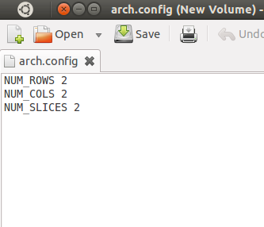

The 3D Mesh architecture generated is as shown in the figure below:

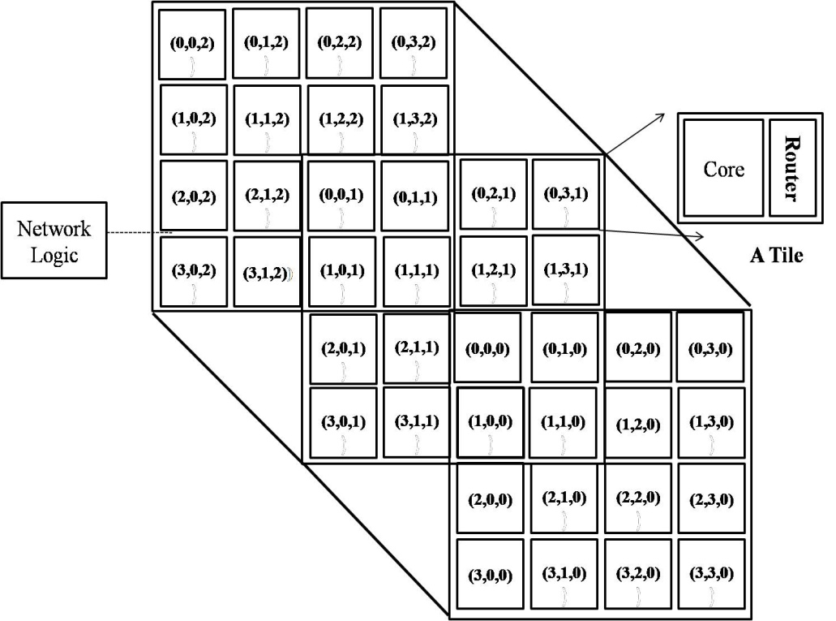

4x4x4 3D Mesh

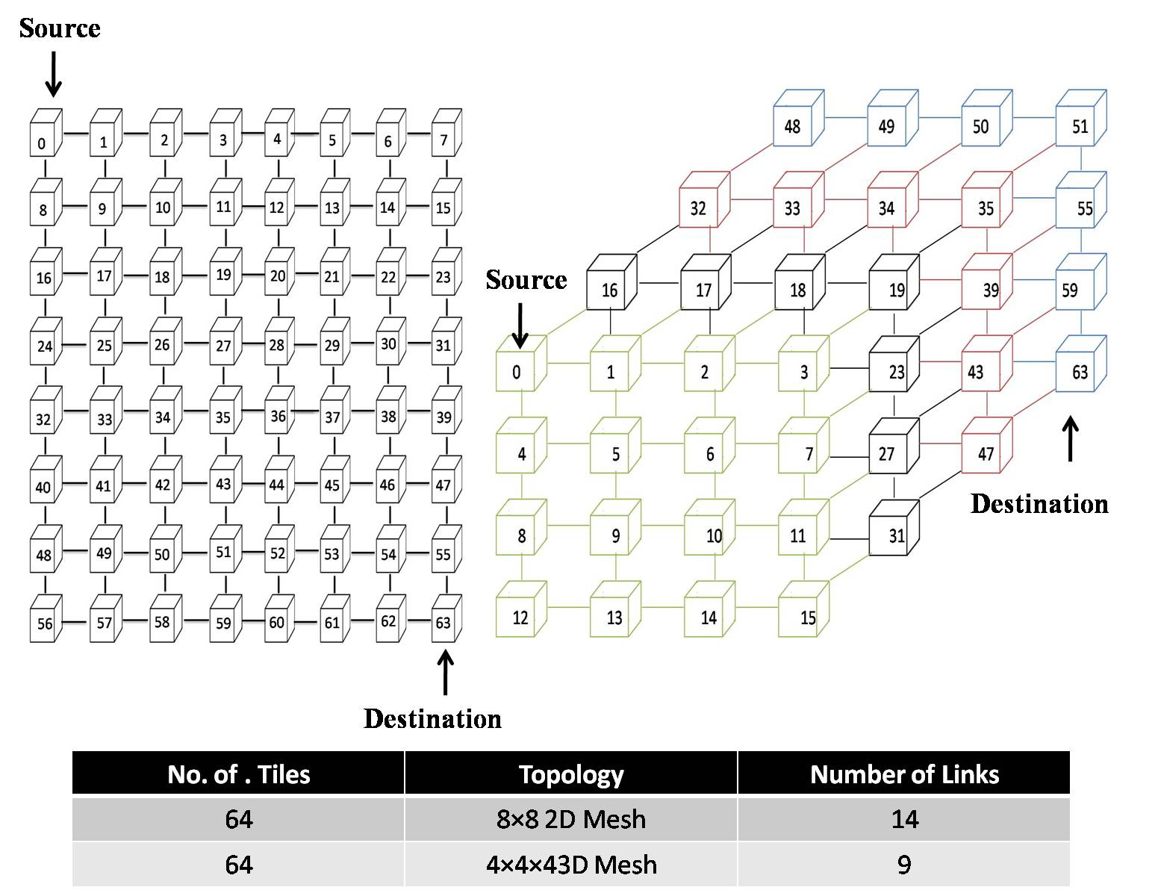
2D and 3D Mesh NoC

- At the run time it will ask for the name of file having application traffic characteristics. So, first you need to have a file having traffic characteristics as shown in the figure:

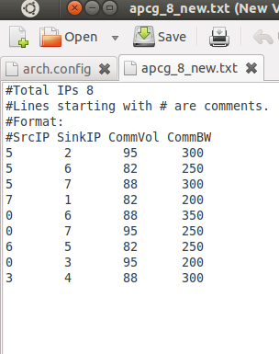

You can save this file by any name. You just need to provide its name at run time followed by “./” as shown in the figure below:

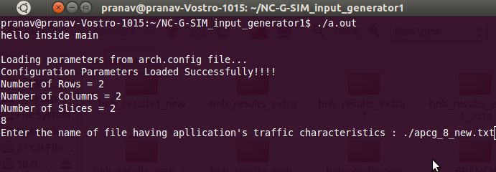

/* The output files are stored in “/home/NC-G-SIM_input_generator/files3d2d/”.

The output files generated by this program are:

- application.config

- traffic folder: At run time this program will ask you to specify the type of load. If you press 'o' the load will be computed from the volume specified in application traffic characteristics file. If you press 'f' it won't compute any load and LOAD for each source tile would become 100.

- topology_config folder: This folder stores following two files:
a. link_length
b. tolpolgy_TD.config

- rtable folder: This folder will be containing the routing table files for all the tiles in your architecture. This folder stores two more files “routingpath.txt” and “same_plane_dest_file.txt”. However these files are not provided as input files to the NCGSIM.

