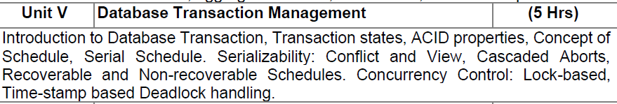
Transaction in DBMS
A transaction refers to a sequence of one or more operations (such as read and write) performed on the database as a single logical unit of work.
- A transaction ensures that either all the operations are successfully executed (committed) or none of them take effect (rolled back).
- Transactions are designed to maintain the integrity, consistency and reliability of the database, even in the case of system failures.

During the transaction the database is inconsistent. Only once the database is committed the state is changed from one consistent state to another.
Example: Let’s consider an online banking application:
Transaction: When a user performs a money transfer, several operations occur, such as:
- Reading the account balance of the sender.
- Writing the deducted amount from the sender’s account.
- Writing the added amount to the recipient’s account.
Operations of Transaction
A user can make different types of requests to access and modify the contents of a database. So, we have different types of operations relating to a transaction. They are discussed as follows:
1) Read(X)
A read operation is used to read the value of a particular database element X and stores it in a temporary buffer in the main memory for further actions such as displaying that value.
Example: For a banking system, when a user checks their balance, a Read operation is performed on their account balance:
SELECT balance FROM accounts WHERE account_id = 'A123';
2) Write(X)
A write operation stores updated data from main memory back to the database. It usually follows a read, where data is fetched, modified (e.g., arithmetic changes) and then written back to save the updated value.
Example: For the banking system, if a user withdraws money, a Write operation is performed after the balance is updated:
UPDATE accounts SET balance = balance - 100 WHERE account_id = 'A123';
This updates the balance of the user’s account after withdrawal.
3) Commit
This operation in transactions is used to maintain integrity in the database. Due to some failure of power, hardware, or software, etc., a transaction might get interrupted before all its operations are completed. This may cause ambiguity in the database, i.e. it might get inconsistent before and after the transaction.
Example: After a successful money transfer in a banking system, a Commit operation finalizes the transaction:
COMMIT;
Once the transaction is committed, the changes to the database are permanent and the transaction is considered successful.
4) Rollback
A rollback undoes all changes made by a transaction if an error occurs, restoring the database to its last consistent state. It helps prevent data inconsistency and ensures safety.
Example: Suppose during the money transfer process, the system encounters an issue, like insufficient funds in the sender’s account. In that case, the transaction is rolled back:
ROLLBACK;
This will undo all the operations performed so far and ensure that the database remains consistent.

Transaction States in DBMS
Transaction states represent the different phases a transaction goes through during its lifecycle in a database system. These states help track the progress and outcome of a transaction to ensure data consistency and integrity.
Different Types of Transaction States in DBMS
These are the different types of Transaction States:
- Active State
- Partially Committed State
- Committed State
- Failed State
- Aborted State
- Terminated State
Transaction States
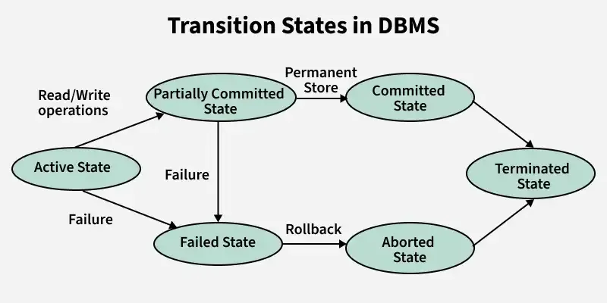
1. Active State
- It is the first stage of any transaction when it has begun to execute. The execution of the transaction takes place in this state.
- Operations such as insertion, deletion, or updation are performed during this state.
- During this state, the data records are under manipulation and they are not saved to the database, rather they remain somewhere in a buffer in the main memory.
2. Partially Committed
- The transaction has finished its final operation, but the changes are still not saved to the database.
- After completing all read and write operations, the modifications are initially stored in main memory or a local buffer. If the changes are made permanent in the database then the state will change to "committed state" and in case of failure it will go to the "failed state".
3. Committed
This state of transaction is achieved when all the transaction-related operations have been executed successfully along with the Commit operation, i.e. data is saved into the database after the required manipulations in this state. This marks the successful completion of a transaction.
4. Failed State
If any of the transaction-related operations cause an error during the active or partially committed state, further execution of the transaction is stopped and it is brought into a failed state. Here, the database recovery system makes sure that the database is in a consistent state.
5. Aborted State
If a transaction reaches the failed state due to a failed check, the database recovery system will attempt to restore it to a consistent state. If recovery is not possible, the transaction is either rolled back or cancelled to ensure the database remains consistent.
In the aborted state, the DBMS recovery system performs one of two actions:
- Kill the transaction: The system terminates the transaction to prevent it from affecting other operations.
- Restart the transaction: After making necessary adjustments, the system reverts the transaction to an active state and attempts to continue its execution.
6. Terminated State
It refers to the final state of a transaction, indicating that it has completed its execution. Once a transaction reaches this state, it has either been successfully committed or aborted. In this state, no further actions are required from the transaction, as the database is now stable.
Example of Transaction States
Imagine a bank transaction where a user wants to transfer $500 from Account A to Account B. The system should handle the following transaction states:
Active State
- The transaction begins. It reads the balance of Account A and checks if it has enough funds.
- Example: Read balance of Account A = $1000.
Partially Committed State
- The transaction performs all its operations but hasn’t yet saved (committed) the changes to the database.
- Example: Deduct $500 from Account A's balance ($1000 - $500 = $500) and temporarily update Account B's balance (add $500).
Committed State
- The transaction successfully completes, and the changes are saved permanently in the database.
- Example: Account A’s new balance = $500; Account B’s new balance = $1500. Changes are written to the database.
Failed State
- If something goes wrong during the transaction (e.g., power failure, system crash), the transaction moves to this state.
- Example: System crashes after deducting $500 from Account A but before adding it to Account B.
Aborted State
- The failed transaction is rolled back, and the database is restored to its original state.
- Example: Account A's balance is restored to $1000, and no changes are made to Account B.
These states ensure that either the transaction completes successfully (committed) or the database is restored to its original state (aborted), maintaining consistency and preventing errors.

ACID Properties of Transaction
Transactions in DBMS must ensure data is accurate and reliable. They follow four key ACID properties:
- Atomicity: A transaction is all or nothing. If any part fails, the entire transaction is rolled back. Example: While transferring money, both debit and credit must succeed. If one fails, nothing should change.
- Consistency: A transaction must keep the database in a valid state, moving it from one consistent state to another. Example: If balance is ₹1000 and ₹200 is withdrawn, the new balance should be ₹800.
- Isolation: Transactions run independently. One transaction’s operations should not affect another’s intermediate steps. Example: Two users withdrawing from the same account must not interfere with each other’s balance updates.
- Durability: Once a transaction is committed, its changes stay even if the system crashes. Example: After a successful transfer, the updated balance remains safe despite a power failure.

Concept Of Schedule
Scheduling is the process of determining the order in which transactions are executed. When multiple transactions run concurrently, scheduling ensures that operations are executed in a way that prevents conflicts or overlaps between them.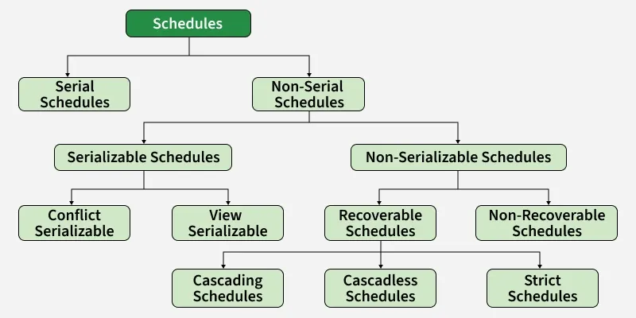

Types of Scheduling:

1. Serial Schedule
Schedules in which transactions execute one after another without interleaving., i.e., no transaction starts until a running transaction has ended are called serial schedules.
- Only one transaction runs at a time.
- No concurrency issues.
- Simple and always consistent.
Example: Consider the following schedule involving two transactions T₁ and T₂ .

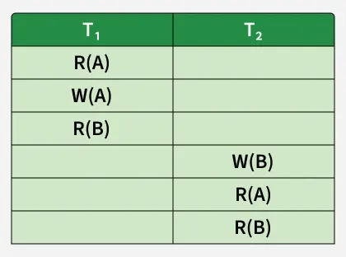

In the above table R(A) and W(A) denotes that a read and write operation is performed on some data item 'A' respectively, denoting a serial schedule since the transactions perform serially in the order T1 —> T2 .

2. Non-Serial Schedule

Transactions execute in an interleaved manner in Non-Serial Schedule.
- Allows concurrency.
- Must be checked for correctness.

Non-serial schedules are of two types:
- Serializable Scheduling (Concurrency Control)
A non-serial schedule that behaves like a serial schedule.

There are two types of serializable schedules:
- Conflict Serializable
Two operations in a schedule are said to conflict if they meet all three of these conditions:
- They belong to different transactions.
- They access the same data item (e.g., both access account A).
- At least one of them is a Write (W) operation.

A schedule is Conflict Serializable if it can be transformed into a Serial Schedule (where transactions run one after another) by swapping only non-conflicting adjacent operations.
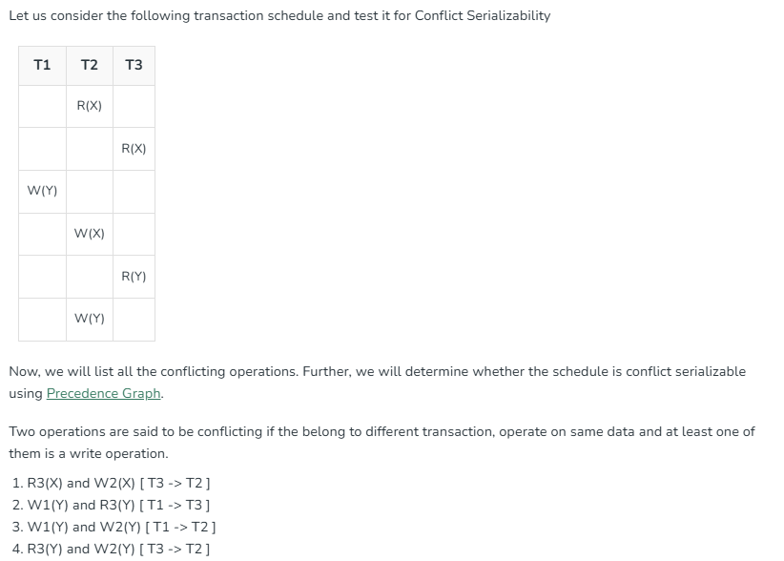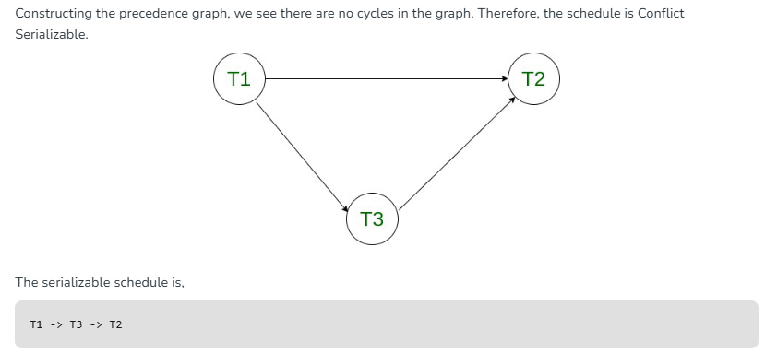

ii. View Serializable: A Schedule is called view serializable if:
- Transactions read the same initial values.
- Transactions read values written by the same transactions.
- The final write is by the same transaction as the serial schedule.

Note: Conflict-serializable schedules are a subset of view-serializable schedules. (Conflict-serializable ⊂ View-serializable.)
Example: Understanding View-Serializability first with a Schedule:
Schedule S1:
T₁ | T₂ | T₃
a=100
read(a)
a=a-40
write(a) //60
a=a-40
write(a) //20
a=a-20
write(a) //0
So, its Conflict Precedence Graph is as follows -

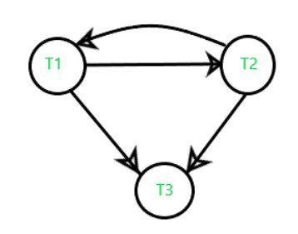
The above graph contains cycle/loop which means it is not conflict-serializable but it does not mean that it cannot be consistent and equivalent to the serial schedule it may or may not be.
Schedule S'1:
In the above example if we do swapping among some transaction's operation so our table will look like this:
T₁ | T₂ | T₃
a=100
read(a) //100
a=a-40
write(a) //60
a=a-40
write(a) //20
a=a-20
write(a) //0

T₁ | T₂ | T₃
a=100
read(a)
a=a-40
write(a) //60
a=a-40
write(a) //20
a=a-20
write(a) //0

S1’ Precedence Graph is as follows:
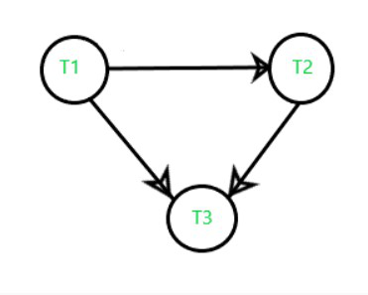The graph of S'1 has no cycles, meaning it’s conflict serializable and view serializable.
Note: In the above example we understood that if a schedule is Conflict-serializable so we can easily predict that It would be
- Equivalent to a serial schedule,
- Consistent,
- And also a View-Serializable.

Method to Check View Serializability
View Equivalent
If a schedule is view equivalent to a serial schedule, it’s view serializable. This requires three conditions:
- Initial Read: Same initial read values.
- Updated Read: Same updated read values.
- Final Update/Write: Same final write values.

- Non-Serializable Scheduling
Schedules that do not preserve serial equivalence and may lead to inconsistencies if not handled carefully.
They are classified into the following types:
i. Recoverable Schedule: Recoverable schedules are those in which a transaction commits only after all transactions whose values it has read have also committed.
- Key Point: If T2 reads a value written by T1, then T2 must commit after T1.
Example: Consider the following schedule involving two transactions T₁ and T₂ .

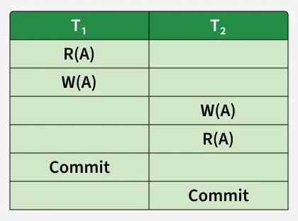
Recoverable Schedule

This is a recoverable schedule since T₁ commits before T₂ , that makes the value read by T₂ correct. There can be three types of recoverable schedule:
i. Cascading Schedule: A schedule where:
- Failure of one transaction forces all dependent transactions to abort.
- Happens when transactions read uncommitted data.

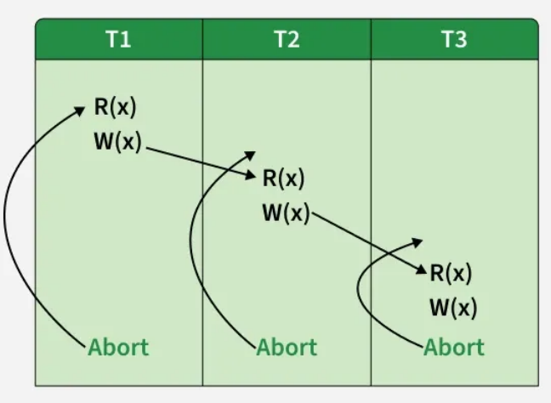
Cascading Abort

v. Non-Recoverable Schedule: A schedule where:
- A transaction commits after reading uncommitted data from another transaction.
- If the writer transaction later aborts, the schedule becomes invalid.
- Key Point: These schedules must be avoided since they lead to inconsistencies.
Example: Consider the following schedule involving two transactions T1 and T2.

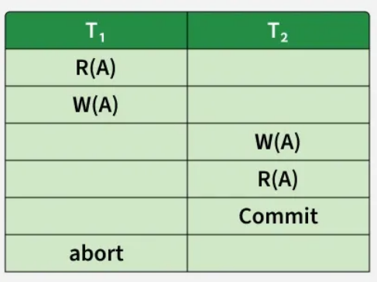
Non-Recoverable Schedule

T₂ read the value of A written by T₁, and committed. T₁ later aborted, therefore the value read by T₂ is wrong, but since T₂ committed, this schedule is non-recoverable.

The following Venn diagram shows the hierarchical relationship among the different types of schedules:
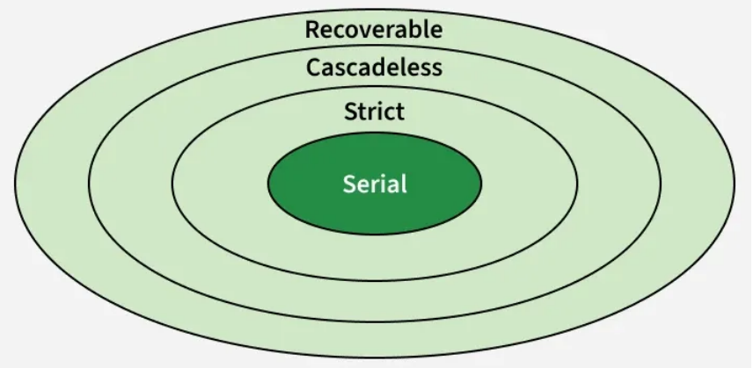
Relationship Venn Diagram of Types of Schedules

Concurrency Control in DBMS

In a Database Management System (DBMS), Concurrency control is a mechanism in DBMS that allows simultaneous execution of transactions while maintaining ACID properties - Atomicity, Consistency, Isolation and Durability. It maintains the integrity, accuracy and reliability of data when multiple users or processes perform read/write operations concurrently. It helps manage issues like:
- Conflicting operations on shared data
- Inconsistent database states
- Lost or incorrect updates
Note: By implementing concurrency control techniques such as locking or timestamp ordering, DBMS ensures that transactions are executed safely and independently, even when they overlap in time.

Need of Concurrency Control
Concurrency control is essential to:
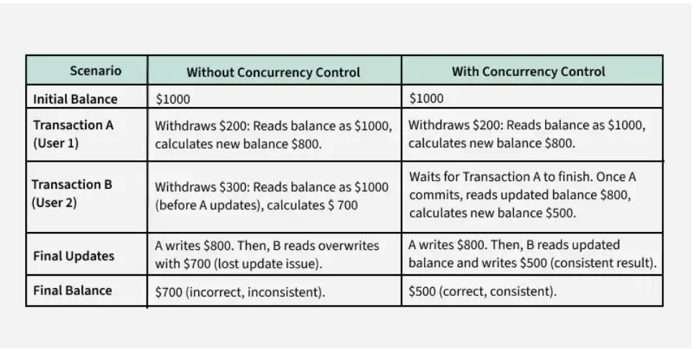
Concurrency Control
- Prevent conflicts between simultaneous transactions.
- Maintain data consistency and accuracy in multi-user environments.
- Avoid problems such as dirty reads, lost updates and inconsistent reads.

Example:
- Without concurrency control: Two users update the same record simultaneously and one update overwrites the other.
- With concurrency control: The DBMS uses locks or timestamps to ensure updates occur sequentially and data remains correct.

Concurrency Problems in DBMS
When multiple transactions execute concurrently, several problems may occur:
- Dirty Read: A transaction reads uncommitted data from another transaction that may later roll back.
- Lost Update: Two transactions update the same data and one update overwrites the other.
- Inconsistent Read: A transaction reads the same data multiple times and the data changes in between reads.

Concurrency Control Protocols
Concurrency control protocols define rules to ensure correct and consistent execution of transactions. The main protocols are:

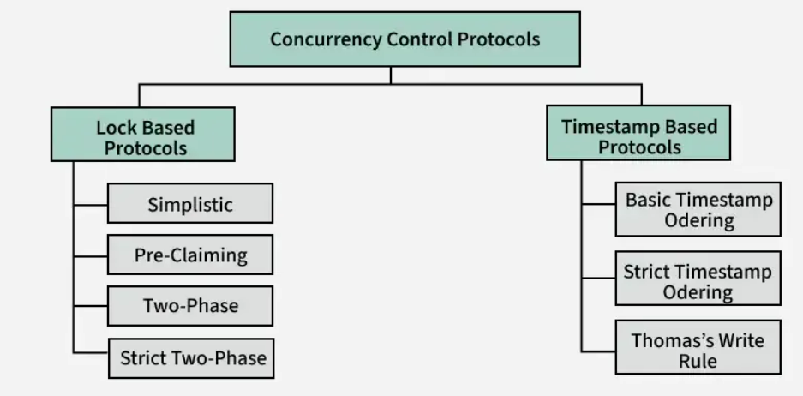
Concurrency Control Protocols

1. Lock-Based Concurrency Control:
- Uses locks to restrict access to data items during a transaction. Common types include shared locks (read) and exclusive locks (write).
- Ensures serializability and prevents conflicts.
- Example: Two-Phase Locking (2PL) guarantees that once a transaction releases a lock, it cannot obtain any new locks.

Types of Lock
- Shared Lock (S):
- Shared Lock is also known as Read-only lock.
- While holding this lock the transaction does not have the permission to update data on the data item.
- S-lock is requested using lock-S instruction.
- Exclusive Lock (X):
- Data item can be both read as well as written.
- This is Exclusive and cannot be held simultaneously on the same data item. X-lock is requested using lock-X instruction.

Rules of Locking
The basic rules for Locking are given below:
Read Lock (or) Shared Lock(S)
- If a Transaction has a Read lock on a data item, it can read the item but not update it.
- If a transaction has a Read lock on the data item, other transaction can obtain Read Lock on the data item but no Write Locks.
- So, the Read Lock is also called a Shared Lock.
Write Lock (or) Exclusive Lock (X)
- If a transaction has a write Lock on a data item, it can both read and update the data item.
- If a transaction has a write Lock on the data item, then other transactions cannot obtain either a Read lock or write lock on the data item.
- So, the Write Lock is also known as Exclusive Lock.

Lock Compatibility Matrix
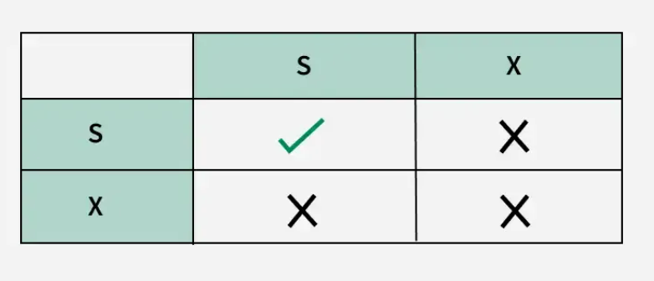
Compatibility Matrix

2.Deadlock Management in DBMS

A deadlock occurs in a multi-user database environment when two or more transactions block each other indefinitely by each holding a resource the other needs. This results in a cycle of dependencies (circular wait) where no transaction can proceed.

For Example: Consider the image below

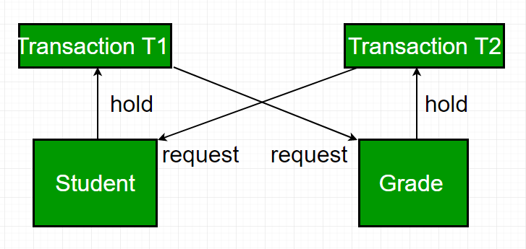Deadlock in DBMS

In the above image, we can see that:
- T1 locks Resource "Student" and needs Resource "Grade"
- T2 locks Resource "Grade" and needs Resource "Student"
- T1 waits for T2, T2 waits for T1, hence resulting in a deadlock

Necessary Conditions of Deadlock

For a deadlock to occur, all four of these conditions must be true:
- Mutual Exclusion: Only one transaction can hold a particular resource at a time.
- Hold and Wait: The Transactions holding resources may request additional resources held by others.
- No Preemption: The Resources cannot be forcibly taken from the transaction holding them.
- Circular Wait: A cycle of transactions exists where each transaction is waiting for the resource held by the next transaction in the cycle.

Why Deadlocks Are a Problem?
- Transactions are stuck indefinitely.
- System throughput decreases as transactions remain blocked.
- Resources are held unnecessarily, preventing other operations.

Key Deadlock Handling Techniques:
- Deadlock Prevention: Ensures at least one of the conditions for deadlock (mutual exclusion, hold and wait, no preemption, circular wait) is never satisfied.
  - Wait-Die (Non-preemptive): Older transaction waits; younger dies.
  - Each transaction gets a timestamp (older = smaller timestamp, higher priority).
  - When a transaction requests a resource (data item) held by another:
  - Rule:
  - If requester is older → it WAITS
  - If requester is younger → it DIES (aborts and restarts later)

  - Wound-Wait (Preemptive): Older transaction "wounds" (aborts) younger when data item is with younger, younger waits for older when data item is with older.
- Deadlock Detection and Recovery: The DBMS allows deadlocks to occur, periodically checking for them using a "Wait-for Graph". If a cycle is detected, one transaction is chosen as a "victim" and rolled back.
- Deadlock Avoidance: Dynamically checks resource requests to ensure the system never enters an unsafe state (e.g., Bankers Algorithm).
- Timeout-Based Methods: If a transaction waits for a lock longer than a specified time, it automatically aborts and restarts.

3. Timestamp-Based Concurrency Control:

The Timestamp Ordering Protocol enforces that older transactions (with smaller timestamps) are given higher priority. This prevents conflicts and ensures the execution is serializable and deadlock-free.For example:
- If Transaction T1 enters the system first, it gets a timestamp TS(T1) = 007 (assumption).
- If Transaction T2 enters after T1, it gets a timestamp TS(T2) = 009 (assumption).

This means T1 is "older" than T2 and T1 should execute before T2 to maintain consistency.

Features of Timestamp Ordering Protocol:

1. Transaction Priority:
- Older transactions (those with smaller timestamps) are given higher priority.
- For example, if transaction T1 has a timestamp of 007 times and transaction T2 has a timestamp of 009 times, T1 will execute first as it entered the system earlier.

2. Early Conflict Management:

Unlike lock-based protocols, which manage conflicts during execution, timestamp-based protocols start managing conflicts as soon as a transaction is created.

3. Ensuring Serializability:

The protocol ensures that the schedule of transactions is serializable. This means the transactions can be executed in an order that is logically equivalent to their timestamp order.

How Timestamp Ordering Works

Each data item X in the database keeps two timestamps:
- W_TS(X): Timestamp of the last transaction that wrote to X
- R_TS(X): Timestamp of the last transaction that read from X

Basic Timestamp Ordering

The Basic TO Protocol works by comparing the timestamp of the current transaction with the timestamps on the data items it wants to read/write:

