INTERNSHIP TASK 1 REPORT
Task Title: Python File Handling & Automation
Name: Pranav Ranjan
Internship: Python Developer Internship
Start Date: 1 May 2026

1. Objective
To understand Python file handling (TXT & CSV), automate file operations (rename, move, delete), and implement exception handling using try-except.

2. Tools & Technologies Used
Python, OS module, CSV module, Shutil module

3. Full Code Implementation

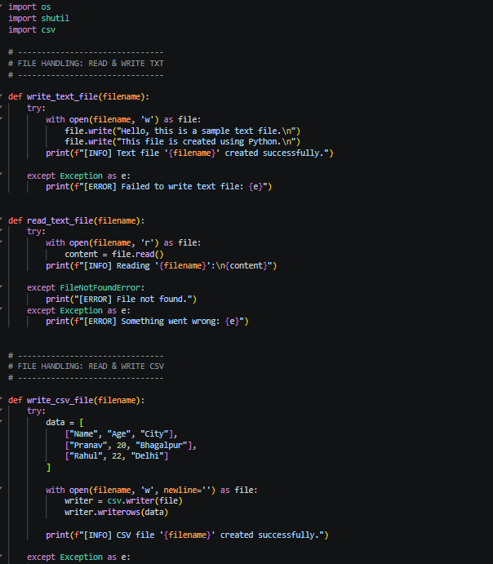

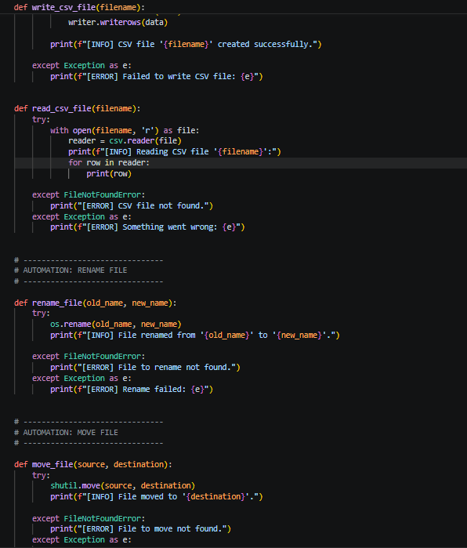

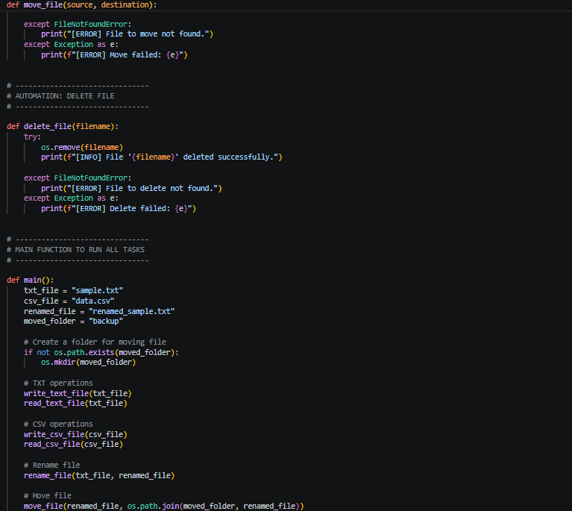

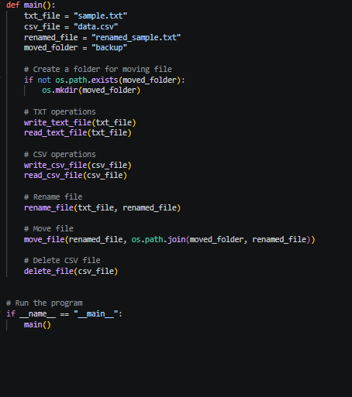

4. Output Screenshots

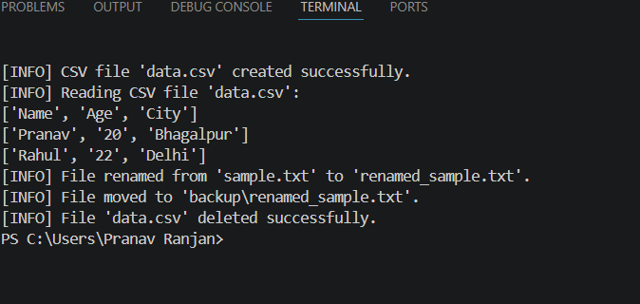

5. Links
GitHub Repository Link: https://github.com/pranavyash2202-tech/python-file-handling-automation

6. Result
Program executed successfully with all file operations.

7. Conclusion
Learned file handling, automation, and exception handling in Python.

