Software Architecture and Design Specification
Project: Railway Reservation System (RRS)
Team: Jackfruit Phase-1
Version 1.2
TEAM 13
Authors:
Yellapantula Venkata Pranav — PES2UG24CS616
Narendra Kathare — PES2UG25CS814
Yashash C — PES2UG24CS611
Date: 14-09-2026
Status: Draft

Revision History
Version | Date | Author | Change Summary
1.0 | 14-09-2026 | Yellapantula Venkata Pranav (PES2UG24CS616) | Drafted SAD sections 1–3.2, 3.5–3.9 from SRS; drew UML Component Diagram (Section 3.3)
1.1 | 14-09-2026 | Narendra Kathare (PES2UG25CS814) | Drafted Section 4 (Design Overview, API Design, Error Handling, UX); drew UML Sequence Diagram 1 — Search, Book & Pay (Section 4.2)
1.2 | 14-09-2026 | Yashash C (PES2UG24CS611) | Drafted Section 3.4 Component Descriptions and Section 5 Appendices; drew UML Sequence Diagram 2 — Cancellation, Refund & Waitlist Promotion (Section 4.2)

Approvals
Role | Name | Signature/Date
Course Coordinator

1. Introduction

1.1 Purpose
This document specifies the software architecture and design of the Railway Reservation System (RRS), a self-contained academic web application for booking, tracking, and managing train reservations. It is intended to guide implementation, review, and evaluation, building on the RRS Software Requirements Specification (SRS) v1.0.

1.2 Scope
Covers passenger-facing services — searching trains, checking seat/berth availability, booking, payment (simulated), PNR tracking, and cancellation/refund — as well as administrative functions for managing trains, schedules, fares, and reports. Excludes integration with real railway infrastructure (e.g. IRCTC) and real payment gateways, which are represented by a mock payment module.

1.3 Audience
Developers, QA engineers, system integrators, and assessment evaluators.

1.4 Definitions
RRS (Railway Reservation System), PNR (Passenger Name Record), RAC (Reservation Against Cancellation), UI (User Interface), API (Application Programming Interface), DB (Database), TLS (Transport Layer Security), CLI (Command-Line Interface), ADR (Architecture Decision Record).

2. Document Overview

2.1 How to use this document
Provides the architectural and design deliverables for RRS: component (UML) diagrams, sequence diagrams, API design, security architecture, and traceability back to SRS requirements.

2.2 Related Documents
RRS Software Requirements Specification (SRS) v1.0, dated 05-09-2026.

3. Architecture

3.1 Goals & Constraints
Goals:
- Overall booking transaction response ≤ 5 seconds for 90% of transactions under normal load (RRS-NF-001).
- 99% availability during scheduled demo/evaluation periods (RRS-NF-002).
- Protection of sensitive user and payment data; no plaintext storage of passwords or card-like data (RRS-NF-003).
Constraints:
- Booking, allocation, storage, and presentation must remain separate, swappable layers behind defined interfaces.
- Payment is handled only by a simulated/mock module — no real payment gateway is integrated for this course project.
- Only synthetic/sample train, schedule, and passenger data is used — no real personal data.
- Must run comfortably on a standard student laptop/development server.

3.2 Stakeholders & Concerns
Stakeholder | Concerns
Passenger | Short, clear booking flow; visibility into booking/PNR status
Administrator | Dashboard with clear, actionable train/schedule/booking information
Evaluator / Instructor | Clean separation between booking, allocation, storage, and presentation layers

3.3 Component (UML) Diagram
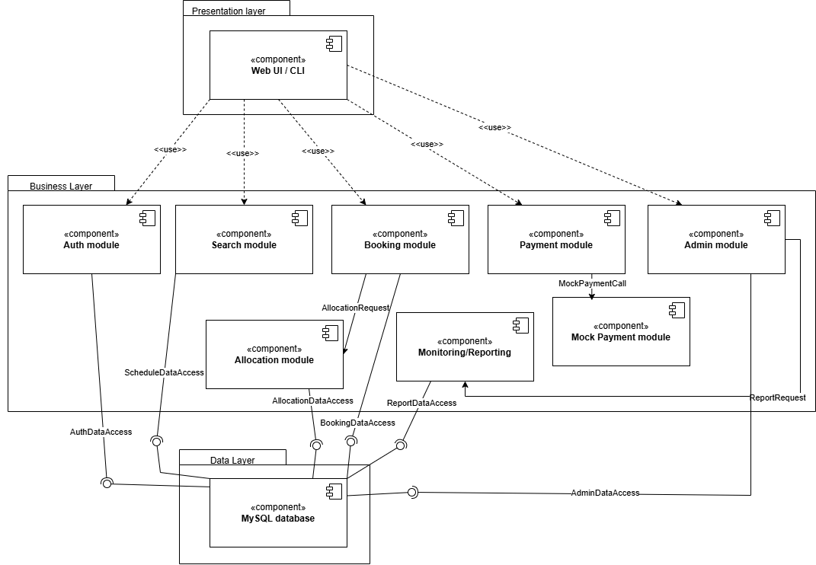

3.4 Component Descriptions
Component | Description
Web UI / CLI | Presentation layer — search/book/pay/track/cancel menu; accessible, high-contrast status indicators
Backend API | Flask HTTP/JSON layer routing requests to the appropriate module
Auth Module | Registration, login, session/idle timeout, account lockout after repeated failures
Search Module | Finds trains by source, destination, and date against schedule data
Booking Module | Creates provisional bookings, generates PNR, handles cancellation and refund calculation
Payment Module | Routes payment requests to the Mock Payment Module and confirms bookings on success
Mock Payment Module | Simulates a payment gateway call, returns Success/Failure; stores only a transaction reference, never card-like data
Allocation Module | Assigns Confirmed/RAC/Waitlisted status by capacity; promotes waitlisted/RAC bookings on cancellation
Admin Module | Add/update/remove trains and schedules; role-restricted at the server, not just the UI
Monitoring / Reporting | Booking, occupancy, and revenue reports; audit log of administrative actions
MySQL Database | Repository-style storage for users, trains, schedules, bookings, and payment records

3.5 Chosen Architecture Pattern and Rationale
Layered architecture was chosen to give a clear separation between presentation, API, business modules (auth, search, booking, payment, allocation, admin), and data storage — directly matching the SRS constraint that these layers stay separate and swappable. A microservices approach was considered and rejected as unnecessarily complex for the scale and evaluation timeline of this course project.

3.6 Technology Stack & Data Stores
- Backend: Python 3.x with Flask, serving HTTP(S)/JSON APIs
- Database: MySQL, accessed through a repository-style interface
- Communication: HTTPS / TLS 1.2+ enforced for all client–server traffic in deployment
- Payment: mock/simulated module only — no real payment gateway integration
- Client: any modern web browser, or a terminal for the CLI build

3.7 Risks & Mitigations
Risks | Mitigation
Mock payment times out or fails, leaving a seat held indefinitely | Provisional booking and held seat are released back to availability on failure/timeout (RRS-F-031)
Database unavailable during a demo/evaluation session | Connection retries and backups; layered design keeps the DB behind a repository interface for easier failover
Race condition on the last available seat/berth during concurrent bookings | Allocation Module owns seat-count updates and assigns Confirmed/RAC/Waitlisted status at booking time (RRS-F-050)
Card-like data accidentally logged or persisted | Mock Payment Module stores only a transaction reference and status, never raw card fields (PRJ-SR-005)

3.8 Traceability to Requirements
Req ID | Requirement (short) | Module
RRS-F-001 | Register / authenticate user | Auth Module
RRS-F-010 | Search trains by route/date | Search Module
RRS-F-021 | Create provisional booking | Booking Module
RRS-F-030 | Confirm booking after payment | Payment Module
RRS-F-040 | Generate PNR / status lookup | Booking Module
RRS-F-041 | Cancel booking, release seat | Booking Module
RRS-F-050 | Auto seat status assignment | Allocation Module
RRS-F-051 | Waitlist/RAC promotion | Allocation Module
RRS-F-060 | Admin train/schedule management | Admin Module
RRS-NF-001 | Response time target | Web UI / Backend API
PRJ-SR-002 | Password hashing | Auth Module
PRJ-SR-003 | Server-side RBAC | Admin Module

3.9 Security Architecture
Threat Modeling (STRIDE), mapped to the SRS security requirements (PRJ-SR-001 to PRJ-SR-006):
STRIDE Category | Mitigation
Spoofing | Authenticated login; session tokens expire after a configured idle timeout (PRJ-SR-004)
Tampering | Role-based access control enforced at the server for admin-only endpoints, not just hidden in the UI (PRJ-SR-003)
Information Disclosure | TLS 1.2+ mandatory for all network connections; passwords hashed, never stored in plaintext (PRJ-SR-001, PRJ-SR-002)
Denial of Service | Account lockout after repeated failed login attempts (RRS-F-003); provisional bookings auto-release on timeout
Repudiation | All administrative actions (schedule changes, refunds) logged with user identity and timestamp (PRJ-SR-006)
Elevation of Privilege | Server-side RBAC; Mock Payment Module never persists full card-like details (PRJ-SR-003, PRJ-SR-005)

4. Design

4.1 Design Overview
RRS is designed as layered modules — presentation, API, business logic (auth, search, booking, payment, allocation, admin), and data storage — for clear separation of concerns and easier maintenance and testing.

4.2 UML Sequence Diagrams
Two flows specific to this project are detailed below.
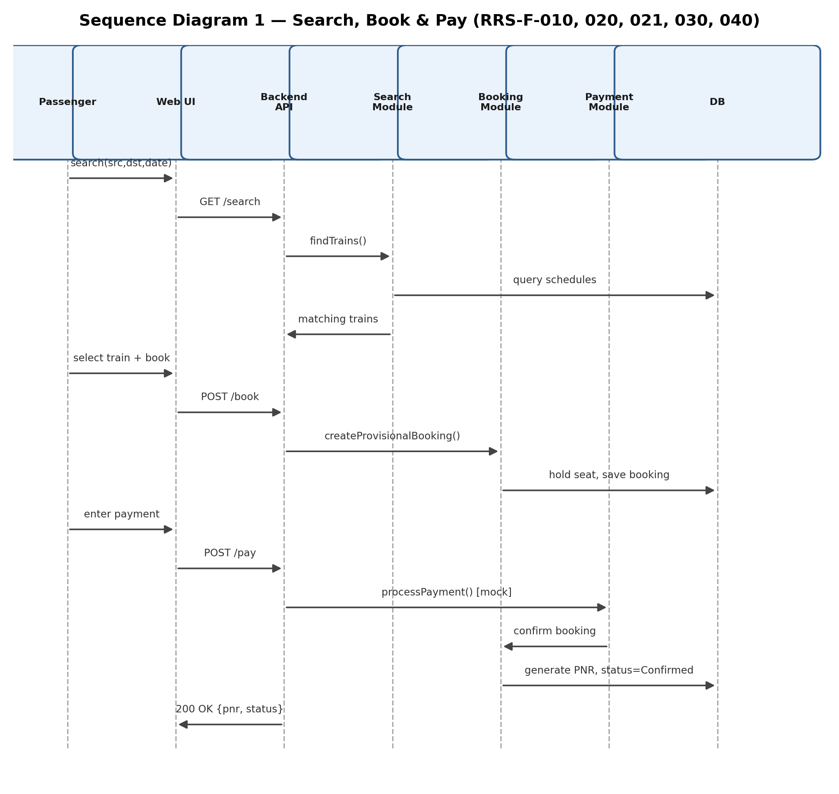
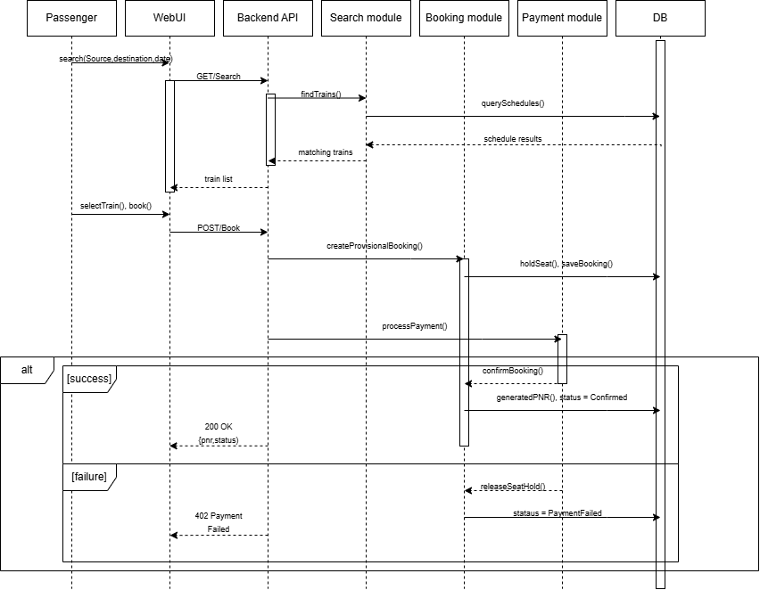

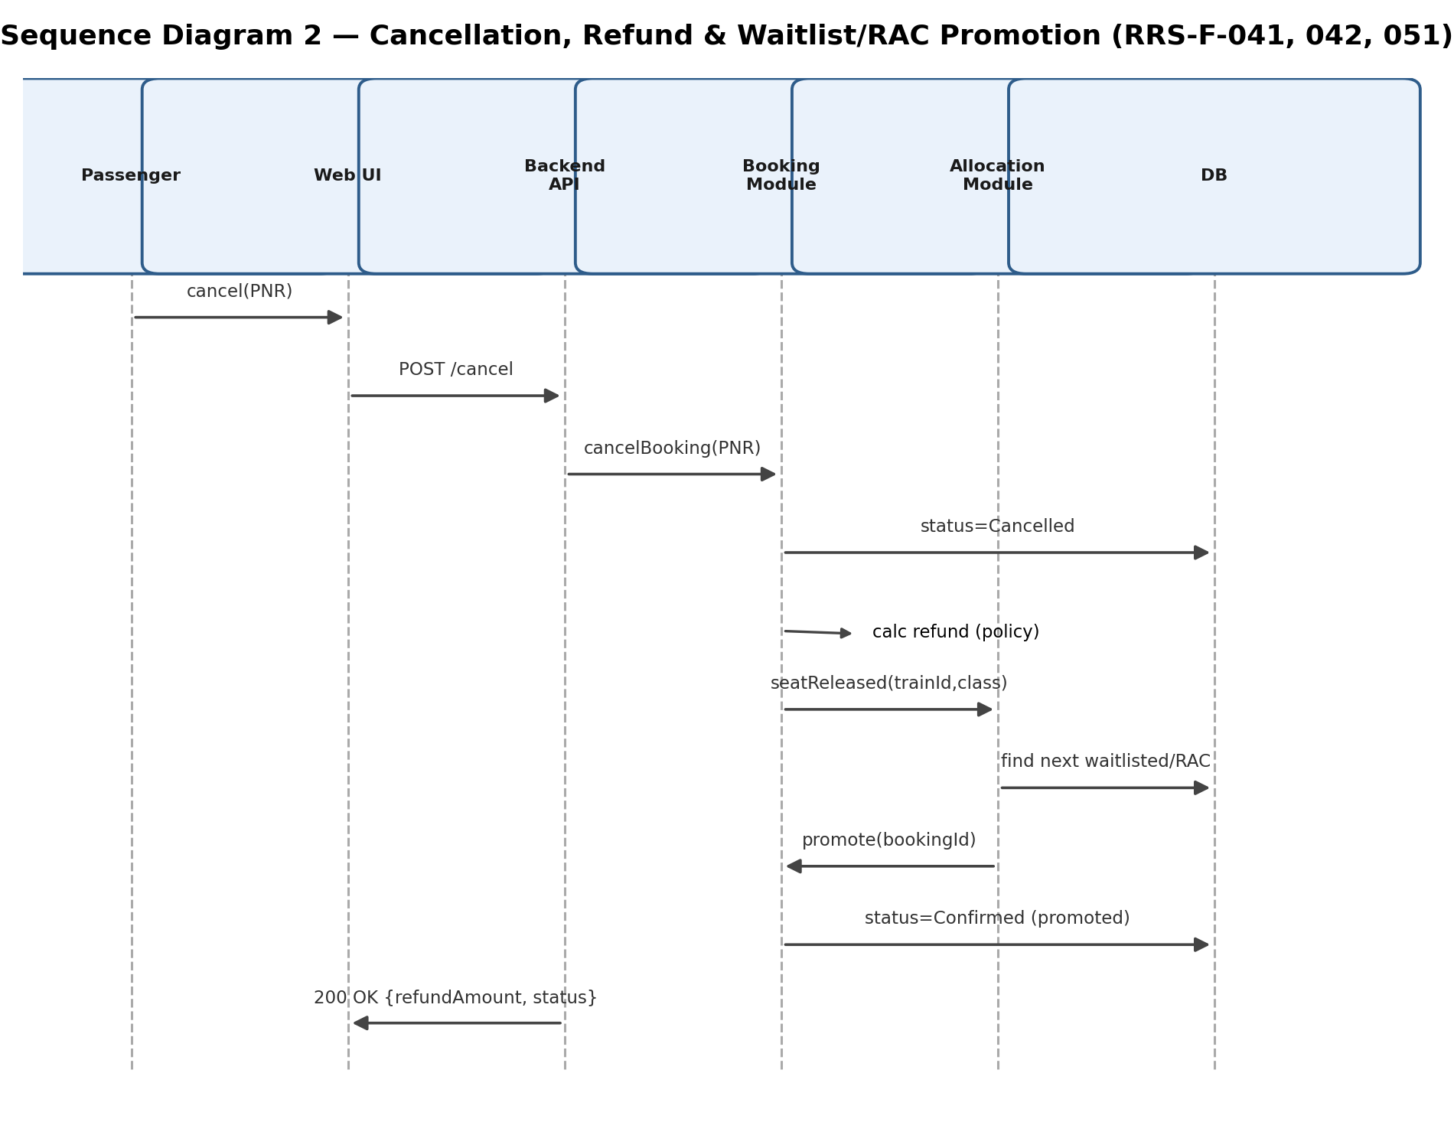
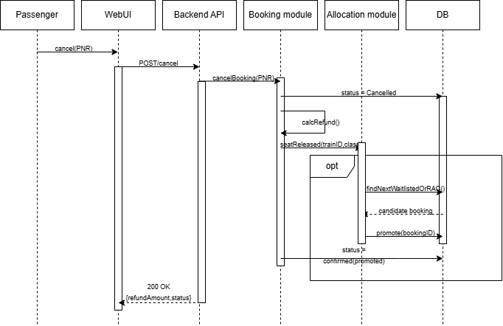

4.3 API Design
Interface definitions for two core endpoints:

POST /book
- Request: {trainId, class, passengerDetails}
- Response: {bookingId, status, seatInfo}
- Errors: 400 invalid/missing fields (RRS-F-022); 409 no seats available

POST /pay
- Request: {bookingId, mockCardRef}
- Response: {status, pnr}
- Errors: 402 payment failed/timed out — booking and seat hold are released (RRS-F-031)

4.4 Error Handling, Logging & Monitoring
Standardized error messages across the API. No sensitive information (including card-like data) is written to logs (PRJ-SR-005). Booking and audit logs are timestamped and retained for the evaluation period (RRS-NF-004); all administrative actions are logged with user identity and timestamp (PRJ-SR-006). Monitoring covers transaction failure rate and system uptime, reported through the Monitoring/Reporting module.

4.5 UX Design
A simple web form (or CLI) with a clear menu: search, book, pay, track PNR, cancel. Accessibility follows the SRS usability requirement (RRS-NF-005) — legible fonts, clear labels, and high-contrast, readable status indicators for Confirmed / RAC / Waitlisted / Cancelled bookings.

4.6 Open Issues & Next Steps
- Integration with a real payment gateway beyond the current mock module
- Mobile app / responsive client in addition to the web form and CLI
- Extending reporting with predictive occupancy analytics

5. Appendices

5.1 Glossary
RRS, PNR, RAC, UI, API, DB, TLS, CLI, ADR — see Section 1.4.

5.2 References
IEEE 42010, OWASP, NIST SP 800-160; RRS Software Requirements Specification v1.0.

5.3 Tools
PlantUML, draw.io, Swagger.

