THINK CHAMP PRIVATE LIMITED

PROJECT ON AI CHATBOT WEB APPLICATION



SUBMITTED TO :
THE CEO OF THINKCHAMP Pvt. Lmtd
GURU LOKESH SIR

SUBMITTED BY :
K. PRANAY

S.NO | CONTENTS | PAGE NO
1 | INTRODUCTION | 1
2 | HISTORY OF THE PROJECT | 2
3 | REQUIREMENTS | 2-3
4 | SOURCE CODE | 4-5
5 | OUTPUT SCREENSHOTS | 6-7
6 | CONCLUSION | 8

AI CHATBOT WEB APPLICATION

1. INTRODUCTION

1.1 Introduction
Artificial Intelligence has transformed the way humans interact with technology. Chatbots are one of the most popular applications of AI that allow users to communicate with systems using natural language. Modern AI chatbots use Large Language Models (LLMs) to understand user inputs and generate meaningful responses.
The AI Chatbot Web Application is developed to provide an interactive conversational platform where users can ask questions and receive intelligent responses. The application utilizes Google's Gemini API for natural language understanding and response generation.
The system features an attractive user interface, conversation history tracking, real-time interaction, and efficient response management. It serves as a practical example of integrating Generative AI into web-based applications.

1.2 Problem Statement
Traditional information systems require users to navigate through multiple pages or search manually for information. This process can be time-consuming and inefficient.
There is a need for an intelligent conversational system capable of understanding natural language queries and providing immediate responses in an easy-to-use interface.

1.3 Objectives
- Develop an AI-powered chatbot web application.
- Enable natural language interaction between users and the system.
- Provide real-time AI-generated responses.
- Maintain conversation history for better user experience.
- Create an attractive and responsive user interface.
- Integrate Google Gemini API for intelligent response generation.

2 . HISTORY OF THE PROJECT
The evolution of chatbot technology began with simple rule-based systems that responded to predefined commands and keywords. One of the earliest chatbots, ELIZA, was developed in the 1960s and demonstrated how computers could simulate human conversation using pattern-matching techniques. Although these systems provided basic interactions, they lacked the ability to understand context and generate intelligent responses.
With advancements in Artificial Intelligence and Natural Language Processing (NLP), chatbot technology evolved significantly. Machine Learning algorithms enabled systems to learn from data and improve their responses over time. Virtual assistants such as Siri, Alexa, and Google Assistant introduced conversational AI to millions of users, making intelligent human-computer interaction more accessible and practical.
The emergence of Large Language Models (LLMs) and Generative AI has revolutionized chatbot development. Modern AI chatbots powered by technologies such as Google's Gemini, OpenAI's GPT, and other advanced language models can understand complex queries, maintain conversational context, and generate human-like responses. The AI Chatbot Web Application developed in this project is based on these modern Generative AI technologies, providing users with an intelligent, efficient, and interactive conversational experience through a web-based platform.

3. REQUIREMENTS
3.1. Software Requirements:
The following software components are required for developing and running the AI Chatbot Web Application:
Software | Version
Operating System | Windows 10 / Windows 11
Programming Language | Python 3.10 or Above
IDE | Visual Studio Code
Framework | Streamlit
AI Platform | Google Gemini API
Libraries | Google Generative AI, Python Dotenv

Software Description
- Python: Main programming language used for application development.
- Streamlit: Framework used to create the chatbot web interface.
- Google Gemini API: Provides Generative AI capabilities for intelligent response generation.
- Python Dotenv: Used to securely manage API keys through environment variables.
- Visual Studio Code: Development environment used for coding and debugging.
- Web Browser: Used to access and interact with the chatbot application.

3.2. Hardware Requirements
The AI Chatbot Web Application requires the following hardware components for development and execution:
Component | Requirement
Processor | Intel Core i3 / i5 / i7 or AMD Equivalent
RAM | Minimum 4 GB (8 GB Recommended)
Storage | Minimum 500 MB Free Disk Space
Display | 1366 × 768 Resolution or Higher
Internet Connection | Required for Gemini API Communication
Input Devices | Keyboard and Mouse

Hardware Description
- Processor: Used for executing the application and processing user requests.
- RAM: Stores application data and supports smooth execution.
- Storage: Required for software installation and project files.
- Internet Connection: Necessary for connecting to Google's Gemini API and obtaining AI-generated responses.
- Display Unit: Used to interact with the chatbot interface.

4. SOURCE CODE

The AI Chatbot Web Application is implemented using Python and Streamlit. The application integrates Google's Gemini API to generate intelligent responses based on user queries.
Import Required Libraries
import os
import html
import streamlit as st
import google.generativeai as genai
from dotenv import load_dotenv
Load Environment Variables
load_dotenv()
api_key = os.getenv("GOOGLE_API_KEY")
Configure Gemini API
genai.configure(api_key=api_key)
model = genai.GenerativeModel("gemini-1.5-flash")
Streamlit Page Configuration
st.set_page_config(
page_title="AI Chatbot",
page_icon="🤖",
layout="wide"
)
Session State Initialization
if "messages" not in st.session_state:
st.session_state.messages = []

if "history" not in st.session_state:
st.session_state.history = []

User Input Processing
user_input = st.text_input("Ask anything:")

if user_input:
response = model.generate_content(user_input)
bot_reply = response.text
Store Chat History
st.session_state.messages.append({
"role": "user",
"content": user_input
})

st.session_state.messages.append({
"role": "assistant",
"content": bot_reply
})
Display Chat Messages
for msg in st.session_state.messages:
st.write(msg["content"])
Run Application
streamlit run app.py

The above code enables the chatbot to receive user queries, communicate with the Gemini API, generate intelligent responses, and maintain conversation history throughout the user session.

5. OUTPUT SCREESHOTS

5.1. Home Page

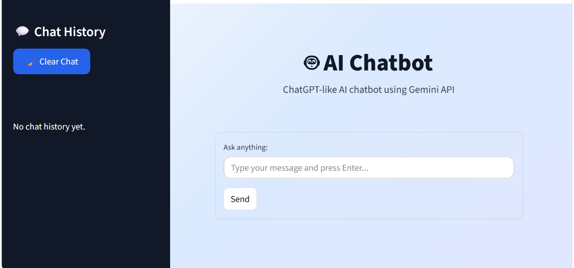

5.2. Testing Data

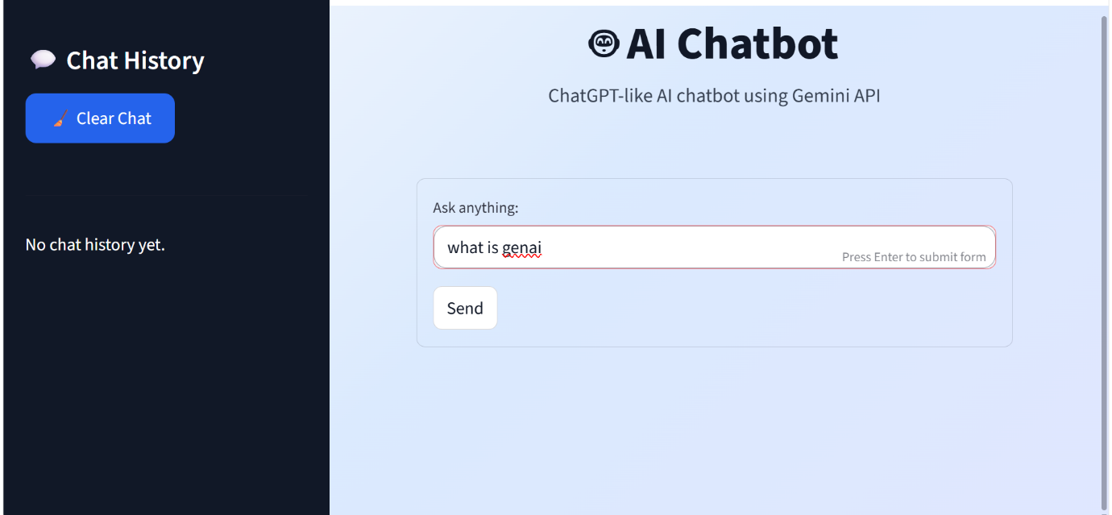

5.3. Output

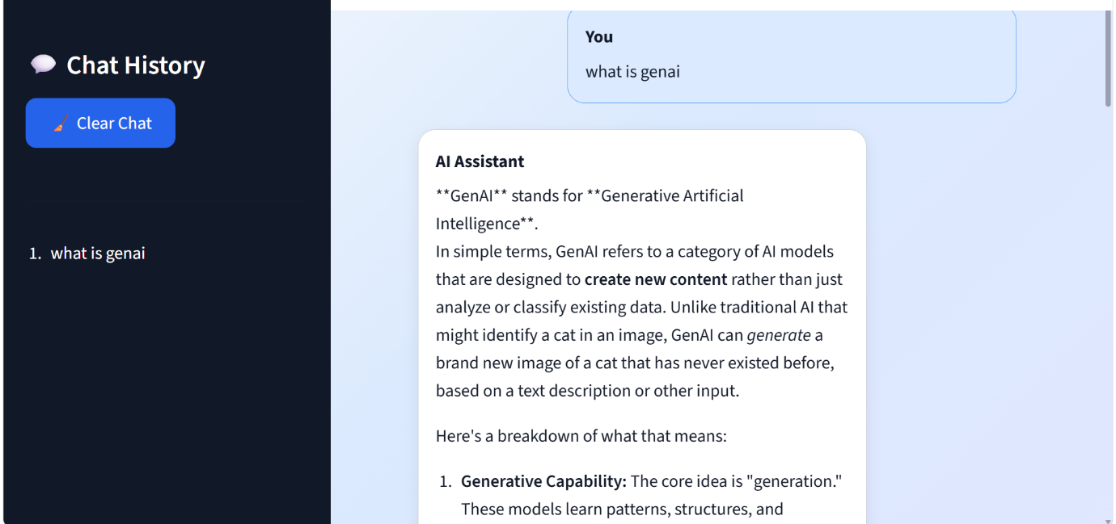

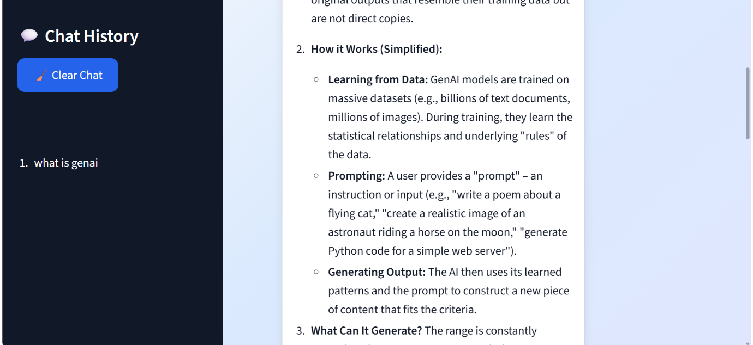

6. CONCLUSION

The AI Chatbot Web Application successfully demonstrates the implementation of Generative Artificial Intelligence in a web-based environment. The system integrates Python, Streamlit, and Google's Gemini API to provide an intelligent conversational platform capable of understanding user queries and generating meaningful responses in real time.
The application offers a user-friendly interface, efficient chat history management, and dynamic response generation, making interactions smooth and engaging. By utilizing advanced Large Language Models, the chatbot can understand natural language effectively and provide accurate, context-aware responses to users.
Overall, the project achieves its objectives of creating an AI-powered conversational assistant that enhances user experience and accessibility. The successful integration of modern AI technologies highlights the potential of Generative AI in developing intelligent applications. Future enhancements such as voice interaction, multilingual support, and database integration can further improve the functionality and usability of the system.

