# Running the Spring Boot Application

* Import the project into Eclipse IDE. And run the below file
* The configured port number in application.properties file is 9020.
  + Check the service: Open your browser and enter the URL <http://localhost:9020>

Expected output:

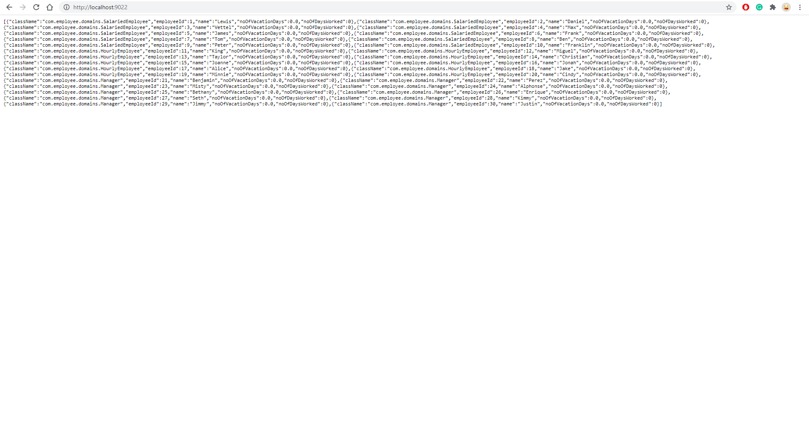

**Running the Angular Application:**

* First install Node JS and Angular CLI on your local machine if you have not already installed.
  + Steps to install:   
    download Node JS and install
  + Open command prompt and execute the command to install Angular CLI:  
     npm install –g @angular/cli
  + ->Open the Angular project in VS Code
  + ->locate to the working directory location
  + In the windows Command prompt locate the Angular app and Install the dependencies using the below command
  + npm install
* When the installation is finished use the below command in the command prompt.
  + ng serve
* The Application will be loaded in the browser and is available on live server with URL
  + Htttp://localhost:4200

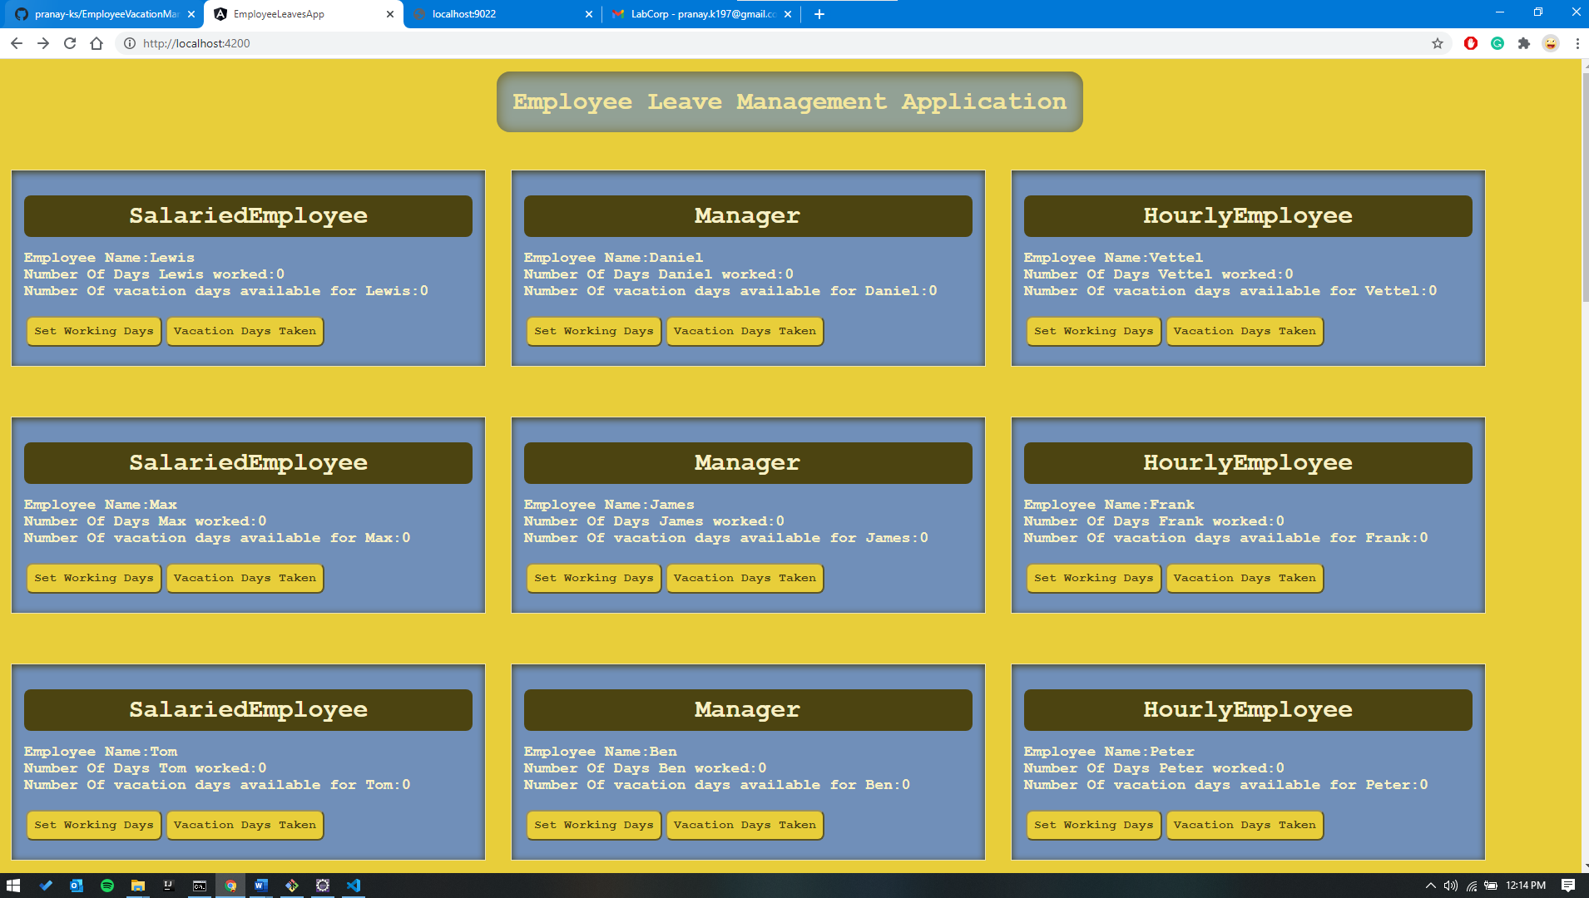

**Validations**

### Maximum number of working days 260. . If exceeds the limit the user will be alerted.

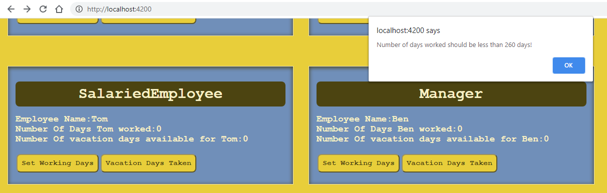

### Maximum number of Vacation based on the Role of the employee is checked. If exceeds the limit the user will be alerted.

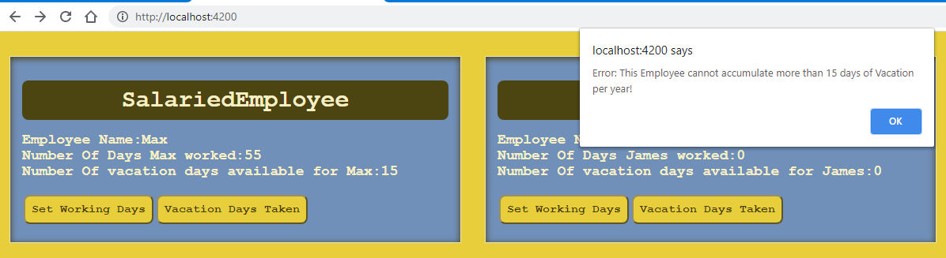

## Use case for Lewis (Salaried Employee)

## Set Working days : Given input number of working days = 150 fetching max number of available vacation days.

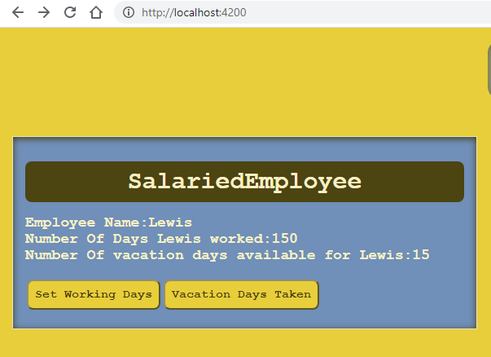

## Set Vacation days Taken

Given input: 10

Fetching number of days reaming and updating on the UI

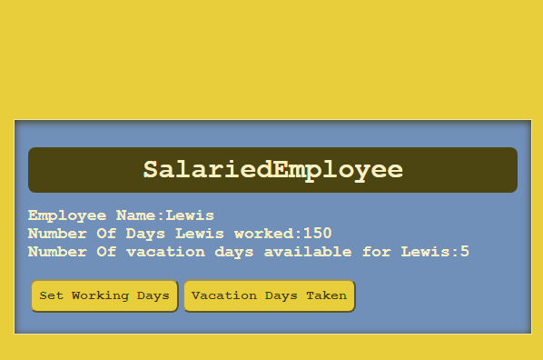

**Spring Boot project files structure**

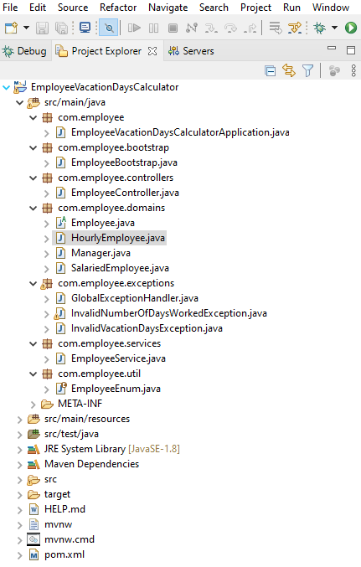

**Angular Project Files Structure**

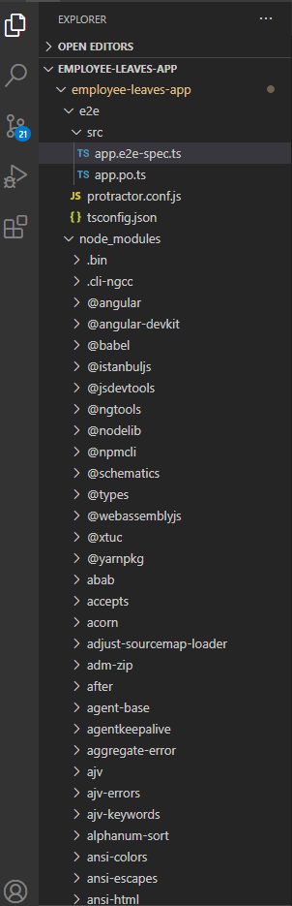

### Pranay K

704-268-9842

Pranay.k197@gmail.com

#### The End.