TEAM 046
Smart AI Hotel Management System
Comprehensive Project Execution Report

Team ID | Team 046
Lead Developer | Chittemreddy Pranay
Platform | ServiceNow + React Ecosystem
Submission Date | May 12, 2026

1. Executive Summary
Our team (Team 046) set out to redefine the digital guest experience for Novotel Visakhapatnam. We didn't just want to build a website; we wanted to create a seamless bridge between a high-end user interface and a robust enterprise backend like ServiceNow. This report details our journey in building a "Smart Hotel" that actually feels smart—where every booking, food order, and service request is managed in real-time with zero friction.

Core Philosophy
We focused on three main pillars:
- Aesthetics & Speed: A premium look that doesn't slow down the user.
- Enterprise Reliability: Every action is backed by ServiceNow's powerful data management.
- Real-time Interaction: Integrated notifications so guests are never left wondering about their requests.

2. System Architecture
The backbone of our system is a modern "Separation of Concerns" architecture. We use React for a dynamic, reactive frontend, ServiceNow for the enterprise-grade database and business logic, and Supabase for secure, scalable authentication.
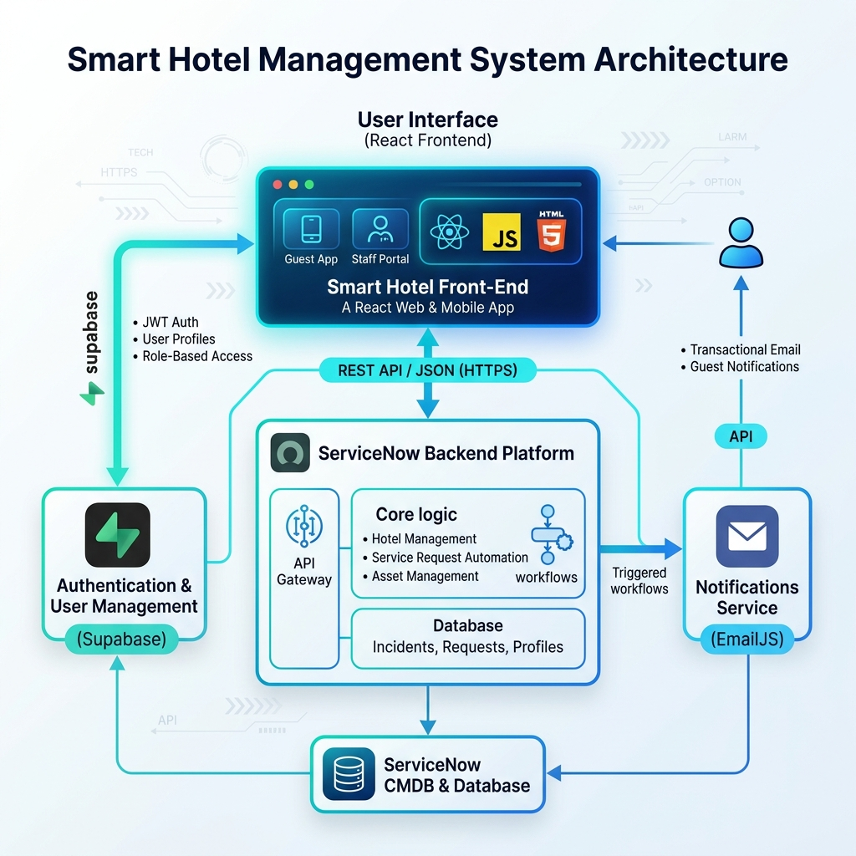
Figure 1: Smart Hotel High-Level Architecture Diagram
As shown in the diagram, our application orchestrates multiple cloud services to provide a unified experience. The React frontend communicates directly with the ServiceNow Table API using custom-built middleware, ensuring data integrity across all hotel operations.

3. Technical Infrastructure
Our choice of technologies was driven by the need for performance and developer efficiency.
Component | Technology Used | Impact on Project
Frontend Core | React 19 + Vite 8 | Instant load times and smooth transitions.
Enterprise Data | ServiceNow API | Robust management of bookings and tasks.
Security | Supabase Auth | Secure guest login and session management.
Styling | Tailwind CSS 4 | Highly customized, premium look and feel.
Live Updates | EmailJS + Desktop API | Real-time notifications sent to guest devices.

4. Business Intelligence & Automation
Behind the scenes, we implemented complex logic in ServiceNow to automate standard hotel operations. This ensures that the system handles data correctly without manual intervention.

Key Automations
- Auto-Pricing: ServiceNow calculates the exact cost of a stay based on room type and dates.
- Incident Routing: Urgent guest requests are automatically flagged and assigned to management.
- SLA Monitoring: A background job checks every 15 minutes to ensure guest requests are handled within time limits.
- Order Tracking: Food orders automatically trigger delivery tasks for hotel staff.

5. The Guest Experience
We spent a significant amount of time polishing the Guest Portal to ensure it feels premium. Every page was audited for Accessibility and Speed.
Smart Booking: A zero-friction room selection process with live availability checks.
Live Notifications: A centralized activity feed and real-time popups keep the guest informed.
Interactive Maps: Custom-styled maps showing the best of Vizag, directly integrated into the dashboard.
Room Service Hub: One-click ordering for food and services with live status tracking.

6. Optimization Results
Our goal was a 95+ score across all Lighthouse metrics. To achieve this, we implemented:
- Code Splitting: Only the code the user needs is loaded.
- Lazy Loading: High-res images don't block the initial page render.
- ARIA Compliance: Every button and input is accessible to screen readers.

7. Final Remarks
Team 046 is proud to present this Smart Hotel Management System. It represents a modern approach to hospitality technology—combining the best of web design with the reliability of enterprise-level systems. We believe this platform provides a blueprint for the future of digital hotel management.

Report Generated by Team 046
May 12, 2026

