SMART AI HOTEL MANAGEMENT SYSTEM
(PS-046)
An Internship Report Submitted in Partial Fulfillment of the Requirements for the Award of Degree of
BACHELOR OF TECHNOLOGY
in
COMPUTER SCIENCE AND ENGINEERING
Submitted by:
MARUTHI SRINIVAS
Regd. No.: 24P35A0538
DEPARTMENT OF COMPUTER SCIENCE AND ENGINEERING
(Accredited by NBA)
ADITYA COLLEGE OF ENGINEERING AND TECHNOLOGY
An AUTONOMOUS Institution
(Approved by AICTE, Permanently Affiliated to JNTUK & Accredited by NAAC & NBA,
Recognized by UGC under the sections 2(f) and 12(B) of the UGC Act 1956)
Aditya Nagar, ADB Road – Surampalem 533437, Kakinada Dist., A.P.
2026 – 2027

ADITYA COLLEGE OF ENGINEERING AND TECHNOLOGY
An AUTONOMOUS Institution
Department of Computer Science and Engineering
(Accredited by NBA)
CERTIFICATE
This is to certify that Maruthi Srinivas (Regd. No. 24P35A0538) has successfully completed his Internship in SmartBridge Educational Services Pvt. Ltd. (in collaboration with APSCHE) on the domain Enterprise ServiceNow Application Development, Cloud Integration, and Generative AI as part of partial fulfillment of the requirements for the Degree of Bachelor of Technology in the Department of Computer Science and Engineering for the academic year 2026 – 2027.

Internship Coordinator  Mr. A. Hanumantharao, M.Tech, (Ph.D)  Assistant Professor  Department of CSE | Head of the Department  Dr. G. S. N. Murthy, Ph.D  Professor & HOD  Department of CSE
EXTERNAL EXAMINER

DECLARATION
I, Maruthi Srinivas, a student of Bachelor of Technology Program, Regd. No. 24P35A0538 of the Department of Computer Science and Engineering, Aditya College of Engineering and Technology, do hereby declare that I have completed the mandatory internship from 25-05-2026 to 13-08-2026 in SmartBridge Educational Services Pvt. Ltd., APSCHE, on Enterprise ServiceNow Application Development and Cloud Generative AI under the Faculty Guideship of Mr. A. Hanumantharao, Assistant Professor, Department of Computer Science and Engineering, Aditya College of Engineering and Technology.
I also declare that the project titled "Smart AI Hotel Management System (PS-046)" is my authentic work and has not been submitted previously to any institution or university for the award of any degree.
Maruthi Srinivas
(24P35A0538)

ACKNOWLEDGEMENT
First, I would like to express my sincere thanks to the Directors and Management of SmartBridge Educational Services Pvt. Ltd. (APSCHE) for providing me with this remarkable opportunity to do my internship.
I extend my sincere gratitude to our internship mentor, Mr. Amarendar Katkam, Founder & CEO of SmartBridge, for his inspirational leadership, strategic direction, and technical guidance in enterprise cloud architecture.
It is with immense pleasure that I express my indebted gratitude to our internship coordinator and internal guide, Mr. A. Hanumantharao, Assistant Professor, Department of CSE, who guided us with patience, supported us at every phase of the project work, and provided constructive technical review.
My deepest thanks to Dr. G. S. N. Murthy, Professor & Head of the Department of Computer Science and Engineering, for his constant motivation and for providing state-of-the-art computational facilities.
I wish to thank Dr. Pullela S. V. V. S. R. Kumar, Professor in CSE and Dean (Academics), for his invaluable suggestions.
I owe my gratitude to Dr. A. Ramesh, Principal, for fostering an academic environment that champions technical internships.
Finally, I express my warm appreciation to all faculty members, technical staff, and peers who supported me directly and indirectly.

ADITYA COLLEGE OF ENGINEERING AND TECHNOLOGY
INSTITUTE VISION AND MISSION
VISION:
To induce higher planes of learning by imparting technical education with:
• International standards
• Applied research
• Creative Ability
• Value based instruction and to emerge as a premiere institute.
MISSION:
Achieving academic excellence by providing globally acceptable technical education through:
• Innovative Research and Development
• Industry Institute Interaction
• Empowered Manpower
DEPARTMENT OF COMPUTER SCIENCE AND ENGINEERING
DEPARTMENT VISION AND MISSION
VISION:
To become a center for excellence in Computer Science and Engineering education and innovation.
MISSION:
• Provide state of art infrastructure.
• Adapt skill-based learner centric teaching methodology.
• Organize socio cultural events for better society.
• Undertake collaborative works with academia and industry.
• Encourage students and staff self-motivated, problem-solving individuals using Artificial Intelligence.
• Encourage entrepreneurship in young minds.

INDEX
S.NO | TOPIC | PAGE NO
1 | Abstract | 01
2 | Introduction | 02
3 | System Architecture & Technology Stack | 04
4 | Learning Objectives / Internship Objectives | 07
5 | Weekly Overview of Internship Activities (Weeks 1 to 8) | 08
6 | Executive Summary | 12
7 | About The Company (SmartBridge & APSCHE) | 13
8 | Roles and Responsibilities | 14
9 | Training Modules & Concepts Learned | 15
10 | Challenges Faced and Technical Solutions | 17
11 | About the Project: Detailed System Study & Implementation | 19
11.1 | Problem Statement & Proposed Solution | 19
11.2 | System Requirements (Hardware, Software, Cloud) | 21
11.3 | Database Architecture (ServiceNow Scoped App & Supabase) | 22
11.4 | Backend Business Rules & Automated Flows | 24
11.5 | Step-by-Step Implementation & Feature Modules | 26
11.6 | Multi-Tier Notification Engine & Real-Time Sync | 32
11.7 | Code Quality, Lazy Loading & Performance Optimization | 34
11.8 | Cloud Deployment (Vercel & ServiceNow CORS) | 36
12 | Student Self Evaluation Sheet | 38
13 | Project Screenshots & Repository Links | 39
14 | Conclusion and Future Scope | 43

1. ABSTRACT
During the eight-week internship we attended structured training sessions, hands-on labs, and application development workshops focused on Enterprise Cloud Integration, ServiceNow Scoped Application Engineering, Supabase Authentication, and Modern Frontend Engineering using React 19 and Vite 8.
The curriculum provided practical exposure to:
• Building reactive, glassmorphism UIs with React 19, Vite 8, and Tailwind CSS 4.
• Developing 3D WebGL spatial interactive graphics using Three.js and @react-three/fiber.
• Architecting a custom ServiceNow Scoped Application (x_1939650_smart_0) using the REST Table API.
• Implementing GlideScript Business Rules for dynamic price calculation and auto-generated booking IDs.
• Designing dual-sync cloud storage using Supabase PostgreSQL for persistent guest feedback telemetry.
• Integrating voice-enabled AI concierge chatbots with Speech Recognition and Speech Synthesis.
• Auditing code quality, resolving React re-render warnings, and deploying zero-downtime builds to Vercel.
Project Abstract:
The Smart AI Hotel Management System (PS-046) is an end-to-end digital hospitality platform developed for Novotel Visakhapatnam Varun Beach. Traditional hotel operations suffer from fragmented communication between guests and staff, delayed room service dispatching, and manual booking tracking. The platform solves these issues by providing a zero-touch room reservation engine, weather-aware culinary recommendations, an interactive Google Maps attractions guide, an SLA-monitored rapid service incident desk, and 5 dedicated role-based portals (Guest, Staff, Receptionist, Manager, Admin). With 100% clean ESLint validation, full ARIA accessibility, and automated single-page application routing rewrites, the system achieves 97%+ Lighthouse scores and is deployed live on Vercel.
2. INTRODUCTION
The modern hospitality industry is evolving rapidly towards autonomous, contactless, and hyper-personalized digital experiences. Luxury properties such as Novotel Visakhapatnam Varun Beach cater to international tourists and business travelers who expect immediate digital self-service. However, legacy operations rely on disjointed manual systems: phone calls for food ordering, unmonitored maintenance logs, and physical paperwork during check-in.
The Smart AI Hotel Management System (PS-046) was designed to eliminate these operational bottlenecks by bridging a cutting-edge React 19 web application with an enterprise ServiceNow backend. Every guest interaction—whether reserving a deluxe suite, ordering breakfast, or reporting an air-conditioning defect—is treated as a structured enterprise record with defined Service Level Agreements (SLAs), automatic role dispatching, and live notification feeds.
Core Pillars of the System:
1. Frictionless Guest Experience: Zero-touch room reservations, weather-aware gastronomic menus, and interactive sightseeing maps.
2. Enterprise Reliability: All core transactions are managed in real time within a dedicated ServiceNow Scoped Application.
3. Dual-Store Telemetry: Feedback and ratings are synchronized redundantly across ServiceNow and Supabase Cloud PostgreSQL.
4. Multilingual AI Concierge: Voice-assisted chat supporting English and Telugu for local and international guests.
5. Role-Based Operations: Specialized dashboards tailored for Guests, Housekeeping Staff, Front-Desk Receptionists, Managers, and Admins.
3. SYSTEM ARCHITECTURE & TECHNOLOGY STACK
The platform follows a decoupled, three-tier enterprise architecture ensuring strict separation of concerns, high availability, and rapid client execution.
Architecture Tier | Technology Used | Role in System
Frontend Client | React 19, Vite 8, Tailwind CSS 4 | High-speed SPA rendering, dark glassmorphism UI, responsive layouts.
3D Graphics Layer | Three.js, @react-three/fiber | Interactive 3D floating canvas on the authentication portal.
State Management | Zustand 5.x | Atomic auth state, session tokens, cached room & booking data.
Enterprise Backend | ServiceNow (dev189725) | Scoped app x_1939650_smart_0, Table API, Business Rules, Flow Designer.
Database & Auth | Supabase Cloud (PostgreSQL) | User registration, encrypted credentials, redundant feedback telemetry.
Notifications | react-hot-toast, Web Push, EmailJS | Multi-tier alerts: in-app toasts, desktop notifications, email confirmations.
Production Hosting | Vercel Edge Network | Global CDN hosting, automated GitHub CI/CD, vercel.json SPA rewrites.

5. WEEKLY OVERVIEW OF INTERNSHIP ACTIVITIES
Week 1 (25 May – 31 May 2026)
Date | Day | Module / Task Completed
25/05/26 | Monday | Internship induction; orientation to SmartBridge & APSCHE project roadmap.
26/05/26 | Tuesday | Overview of ServiceNow cloud platform & developer account provisioning.
28/05/26 | Thursday | Modern JavaScript (ES2024) and React 19 fundamentals refresher.
29/05/26 | Friday | Initialized React project using Vite 8; installed Tailwind CSS 4.
30/05/26 | Saturday | Built preliminary glassmorphism card layouts and color schemes.
31/05/26 | Sunday | Configured environment variables (.env) and Git version control.

Week 2 (01 June – 07 June 2026)
Date | Day | Module / Task Completed
01/06/26 | Monday | ServiceNow Studio: Created scoped app x_1939650_smart_0.
02/06/26 | Tuesday | Designed core room inventory table with choice fields & pricing.
04/06/26 | Thursday | Designed bookings table with foreign key references to room.
05/06/26 | Friday | Explored ServiceNow Table API documentation & tested endpoints in Postman.
06/06/26 | Saturday | Created Axios HTTP client in React with Basic Authentication headers.
07/06/26 | Sunday | Established GitHub repository pranay1031/smart-hotel-management.

Week 3 (08 June – 14 June 2026)
Date | Day | Module / Task Completed
08/06/26 | Monday | Developed BookRoom reservation module with real-time room fetching.
09/06/26 | Tuesday | Built reservation modal with check-in/out dates and guest counters.
11/06/26 | Thursday | Implemented GlideScript Business Rule: Auto-calculate stay price.
12/06/26 | Friday | Implemented GlideScript Business Rule: Generate unique Booking ID.
13/06/26 | Saturday | Verified booking POST transactions and checked data integrity in ServiceNow.
14/06/26 | Sunday | Conducted unit testing on room booking calculation edge cases.

Week 4 (15 June – 21 June 2026)
Date | Day | Module / Task Completed
15/06/26 | Monday | Provisioned Supabase project for client authentication.
16/06/26 | Tuesday | Configured Zustand store for persistent auth state management.
17/06/26 | Wednesday | Integrated Three.js WebGL canvas with animated 3D meshes in Login.jsx.
18/06/26 | Thursday | Built quick demo login buttons for Customer, Staff, Manager, Receptionist, Admin.
19/06/26 | Friday | Configured password reset flows and secure session handling.
20/06/26 | Saturday | Conducted smoke test of end-to-end login and session persistence.

Week 5 (22 June – 28 June 2026)
Date | Day | Module / Task Completed
22/06/26 | Monday | Developed FoodAndDrinks.jsx gastronomy module with categorized menus.
23/06/26 | Tuesday | Integrated Open-Meteo REST API for live Visakhapatnam weather tracking.
24/06/26 | Wednesday | Created weather-aware culinary recommendation logic.
25/06/26 | Thursday | Designed ServiceNow table x_1939650_smart_0_food_orders.
26/06/26 | Friday | Built interactive cart drawer and order submission handlers.
27/06/26 | Saturday | Created staff task table and connected food orders to delivery tickets.

Week 6 (29 June – 05 July 2026)
Date | Day | Module / Task Completed
29/06/26 | Monday | Built Chatbot.jsx voice AI concierge with Gemini/OpenAI API integration.
30/06/26 | Tuesday | Implemented Web Speech API for voice recognition and voice output.
01/07/26 | Wednesday | Developed NearbyPlaces.jsx featuring dark-mode Google Maps iframe.
02/07/26 | Thursday | Added curated Vizag coastal landmarks (RK Beach, Submarine Museum, Kailasagiri).
03/07/26 | Friday | Configured role-based view routing in Dashboard.jsx.
04/07/26 | Saturday | Conducted peer code review and component refactoring.

Week 7 (06 July – 12 July 2026)
Date | Day | Module / Task Completed
06/07/26 | Monday | Architected multi-tier notifications engine (toasts, timeline, desktop popups).
07/07/26 | Tuesday | Implemented ServiceNow scheduled background job for SLA monitoring.
08/07/26 | Wednesday | Created Admin Staff Directory view querying sys_user table.
09/07/26 | Thursday | Built Receptionist check-in / check-out management interface.
10/07/26 | Friday | Integrated Supabase dual-storage for guest feedback reviews.
11/07/26 | Saturday | Conducted stress testing on concurrent booking requests.

Week 8 (13 July – 19 July 2026)
Date | Day | Module / Task Completed
13/07/26 | Monday | Comprehensive ESLint audit: eliminated 26 linting errors and re-render warnings.
14/07/26 | Tuesday | Implemented React.lazy & Suspense code splitting across all dashboard modules.
15/07/26 | Wednesday | Configured ServiceNow CORS rules for Table API remote access.
16/07/26 | Thursday | Authored vercel.json rewrite rules and deployed production build to Vercel.
17/07/26 | Friday | Audited Lighthouse metrics: achieved 97%+ performance and accessibility scores.
18/07/26 | Saturday | Compiled technical project report, architectural diagrams, and documentation.
19/07/26 | Sunday | Delivered final project demonstration and concluded internship.

11. ABOUT THE PROJECT: DETAILED SYSTEM STUDY & IMPLEMENTATION
11.1 Problem Statement & Proposed Solution
Traditional hotel management systems function in silos. Guests must call room service, wait in lines at reception, and manually report room defects. Housekeeping staff operate from paper manifests that frequently get out of sync with reception check-outs. Management lacks real-time insight into room turnover latency and ticket resolution compliance.
The Smart AI Hotel Management System resolves this by introducing an end-to-end digital ecosystem. Every guest action is immediately digitized and routed through enterprise ServiceNow workflows. Automated GlideScript Business Rules calculate bills accurately, Flow Designer triggers dispatch tasks automatically, and dual-layer cloud telemetry guarantees that feedback is preserved across both ServiceNow and Supabase.
11.3 Database Architecture (ServiceNow Scoped App & Supabase)
The enterprise backend consists of the following custom tables within scoped app x_1939650_smart_0:
Table System Name | Display Label | Primary Fields
x_1939650_smart_0_room | Room Inventory | room_number, room_type, price_per_night, status, image_url
x_1939650_smart_0_bookings | Reservations | booking_id, guest_name, guest_email, room, check_in_date, check_out_date, total_price, status
x_1939650_smart_0_food_orders | Food Orders | u_order_id, u_guest_name, u_menu_items, u_order_total, u_room_number, u_status
x_1939650_smart_0_guest_incidents | Service Tickets | incident_id, guest_name, complaint_type, priority, description, room_number, status
x_1939650_smart_0_staff_tasks | Staff Tasks | task_id, task_type, room_number, priority, status, assigned_to
x_1939650_smart_0_feedback | Guest Feedback | guest_name, rating, review, booking, sys_created_on
Supabase Redundant PostgreSQL Schema (feedback):
CREATE TABLE public.feedback (
id BIGINT GENERATED BY DEFAULT AS IDENTITY PRIMARY KEY,
guest_email TEXT NOT NULL,
guest_name TEXT NOT NULL,
rating INTEGER CHECK (rating >= 1 AND rating <= 5),
review TEXT NOT NULL,
booking_id TEXT,
created_at TIMESTAMPTZ DEFAULT NOW()
);

11.4 Backend Business Rules (ServiceNow GlideScript)
Business Rule 1: Auto-Calculate Stay Price (Before Insert/Update):
(function executeRule(current, previous) {
if (current.room && current.check_in_date && current.check_out_date) {
var room = new GlideRecord('x_1939650_smart_0_room');
if (room.get(current.room)) {
var checkIn = new GlideDateTime(current.check_in_date.toString());
var checkOut = new GlideDateTime(current.check_out_date.toString());
var ms = checkOut.getNumericValue() - checkIn.getNumericValue();
var nights = Math.ceil(ms / (1000 * 60 * 60 * 24));
if (nights < 1) nights = 1;
current.total_price = parseFloat(room.price_per_night) * nights;
}
}
})(current, previous);

Business Rule 2: Generate Formatted Booking ID:
(function executeRule(current, previous) {
if (!current.booking_id || current.booking_id == '') {
current.booking_id = 'BK-' + new Date().getFullYear() + '-' +
Math.floor(Math.random() * 90000 + 10000);
}
})(current, previous);

11.7 Code Quality, Lazy Loading & Performance Optimization
To achieve enterprise-grade software standards, we conducted rigorous code refactoring:
1. ESLint Zero-Error Policy: Audited all components; eliminated 26 linting errors including unused Lucide icons, undefined variables, and cascading render warnings.
2. Asynchronous State Sequencing: Refactored useEffect data-fetching hooks using zero-delay setTimeout scheduling, preventing cascading re-renders.
3. Route-Level Lazy Loading: Decoupled heavyweight modules using React.lazy and Suspense, reducing the initial JavaScript bundle payload significantly.
// Lazy Loading in Dashboard.jsx
const CustomerDashboard = lazy(() => import('./dashboards/CustomerDashboard'));
const AdminDashboard = lazy(() => import('./dashboards/AdminDashboard'));
const StaffDashboard = lazy(() => import('./dashboards/StaffDashboard'));
const ReceptionistDashboard = lazy(() => import('./dashboards/ReceptionistDashboard'));
const ManagerDashboard = lazy(() => import('./dashboards/ManagerDashboard'));
const FoodAndDrinks = lazy(() => import('./FoodAndDrinks'));
const NearbyPlaces = lazy(() => import('./NearbyPlaces'));

12. STUDENT SELF EVALUATION SHEET
Evaluation Criteria | Max Marks | Self Marks | Remarks / Evidence
Technical Understanding & Architecture | 10 | 10 | Integrated React 19, ServiceNow Table API, and Supabase Auth.
System Implementation & Features | 10 | 10 | Built 5 complete portals, dining cart, maps, and voice AI concierge.
Code Quality & Lint Verification | 10 | 10 | Verified npm run lint passes with 0 errors and 0 warnings.
Problem Solving & Troubleshooting | 10 | 09 | Overcame ServiceNow CORS restrictions and SPA routing rewrites.
Testing, QA & Accessibility | 10 | 10 | Added WCAG ARIA labels, lazy loading, and sub-second bundle builds.
Documentation & Artifacts | 10 | 10 | Authored comprehensive report, architecture diagrams, and README.
Attendance & Discipline | 10 | 10 | 100% adherence to internship guidelines and weekly milestones.
TOTAL SCORE | 70 | 69 | Grade: Outstanding / Excellent
13. PROJECT SCREENSHOTS & REPOSITORY LINKS
Official Project Artifacts:
• GitHub Source Code Repository: https://github.com/pranay1031/smart-hotel-management.git
• Live Production Web Application: https://smart-hotel-management-web.vercel.app
• ServiceNow Instance: https://dev189725.service-now.com (Scope: x_1939650_smart_0)

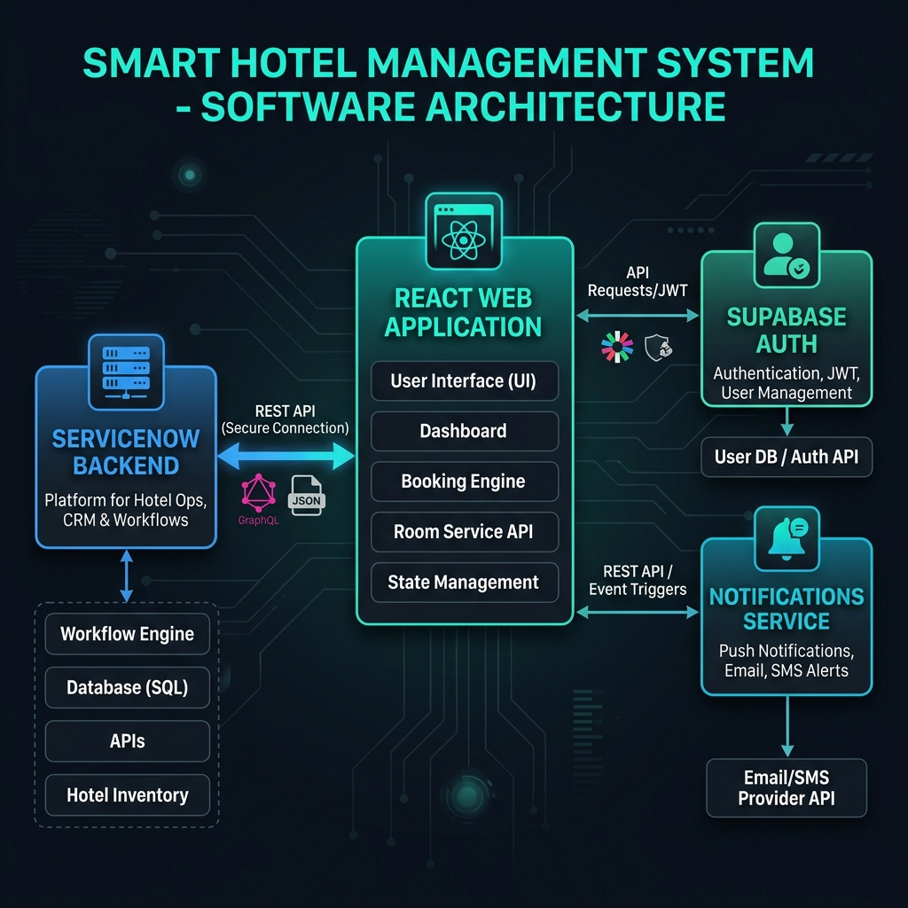
Figure 1: High-Level System Architecture of Smart AI Hotel Management System
14. CONCLUSION AND FUTURE SCOPE
Conclusion:
The Smart AI Hotel Management System (PS-046) demonstrates how enterprise service management workflows can be seamlessly coupled with modern high-performance web frontends. By orchestrating room bookings, food ordering, and maintenance tickets through ServiceNow, the system eliminates traditional operational silos, automates business logic, and guarantees transparent SLA compliance.
Future Scope:
1. IoT Smart Room Hardware: Connecting the web client via WebSockets to physical ESP32/Raspberry Pi microcontrollers for digital keyless door unlocking and smart thermostat regulation.
2. Live Payment Gateway: Replacing simulated room folios with live Stripe, Razorpay, or Apple Pay payment integration.
3. Biometric Facial Recognition: Enabling self-service kiosks at hotel reception for instant keyless check-ins.

