**Agricultural case study of India**

**Introduction**

Agriculture is the primary source of livelihood for most of the Indian population. It employs approximately 52% of the labor [1]. Its contribution to Gross Domestic Product (GDP) is between 14% to 15% [1]. In this report, we study more extensively the agricultural dynamics of India from the year 1997 to the year 2014. In the following section, we dive into the analysis of the result obtained from the given dataset.

**Analysis of the obtained results**

First, we studied the two primary staple food of India, which are rice and wheat. In Fig.(1), we have plotted the total rice and wheat production in India with respect to the progression of time.

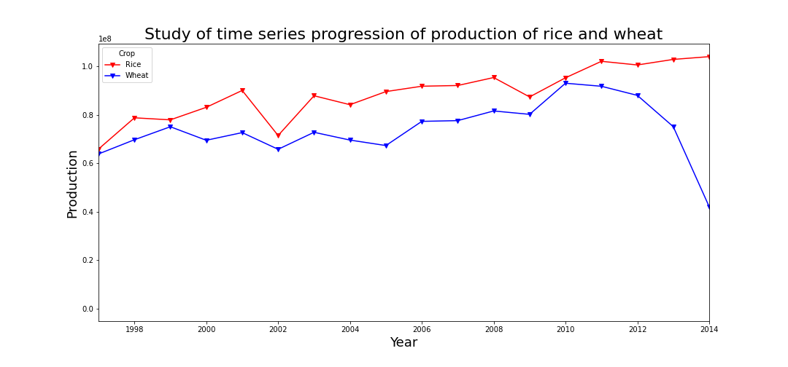  
Figure 1

From the Fig.(1) we observe the following,

1. **We observe that the wheat and rice production in India from the year 1996 to the end of 2001 has been increasing. After literature review, we found that this trend was observed because of higher government grain subsidy outlays and declining per capita consumption of wheat and rice. A detailed report of this observation has been discussed in ref.[2].**
2. **From the above graph, we observe that there is a drastic decline in the production of rice for the year 2002. The major factor due to which such a sharp decline was observed due to the decline in the surface water availability in the southeastern coastal regions of India. More extensive discussion has been given in ref.[3].**
3. **We also observe from the above figure that there is a very sharp decline in the production of wheat in the year 2014. The primary reason behind this decline is poor monsoon and unseasonal rains in February-March. More detailed discussion is given in ref.[4].**
4. **We also observe that overall the rice production has been increasing from the year 1997 to the year 2014. It leads to India being one of the top exporters of rice in the whole world [5]. This exceptional growth in the production of rice can be attributed to the green revolution [6].**

The next logical extension of the above study is to find out the top 5 five states producing the highest average wheat and rice in the years between 1997-2014. To this end, fig.(2) and fig.(3) shows the top 5 states producing rice and wheat, respectively.

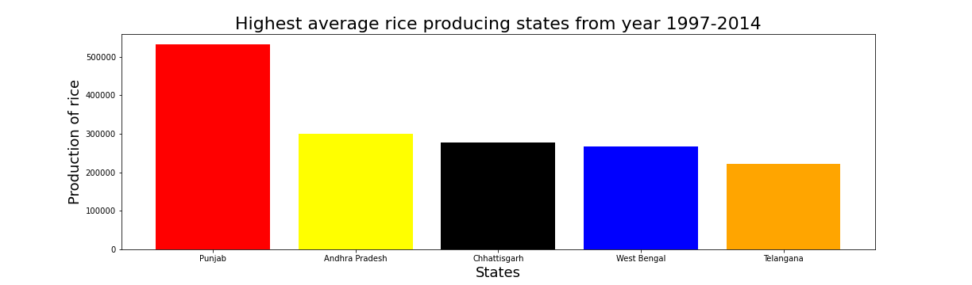  
Figure 2

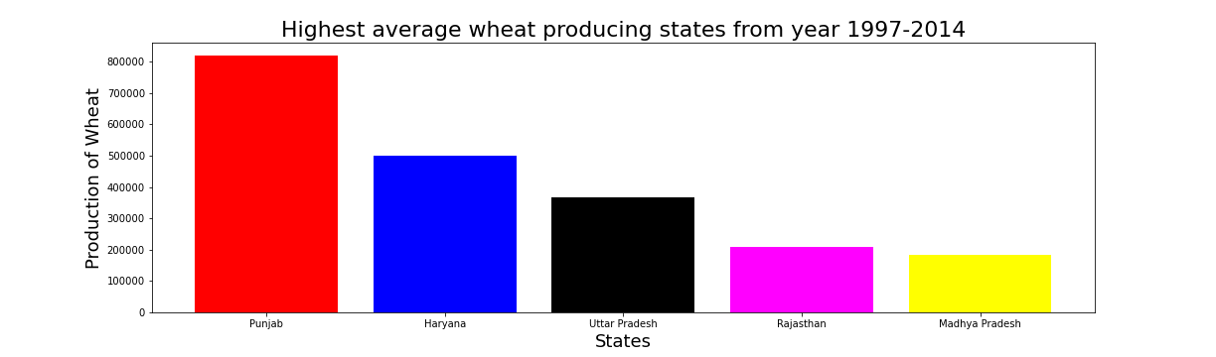  
Figure 3

1. **From fig.(2), the top 5 average producers of rice from the year 1997 to 2014 are Punjab, Andhra Pradesh, West Bengal, Telangana.** In Punjab, there is **low winter temperature from May-July, and therefore, a single crop of rice is sown during this time of the year [7]. West Bengal and Chhattisgarh receives heavy rainfall, and rice is grown mainly under rainfed conditions [7]. In Telangana and Andhra Pradesh, the rice is primarily grown in deltaic tracts of the Godavari and Krishna [7].**
2. **From fig.(3), the top 5 average producers of wheat from year 1997 to 2014 are, Punjab, Harayana, Uttar Pradesh, Rajasthan, and Madhya Pradesh.**

There are mainly two seasonal crops grown in India, and they are Kharif and Rabi [8]. The Kharif and Rabi are the two cropping patterns, and they are adopted in many Asian countries, depending upon the monsoon. The cropping season of Kharif crops starts with the onset of the monsoon and ends when the rainy season is over. On the other hand, Rabi crops are sown when the monsoon ends and harvested before the advent of the summer season. To this end, in fig.(4) and fig.(5), we study the major crops which are grown in India from 1997 to 2014 in the Kharif and Rabi seasons, respectively.

1. **From fig.(4) we observe that sugarcane is the predominant Kharif crop. Currently, India is the world's second-largest exporter of sugarcane, and for more details read ref.[9]. The reason behind this sheer dominance of sugarcane can be seen because sugarcane is the prime source of sugar in India. It occupies a prominent position in the Indian Agricultural scenario on account of its wider adoption in different agro-climatic conditions of the country [10]. It has a significant role in the national economy it provides raw material to sugar and over 25 other major industries viz. producing alcohol, papers, chemicals, and cattle feed [10]. It also finds a place in the pharmaceutical industry, next to textiles are entirely based on cane production as raw material [10].**
2. **From fig.(5) we observe that the crops wheat, potato, and rice are predominant crops of the Rabi season, and this observation is also concurred by the article written in ref.[11]. The predominance of wheat is because, after the 'Green Revolution' period in the late sixties, our country became self-dependent in wheat production. Currently, India is producing much more excess wheat than the requirement, and Godowns are over-flooded by wheat [12].**
3. **From fig.(4) and fig.(5), sugarcane and wheat have skewed production compared to other crops during that particular season. However, this skewed production of a single crop in a particular season can be balanced by crop diversification. However, crop diversification depends upon a lot of factors, such as increasing income on small farm holdings, withstanding price fluctuation, mitigating effects of increasing climate variability, balancing food demand, etc. More detailed discussion in this regard is given in ref.[13]. The need for diversification from sugarcane and wheat has also been addressed in the following, ref.[14] and ref.[15], respectively.**

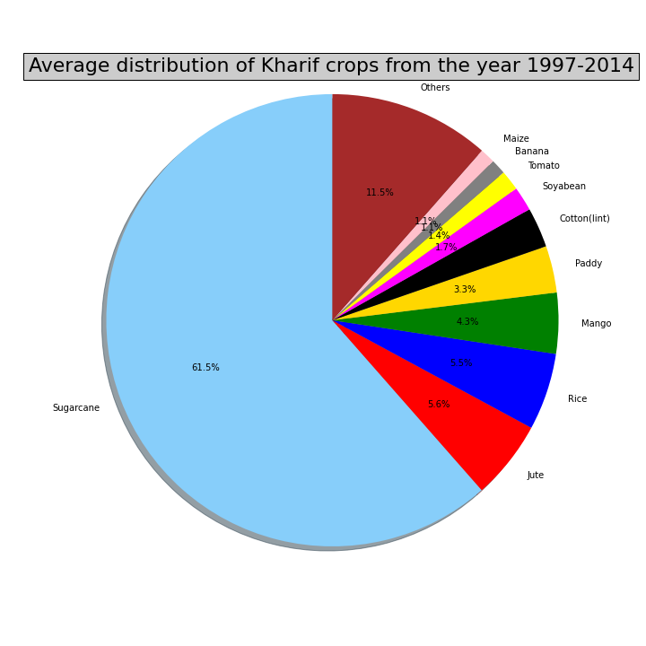  
Figure 4

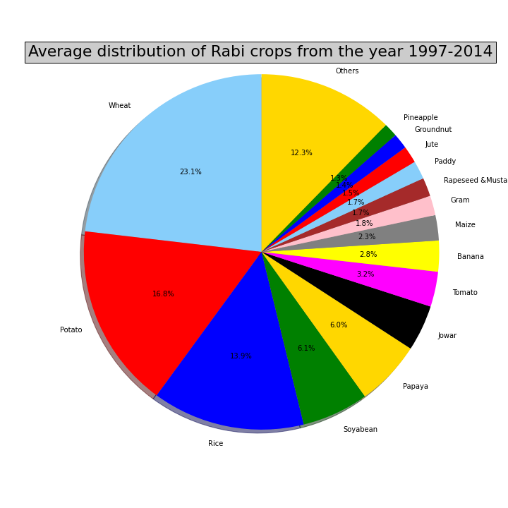  
Figure 5

We finally study the variation of the total agricultural land with respect to progression time. The motivation behind studying the total agricultural land of India is that it has a deep impact on terrestrial biodiversity and carbon storage [16]. To this end, we plot the fig.(6), and its analysis is given below.

1. **From fig.(6), we observe that there is a gradual decline in agricultural land after the year 2010. The decrease is mainly attributed to the diversion of cultivable land for non-agricultural purposes, such as construction, industries, and other development activities [17].**

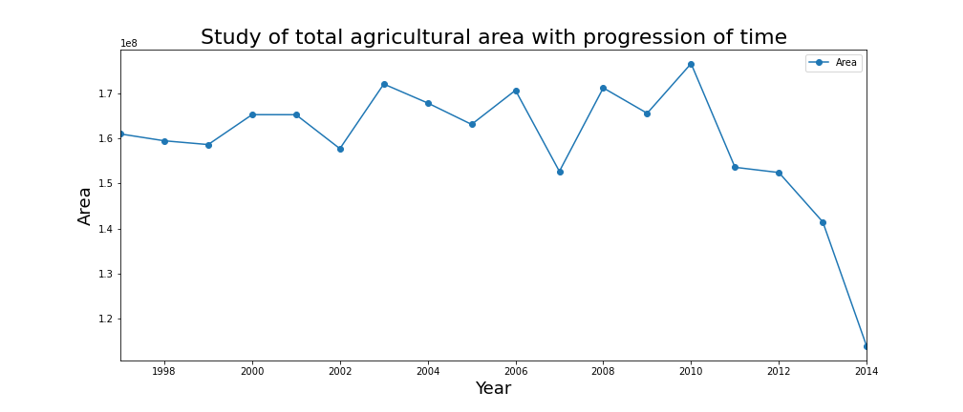  
Figure 6

**References**

[1] Aricultural study (<http://www.hillagric.ac.in/aboutus/vc/vc_addresses/pdf/2017/08.12.2017-Agri.Edu.Day-03.12.2017.pdf>).

[2] Production and Producer Policy (<https://www.ers.usda.gov/webdocs/publications/45802/11575_err41b_1_.pdf?v=0>).

[3] Zampieri, Matteo, et al. "Surface freshwater limitation explains worst rice production anomaly in India in 2002." Remote Sensing 10.2 (2018): 244.

[4] India's foodgrain output fell 4.66% in 2014-15 (<https://economictimes.indiatimes.com/news/economy/indicators/indias-foodgrain-output-fell-4-66-in-2014-15/articleshow/48515634.cms?utm_source=contentofinterest&utm_medium=text&utm_campaign=cppst>).

[5] Kumar, Manish. "India’s rice export: What is in it for farmers?." Agrarian South: Journal of Political Economy 8.1-2 (2019): 136-171.

[6] Nelson, Ann Raeboline Lincy Eliazer, Kavitha Ravichandran, and Usha Antony. "The impact of the Green Revolution on indigenous crops of India." Journal of Ethnic Foods 6.1 (2019): 1-10.

[7] A status note on Rice in India (<https://www.nfsm.gov.in/StatusPaper/Rice2016.pdf>).

[8] Cropping seasons of India- Kharif & Rabi (<http://www.arthapedia.in/index.php%3Ftitle=Cropping_seasons_of_India-_Kharif_%2526_Rabi>).

[9] Sugarcane (<https://en.wikipedia.org/wiki/Sugarcane>).

[10] Shukla, S. K., et al. "Sugarcane in India: Package of practices for different agro-climatic zones." *Indian Instituite of Sugarcane Research, Lucknow, India* (2017): 1-64.

[11] Sahay, B., et al. "In-season assessment of rabi crop progression and condition from multi source data." *The International Archives of Photogrammetry, Remote Sensing and Spatial Information Sciences* 40.8 (2014): 919.

[12] About wheat (<https://farmer.gov.in/m_cropstaticswheat.aspx>).

[13] Crop diversification and new varieties ([https://www.ctc-n.org/technologies/crop-diversification-and-new-varieties#:~:text=Major%20driving%20forces%20for%20crop,effects%20of%20increasing%20climate%20variability](https://www.ctc-n.org/technologies/crop-diversification-and-new-varieties" \l ":~:text=Major driving forces for crop,effects of increasing climate variability)).

[14] Shukla, S. K., et al. "Crop diversification options involving pulses and sugarcane for improving crop productivity, nutritional security and sustainability in India." *Sugar Tech* 19.1 (2017): 1-10.

[15] Banjara, Tej Ram, et al. "Diversification of rice–wheat cropping system improves growth, productivity and energetics of rice in the Indo-Gangetic Plains of India." *Agricultural Research* (2021): 1-10.

[16] Hinz, Roman, et al. "Agricultural development and land use change in India: A scenario analysis of trade‐offs between UN Sustainable Development Goals (SDGs)." *Earth's Future* 8.2 (2020): e2019EF001287.

[17] Cultivable land continues to shrink (<https://timesofindia.indiatimes.com/india/cultivable-land-continues-to-shrink/articleshow/21852689.cms?utm_source=contentofinterest&utm_medium=text&utm_campaign=cppst>).