A PROJECT REPORT ON
BAYESIAN DEEP LEARNING-BASED SIC FAILURE PREDICTION AND
RELIABILITY-AWARE USER SCHEDULING FOR IMPERFECT-SIC
NOMA NETWORKS
Submitted in partial fulfilment of the requirements for the course
MACHINE LEARNING
25SC2107E
A.Y.: 2026–27
Submitted by
Name: __________________________ Roll No.: __________________
Name: __________________________ Roll No.: __________________
Name: __________________________ Roll No.: __________________
Under the Esteemed Guidance of
Mr. N. Lava Prasad
Assistant Professor, Department of ECE
DEPARTMENT OF ELECTRONICS & COMMUNICATION ENGINEERING

ABSTRACT
Non-Orthogonal Multiple Access (NOMA) allows multiple users to share the same time and frequency resources and is considered a useful technique for improving spectral efficiency in 5G and emerging 6G wireless systems. NOMA receivers commonly use Successive Interference Cancellation (SIC) to separate superimposed signals. In practical links, SIC may fail because of noise, inter-user interference, channel variation, channel-estimation error, mobility and insufficient received-power separation. Such failures can increase bit error rate (BER), outage probability and reduce useful throughput. This project develops a simulation-based machine-learning pipeline that predicts SIC failure risk and uses the prediction to support reliability-aware user pairing.
The implementation generates a synthetic dataset from a physically motivated imperfect-SIC model. Eight features are used: signal-to-noise ratio (SNR), channel gain, received power, interference power, channel-estimation error, received-power gap, user mobility and user distance. The target is a binary SIC-failure label. Inputs are standardized, and the data are divided into stratified training and test sets. A one-hidden-layer neural classifier with 32 ReLU units and dropout is trained using mini-batch gradient descent and binary cross-entropy. During inference, dropout remains active for repeated stochastic predictions. The mean predicted probability estimates failure risk, while the standard deviation of repeated predictions is used as an uncertainty estimate.
A conventional strongest-with-weakest pairing method is compared with a reliability-aware method. The latter evaluates candidate strong/weak pairs and minimizes a cost equal to predicted failure probability plus 0.50 times prediction uncertainty, using minimum-cost matching. In the submitted run, the classifier achieved 84.57% test accuracy, ROC-AUC of 0.9283 and a Brier score of 0.1222. For 40 scheduled pairs, reliability-aware scheduling reduced predicted failure probability from approximately 0.190 to 0.108 and improved the simulated reliability from 0.850 to 0.925. These results are preliminary simulation results generated from synthetic data; they do not establish performance on a real wireless network. Further validation, repeated trials and calibration analysis are recommended.
Keywords: NOMA, Successive Interference Cancellation, Bayesian learning, Monte Carlo dropout, uncertainty estimation, user scheduling, reliability.

Supervisor Signature: __________________________ Course Instructor: __________________________

INDEX
Section | Page (approx.)
Abstract | ii
List of Abbreviations | iii
1. Introduction | 1
1.1 Background and Motivation | 1
1.2 Problem Statement | 2
1.3 Objectives and Scope | 2
2. System Model and Background | 3
2.1 NOMA and SIC | 3
2.2 Imperfect-SIC Model | 4
2.3 Dataset and Features | 5
3. Proposed Methodology | 6
3.1 Overall Workflow | 6
3.2 Preprocessing and Classifier | 7
3.3 MC-Dropout Uncertainty | 8
3.4 Reliability-Aware Scheduling | 9
4. Implementation and Experimental Setup | 10
4.1 Software and Code Modules | 10
4.2 Training Configuration | 11
4.3 Evaluation Metrics | 11
5. Results and Discussion | 12
5.1 SIC Failure Prediction | 12
5.2 Uncertainty Visualization | 13
5.3 Scheduling Comparison | 14
6. Limitations and Future Work | 15
7. Conclusion | 16
References | 17
Appendix A: Configuration Summary | 18

Note: Page numbers are indicative. They may shift slightly when edited or when additional figures are inserted.

LIST OF ABBREVIATIONS
Abbreviation | Meaning
BER | Bit Error Rate
BCE | Binary Cross-Entropy
DNN | Deep Neural Network
ECE | Electronics and Communication Engineering
MC | Monte Carlo
NOMA | Non-Orthogonal Multiple Access
ReLU | Rectified Linear Unit
ROC-AUC | Area Under the Receiver Operating Characteristic Curve
SIC | Successive Interference Cancellation
SINR | Signal-to-Interference-plus-Noise Ratio
SNR | Signal-to-Noise Ratio
ML | Machine Learning
CSV | Comma-Separated Values
Mbps | Megabits per second

Report Organization
Chapter 1 introduces the problem, motivation, objectives and scope. Chapter 2 explains the NOMA/SIC setting and the synthetic data model. Chapter 3 describes preprocessing, the neural classifier, uncertainty estimation and the scheduling strategy. Chapter 4 documents the implementation and experimental setup. Chapter 5 presents the supplied metrics and generated plots. Chapter 6 discusses limitations and future improvements, followed by the conclusion, references and configuration appendix.

1. INTRODUCTION

1.1 Background and Motivation
Wireless communication systems continue to support increasing numbers of connected devices, higher data rates and diverse quality-of-service requirements. Spectral efficiency is therefore an important design consideration. Non-Orthogonal Multiple Access (NOMA) is a multiple-access approach in which users can share a time-frequency resource while being distinguished, in part, through different power levels and receiver-side signal processing.
In a simplified power-domain NOMA downlink, signals intended for multiple users are superimposed before transmission. A receiver may decode a higher-power signal first and subtract its reconstructed contribution before decoding another signal. This process is known as Successive Interference Cancellation (SIC). The success of SIC depends on adequate channel knowledge, decoding quality and interference conditions.

1.2 Why Imperfect SIC Matters
Realistic receivers do not operate under perfectly known channels or noiseless conditions. Residual interference can remain after cancellation, and decoding decisions may be wrong. Channel-estimation error, user mobility, changing interference and a small received-power gap can all make the cancellation process less dependable. A scheduler that considers only channel strength may therefore choose a pair that looks attractive in a conventional sense but has a high probability of SIC failure.

1.3 Machine Learning Motivation
Machine learning can learn statistical relationships between link conditions and failure outcomes. Rather than returning only a hard class label, a probabilistic classifier can estimate the likelihood of failure. This project extends that idea by using repeated dropout-based predictions to obtain a simple uncertainty indicator. Both predicted risk and uncertainty are then considered by the scheduling component.

1. INTRODUCTION (CONTINUED)

1.4 Problem Statement
The project addresses the problem of selecting NOMA user pairs when SIC is imperfect. Given observable communication features, the system estimates the probability that cancellation will fail and uses this risk estimate to select pairings that are expected to be more reliable. The work is implemented as a reproducible simulation pipeline with synthetic training data and a simulated evaluation model.

1.5 Objectives
- Generate synthetic SIC attempts with link and receiver conditions that influence the probability of failure.
- Prepare model inputs through a stratified training/test split and feature standardization.
- Train a binary neural classifier to estimate SIC-failure probability.
- Use Monte Carlo dropout at inference time to estimate prediction uncertainty.
- Compare conventional strongest-with-weakest pairing with reliability-aware minimum-cost matching.
- Evaluate both approaches using predicted failure probability, observed simulated SIC failure rate, BER, outage, throughput and reliability.

1.6 Scope of the Work
The current scope is a software-based simulation. It does not use live radio measurements, a physical testbed or a real-world wireless dataset. The synthetic data generator defines a controlled relationship between features and failure probability, while a separate link-evaluation approximation is used to compare scheduled pairs. Conclusions must therefore be limited to the submitted simulation and its assumptions.

1.7 Expected Contribution
The key contribution is an end-to-end demonstration linking supervised prediction, uncertainty estimation and resource scheduling. The scheduler uses a risk-aware objective instead of pairing users solely by their sorted SNR positions. The code also saves intermediate artifacts, metrics and figures so that the experiment can be repeated and inspected.

2. SYSTEM MODEL AND BACKGROUND

2.1 NOMA System Overview
NOMA permits two or more users to occupy the same time-frequency resource. In power-domain NOMA, the transmitted waveform is a superposition of user signals with different allocated powers. At the receiver, SIC is used to decode and subtract selected signals. A strong-channel user may decode a weaker user's higher-power signal before decoding its own signal, subject to the decoding order and link conditions.
This project focuses on pairing two users, described as a strong candidate and a weak candidate. The user with higher SNR is treated as the strong user for the pair and is the receiver at which SIC risk is assessed. The power gap between users is included as an input feature because a larger separation can make the decoding/cancellation task easier in the synthetic model.

2.2 Signal Quality and Interference
The simulation calculates received power from transmit power and channel gain. Channel gain is derived from a distance-dependent path-loss expression with a random perturbation. Interference is sampled over a range and combined with the assumed noise power to obtain an SNR-like quality indicator. A 10 dB implementation margin is subtracted to represent practical receiver losses in the simplified simulation.

2.3 Assumptions
- The generated links have distances between 40 m and 500 m.
- Transmit power is sampled between 18 dBm and 32 dBm.
- Noise power is fixed at −100 dBm.
- Interference is randomly sampled around a range of approximately −112 dBm to −78 dBm, with additional variation.
- Channel-estimation error, mobility and power separation influence the synthetic failure probability.
- Random seeds are set in the submitted code to support repeatable runs.

2.4 System-Level Processing
The complete pipeline begins with generated link conditions, creates a binary failure label, trains the predictor and evaluates its predictions. For scheduling, a new set of users is generated, candidate pairs are scored, and both pairing policies are evaluated under a stochastic imperfect-SIC link model.

2. SYSTEM MODEL AND DATASET

2.5 Synthetic Dataset Generation
The data-generation module creates one row per SIC decoding attempt. It samples user distance, path loss, transmit power, interference, channel-estimation error, power gap and mobility. A latent probability is formed from a weighted combination of link quality and non-ideal SIC factors. The probability is passed through a sigmoid function and a binary failure outcome is sampled from a Bernoulli distribution.
The submitted configuration sets N_SAMPLES = 7000. The resulting data are written to outputs/data/synthetic_sic_dataset.csv. The PPT supplied with the project mentions 60,000 synthetic attempts; however, the uploaded configuration code sets the runtime sample count to 7,000. This report follows the executable configuration, so the count should be confirmed and made consistent across the report and presentation before final submission.

2.6 Input Features
Feature name | Meaning | Role in the model
snr_db | Signal-to-noise ratio in dB | Summarizes received link quality after the simplified interference/noise calculation.
channel_gain_db | Channel gain in dB | Represents distance-related propagation loss.
received_power_dbm | Received signal power | Combines transmit power and channel gain.
interference_dbm | Interference power | Represents inter-user and environmental interference.
channel_estimation_error | Estimation error term | Represents imperfect channel knowledge.
power_gap_db | Received-power gap | Represents separation between strong and weak users.
mobility_kmh | Mobility indicator | Represents user movement in the simulation.
user_distance_m | User distance in metres | Captures distance-related link variation.

2.7 Target Variable
The target column sic_failure is binary: 1 indicates a simulated SIC failure and 0 indicates no failure. The generator also stores true_failure_probability, which is used to construct the synthetic outcome and is not included among the eight model input features.

3. PROPOSED METHODOLOGY

3.1 Overall Workflow
The implementation follows a sequence of data generation, preprocessing, classifier training, repeated inference, user-pair selection and performance evaluation. Each stage is separated into a Python module to keep the experiment understandable and maintainable.
Stage | Description
1. Data generation | Sample channel, power, interference, distance, mobility and estimation-error conditions; produce a binary SIC-failure outcome.
2. Preprocessing | Split the dataset using stratification and standardize input features with a scaler fitted only on the training data.
3. Model training | Train a one-hidden-layer neural classifier using mini-batches and binary cross-entropy loss.
4. Repeated inference | Run stochastic dropout predictions repeatedly; calculate mean probability and standard deviation.
5. Pair scoring | Score candidate strong/weak user pairs using predicted failure probability and uncertainty.
6. Scheduling | Use minimum-cost matching to select a lower-cost set of pairings.
7. Evaluation | Compare scheduling methods using simulated failure, BER, outage, throughput and reliability metrics.

3.2 Workflow Diagram Placeholder
Insert a polished workflow figure here if required by the final submission. The sequence represented in the code is:
Synthetic Conditions → Feature Preprocessing → Neural Classifier → MC-Dropout Predictions
Mean Failure Risk + Uncertainty → Reliability-Aware Pairing → Link Evaluation → Metrics
[Reserved space for an optional system architecture / workflow diagram]

3. MODEL DESIGN AND TRAINING

3.3 Neural Classifier
The submitted implementation defines a compact feed-forward neural network in NumPy. The input vector contains eight standardized features. The hidden layer contains 32 units with Rectified Linear Unit (ReLU) activation, and the output layer produces one logit that is transformed through a sigmoid function to obtain a probability between zero and one.
Layer / operation | Configuration | Purpose
Input | 8 standardized features | Represent the link and user conditions.
Dense hidden layer | 32 units, ReLU | Learn non-linear relationships between conditions and failure labels.
Dropout | Rate 0.25 | Randomly masks hidden activations during training and repeated inference.
Output | One sigmoid probability | Estimate the probability of SIC failure.

3.4 Training Procedure
- Set random seeds for reproducibility.
- Use a stratified 80:20 train/test split so the class distribution is approximately preserved.
- Fit StandardScaler on the training features and apply the same transform to test features.
- Train for 55 epochs with batch size 128 and learning rate 0.001.
- Use binary cross-entropy as the training objective and mini-batch gradient descent to update weights.
- Save the learned weights and feature names in an NPZ file.

3.5 Binary Cross-Entropy
For a binary target y and predicted probability p, binary cross-entropy is given by:
L = − [ y log(p) + (1 − y) log(1 − p) ]
The training code computes the average loss over the training set for each epoch. The saved training-loss plot is used to inspect whether the optimization objective decreases during training.

3. UNCERTAINTY ESTIMATION AND SCHEDULING

3.6 Monte Carlo Dropout
The model keeps dropout active during prediction and repeats inference multiple times for the same input. Because different hidden units are randomly masked on each pass, the model produces a set of slightly different probability estimates. The average of these estimates is used as the predicted SIC-failure probability, while their standard deviation is used as an uncertainty indicator.
Predicted risk = mean(p₁, p₂, …, pₘ)
Prediction uncertainty = standard deviation(p₁, p₂, …, pₘ)
The main evaluation uses 40 repeated predictions for test-set uncertainty. The scheduling helper uses repeated stochastic predictions for candidate pairs (35 passes per pair in the submitted code). A larger standard deviation indicates that the prediction varies more across stochastic passes. It is an approximate uncertainty measure rather than a guarantee of calibrated Bayesian posterior uncertainty.

3.7 Conventional Pairing
The conventional baseline sorts users by SNR and pairs the strongest user with the weakest user, then the next strongest with the next weakest, continuing inward. This is a common simple near/far pairing rule and provides a baseline for comparison.

3.8 Reliability-Aware Pairing
The reliability-aware scheduler splits the sorted users into the lower-SNR and higher-SNR candidate pools. It evaluates every candidate strong/weak combination, computes the predicted failure probability and uncertainty, and defines the pair cost as:
Pair cost = predicted failure probability + 0.50 × uncertainty
A minimum-cost assignment algorithm then chooses the matching with the lowest total cost. The conventional and reliability-aware methods use the same strong and weak candidate pools; the changed decision is how the weak users are assigned to strong users.

4. IMPLEMENTATION AND EXPERIMENTAL SETUP

4.1 Software Requirements
Component | Use in the project
Python | Main programming language for simulation and model implementation.
NumPy | Numerical arrays, random sampling and neural-network computations.
Pandas | Dataset preparation and CSV output.
scikit-learn | Train/test split, standardization and prediction evaluation metrics.
SciPy | Minimum-cost assignment using linear_sum_assignment.
Matplotlib | Generation of training, uncertainty and scheduling plots.
python-docx (report only) | Used to prepare this editable report; not required by the project runtime.

4.2 Code Module Description
File | Responsibility
config.py | Experiment parameters, feature names, random seed and output directories.
main.py | Coordinates data generation, training, evaluation, file saving and plot generation.
src/data_generation.py | Creates synthetic SIC data and pair-level features.
src/preprocessing.py | Performs stratified splitting and feature standardization.
src/bayesian_model.py | Implements the dropout neural network, training and repeated predictions.
src/scheduling.py | Implements conventional and reliability-aware user pairing.
src/performance.py | Evaluates each schedule under a stochastic link model.
src/visualization.py | Saves training-loss, uncertainty and scheduling-comparison figures.

4.3 Output Artifacts
The submitted ZIP contains saved model weights, the generated dataset, JSON model metrics, CSV schedule details, a final comparison CSV and three plot images. These artifacts are useful for checking the values reported in the results chapter and for presenting the simulation during the expo.

4. EXPERIMENTAL CONFIGURATION AND METRICS

4.4 Main Configuration
Parameter | Value
Random seed | 42
Synthetic data rows in submitted config | 7,000
Test split | 20% (stratified)
Input features | 8
Batch size | 128
Training epochs | 55
Learning rate | 0.001
Hidden units / activation | 32 / ReLU
Dropout rate | 0.25
Repeated test predictions | 40
Scheduling users / pairs | 80 users / 40 pairs
Noise power | −100 dBm

4.5 Prediction Metrics
Accuracy is the proportion of test examples classified correctly at a probability threshold of 0.5. ROC-AUC measures the ranking ability of the score across thresholds. The Brier score is the mean squared difference between predicted probabilities and binary outcomes; lower values indicate better probabilistic predictions. Mean uncertainty is the average standard deviation across repeated dropout predictions.

4.6 Scheduling Metrics
The scheduling evaluation reports predicted SIC-failure probability, observed simulated SIC-failure rate, BER, outage probability, throughput and reliability. In the code, BER is computed from an effective-SNR approximation. Outage is assigned when effective SNR falls below a threshold or SIC fails. Throughput is set to zero during outage and otherwise estimated using spectral efficiency for a nominal 10 MHz channel. Reliability is computed as one minus outage.
These definitions are specific to the submitted simulation. They should not be interpreted as measured field performance or as a full standards-compliant physical-layer implementation.

5. RESULTS AND DISCUSSION

5.1 SIC Failure Predictor
The metrics saved by the submitted run are shown below. The test split contains data held out from model training, but both the training and test data are drawn from the same synthetic generator.
Metric | Recorded value | Interpretation
Test accuracy | 0.8457 | 84.57%
ROC-AUC | 0.9283 | Good separation in this synthetic test setting
Brier score | 0.1222 | Probabilistic prediction error measure
Mean prediction uncertainty | 0.0974 | Average MC-dropout standard deviation

The recorded test accuracy is approximately 84.57%, and the ROC-AUC is approximately 0.9283. The latter indicates that the model generally ranks failure cases above non-failure cases in this generated test set. The Brier score of approximately 0.1222 adds a probability-sensitive measure that complements accuracy and ROC-AUC.
These results demonstrate the behavior of the implemented pipeline under its assumptions. Since the data are synthetic, they do not by themselves establish that the same scores would be obtained from a real NOMA receiver or a measured wireless dataset.

5.2 Training Loss
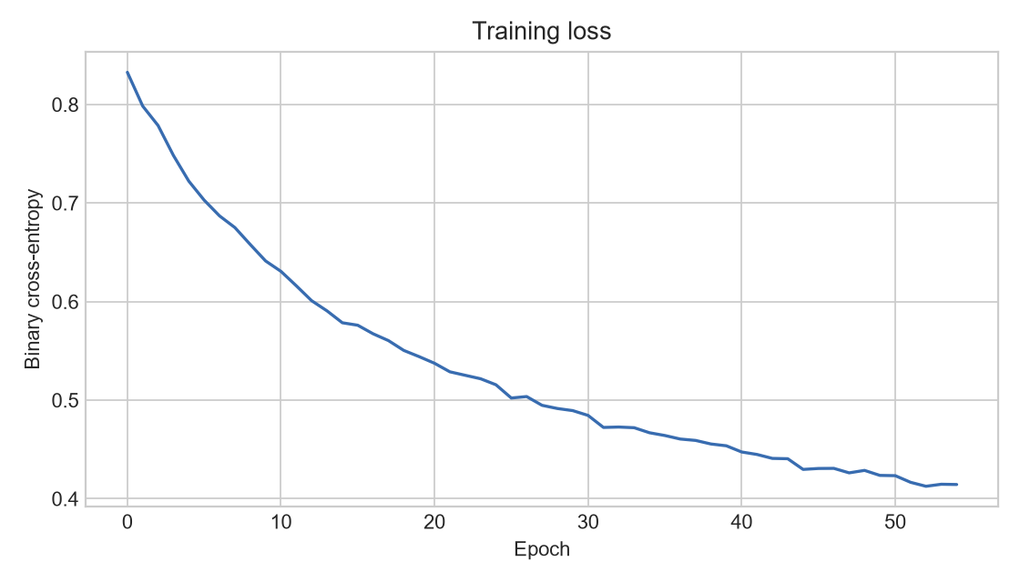
Figure 5.1: Training binary cross-entropy loss over 55 epochs.
The loss curve decreases over training, indicating that the optimization procedure reduces the training objective. A decreasing training loss alone does not prove generalization; held-out evaluation and further validation remain important.

5. RESULTS: UNCERTAINTY ANALYSIS

5.3 Prediction Probability and Uncertainty
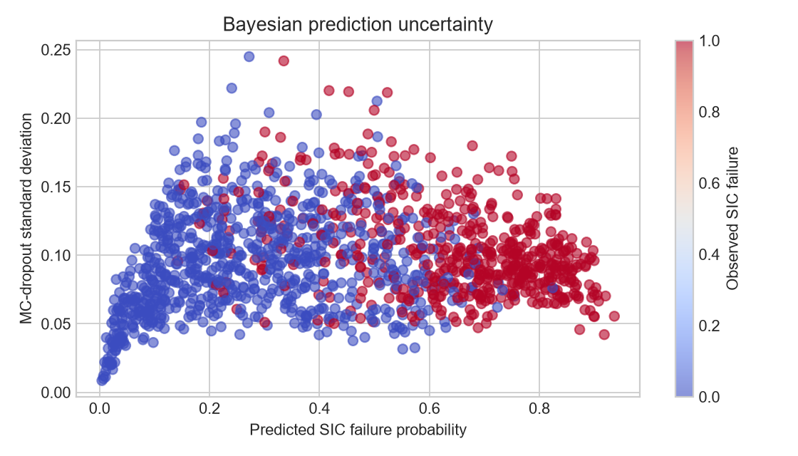
Figure 5.2: Predicted SIC-failure probability versus MC-dropout standard deviation; point colour indicates the observed test label.
Each point represents a test example. The horizontal axis is the model's mean predicted failure probability, and the vertical axis is the standard deviation of repeated stochastic predictions. The point colour distinguishes the observed SIC-failure label. This view helps inspect whether uncertain predictions occur across the probability range and whether failure and non-failure examples overlap.
The mean uncertainty recorded for the test examples is approximately 0.0974. Uncertainty is included in the scheduler's cost because a pair with a low mean risk but a comparatively unstable prediction may deserve less preference than a pair with similarly low risk and lower uncertainty.
The plot should be read as a diagnostic visualization rather than a formal calibration plot. A reliability diagram, expected calibration error and confidence-interval analysis would provide additional information about whether the predicted probabilities match observed event frequencies.

5. RESULTS: SCHEDULING COMPARISON

5.4 Conventional Versus Reliability-Aware Pairing
Scheduler | Pred. failure | SIC failure rate | BER | Outage | Throughput (Mbps) | Reliability
Conventional | 0.190 | 0.075 | 0.069 | 0.150 | 36.06 | 0.850
Reliability-aware | 0.108 | 0.000 | 0.039 | 0.075 | 37.39 | 0.925

For this run, the reliability-aware method reduced mean predicted SIC-failure probability from approximately 0.190 to 0.108. The simulated SIC-failure rate changed from 0.075 to 0.000 across 40 evaluated pairs, BER decreased from approximately 0.0691 to 0.0387, and outage decreased from 0.150 to 0.075. Throughput increased from approximately 36.06 Mbps to 37.39 Mbps, while reliability increased from 0.850 to 0.925.
The zero observed failures in the reliability-aware schedule apply only to this particular set of 40 simulated pairs. It should not be interpreted as a general guarantee of zero SIC failures. Since the evaluation is stochastic and the sample is small, repeated trials with multiple random seeds are needed to estimate variability.

5.5 Scheduling Comparison Plot
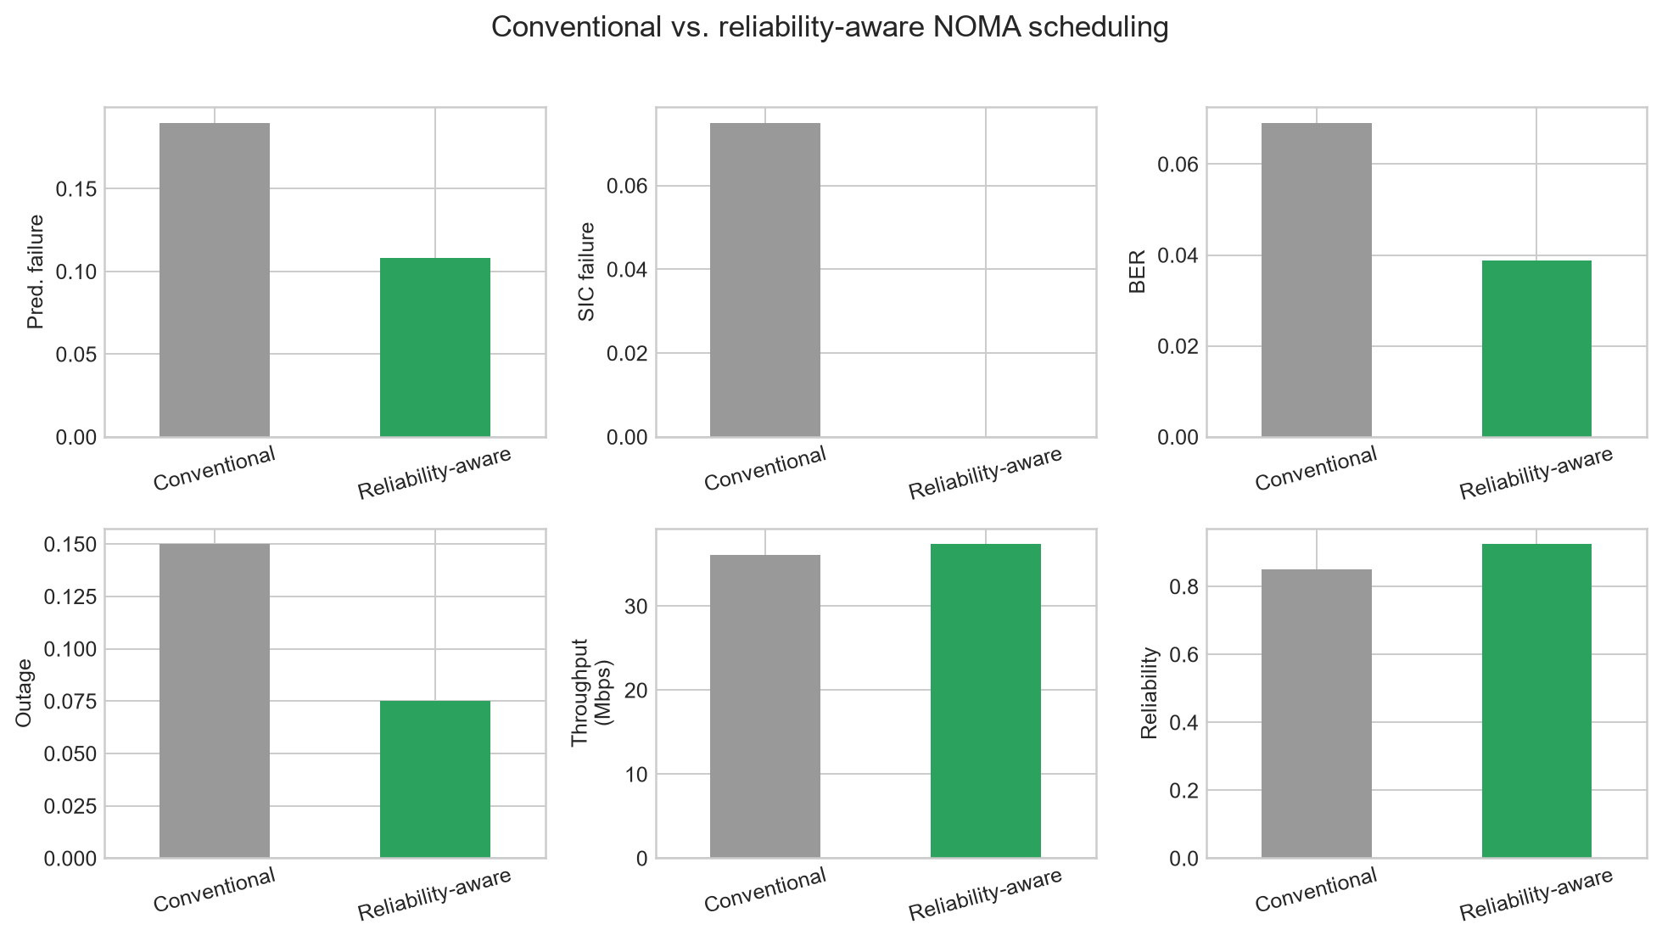
Figure 5.3: Metric comparison between conventional and reliability-aware scheduling.

5. DISCUSSION

5.6 Interpretation of the Results
The results are consistent with the design goal of using a predicted risk signal to inform user pairing. Conventional pairing relies on SNR order alone, whereas reliability-aware pairing considers model output for each candidate pair. The cost function also penalizes prediction uncertainty. The resulting schedule can therefore differ from the conventional near/far pairing even though both methods use the same strong-user and weak-user pools.
The predictor's ROC-AUC is useful for evaluating ranking performance, while the Brier score evaluates probability error. Both are relevant because the scheduling method uses probabilities rather than only binary class decisions. The uncertainty estimate provides an additional signal, but its practical usefulness should be tested through sensitivity analysis and calibration checks.

5.7 Fairness and Experimental Controls
The implementation uses the same user pool for the two schedulers and preserves the same near/far candidate pools. This helps isolate the effect of the pairing decision. Random seeds are fixed in the configuration and the outputs are written to files. Nevertheless, the evaluation compares one saved run, and the observed metrics can vary under different seeds or simulated user sets.

5.8 Important Reproducibility Check
The project presentation states 60,000 synthetic SIC attempts, while the code configuration in the uploaded ZIP sets N_SAMPLES to 7,000. This report uses the executable configuration value. Before presenting or submitting, update either the code or the slide/report to ensure that the dataset count reflects the exact run being discussed. If the intended experiment is 60,000 samples, rerun the code with N_SAMPLES set to 60000 and regenerate all metrics and plots rather than simply changing the stated number.

6. LIMITATIONS AND FUTURE WORK

6.1 Current Limitations
- Synthetic-data dependence: both model training and testing rely on a generated dataset rather than measured radio data.
- Simplified link model: path loss, interference, receiver losses and throughput are represented through a controlled simulation, not a complete radio-stack implementation.
- Approximate uncertainty: MC-dropout standard deviation is a useful indicator, but it is not proof that probabilities are calibrated or that uncertainty captures every source of model error.
- Single-run scheduling evidence: the displayed comparison uses 40 pairs from one generated user set; one run is not sufficient to establish robust statistical improvement.
- Potential configuration mismatch: the presentation sample count and code sample count differ and should be reconciled before the final expo.
- Limited hyperparameter exploration: the submitted implementation uses a fixed hidden-layer size, dropout rate, learning rate and uncertainty weight.

6.2 Future Improvements
- Validate on a larger dataset or a validated wireless simulator with clearly documented channel assumptions.
- Run multiple independent seeds and report mean and standard deviation for all scheduling metrics.
- Use stratified k-fold cross-validation and a structured hyperparameter search.
- Evaluate probability calibration using reliability diagrams and calibration scores.
- Perform a sensitivity study for the uncertainty penalty weight, including the current value of 0.50.
- Compare against additional baselines, such as random matching, channel-aware optimization and risk-only scheduling.
- Add more detailed plots and retain per-pair results for error analysis.
- Document the simulation assumptions and code versions so that results can be reproduced by another group.

7. CONCLUSION
This project implements a machine-learning-assisted approach to predicting Successive Interference Cancellation failure and using that prediction to support reliability-aware user scheduling in a simulated NOMA network. The system creates synthetic link conditions, constructs a binary failure label, standardizes eight input features and trains a one-hidden-layer neural classifier. Repeated dropout inference provides both a mean failure probability and a standard-deviation-based uncertainty indicator.
The scheduler compares a conventional strongest-with-weakest pairing rule with a reliability-aware minimum-cost matching method. The matching cost combines predicted SIC-failure probability with an uncertainty penalty. In the submitted run, the classifier achieved 84.57% accuracy and 0.9283 ROC-AUC on the synthetic test split. Across 40 scheduled pairs, the reliability-aware method produced lower predicted failure risk and improved the simulated BER, outage, throughput and reliability values compared with the conventional baseline.
The results support the feasibility of connecting a probabilistic classifier to a scheduling decision in a controlled simulation. However, they should be treated as preliminary because the dataset is synthetic, the link model is simplified and only one scheduling run is reported. A larger or externally validated dataset, repeated trials, calibration analysis and a sensitivity study are the next steps required to strengthen the evidence.

Final Outcome
The end-to-end prototype is implemented: synthetic data generation, preprocessing, SIC-failure prediction, uncertainty estimation, user pairing, metric calculation and plot generation are all represented in the submitted code. Further validation and refinement remain before making claims about real-world network performance.

REFERENCES
The following references provide background for the concepts used in the project. They are general technical references and should be checked against the exact citation style required by the department.
[1] L. Dai, B. Wang, Y. Yuan, S. Han, C.-L. I, and Z. Wang, “Non-orthogonal multiple access for 5G: solutions, challenges, opportunities, and future research trends,” IEEE Communications Magazine, vol. 53, no. 9, pp. 74–81, 2015.
[2] Z. Ding, Z. Yang, P. Fan, and H. V. Poor, “On the performance of non-orthogonal multiple access in 5G systems with randomly deployed users,” IEEE Signal Processing Letters, vol. 21, no. 12, pp. 1501–1505, 2014.
[3] Y. Gal and Z. Ghahramani, “Dropout as a Bayesian approximation: representing model uncertainty in deep learning,” in Proceedings of the 33rd International Conference on Machine Learning (ICML), 2016.
[4] T. G. Dietterich, “An experimental comparison of three methods for constructing ensembles of decision trees,” Machine Learning, vol. 40, pp. 139–157, 2000. (Background on ensemble-based prediction; not a direct source for the project's implementation.)
[5] scikit-learn developers, “Model evaluation: quantifying the quality of predictions,” scikit-learn documentation.
[6] NumPy Developers, “NumPy documentation.”
[7] SciPy Developers, “scipy.optimize.linear_sum_assignment,” SciPy documentation.
[8] Submitted project source code and outputs: config.py, main.py, src/data_generation.py, src/preprocessing.py, src/bayesian_model.py, src/scheduling.py, src/performance.py, src/visualization.py, outputs/metrics/model_metrics.json and outputs/metrics/final_comparison.csv.

Source-Based Note
Implementation details and numerical results in this report are taken from the supplied abstract, project presentation and uploaded source-code archive. The report does not claim that the synthetic simulation has been validated on real network measurements.

APPENDIX A: CONFIGURATION SUMMARY

A.1 Key Configuration Values
The values below are read from the submitted config.py and main implementation. If the experiment is rerun with changed values, all metrics and plots should be regenerated and this appendix updated.
Variable | Configured value | Description
SEED | 42 | Reproducibility seed.
N_SAMPLES | 7000 | Number of synthetic SIC attempts generated by main.py.
TEST_SIZE | 0.20 | Fraction of rows reserved for testing.
BATCH_SIZE | 128 | Mini-batch size during training.
EPOCHS | 55 | Number of training epochs.
LEARNING_RATE | 1e-3 | Gradient-descent learning rate.
MC_SAMPLES | 40 | Repeated predictions for test uncertainty.
N_SCHEDULING_USERS | 80 | Number of users generated for scheduling.
NOISE_POWER_DBM | −100.0 | Assumed receiver noise power.

A.2 Output Files
Output path | Purpose
outputs/data/synthetic_sic_dataset.csv | Synthetic model-development dataset.
outputs/models/mc_dropout_sic_model.npz | Saved model weights and feature names.
outputs/metrics/model_metrics.json | Accuracy, ROC-AUC, Brier score and mean uncertainty.
outputs/metrics/final_comparison.csv | Aggregated metrics for both scheduling methods.
outputs/metrics/conventional_pairs.csv | Conventional pairing decisions and predicted risk.
outputs/metrics/reliability_aware_pairs.csv | Reliability-aware pairing decisions and predicted risk.
outputs/plots/training_loss.png | Training loss curve.
outputs/plots/uncertainty_scatter.png | Prediction-risk and uncertainty scatter plot.
outputs/plots/scheduling_comparison.png | Comparison of scheduling metrics.

A.3 Optional Additional Screenshot
Reserved space for an additional output screenshot or a terminal view showing the execution summary. Insert a relevant image here if it is requested during the project expo.

