**Stock Market Analysis**

**Environment Setup**:

Software:

● Visual Studio Code

● Microsoft Excel

● Power BI Desktop Language:

● Python

Libraries:

● Pandas

● Numpy

● Matplotlib

* Using Python
* Exploratory Data Analysis
* import pandas as pd
* import matplotlib.pyplot as plt
* import datetime
* axis = pd.read_csv('AXISBANK-BSE.csv')
* cipla = pd.read_csv('CIPLA-BSE.csv')

• This imports the Pandas library, which is used for data manipulation and analysis. By importing it as pd, you can use the shorthand pd to call Pandas functions.

• matplotlib**. pyplot** as plt: This imports the pyplot module from the Matplotlib library, which is used for creating static, animated, and interactive visualizations in Python. By importing it as plt, you can use the shorthand plt to call pyplot functions.

• import **datetime**: This imports the datetime module, which supplies classes for manipulating dates and times. It is useful for parsing, formatting, and performing arithmetic with date and time data.

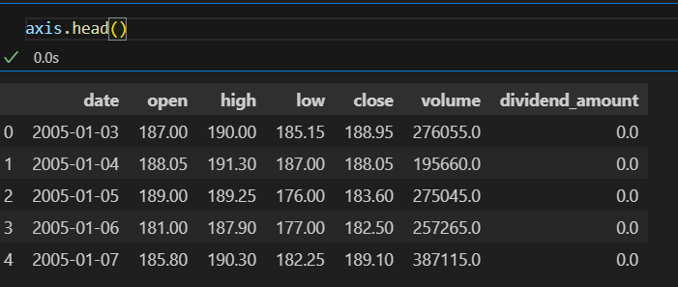

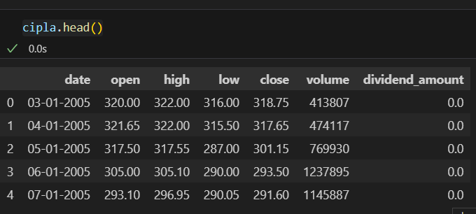

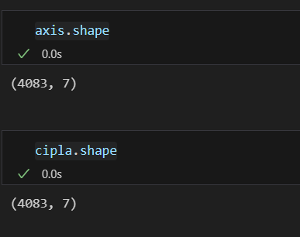

• **axis. Shape:** This gets the shape of the axis Data Frame, which contains the data loaded from 'AXISBANK-BSE.csv'. The shape is a tuple where the first element is the number of rows and the second element is the number of columns.

**• Cipla. Shape**: Similarly, this gets the shape of the cipla DataFrame, which contains the data loaded from 'CIPLA-BSE.csv'.

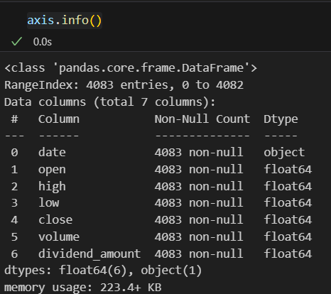

* **Missing Values**

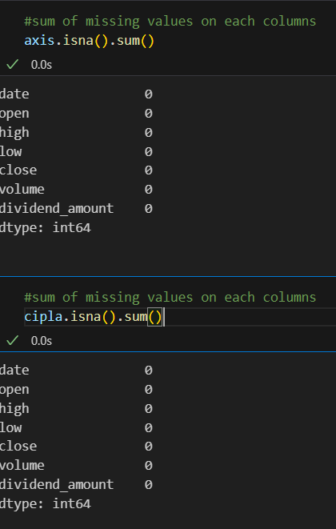

* **Exploratory Data Analysis (EDA)**

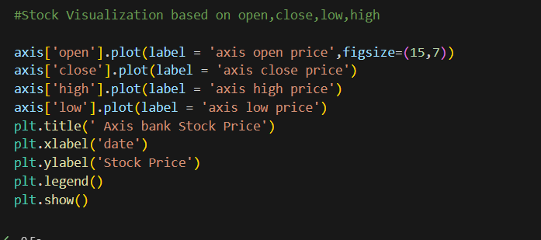

* This script creates a comprehensive visualization of the Axis Bank stock prices over time, displaying the open, close, high, and low prices in a single plot. Each line is clearly labeled, and a legend is provided to distinguish between them. The plot is customized with a title and axis labels to improve readability and context. This kind of visualization is useful for analyzing the stock's performance and trends over a given period.

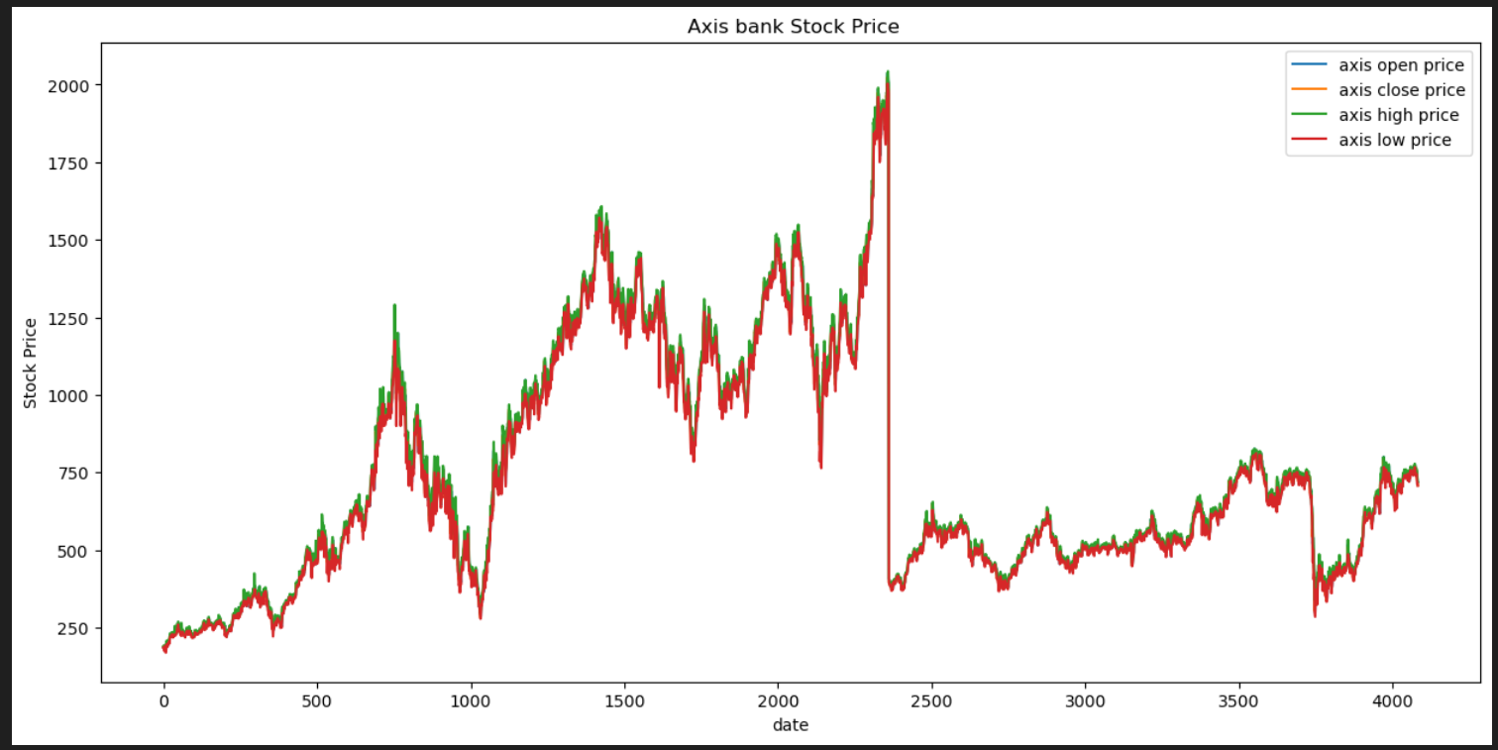

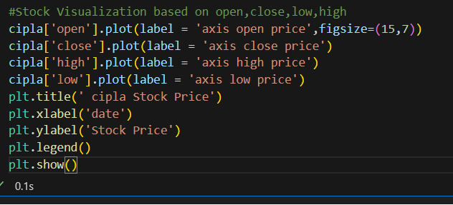

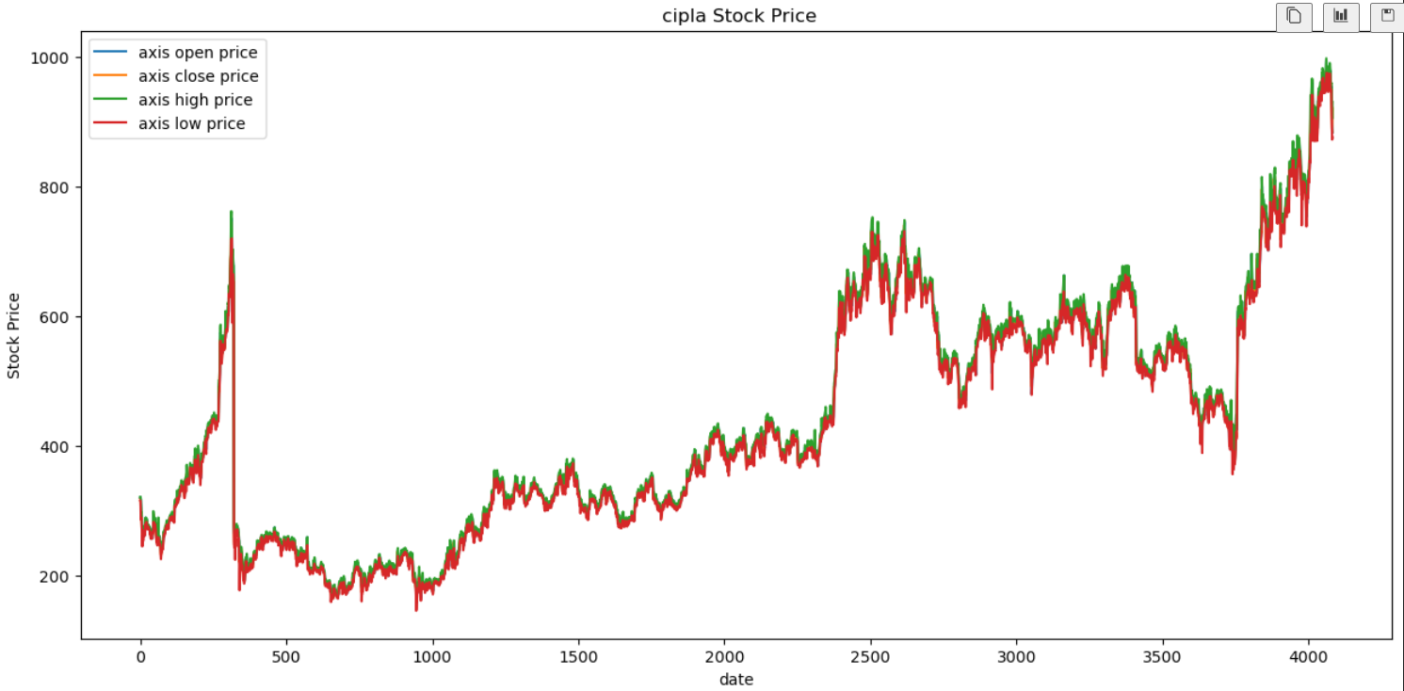

* This script creates a detailed visualization of Cipla's stock prices over time, displaying the open, close, high, and low prices in a single plot. Each line is clearly labeled, and a legend is provided to distinguish between them. The plot is customized with a title and axis labels to improve readability and context. This visualization is useful for analyzing Cipla's stock performance and trends over a given period.

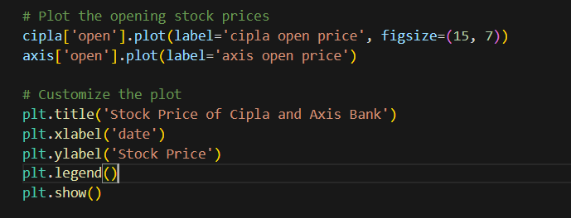 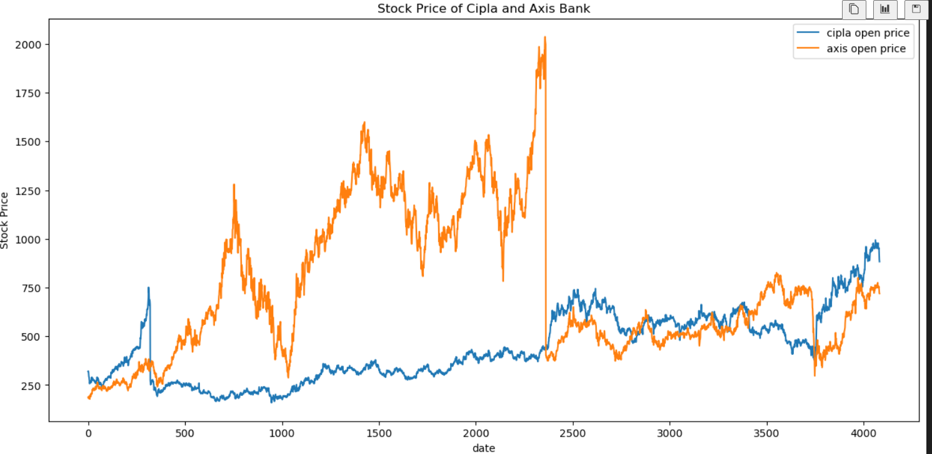

* This script creates a comparative visualization of the opening prices of Cipla and Axis Bank stocks over time. By plotting both stock prices on the same graph, it allows for a direct comparison of their performance. The plot is labelled clearly with titles and axis labels, and a legend is provided to distinguish between the two stocks. This visualization is useful for analysing and comparing the trends and behaviours of these two different stocks over the same period.

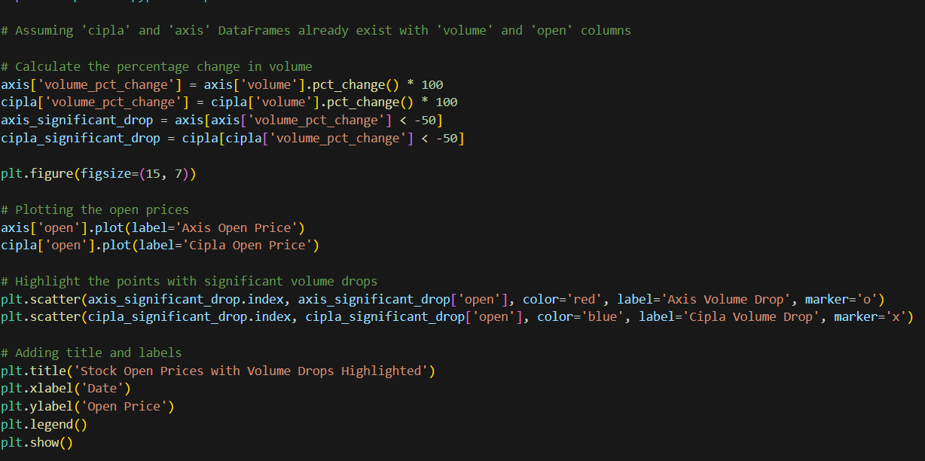

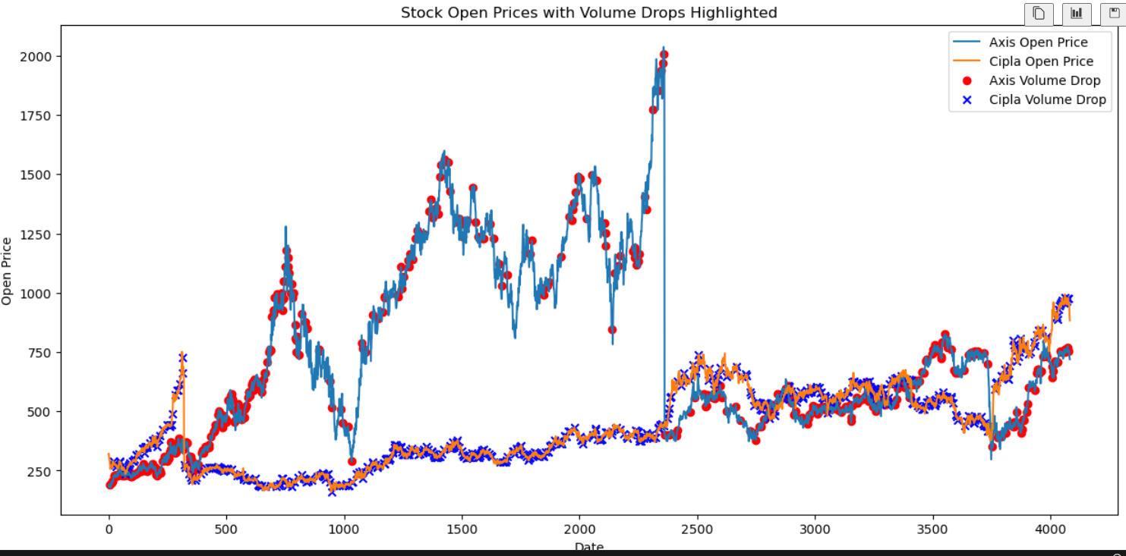

* This script plots the opening prices of Cipla and Axis Bank stocks over time and highlights significant drops in trading volume (greater than 50% decrease) using scatter markers. Red circles denote significant volume drops for Axis Bank, and blue crosses denote significant volume drops for Cipla. This visualization helps in identifying and comparing the points of unusual trading activity alongside stock opening prices.

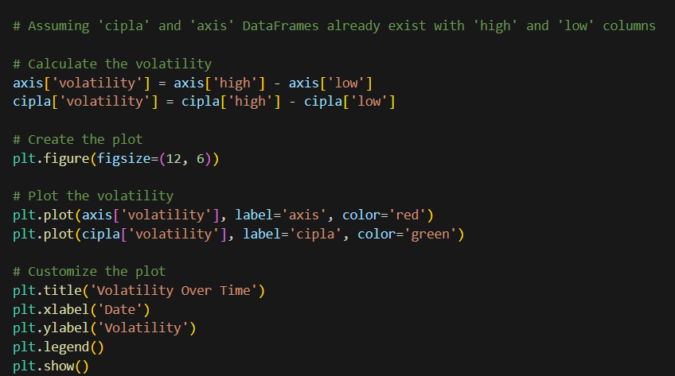

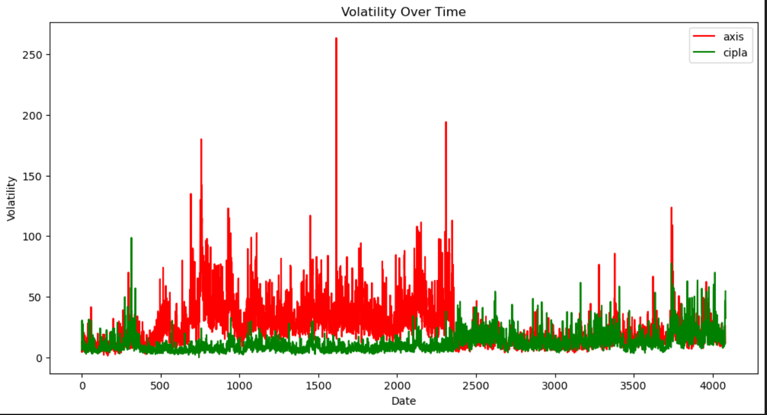

* This script calculates the daily volatility of Axis Bank and Cipla stocks, defined as the difference between the high and low prices for each day. It then plots this volatility over time, with red representing Axis Bank and green representing Cipla. The plot is clearly labeled with a title, axis labels, and a legend, making it easy to compare the volatility patterns of the two stocks. This visualization is useful for analyzing the price fluctuations and understanding the risk associated with each stock.

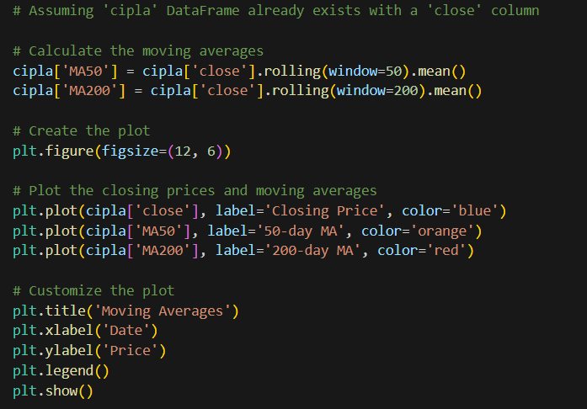

* This script calculates and plots the 50-day and 200-day moving averages of Cipla's closing stock prices. The closing prices are plotted in blue, the 50-day moving average in orange, and the 200-day moving average in red. The plot is clearly labeled with a title, axis labels, and a legend, making it easy to visualize and compare the trends indicated by the moving averages against the actual closing prices. This visualization helps in identifying long-term trends and potential buy or sell signals based on the moving averages.

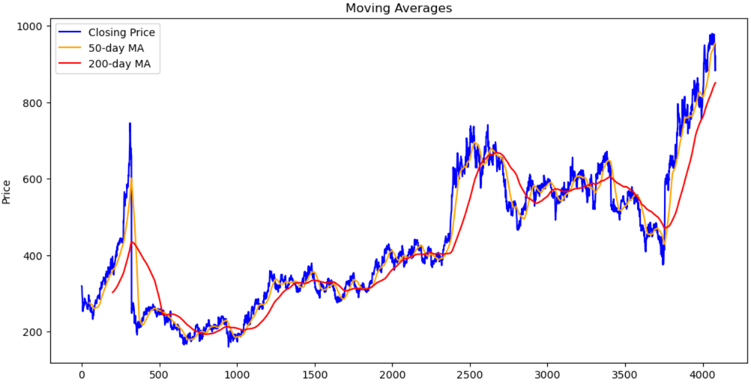

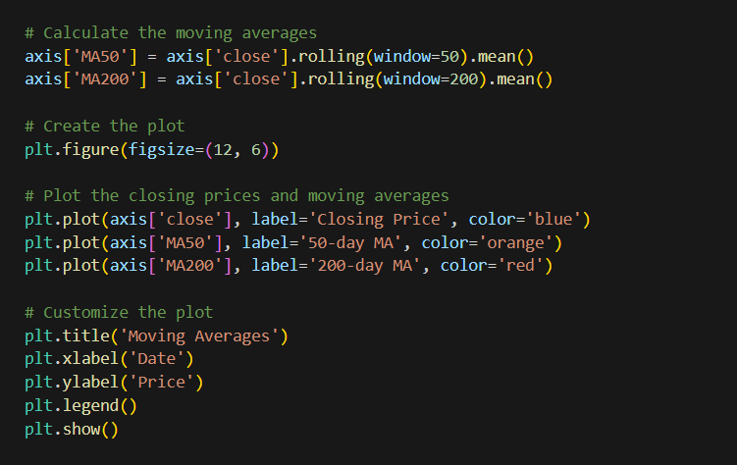

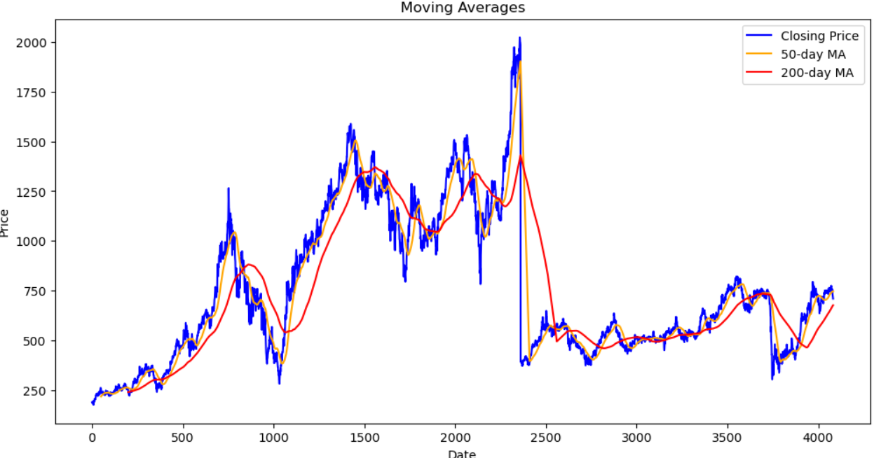

* This script calculates and plots the 50-day and 200-day moving averages of Axis Bank's closing stock prices. The closing prices are plotted in blue, the 50-day moving average in orange, and the 200-day moving average in red. The plot is clearly labelled with a title, axis labels, and a legend, making it easy to visualize and compare the trends indicated by the moving averages against the actual closing prices. This visualization helps in identifying long-term trends and potential buy or sell signals based on the moving averages.
* Temporal Analysis:

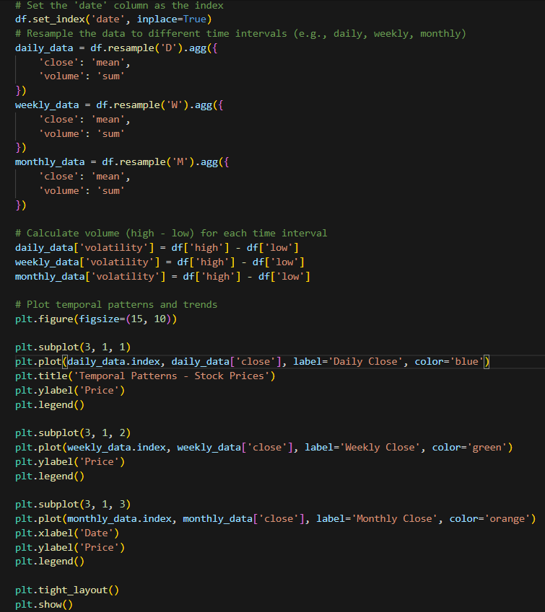

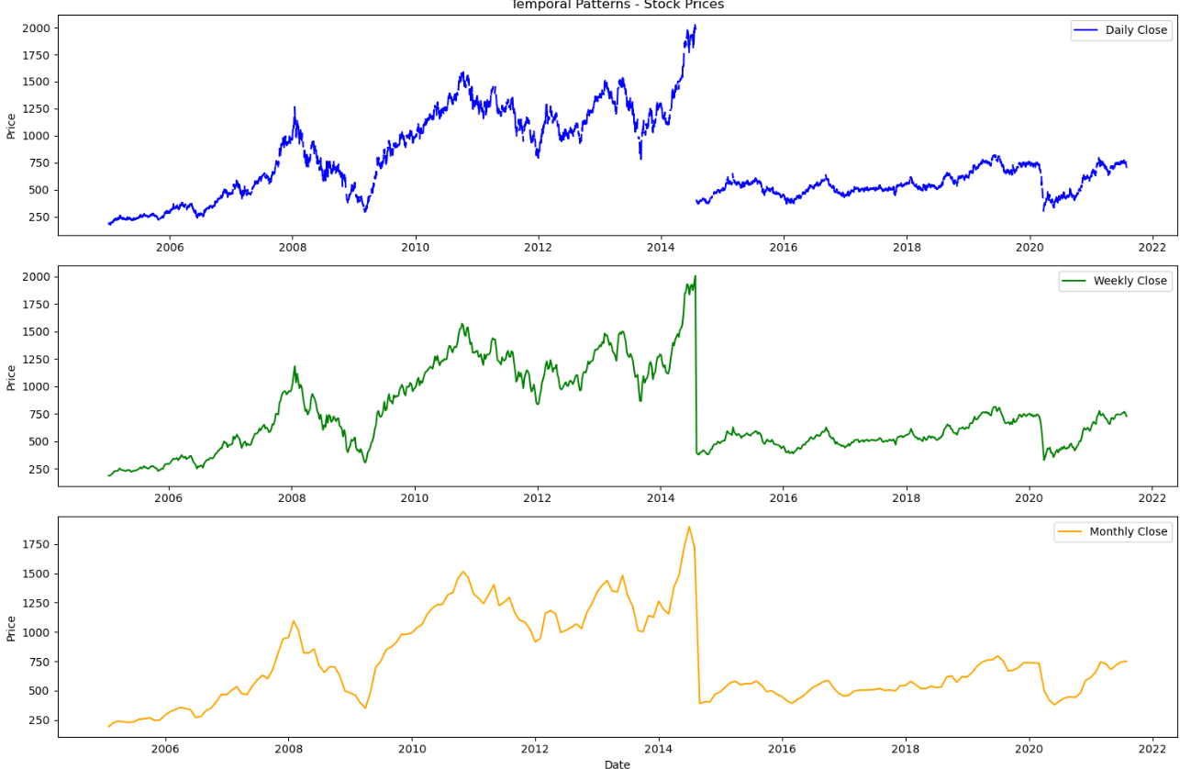

* **Using MS Excel**

**Analysis of Axis vs Cipla Open Price Yearly**

* **Overview:**
  + The chart displays the yearly opening price changes for Axis and Cipla from 2005 to 2021.
  + Axis is represented by the blue line and Cipla by the orange line.
* **Axis (Blue Line) Highlights:**
  + The highest increase occurred in 2013 with a 12.03% rise.
  + Significant fluctuations are observed, notably in 2008, 2013, and 2021.
  + There was a sharp drop in 2016 to 3.10%, the lowest point in the timeline.
* **Cipla (Orange Line) Highlights:**
  + Cipla's opening prices have generally been more stable compared to Axis.
  + The highest increase was 10.54% in 2021.
  + A notable drop in 2008 to 2.93%, but the trend shows a steady rise post-2009 with less volatility compared to Axis.
* **Comparative Insights:**
  + Axis experienced more volatility in its yearly opening prices compared to Cipla.
  + In the early years (2005-2008), both companies showed a downward trend, with Axis having sharper changes.
  + From 2013 to 2015, Axis had higher percentages, but Cipla surpassed Axis from 2015 to 2020.
  + The recent years show both companies experiencing an upward trend, with Cipla peaking in 2021.

**Axis Vs Cipla Avg High Price**:

* + This bar chart shows the average yearly high prices for Axis Bank (blue bars) and Cipla (orange line).
  + Axis Bank's high prices show a significant increase in 2021, while Cipla's high prices peaked in 2015.

1. **Axis Vs Cipla Avg Low Price**:
   * This bar chart represents the average yearly low prices for Axis Bank (blue bars) and Cipla (orange line).
   * Both companies show an increasing trend in low prices over the years, with Axis Bank showing a significant jump in 2021.

* **MS EXCEL DASHBOARD**

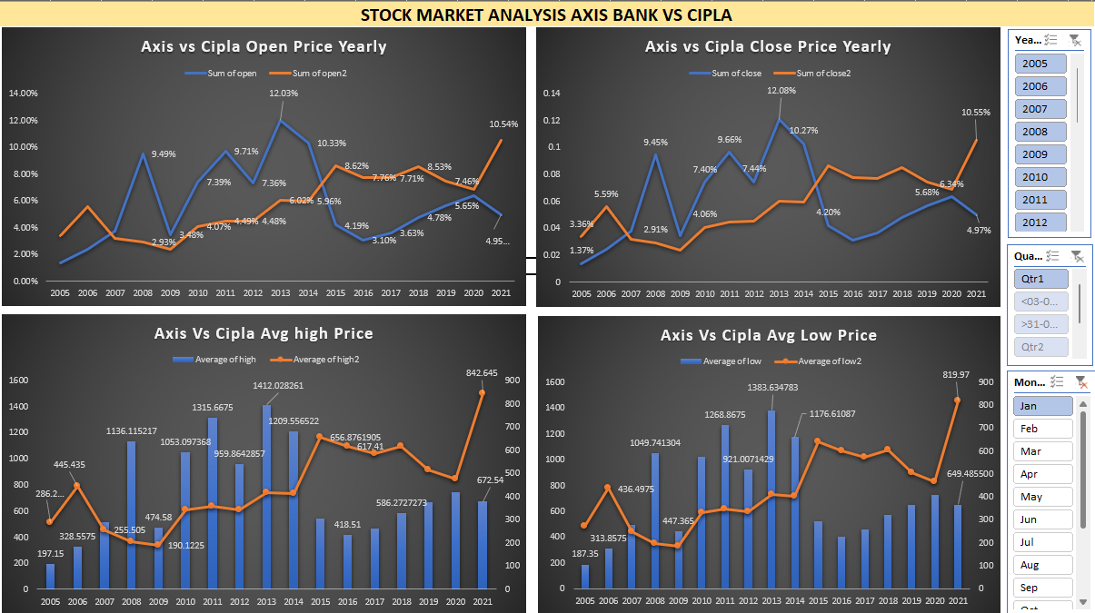

* **POWER BI DASHBOARD**

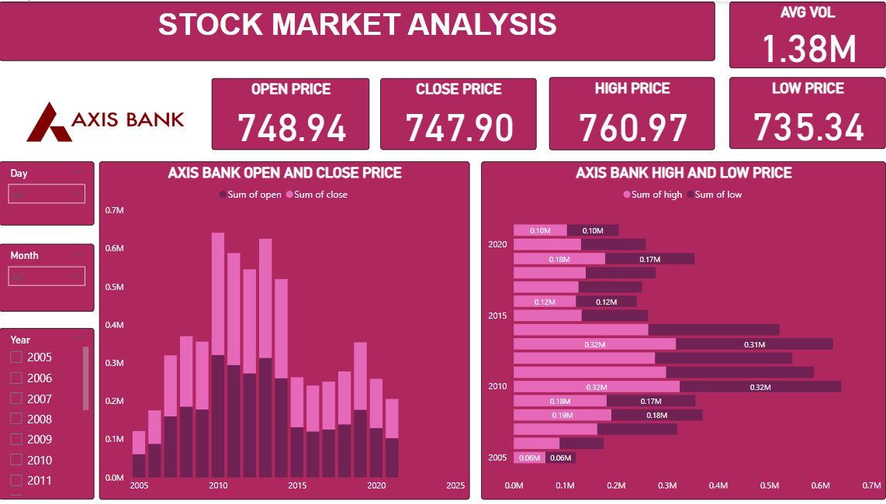

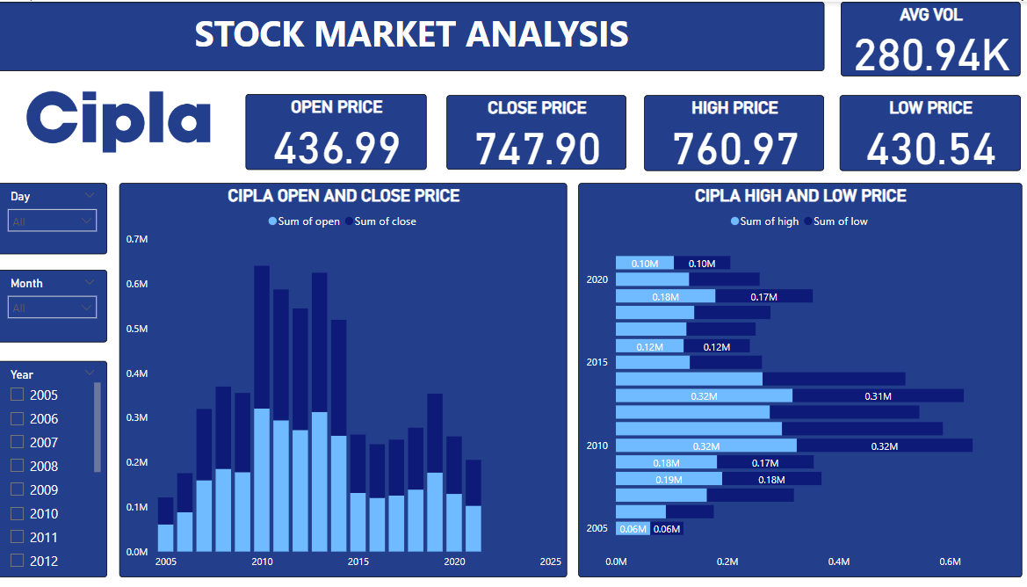

* **LINE CHART**

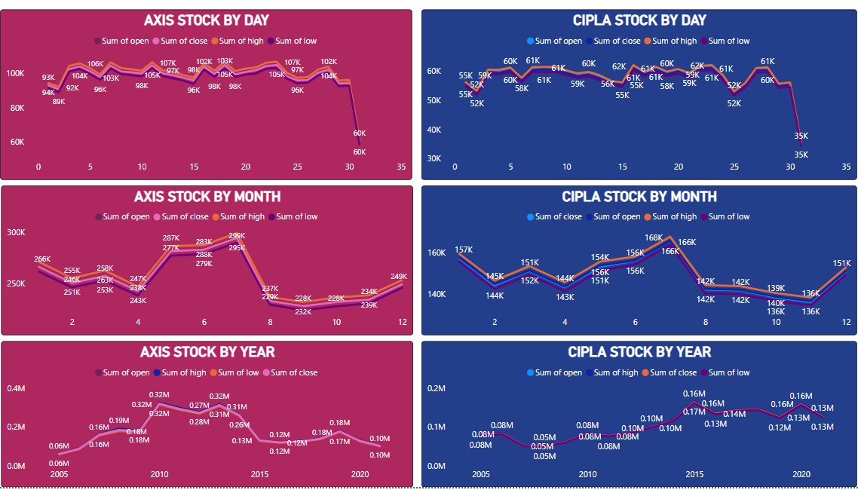

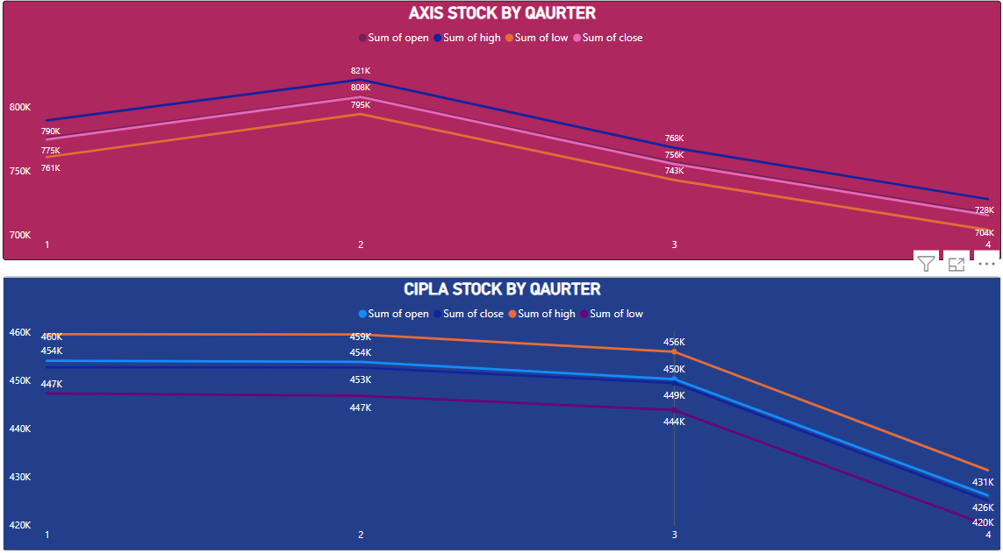

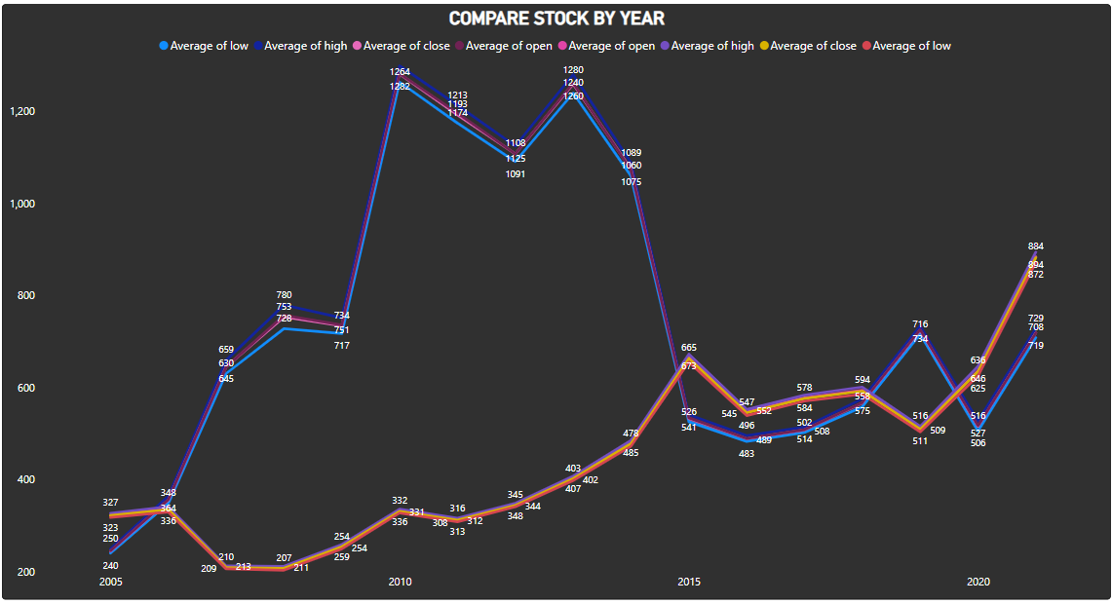

* **TABLE**

