**PHST 500: Introduction to Biostatistics and Data Management for Public Health I**

**Midterm Project**

**Results from R**

**[PRANAY S ARYAL]**

*Frequency Table for Treatment Groups*

**Fill out the table below with the appropriate information.**

|  |  |  |
| --- | --- | --- |
| **Group** | **Count** | **Percentage** |
| Placebo | 96 | 34.66 |
| Standard | 87 | 31.41 |
| Experimental | 94 | 33.94 |

*Crosstabulation of Family History, Eczema Severity, and Treatment Compliance with Treatment Group*

**Fill out the three tables below with the appropriate information. In each cell, you should write “count (percent)”. The first cell in the first table is given as an example of how you should enter information in each cell.**

|  |  |  |  |
| --- | --- | --- | --- |
| **Family History** | **Placebo** | **Standard** | **Experimental** |
| No | 47 (49%) | 46(53%) | 53(53%) |
| Yes | 49(51%) | 41(47%) | 41(47%) |

|  |  |  |  |
| --- | --- | --- | --- |
| **Eczema Severity** | **Placebo** | **Standard** | **Experimental** |
| Mild | 40(42%) | 33(38%) | 26(28%) |
| Moderate | 27(29%) | 33(38%) | 35(37%) |
| Severe | 28(29%) | 21(24%) | 33(35%) |

|  |  |  |  |
| --- | --- | --- | --- |
| **Compliance** | **Placebo** | **Standard** | **Experimental** |
| No | 42(44%) | 34(39%) | 32(34%) |
| Yes | 54(56%) | 53(61%) | 62(66%) |

*Summary Statistics for Age, Change in Eczema Score, and Size of Affected by Treatment Group*

**Enter the appropriate information in each cell. Round all of your entries to a reasonable decimal place (1 or 2). Do NOT post long decimal entries in this table. The first cell is entered for you.**

|  |  |  |  |  |  |  |  |  |  |
| --- | --- | --- | --- | --- | --- | --- | --- | --- | --- |
| **Statistic** | **AGE** | | | **SIZE OF AFFECTED AREA** | | | **CHANGE IN SCORE** | | |
| **Placebo** | **Standard** | **Experimental** | **Placebo** | **Standard** | **Experimental** | **Placebo** | **Standard** | **Experimental** |
| Mean | 39.19 | 39.0 | 39.77 | 1.05 | 0.90 | 0.93 | -0.1875 | -9.59 | -10.00 |
| SD | 10.50 | 10.04 | 8.54 | 0.75 | 0.79 | 0.73 | 4.71 | 5.49 | 5.46 |
| IQR | 13.5 | 14.00 | 11.75 | 1.09 | 0.96 | 0.90 | 7 | 7 | 6 |
| Skewness | -0.18 | 0.36 | -0.27 | 0.76 | 1.33 | 1.02 | 0.63 | -0.24 | 0.04 |
| Kurtosis | -0.32 | -0.52 | -0.30 | 0.31 | 1.35 | 0.30 | 0.17 | 0.08 | 0.79 |
| Minimum | 11.00 | 19.00 | 16.00 | 0.02 | 0.02 | 0.01 | -9 | -25 | -24 |
| Q1 | 32.75 | 32.00 | 34.25 | 0.41 | 0.35 | 0.37 | -4 | -13 | -13 |
| Median | 40.00 | 39.00 | 40.00 | 0.92 | 0.64 | 0.72 | -0.5 | -9.00 | -10.00 |
| Q3 | 46.2 | 46.00 | 46.00 | 1.50 | 1.30 | 1.27 | 3.00 | -6.00 | -7 |
| Maximum | 62.00 | 66.00 | 60.00 | 3.82 | 3.83 | 2.98 | 15.00 | 4.00 | 5.00 |

*Boxplot of Change in Eczema Score by Treatment Group*

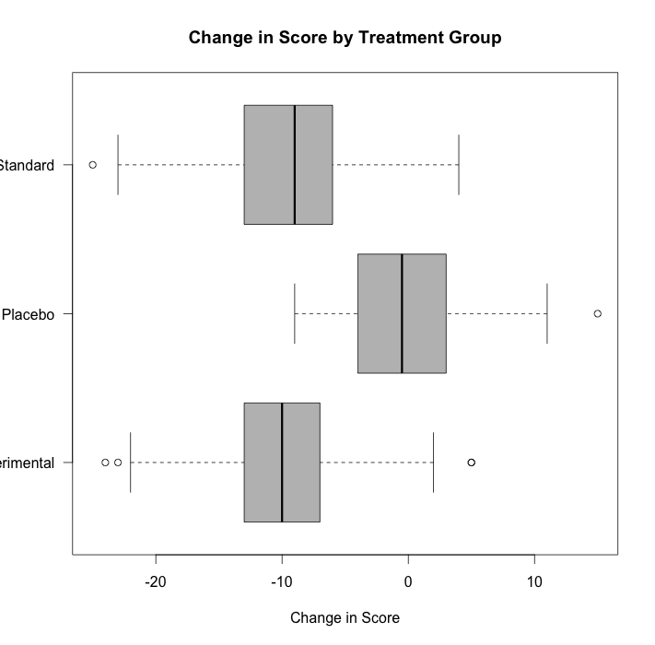

*Histogram of Size of Affected Area*

