Intelligent API Testing Framework with AI-powered test generation

Architecture & Design (Hackathon Submission)

1. Overview
API AI Tester is an intelligent, AI-powered API testing framework designed to automatically generate, execute, and report API test cases for REST APIs using OpenAPI/Swagger specifications. The solution combines deterministic rule-based logic with AI-driven reasoning using a local Large Language Model (LLM), making it suitable for secure, offline, and enterprise environments.

2. Key Capabilities
- Automatic Test Generation- from OpenAPI/Swagger specs
- AI-Powered Intelligence- with 6+ local LLM models
- Parallel Test Execution- for faster results
- Comprehensive Reporting- HTML + JUnit XML reports
- CI/CD Integration- with Jenkins support
- Enterprise-Ready- with local LLM execution (no cloud dependency)
- Default Configuration- with FakeStoreAPI for instant testing
- LLM Performance Benchmarking- with visual dashboard

3. High-Level Architecture
The system follows a layered and modular architecture to ensure scalability, explainability, and ease of extension.
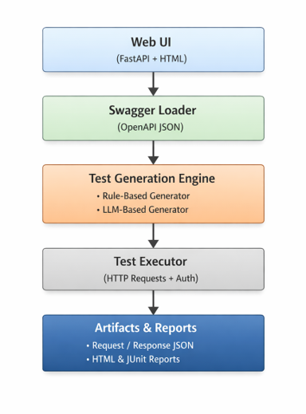
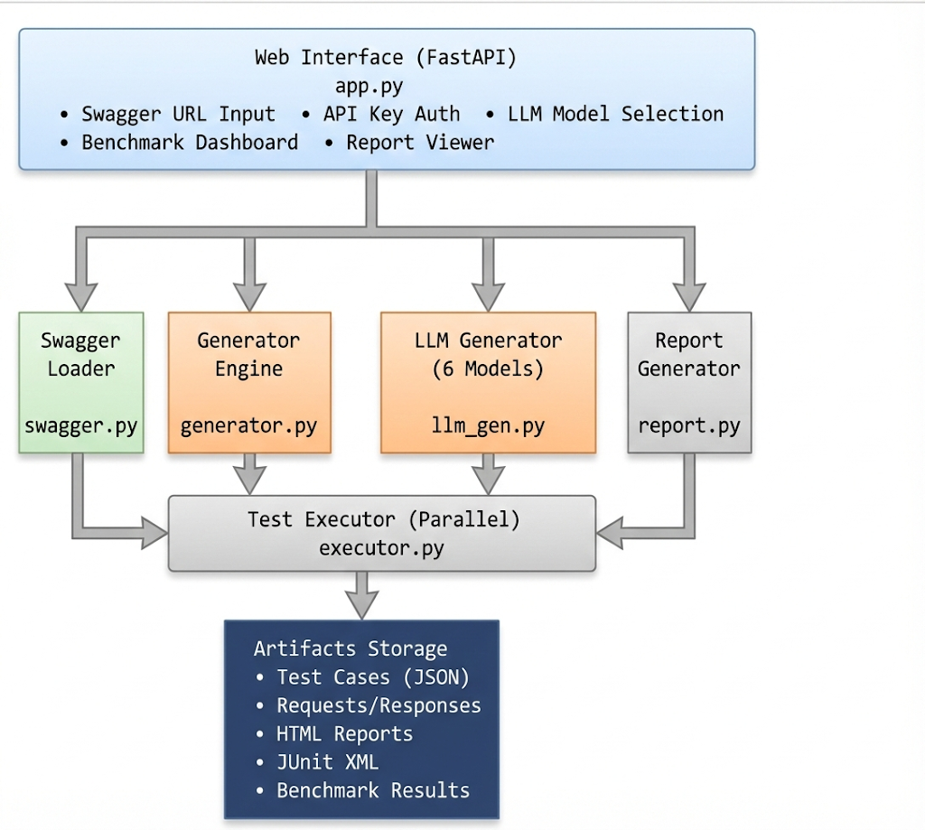

Architecture Layers
- Presentation Layer - FastAPI web interface with interactive UI
- Orchestration Layer - Test pipeline coordination and execution flow
- Intelligence Layer - LLM-based test generation with multiple model support
- Execution Layer - Parallel API test execution with ThreadPoolExecutor
- Reporting Layer - Multi-format report generation and visualization
- Storage Layer - Structured artifact management with traceability

Technology Stack Used

Backend & Web Framework
- FastAPI - Python framework used to build the core web application and REST APIs.
- Uvicorn - Acts as the application server that runs the FastAPI .

AI & Intelligence Layer
- Ollama - Used as a local AI runtime to execute Large Language Models (LLMs) without any cloud dependency.
- Local LLM Models (via Ollama)
Includes models such as Qwen, Gemma, Llama, TinyLlama, and Phi-3, supporting different trade-offs between speed and test quality.

API Execution & Automation
- Requests - Python library used to execute actual API calls (GET, POST, PUT, DELETE) during test execution. It handles headers, authentication tokens, request payloads, and response capture.
- ThreadPoolExecutor (Python Standard Library)
Enables parallel execution of API test cases to significantly reduce overall test runtime.

Reporting & Visualization
- Jinja2
Used to generate dynamic HTML reports and dashboards, including test summaries, pass/fail status, execution timings, and AI benchmarking views.
- junit-xml
Generates JUnit-compatible XML reports to support CI/CD tools such as Jenkins and GitHub Actions.

UI & Data Handling
- python-multipart
Enables FastAPI to process form data and user inputs submitted through the web interface.

Standards & Specifications
- OpenAPI / Swagger
Used as the source of truth for API definitions. The system parses API paths, methods, parameters, and schemas directly from the Swagger specification.

Development & CI/CD
- Python 3.x- Primary programming language used across the entire application.
- Jenkins (CI/CD Integration)
Supports automated test execution and report publishing using generated JUnit XML artifacts.

4. AI / LLM Architecture
The AI capability is powered by a local LLM runtime to avoid cloud dependency and quota limits.
AI-powered test generation is enabled using local Ollama runtime with multiple supported models:
Model Name | Model Size | Performance | Output Quality | Recommended Usage
Qwen 2.5 (0.5B) | 0.5 Billion | Very Fast | Good | Fast experimentation and demos
TinyLlama | 1.1 Billion | Very Fast | Fair | Low-resource environments
Llama 3.2 (1B) | 1 Billion | Medium | Good | Balanced speed and quality
Gemma 3 (1B) | 1 Billion | Medium | Very Good | High-quality functional tests
Llama 3 (8B) | 8 Billion | Slow | Excellent | Production-grade testing
Phi-3 Mini | 3.8 Billion | Slow | Very Good | Complex APIs and schemas

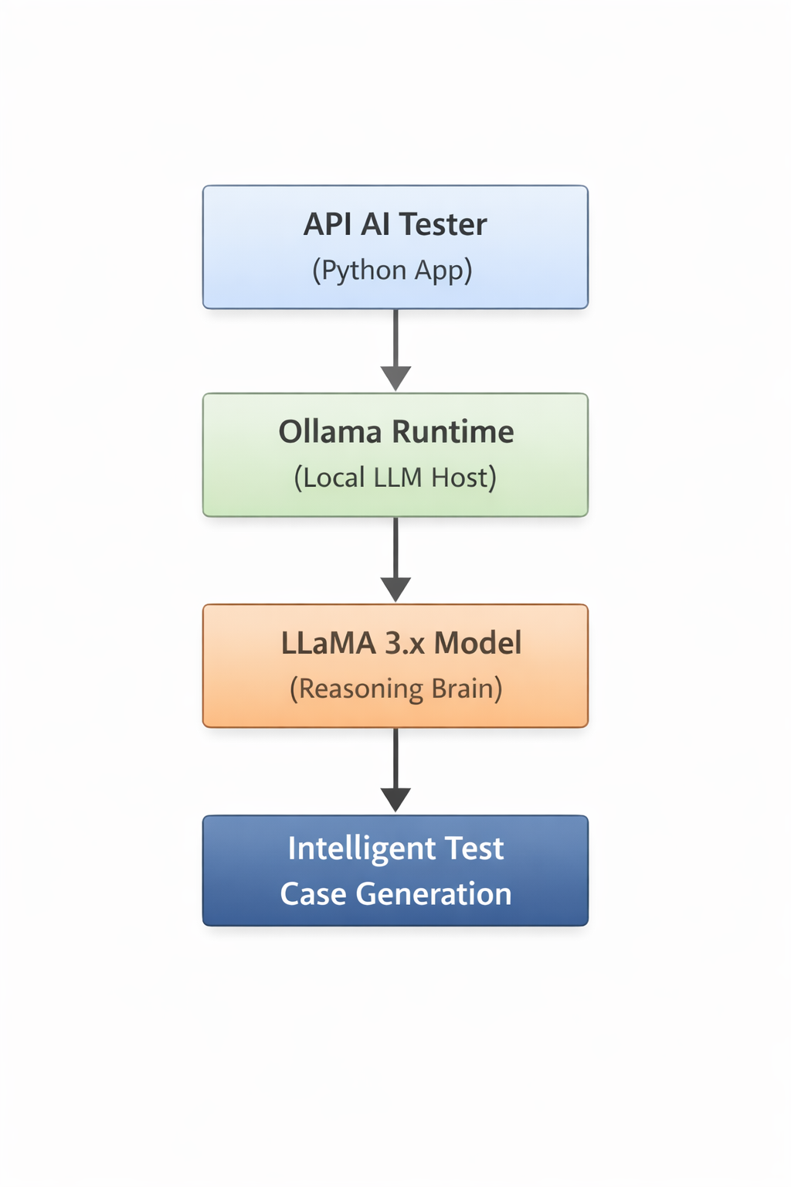

5. Key Characteristics:

- Fully local execution - No data sent to cloud
- No API Keys or Quotas - Unlimited test generation
- Offline & Secure - Works in air-gapped environments
- Automatic Fallback - Rule-based generation if LLM unavailable
- Model Comparison - Built-in benchmarking dashboard
- Parallel Processing - Batch processing for speed (2 workers)

6. End-to-End Execution Flow
1. User provides Swagger/OpenAPI URL, Base API URL, and Authentication details via Web UI.
2. Swagger Loader parses API paths, methods, parameters, and schemas.
3. Test Generator creates:
- Positive test cases
- Unauthorized / negative test cases
4. LLM (optional) enriches tests with semantic understanding and realistic payloads.
5. Test Executor builds full URLs and injects required headers.
6. APIs are executed and responses are captured.
7. Request and response JSON files are stored with unique test IDs.
8. HTML and JUnit reports are generated per execution.
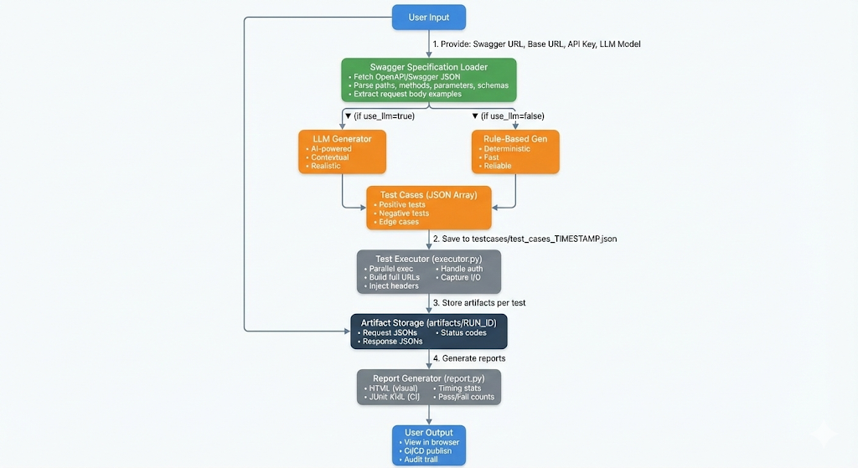

7. Artifact & Traceability Flow
Each test execution produces a timestamped run directory:
runs/
└── YYYYMMDD_HHMMSS/
├── requests/
│ └── <test_id>_request.json
├── responses/
│ └── <test_id>_response.json
├── report.html
└── report.xml
└── benchmarks.html
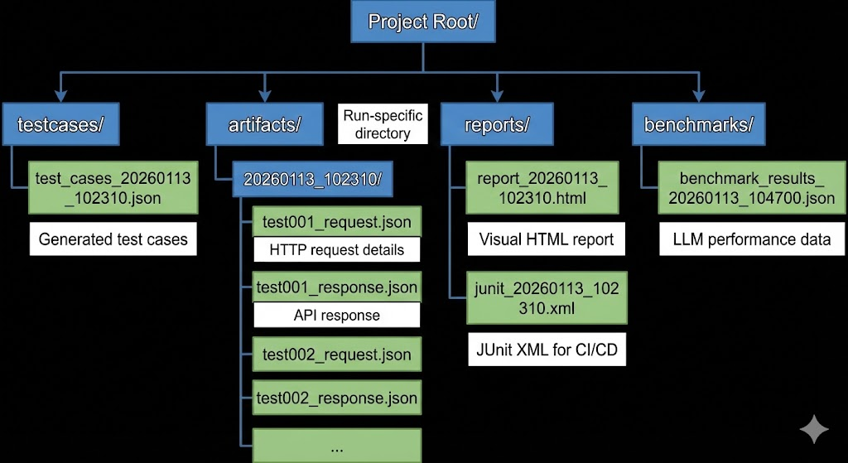
This ensures:
- Full auditability
- Easy debugging
- CI/CD compatibility

8. Benefits of Artifact Storage
- Full Auditability - Complete request/response history
- Easy Debugging - Inspect exact API interactions
- Regression Testing - Compare results across runs
- CI/CD Integration - JUnit XML for automated pipelines
- Compliance - Meets regulatory traceability requirements

9. Security & Enterprise Readiness
- Supports enterprise authentication mechanisms (AuthToken, custom headers).
- No credentials are logged or exposed.
- AI inference happens locally; no data leaves the system.
- Suitable for regulated and internal enterprise environments.

10. Conclusion
API AI Tester showcases a modern AI-enabled testing architecture that balances innovation with reliability. By leveraging local LLMs and a clean modular design, the solution proves how Generative AI can be safely and effectively applied to enterprise software quality engineering.

