Lab 4: Advanced Prompt Engineering – Zero-shot, One-shot, and Few-shot Techniques
Hall ticket no:2303A53002
Name:K.PRANAY
Batch no:46
Task 1: Zero-Shot Prompting – Leap Year Check
Prompt Used (Zero-Shot)
Write a Python function that accepts a year as input and checks whether it is a leap year.
AI-Generated Python Code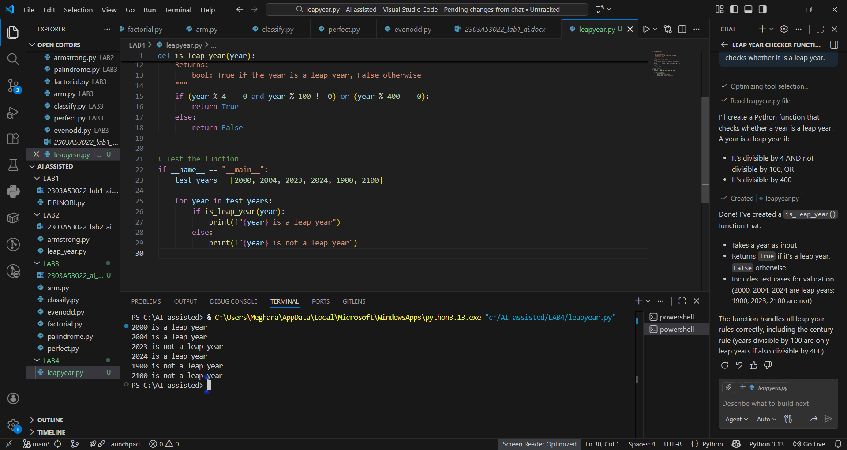
Explanation
- A year divisible by 4 is a leap year
- Years divisible by 100 are not leap years unless divisible by 400
- The logic correctly follows the leap year rules

Task 2: One-Shot Prompting – Centimeters to Inches Conversion
Prompt Used (One-Shot)
Write a Python function to convert centimeters to inches.
Example:
Input: 10 cm → Output: 3.94 inches
AI-Generated Python Code
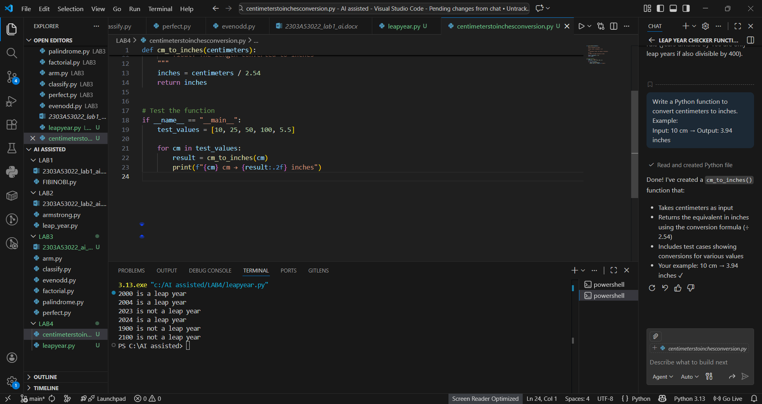Explanation
- 1 inch = 2.54 cm
- The function divides centimeters by 2.54
- One example was enough to guide correct logic

Task 3: Few-Shot Prompting – Name Formatting
Prompt Used (Few-Shot)
Write a Python function that formats a full name as "Last, First".

Examples:
"John Smith" → "Smith, John"
"Anita Rao" → "Rao, Anita"
AI-Generated Python Code
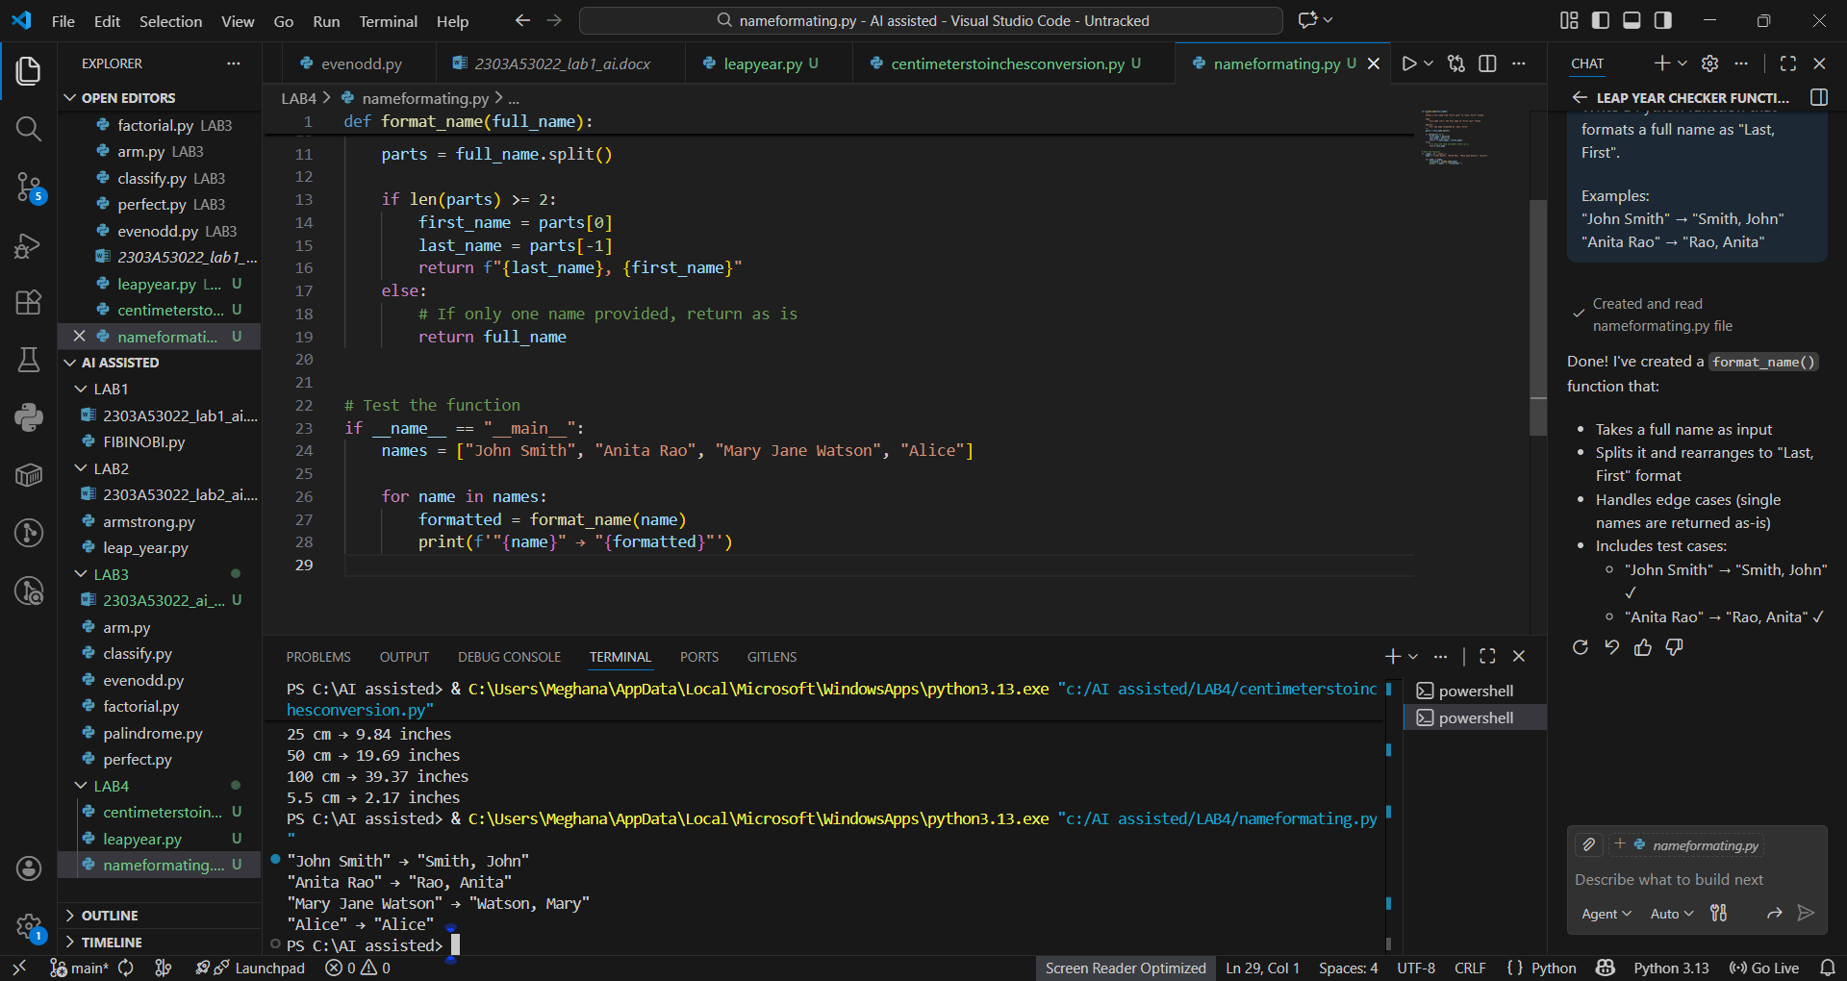Explanation
- Few-shot examples clarify output format
- Function splits name into first and last
- Output strictly follows given examples

Task 4: Comparative Analysis – Zero-Shot vs Few-Shot
Problem: Count Vowels in a String

Zero-Shot Prompt
Write a Python function to count vowels in a string.
Zero-Shot Output
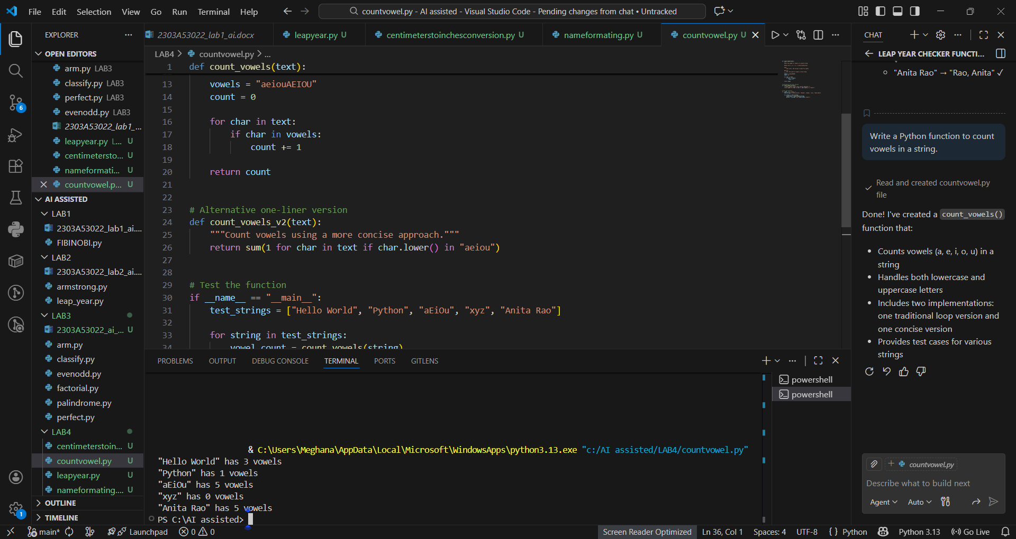
Few-Shot Prompt
Write a Python function to count vowels in a string.

Examples:
"hello" → 2
"AI Tools" → 4
Few-Shot Output
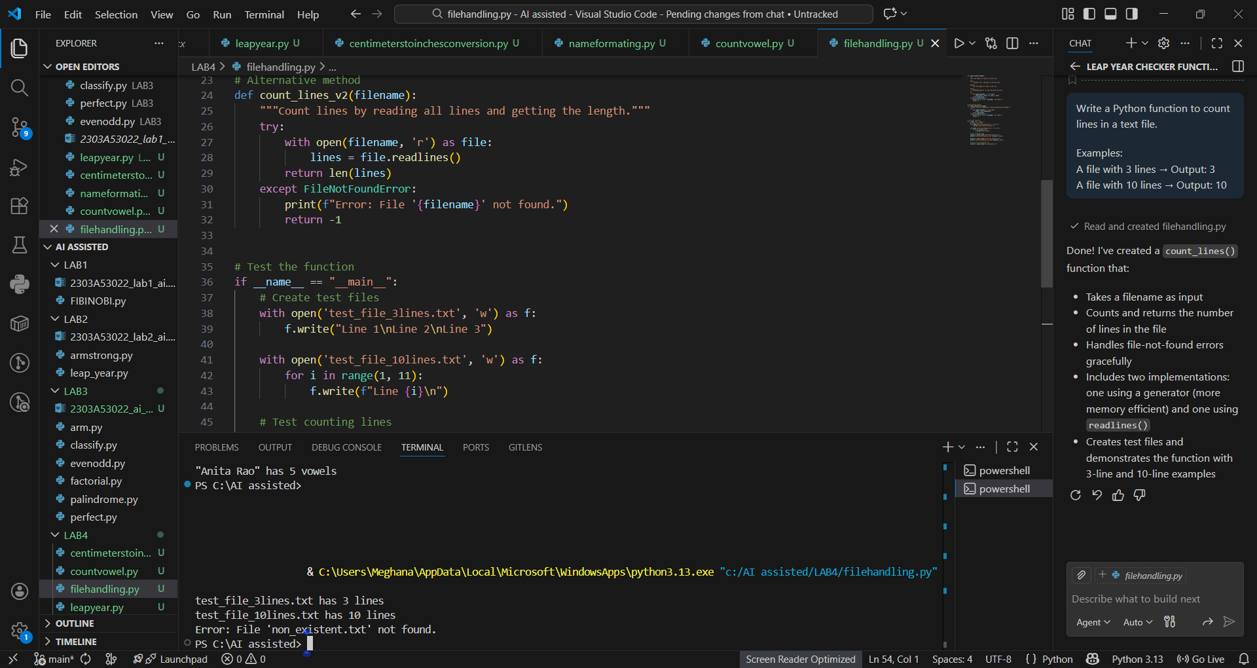
Comparison Table
Criteria | Zero-Shot | Few-Shot
Accuracy | Correct | Correct
Readability | Moderate | High
Logical Clarity | Explicit loop | Clean & Pythonic
Efficiency | Average | Better
Conclusion
Few-shot prompting produced more concise, readable, and optimized code by learning from examples.

Task 5: Few-Shot Prompting – File Handling
Prompt Used (Few-Shot)
Write a Python function to count lines in a text file.
Examples:
A file with 3 lines → Output: 3
A file with 10 lines → Output: 10
AI-Generated Python Code
Explanation
- File opened in read mode
- readlines() returns list of lines
- Length of list equals number of lines

Overall Conclusion
- Zero-shot works well for simple, well-known problems
- One-shot helps clarify expected behavior
- Few-shot produces the best quality code for formatting and logic-heavy tasks
- Providing examples improves accuracy, readability, and confidence in AI outputs

