Roll.no:2303a53002
NAME:KOLLI PRANAY
BATCH:46
Lab 11 – Data Structures with AI: Implementing Fundamental
Structures
Lab Objectives
• Use AI to assist in designing and implementing fundamental data
structures in Python.
• Learn how to prompt AI for structure creation, optimization, and
documentation.
• Improve understanding of Lists, Stacks, Queues, Linked Lists,
Trees, Graphs, and Hash Tables.
• Enhance code quality with AI-generated comments and
performance suggestions.
Task Description #1 – Stack Implementation
Task: Use AI to generate a Stack class with push, pop, peek, and is_empty
methods.
Sample Input Code:
class Stack:
pass
Expected Output:
• A functional stack implementation with all required methods and
docstrings.

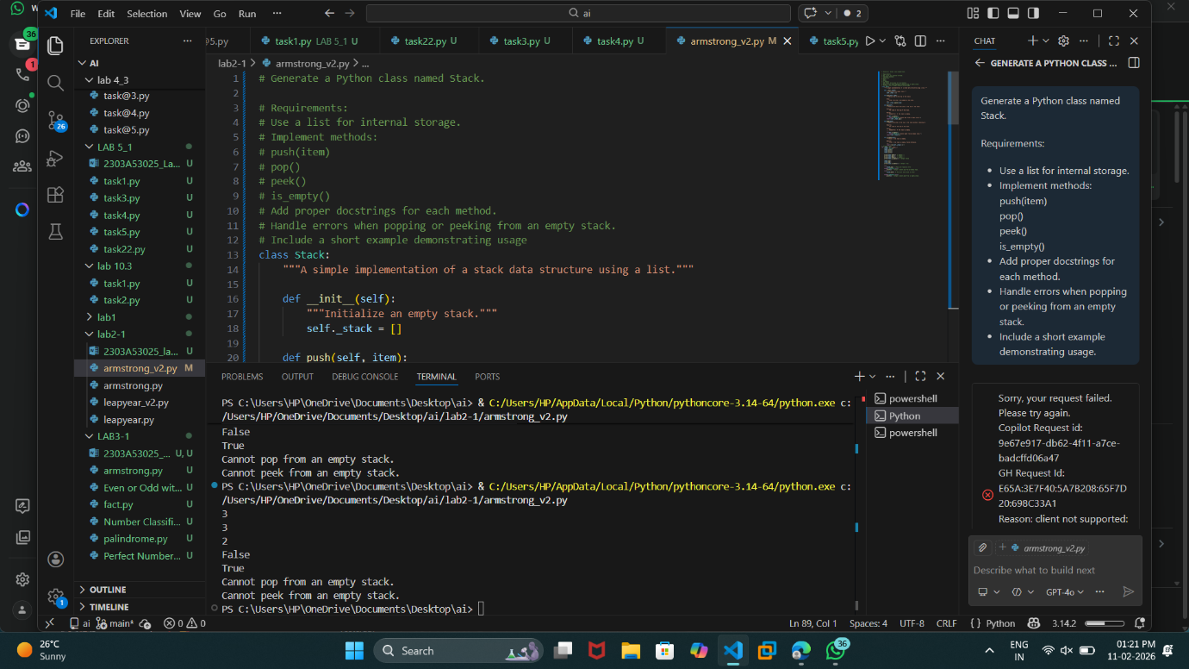
Task Description #2 – Queue Implementation
Task: Use AI to implement a Queue using Python lists.
Sample Input Code:
class Queue:
pass
Expected Output:
• FIFO-based queue class with enqueue, dequeue, peek, and size
Methods
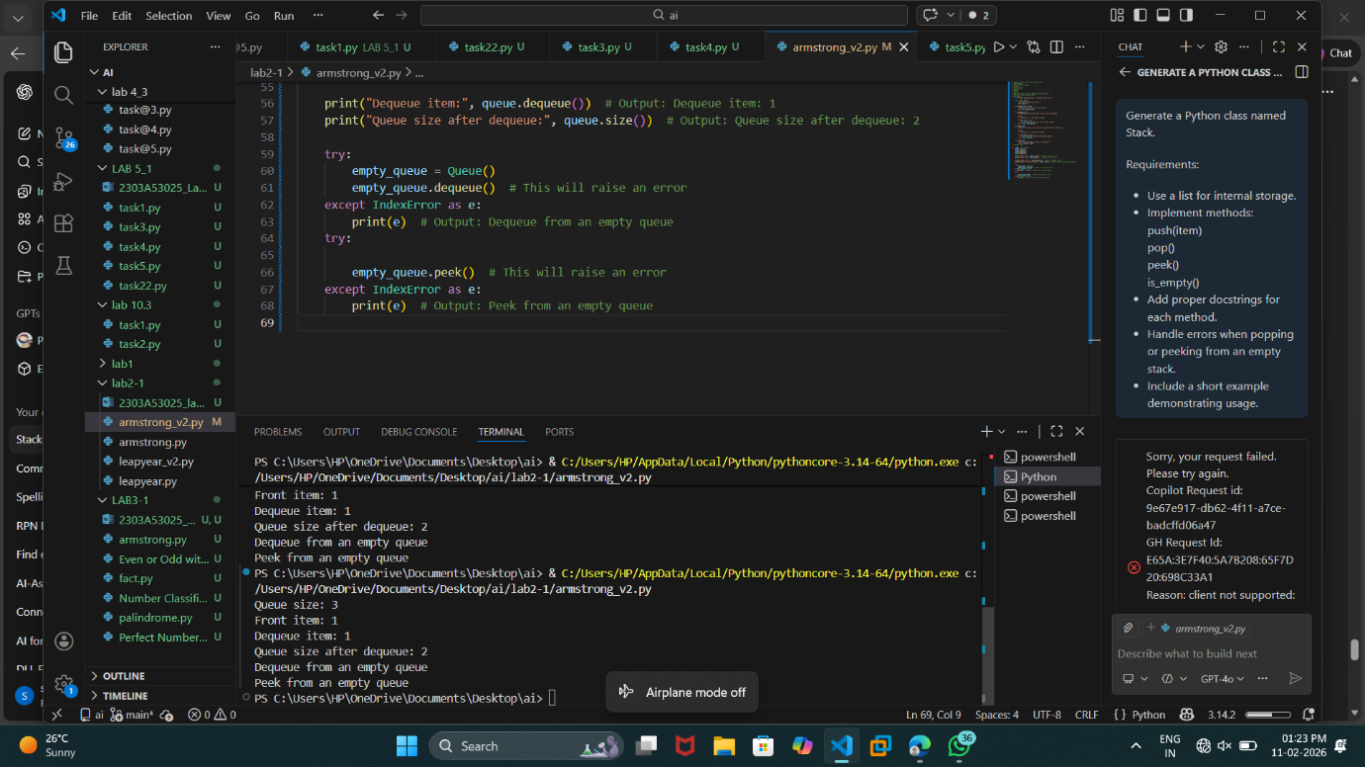
Task Description #3 – Linked List
Task: Use AI to generate a Singly Linked List with insert and display
methods.
Sample Input Code:
class Node:
pass
class LinkedList:
pass
Expected Output:
• A working linked list implementation with clear method
documentation.
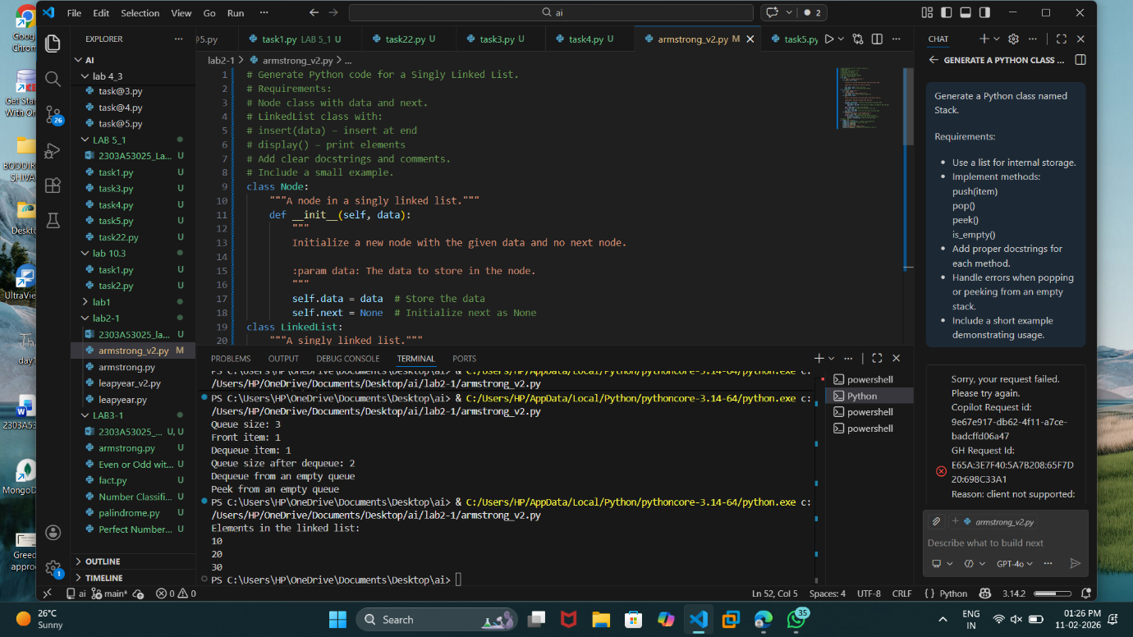
Task Description #4 – Binary Search Tree (BST)
Task: Use AI to create a BST with insert and in-order traversal methods.
Sample Input Code:
class BST:
pass
Expected Output:
• BST implementation with recursive insert and traversal method
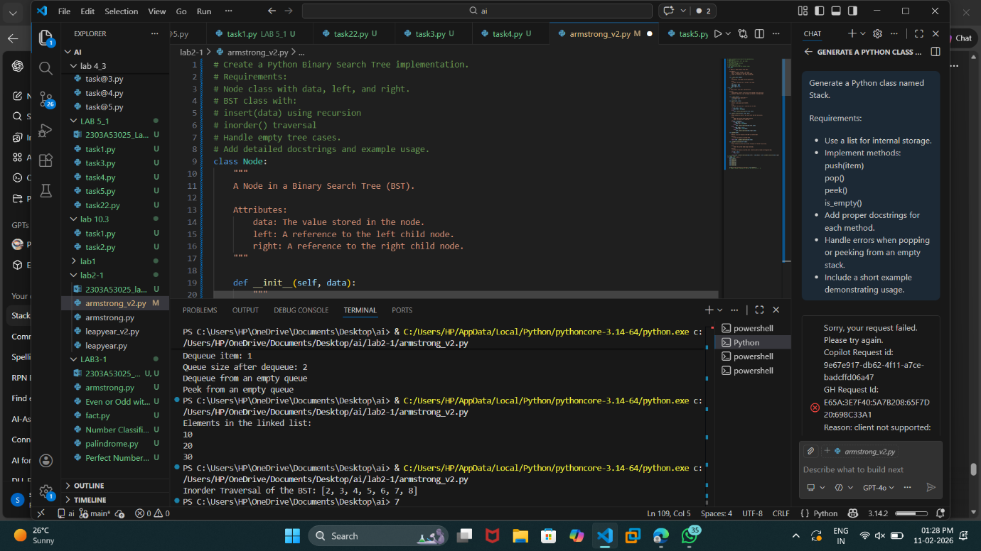
Task Description #5 – Hash Table
Task: Use AI to implement a hash table with basic insert, search, and
delete methods.
Sample Input Code:
class HashTable:
pass
Expected Output:
• Collision handling using chaining, with well-commented methods.
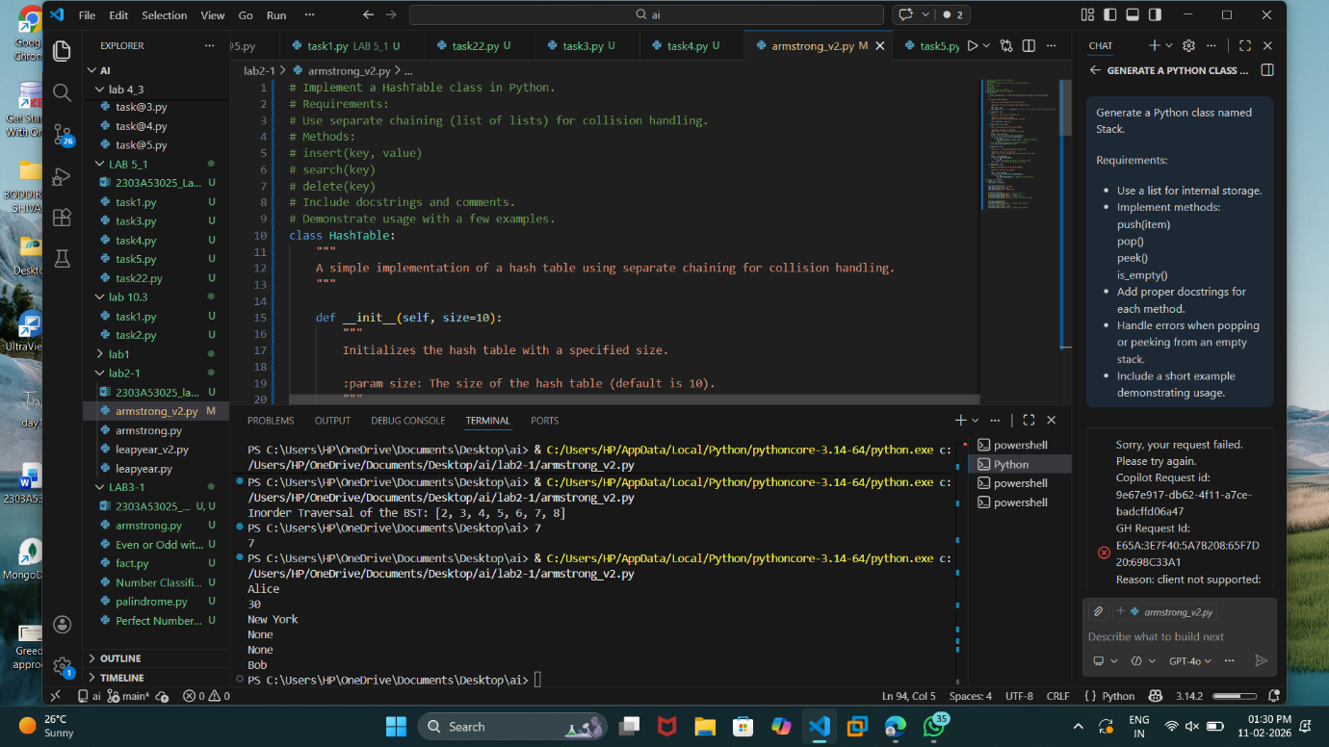

Task Description #6 – Graph Representation
Task: Use AI to implement a graph using an adjacency list.
Sample Input Code:
class Graph:
pass
Expected Output:
• Graph with methods to add vertices, add edges, and display
connections.
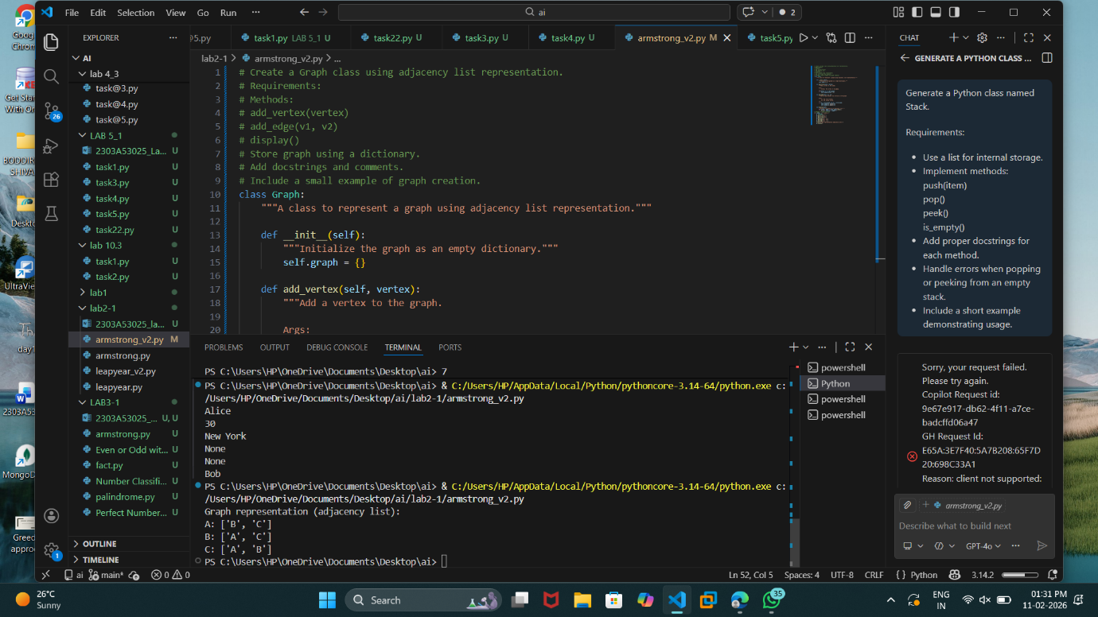
Task Description #7 – Priority Queue
Task: Use AI to implement a priority queue using Python’s heapq
module.
Sample Input Code:
class PriorityQueue:
pass
Expected Output:
• Implementation with enqueue (priority), dequeue (highest priority),
and display methods.
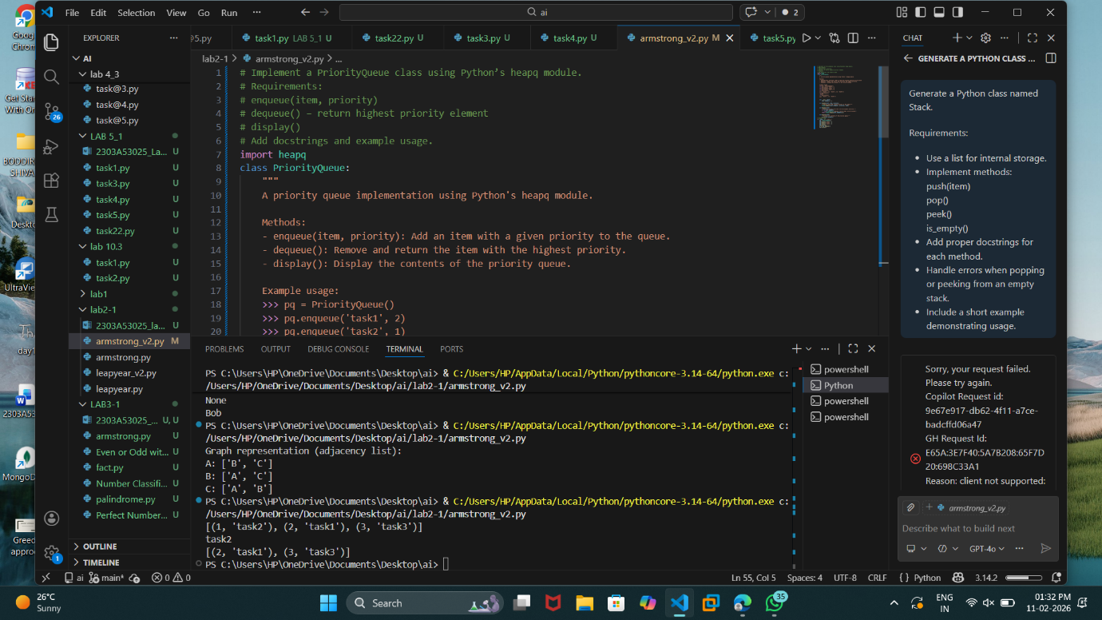

Task Description #8 – Deque
Task: Use AI to implement a double-ended queue using
collections.deque.
Sample Input Code:
class DequeDS:
pass
Expected Output:
• Insert and remove from both ends with docstrings.
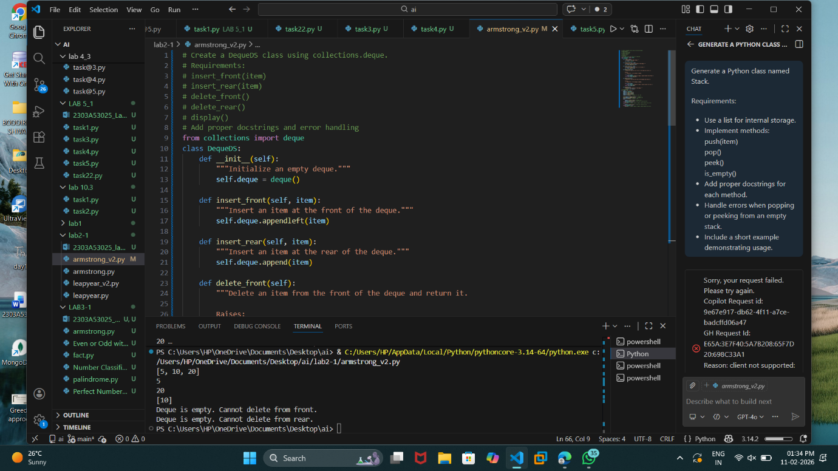

Task Description #9 Real-Time Application Challenge – Choose the
Right Data Structure
Scenario:
Your college wants to develop a Campus Resource Management System
that handles:
1. Student Attendance Tracking – Daily log of students
entering/exiting the campus.
2. Event Registration System – Manage participants in events with
quick search and removal.
3. Library Book Borrowing – Keep track of available books and their
due dates.
4. Bus Scheduling System – Maintain bus routes and stop
connections.
5. Cafeteria Order Queue – Serve students in the order they arrive.
Student Task:
• For each feature, select the most appropriate data structure from
the list below:
o Stack
o Queue
o Priority Queue
o Linked List
o Binary Search Tree (BST)
o Graph
o Hash Table
o Deque
• Justify your choice in 2–3 sentences per feature.
• Implement one selected feature as a working Python program with
AI-assisted code generation.
Expected Output:
• A table mapping feature → chosen data structure → justification.
• A functional Python program implementing the chosen feature
with comments and docstrings.
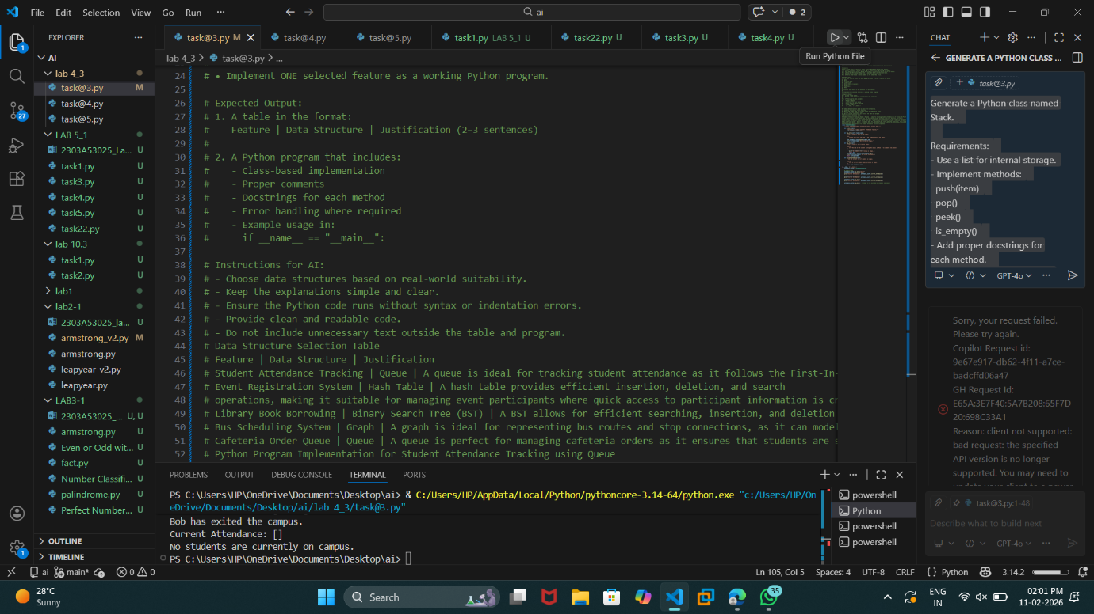

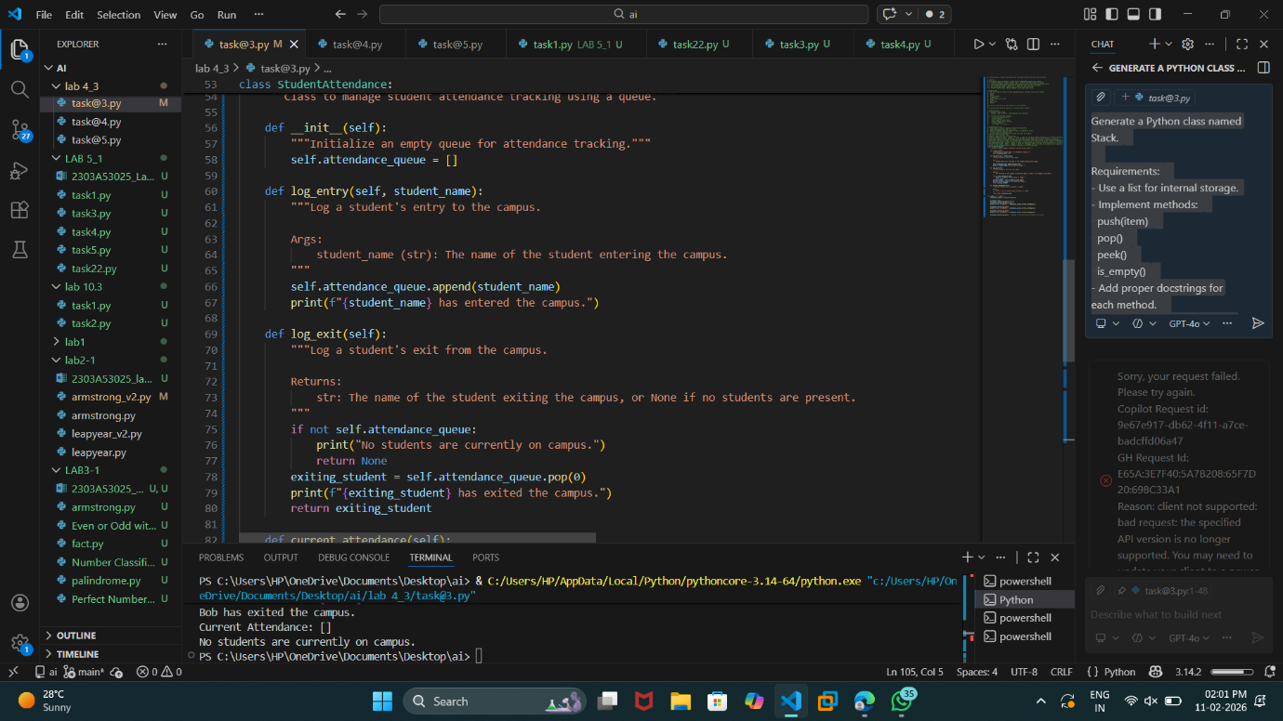

Task Description #10: Smart E-Commerce Platform – Data Structure
Challenge
An e-commerce company wants to build a Smart Online Shopping System
with:
1. Shopping Cart Management – Add and remove products
dynamically.
2. Order Processing System – Orders processed in the order they are
placed.
3. Top-Selling Products Tracker – Products ranked by sales count.
4. Product Search Engine – Fast lookup of products using product ID.
5. Delivery Route Planning – Connect warehouses and delivery
locations.
Student Task:
• For each feature, select the most appropriate data structure from
the list below:
o Stack
o Queue
o Priority Queue
o Linked List
o Binary Search Tree (BST)
o Graph
o Hash Table
o Deque
• Justify your choice in 2–3 sentences per feature.
• Implement one selected feature as a working Python program with
AI-assisted code generation.
Expected Output:
• A table mapping feature → chosen data structure → justification.
• A functional Python program implementing the chosen feature
with comments and docstrings.

