WEEK=14
NAME:KOLLI PRANAY
HT NO:2303A53002
BATCH:46
Task 1 – AI-Assisted Personal Portfolio Website
🔹 Prompt Used
Generate a responsive personal portfolio website using HTML5.
Include sections: Home, About, Projects, Contact.
Use Flexbox for layout.
Add hover effects on project cards.
Enable smooth scrolling navigation.

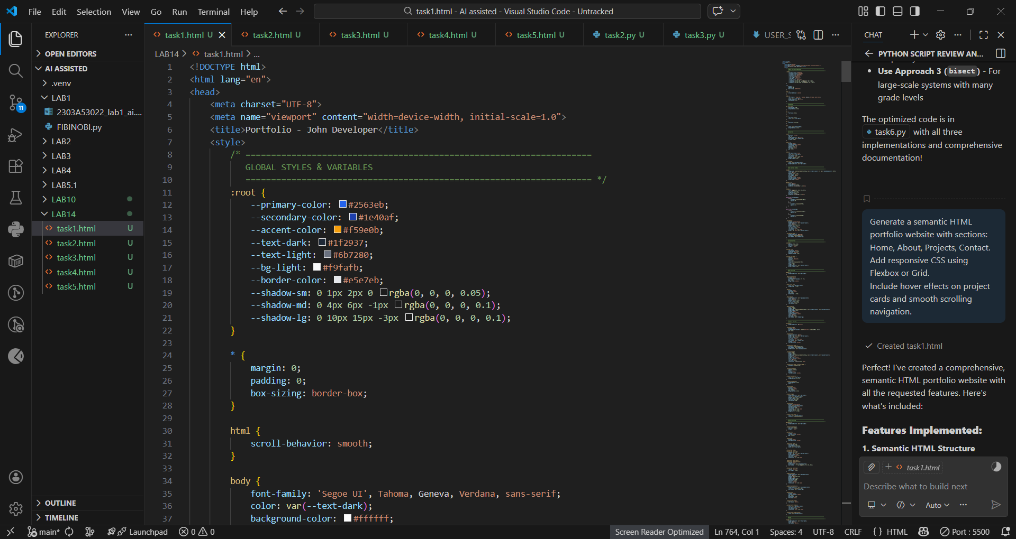
🔹 Output
- Navigation bar at top.
- Four sections displayed vertically.
- Project cards enlarge on hover.
- Layout becomes vertical on mobile screens.
- Smooth scrolling between sections.
- 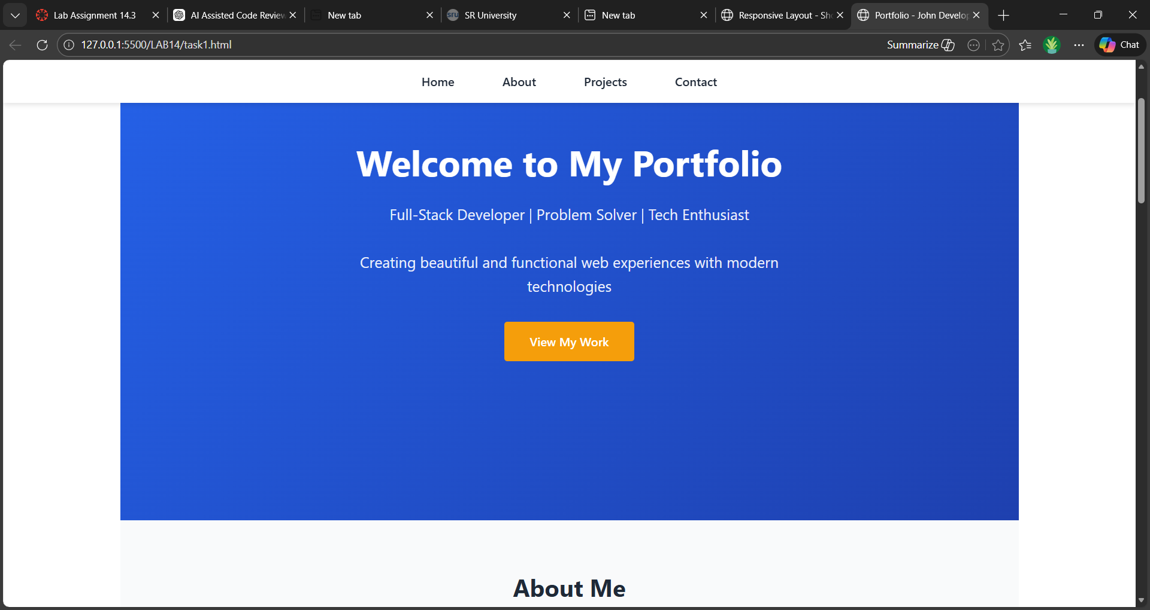

✅ Task 2 – Restaurant Landing Page
🔹 Prompt Used
Create a restaurant landing page with navigation bar.
Add menu section using CSS Grid.
Add automatic image slider using JavaScript.
Make page responsive.

🔹 Code 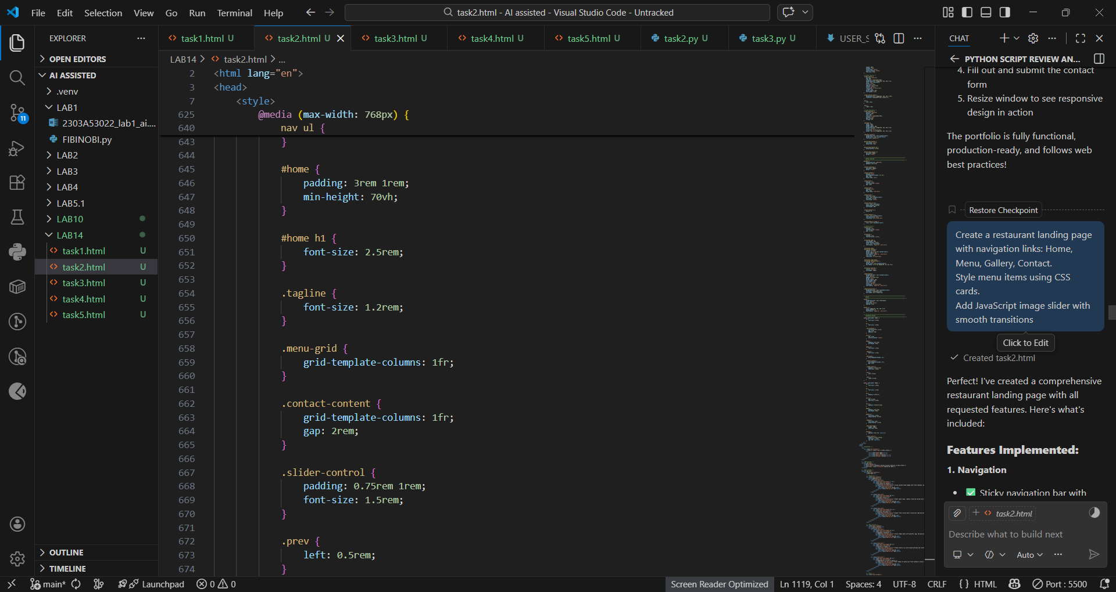

🔹 Output
- Red navigation bar.
- Menu items displayed in responsive grid.
- Gallery images change automatically every 3 seconds.
- Works on mobile screens.
- 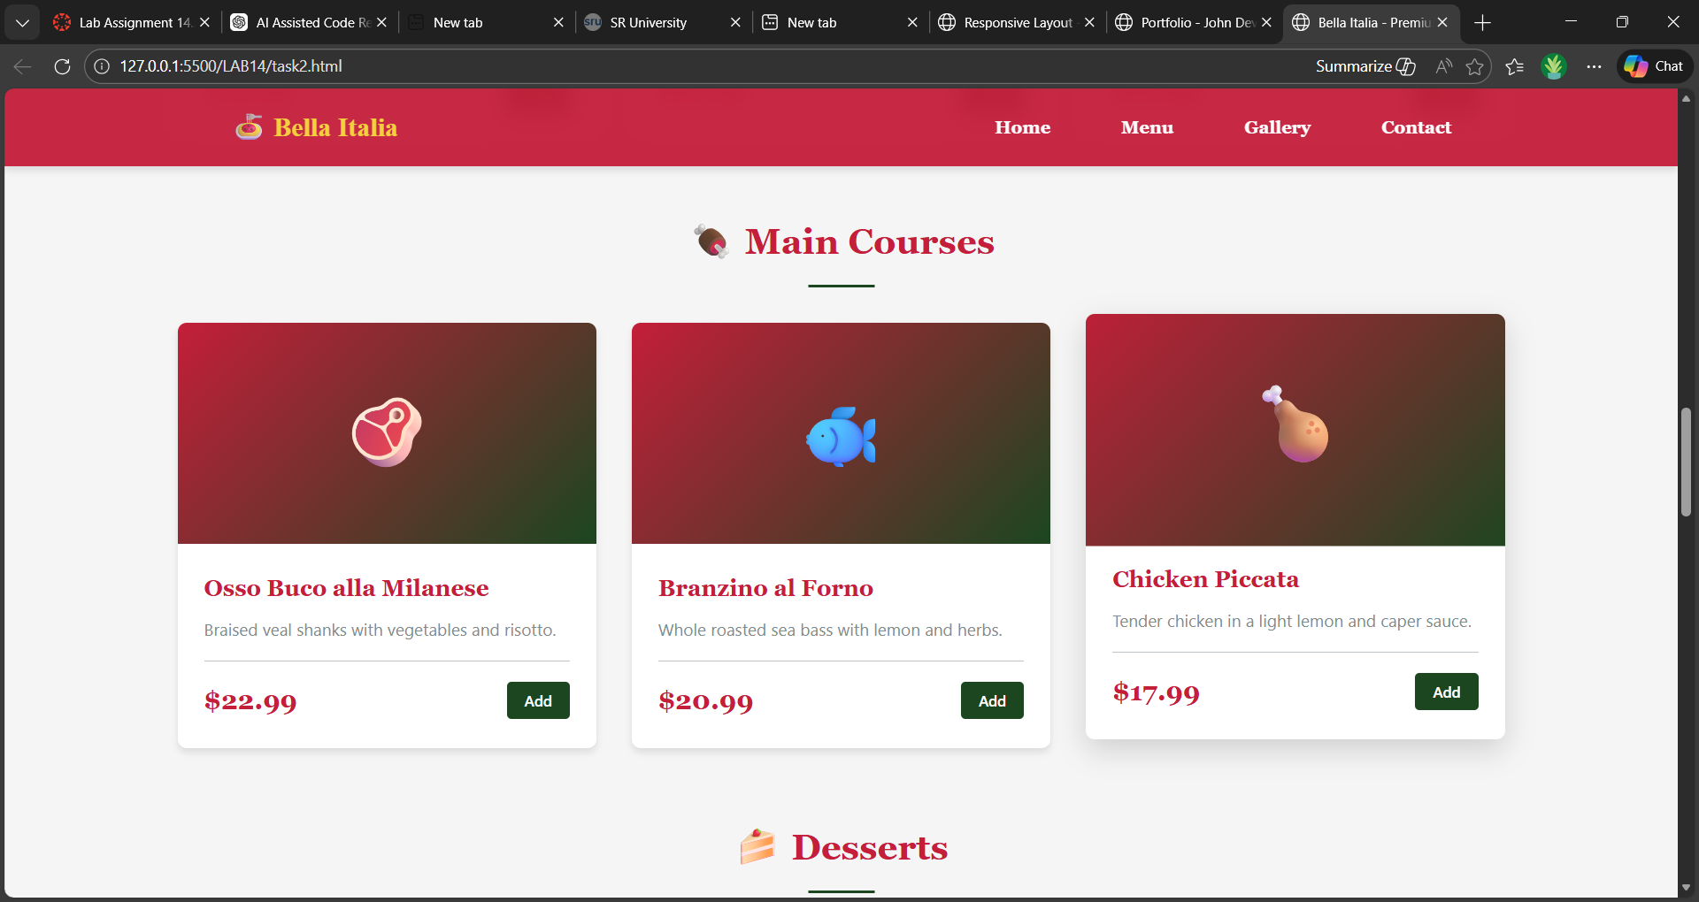

✅ Task 3 – Event Registration Form
🔹 Prompt Used
Generate an event registration form with fields:
Name, Email, Phone.
Add validation for phone (10 digits).
Style form for better readability.

🔹 Code 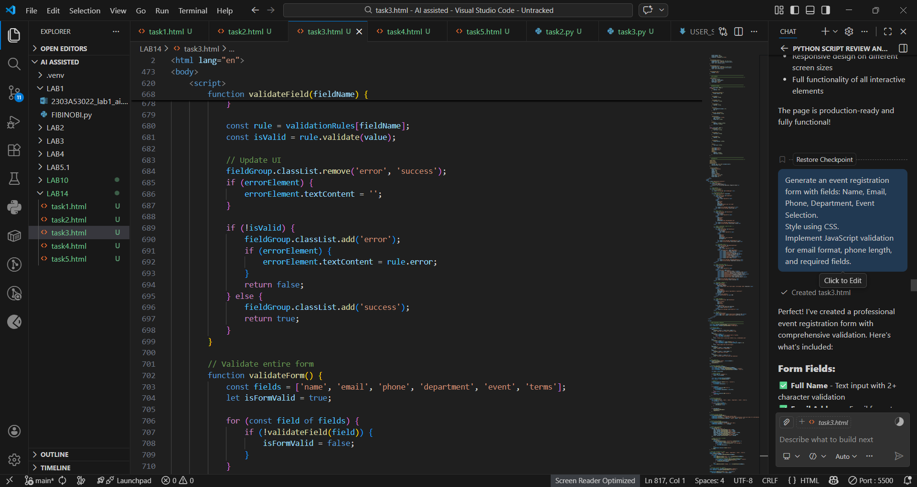

🔹 Output
- Centered registration form.
- Required fields prevent empty submission.
- Alert appears if phone number is not 10 digits.
- Clean and readable UI.
- 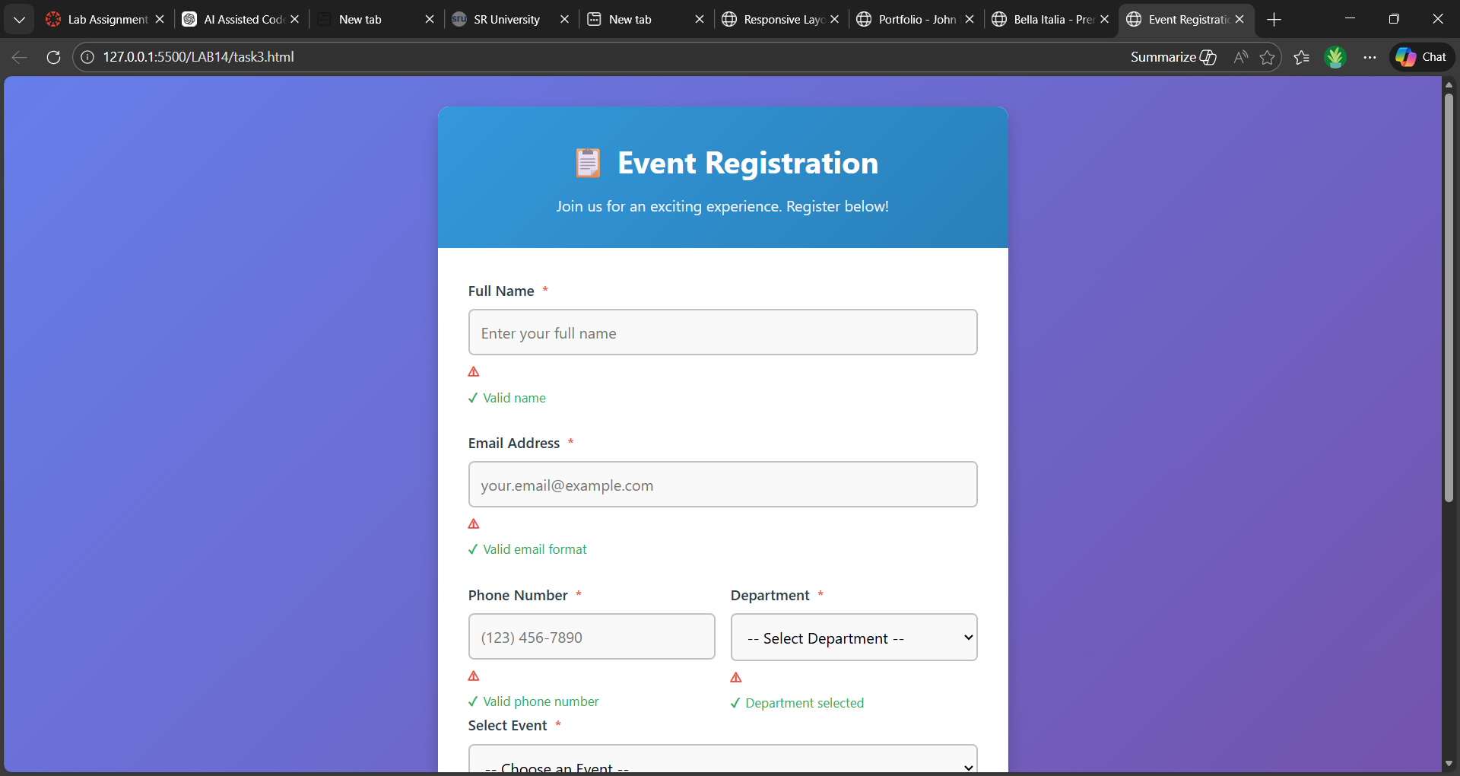

✅ Task 4 – E-Commerce Product Page
🔹 Prompt Used
Create product catalog using CSS Grid.
Add Add-to-Cart button.
Display cart counter at top right.

🔹 Code 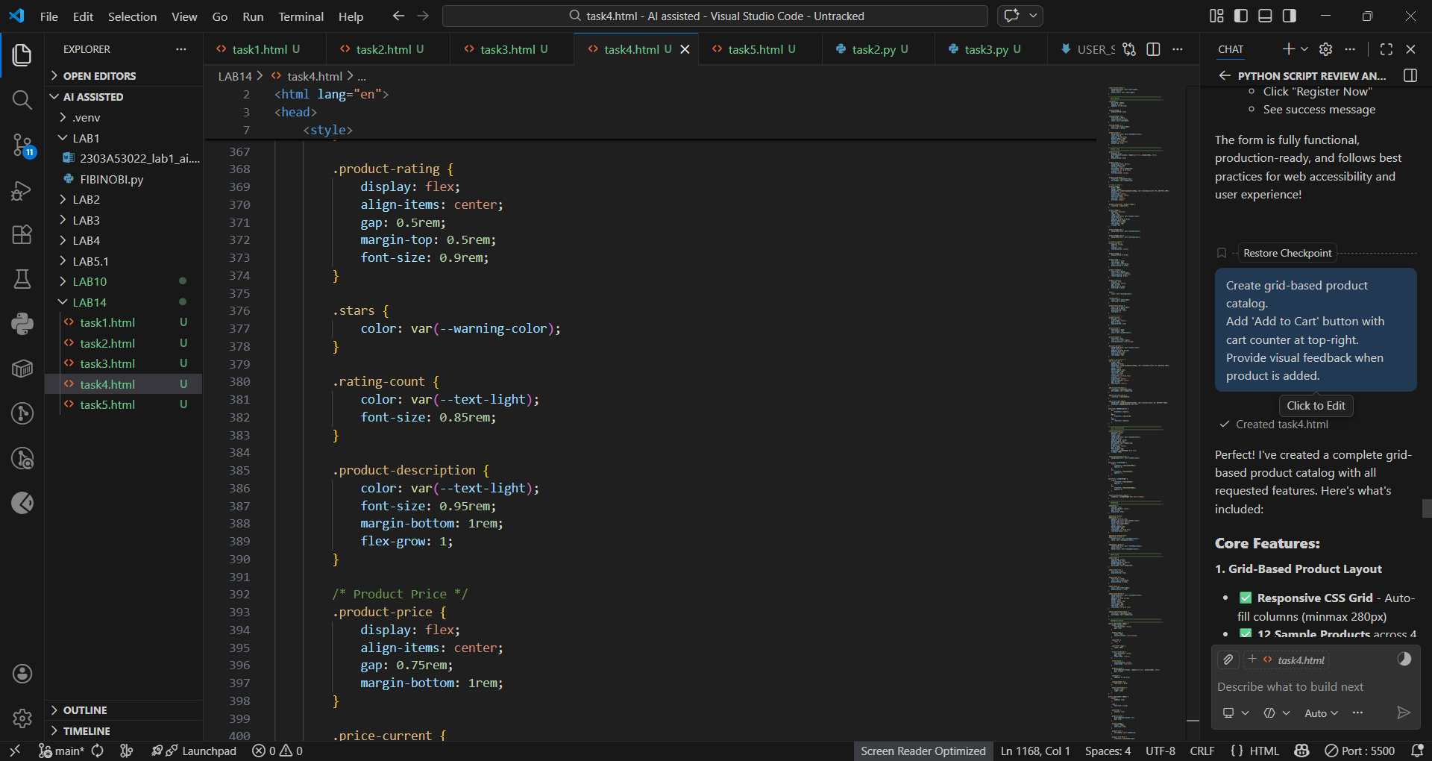

🔹 Output
- Product grid layout.
- Cart counter visible at top-right.
- Counter increases on button click.
- Alert confirms addition.
- 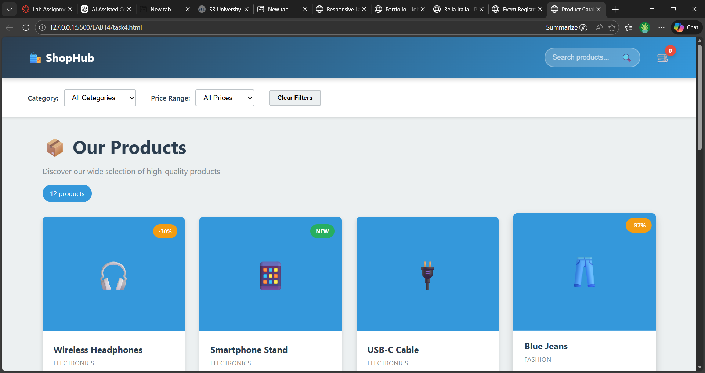

✅ Task 5 – Responsive Layout
🔹 Prompt Used
Design responsive layout with header, main, footer.
Use media queries for smaller screens.

🔹 Code 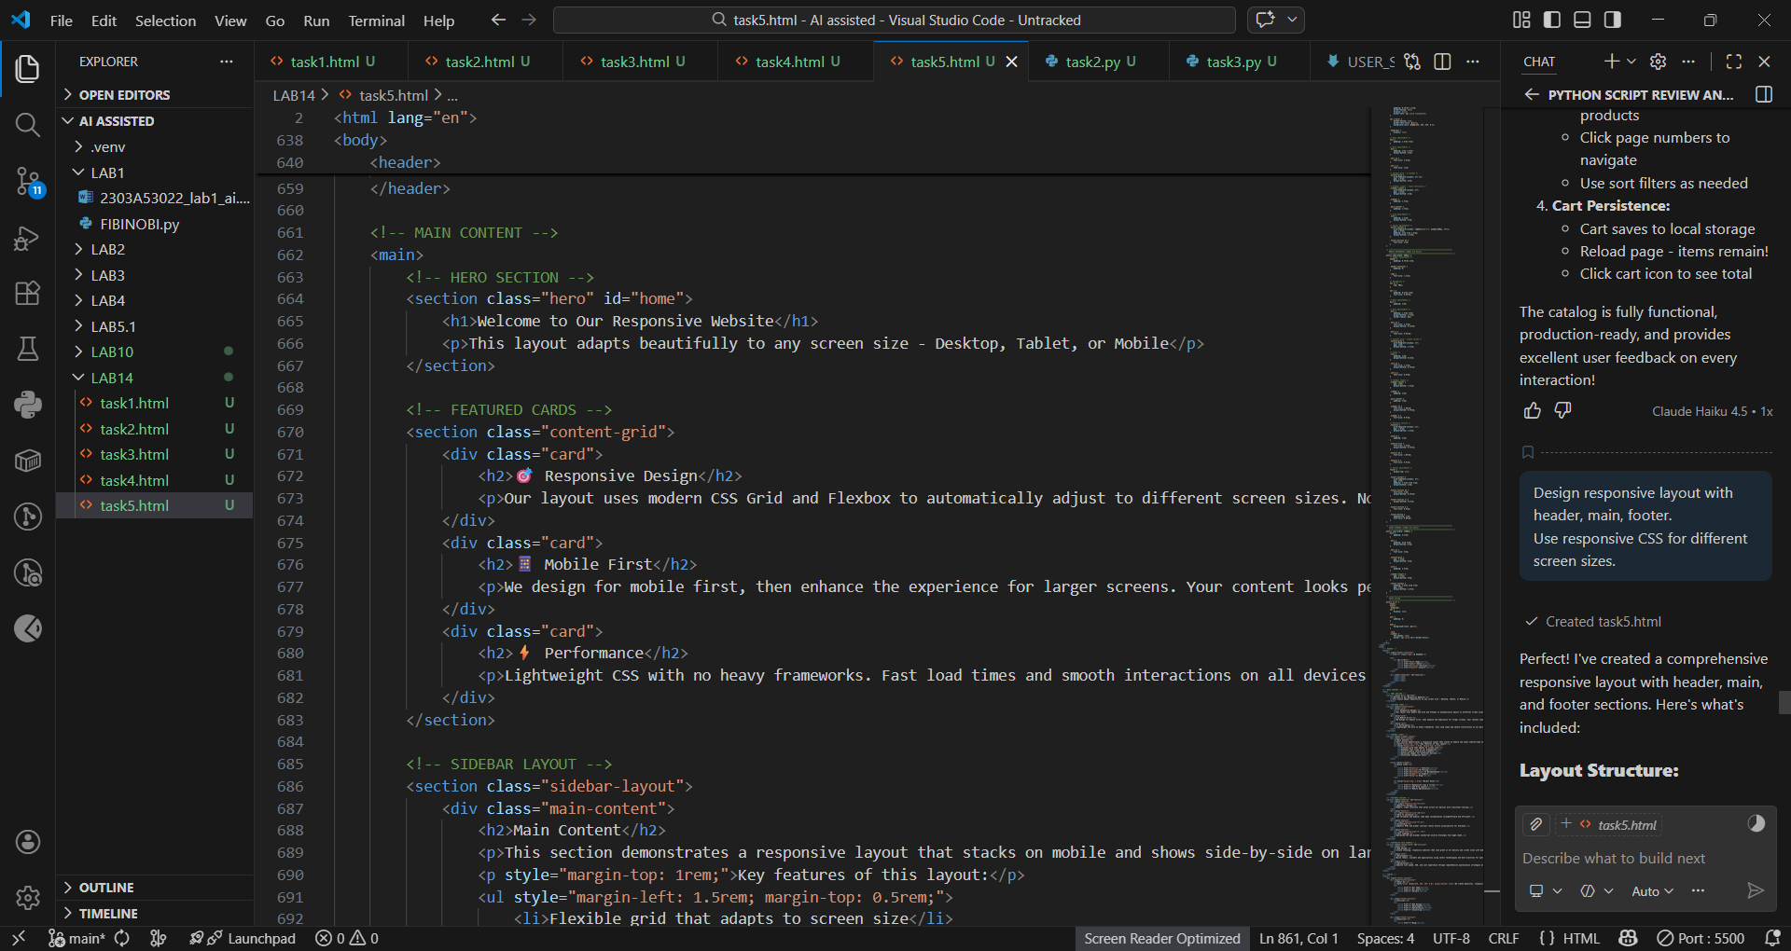

🔹 Output
- Header at top.
- Main content in center.
- Footer at bottom.
- Text size adjusts for smaller screens.
- 