ACL 2014 gratefully acknowledges the following sponsors for their support:

**Platinum Level:**



**Gold Level:**

 

 

 

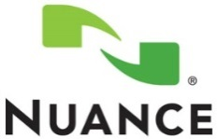 

**Silver Level:**

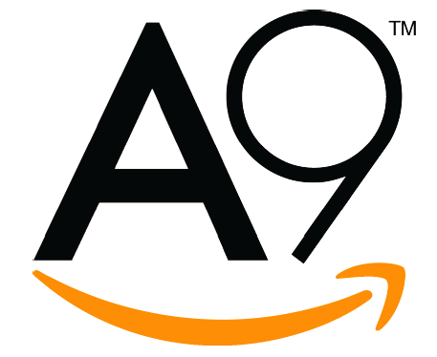 

**Bronze Level:**

Brandeis logo Facebook logo 

**Supporters:**

 