

**Covid-19 Helper App**

**Mujeeb Javed, Pranav Kulkarni, Titash Banerjee, Chirantan Paul, Ippili Pranay Kumar, Pronil Polpakkara**

**Objective:**

*The aim of the project is to design an app*

* *that will give the vaccination availability in a given area and also give the number of cases, deaths and also recovery rate in India.*
* *that will tell the user whether they are at risk of Covid-19.*

**Circuit/Block Diagram:**

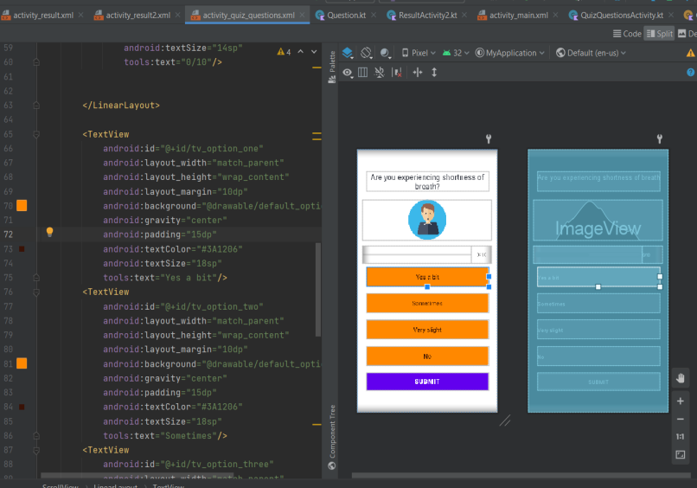 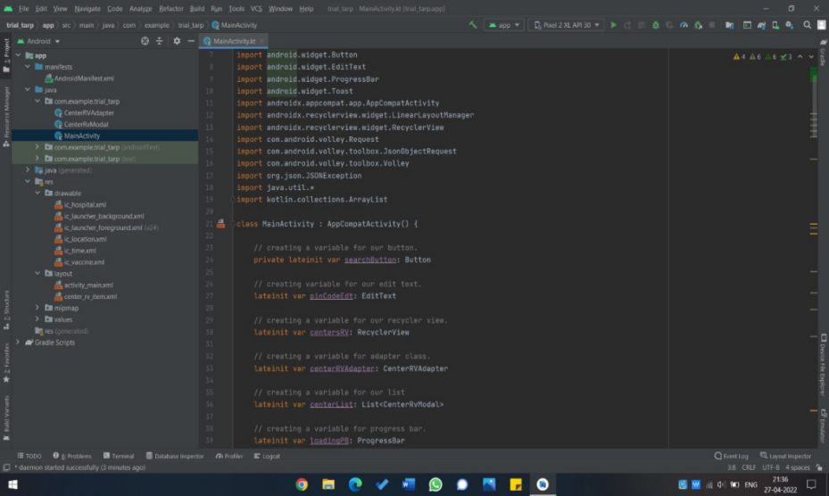 **Output Images/Simulation Results:**

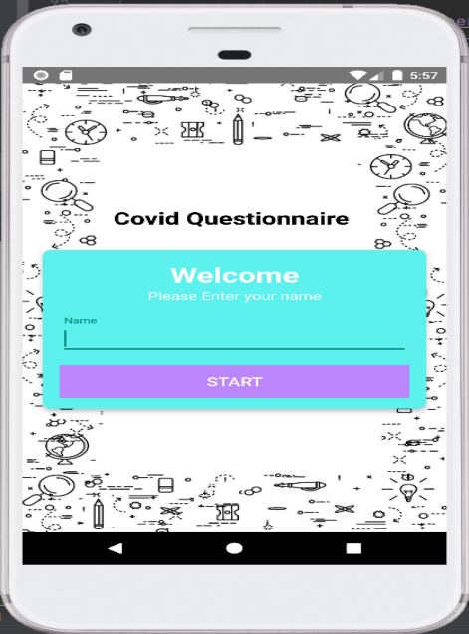 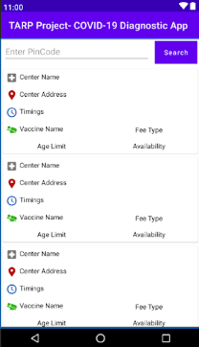 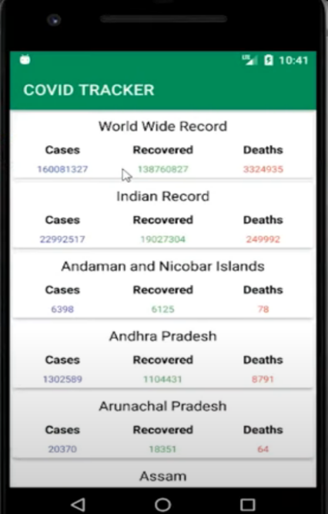 **Summary:**

* *The app is functional and will give reports according to the user’s choices, will give recommendations of the nearest vaccination centers with availability with the total number of cases in India.*
* *This app will help the user to self-assess Covid-19 symptoms and stay cautious.*