1. Write a MongoDB query to display all the documents in the collection restaurants

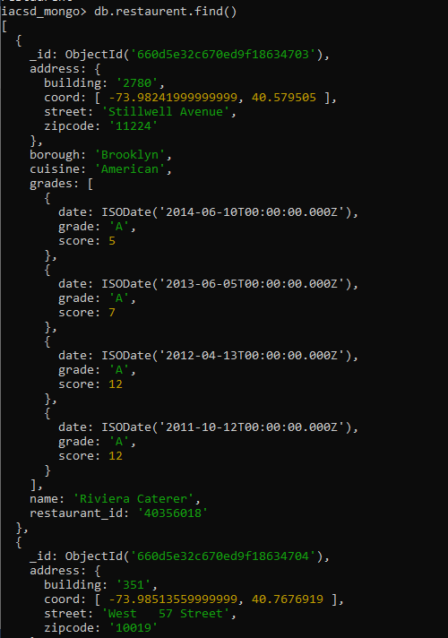

1. Write a MongoDB query to display the fields restaurant_id, name, borough and cuisine for all the documents in the collection restaurant.

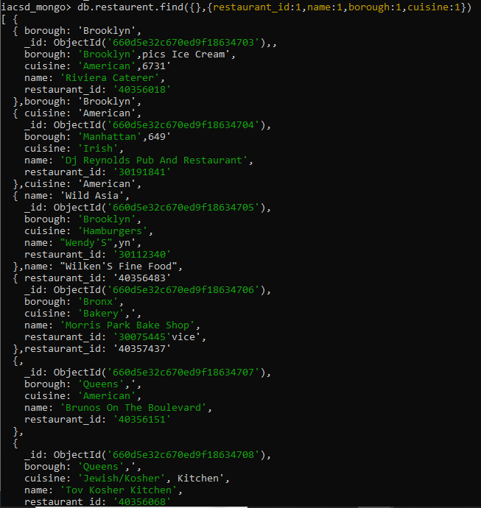

3. Write a MongoDB query to display the fields restaurant_id, name, borough and cuisine, but exclude the field _id for all the documents in the collection restaurant.

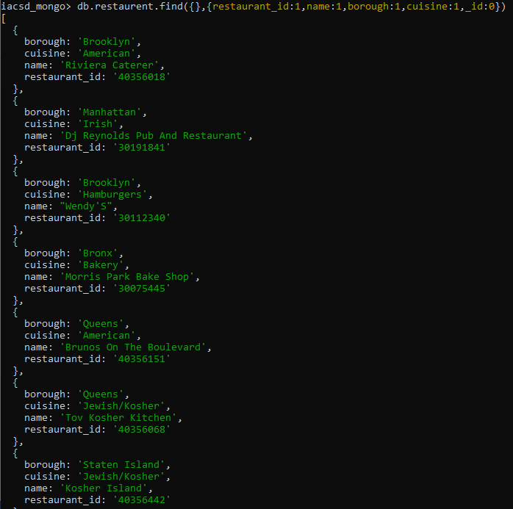

4. Write a MongoDB query to display the fields restaurant_id, name, borough and zip code, but exclude the field _id for all the documents in the collection restaurant.

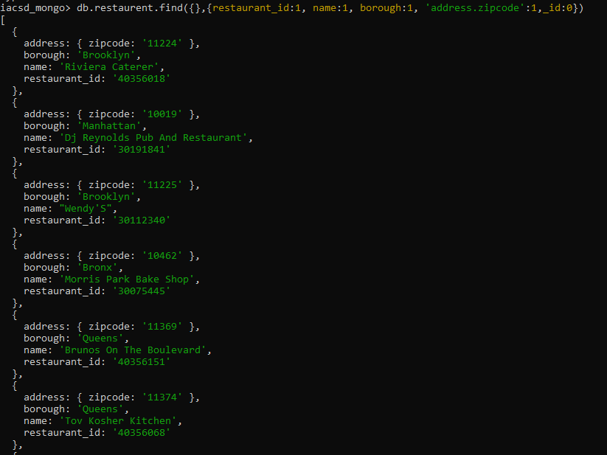

5. Write a MongoDB query to display all the restaurant which is in the borough Bronx

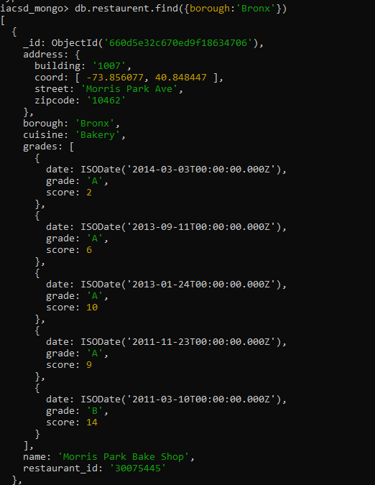

6. Write a MongoDB query to display the first 5 restaurant which is in the borough Bronx.

