EVENT BOOKING APPLICATION
Design Document

Angular 17 · Flask 3 · MySQL 8 · JWT Auth

1. Executive Summary
The Event Booking Application is a full-stack web application that allows users to discover and subscribe to scheduled events via a weekly calendar interface. Administrators manage the event catalogue by creating and deleting time slots.

The key business rule is that any number of users can subscribe to the same event — there is no per-slot capacity limit. Each user may subscribe to a given event only once.

Attribute | Value
Primary Users | Regular users and administrators
Core Feature | Weekly calendar with open-subscription events
Auth Model | JWT tokens — 8-hour expiry, role claims embedded
Booking Rule | Unlimited subscribers per event; one subscription per user per event
Architecture | Three-tier: Angular SPA → Flask REST API → MySQL
Deployment | Configurable via environment variables; no hardcoded secrets

2. System Architecture

2.1 Three-Tier Architecture
The application follows a classic three-tier separation of concerns. Each tier communicates only with the tier directly adjacent to it.

PRESENTATION TIER
Angular 17 SPA · Angular Material · RxJS · Signals
↓
BUSINESS LOGIC TIER
Flask 3 REST API · Flask Blueprints · JWT Auth · SQLAlchemy ORM
↓
DATA TIER
MySQL 8 · InnoDB · utf8mb4 · Foreign keys · Composite unique constraints

2.2 Backend Blueprint Structure
The Flask backend uses the Application Factory pattern. main.py creates and configures the app but contains zero routes. Every domain is encapsulated in its own Blueprint.

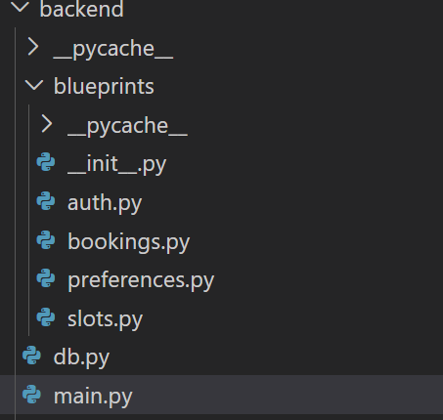

2.3 Frontend Structure
The Angular frontend uses standalone components (no NgModule). Each component declares its own imports explicitly. Services are provided in root — singletons shared app-wide.

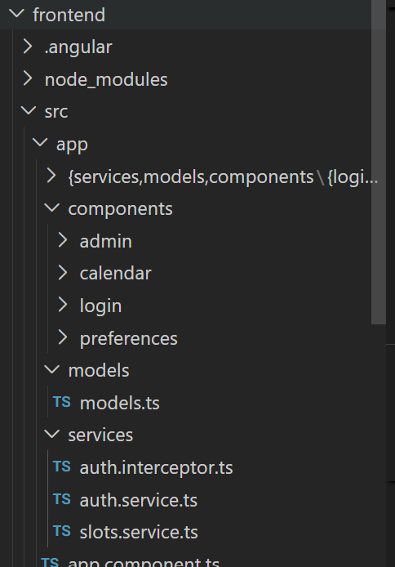

3. Database Design

3.1 Entity Relationship Overview

! | Core booking rule: the bookings table has a COMPOSITE unique constraint on (time_slot_id, user_id). This means any number of different users can book the same slot — but no single user can book it twice. There is no UNIQUE on time_slot_id alone.

users  ───────────────  PK id INT  username VARCHAR(50)  password VARCHAR(255)  is_admin INT | 1 ────── * | user_preferences  ───────────────  PK id INT  FK user_id INT  category VARCHAR(10) |  | time_slots  ───────────────  PK id INT  title VARCHAR(150)  category VARCHAR(10)  start_time DATETIME  end_time DATETIME
 |  |  |  | 1
1 |  |  |  | │
│ |  | bookings  ───────────────  PK id INT  FK time_slot_id INT  FK user_id INT  UQ (time_slot_id, user_id)
1 user → * bookings |  | 1 slot → * bookings

3.2 Table Definitions

users
Column | Type | Constraint | Notes
id | INT | PK, AUTO_INCREMENT | Surrogate primary key
username | VARCHAR(50) | UNIQUE, NOT NULL | Login identifier
password | VARCHAR(255) | NOT NULL | SHA-256 hashed — never plain
is_admin | INT | NOT NULL, DEFAULT 0 | 0 = user, 1 = admin

time_slots
Column | Type | Constraint | Notes
id | INT | PK, AUTO_INCREMENT | Surrogate primary key
title | VARCHAR(150) | NOT NULL | Display name for the event
category | VARCHAR(10) | NOT NULL | Cat 1 | Cat 2 | Cat 3 (validated in app)
start_time | DATETIME | NOT NULL | UTC datetime
end_time | DATETIME | NOT NULL | Must be > start_time (validated in app)

bookings
Column | Type | Constraint | Notes
id | INT | PK, AUTO_INCREMENT | Surrogate primary key
time_slot_id | INT | FK → time_slots.id | Cascade delete removes booking when slot deleted
user_id | INT | FK → users.id | Cascade delete removes booking when user deleted
— | — | UQ (time_slot_id, user_id) | One user can subscribe to a slot only once — many users can subscribe to the same slot

user_preferences
Column | Type | Constraint | Notes
id | INT | PK, AUTO_INCREMENT | Surrogate primary key
user_id | INT | FK → users.id | Cascade delete on user removal
category | VARCHAR(10) | NOT NULL | One row per selected category

4. API Design

4.1 Authentication
Login returns a signed JWT containing the user's ID and role. No subsequent request needs to pass user credentials — the token carries all necessary identity information.

Method | Endpoint | Auth | Request Body | Response
POST | /auth/register | None | {"username","password","is_admin?"} | 201 User object | 400
POST | /auth/login | None | {"username","password"} | 200 {access_token, user} | 401
GET | /categories | None | — | 200 ["Cat 1","Cat 2","Cat 3"]

4.2 Protected Endpoints
All endpoints below require the Authorization: Bearer <token> header. The user's identity is read from the token — no user_id in the request body.

Method | Endpoint | Role | Description
GET | /users/<id>/preferences | Own/Admin | Get saved category list
PUT | /users/<id>/preferences | Own/Admin | Replace saved categories (full replace, not patch)
GET | /slots | Any | List slots — filterable by week_start, week_end, categories
POST | /slots | Admin | Create a new time slot
DELETE | /slots/<id> | Admin | Delete slot + all its subscriptions (cascade)
POST | /slots/<id>/book | Any | Subscribe current user — identity from JWT
DELETE | /slots/<id>/book | Any | Unsubscribe current user — identity from JWT

4.3 Booking API — Multi-User Design

✓ | POST /slots/<id>/book can be called by any number of different users for the same slot ID. The server returns 409 only if the same user tries to book the same slot twice. There is no capacity check.

Scenario | HTTP Status | Response Body
First user subscribes to slot 5 | 200 | {"detail": "Booked successfully"}
Second user subscribes to slot 5 | 200 | {"detail": "Booked successfully"}
100th user subscribes to slot 5 | 200 | {"detail": "Booked successfully"}
Same user tries to subscribe to slot 5 again | 409 | {"detail": "You have already booked this slot"}
Slot does not exist | 404 | {"detail": "Slot not found"}

5. Authentication & Request Flow

5.1 Login Flow

User submits  username + password | → | POST /auth/login  Flask | → | Hash password  SHA-256 lookup | → | Create JWT  8h expiry + is_admin claim | → | Store token  localStorage

5.2 Authenticated Request Flow

1 | Component calls a SlotsService method
2 | HttpClient builds the request
3 | authInterceptor clones request, adds Authorization: Bearer <token>
4 | Request arrives at Flask route
5 | @jwt_required() / @admin_required decodes and validates token
6 | Route handler executes — identity from get_jwt_identity()
7 | Response returned to component's .subscribe() callback

! | If the response is 401 (token expired or missing), the interceptor calls auth.logout() and navigates to /login. Components do not handle 401 manually.

7. Setup & Deployment

7.1 Environment Variables

Variable | Default | Required in Prod? | Description
DB_USER | root | Yes | MySQL username
DB_PASSWORD | password | Yes | MySQL password
DB_HOST | localhost | Yes | MySQL host
DB_PORT | 3306 | No | MySQL port
DB_NAME | event_booking | No | Database name
JWT_SECRET_KEY | change-me-in-production | Yes | Random 32+ char secret for signing

8.2 Run Commands

1. CREATE DATABASE event_booking
2. cd backend
python -m venv venv
.\venv\Scripts\Activate.ps1
pip install -r requirements.txt

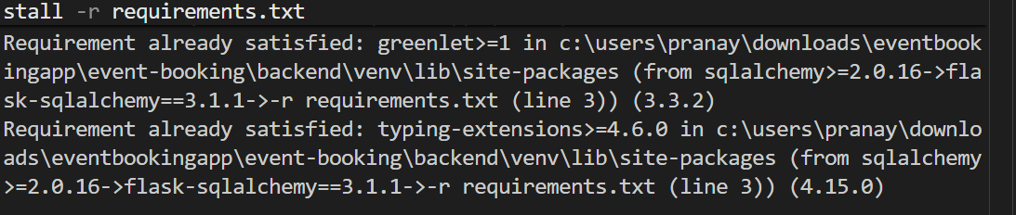

$env:DB_USER = "<<username_of_db>>"

$env:DB_PASSWORD = "<<password_of_db>>"

$env:JWT_SECRET_KEY = "<<jwt_secret_key>>"

python main.py

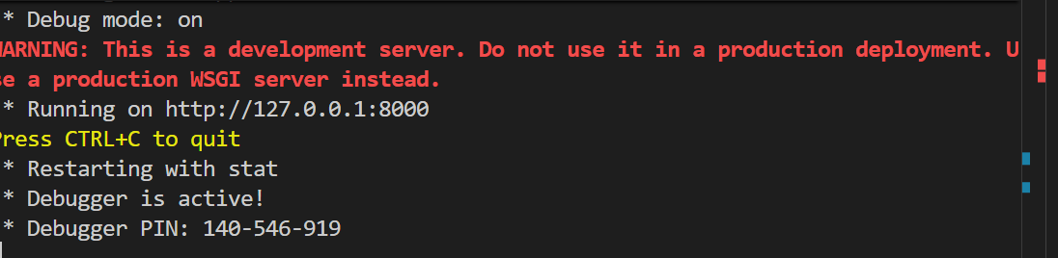

cd frontend

npm install

npm start

