Project Proposal: Smart Document Scanner & Chatbot Assistant

Prepared by:
Pranay Nambiar
Noor Mohammed
- Objective
To develop a web-based platform that enables users to:
Upload important documents (receipts, invoices, certificates)
Automatically extract and analyze text content using OCR
Interact with a chatbot that can understand and respond based on document content
Export extracted data in structured formats (CSV, JSON)
Maintain a history of document uploads and queries
Ensure mobile responsiveness and ease of use
- Key Features
- Document Upload Interface
- OCR Processing (Tesseract / PaddleOCR)
- Data Extraction and Structuring
- Al Chatbot to Query Document Content
- Export Results (CSV / JSON)
- User Authentication and Management
- Mobile-Responsive Web Design
- Technologies Used
Component Technology
Frontend React.js + TailwindCSS
Backend FastAPI (Python)
OCR Engine Tesseract OCR / PaddleOCR
Chatbot LangChain + HuggingFace Model (Mistral / Phi-2)
Storage Firebase Storage or MongoDB
Authentication Firebase Auth
Hosting Vercel (Frontend) + Render (Backend)
- System Architecture
[User Uploads Document]
[React.js Frontend]
[FastAPI Backend]
[Tesseract OCR / PaddleOCR]
[Text Parsing & Structuring]
[LangChain + LLM Chatbot]
[Response + Download + Export]
- Implementation Timeline (20 Days)
Phase Days Tasks
1 Day 1-3 Project setup, basic UI, Firebase Auth 2 Day 4-6 OCR integration (Tesseract / PaddleOCR)
- Day 7-9 Text parsing and formatting
- Day 10-13 Chatbot integration with LangChain & Hugging Face
- Day 14-16 Export functions (CSV, JSON)
- Day 17-18 User dashboard with document history
- Day 19-20 Testing, UI polish, mobile responsiveness, deploy
- Hosting & Cost Estimation
Frontend (Vercel) - Free
Backend (Render) - Free tier
OCR Engine (Tesseract) - Open Source
Chatbot (HuggingFace) - Free tier
Authentication & DB (Firebase) - Free tier
Total cost: O INR
- Uniqueness & Added Value
Al-powered document understanding
Conversational search with documents
Free-to-use tech stack for students/startups
Real-world skill development (OCR, LangChain, React)
Mobile optimized and beginner-friendly UI
- Team Roles
Name Role
Pranay Nambiar Frontend, Chatbot Integration Noor Mohammed Backend, OCR, Data Extraction
- Future Scope
Support for image-based handwritten documents
Integration with Google Drive / Dropbox
Multi-language OCR and chatbot response
Admin analytics dashboards

User Browser
OCR
Extracted Text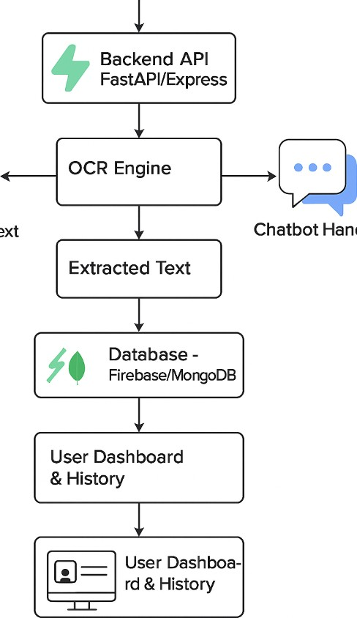
Handler



