Title:- Forced Alignment using Montreal Forced Aligner (MFA)
1. Objective
The goal of this assignment is to automatically align speech audio with its corresponding text transcription using the Montreal Forced Aligner (MFA). This process allows us to determine the start and end times of words and phonemes in the audio, providing precise temporal information for linguistic analysis or speech processing tasks.
2. Environment Setup Summary
- Platform: Anaconda environment
- Conda Environment: mfa_env created with Python 3.10
- Montreal Forced Aligner Installation: via pip
- Dictionary Used: english_us_arpa
- Acoustic Model: english_mfa
- Dataset: 6 audio files (wav/) with corresponding transcripts (transcripts/)
- Tools for Verification: Praat for visualizing .TextGrid files
Setup Steps:
- Installed Anaconda and created a dedicated environment.
- Installed MFA using pip inside the environment.
- Organized the dataset into wav/ and transcripts/ folders.
- Downloaded and linked the required dictionary and acoustic model.
- Verified installation with mfa --version.
3. Alignment Results
- Files Processed: 6 audio-transcript pairs
- Outputs: 6 .TextGrid files in the output/ folder
- Verification: Opened in Praat to inspect word and phoneme tiers
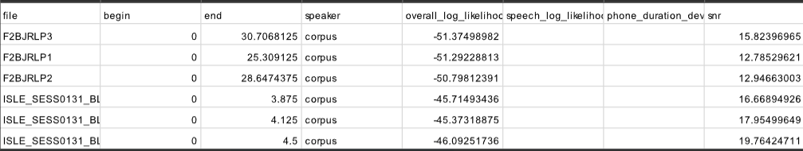
- Sample Visualization:

4. Observations
- Word and phoneme boundaries are accurate for most utterances.
- <unk> or spn symbols appear where the dictionary cannot map a word or during silence.
- Alignment quality is satisfactory; minor timing offsets exist in fast speech or unclear pronunciation.
- MFA efficiently handles batch alignment for multiple files.
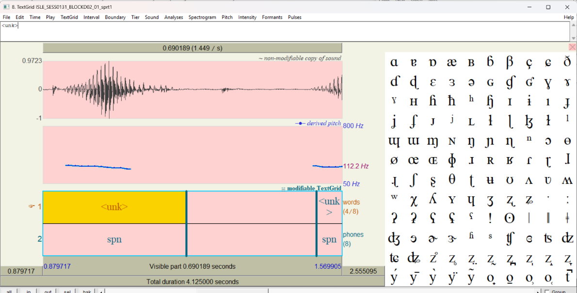
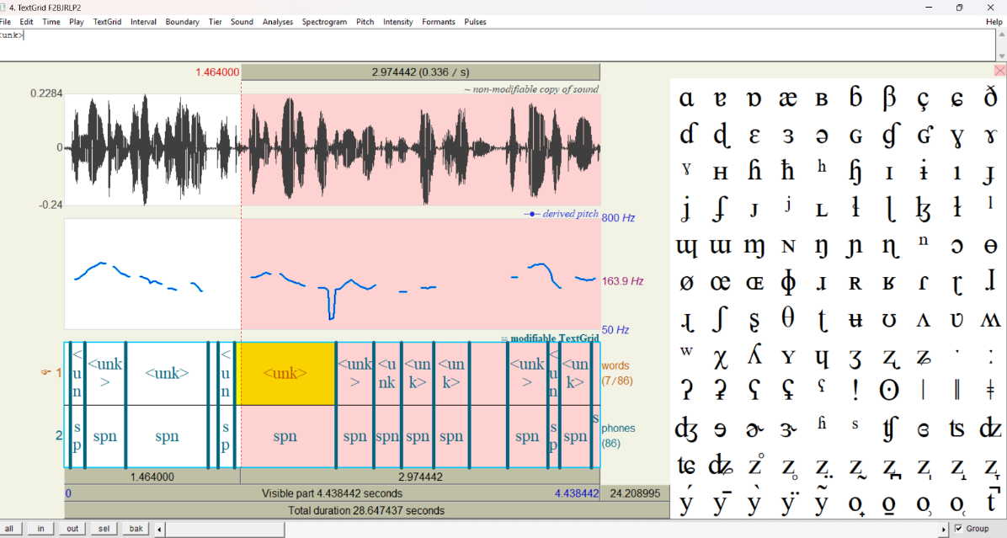

5.Links
- Github:https://github.com/pranaypadole22/-Forced-Alignment-using-Montreal-Forced-Aligner-MFA-IIITH-Assignment.git

- Drive:https://drive.google.com/drive/folders/15qmCW8dJfYE90jvuDP2ELlP3YJGBFDVo?usp=sharing

