CSCI UA.0480 – Applied Internet Technology
Final Exam Practice Questions Set 2
- Answer these questions about salt!
  - In the context of storing passwords after a user registers, when is a salt added?

  - How is the salt used to authenticate a user when a user is attempting to login by sending a username and password?

- If two CSS rules target the same elements, how do you determine which rule will be applied? A high level description is adequate.
- Describe at least 2 disadvantages when using AJAX polling to simulate real time communication in web applications?
  - ________________________________________________________________________________
________________________________________________________________________________
  - ________________________________________________________________________________
________________________________________________________________________________
  - ________________________________________________________________________________
________________________________________________________________________________

- Describe 2 situations where you should not (or at least be very careful!) using arrow functions:
  - ________________________________________________________________________________
________________________________________________________________________________
  - ________________________________________________________________________________
________________________________________________________________________________
- One example of cross site request forgery is a script running on a malicious site that issues a POST request to another site that the user may be logged in to. Because the user is already logged in, the malicious script has access to the user's authenticated session! Describe the technique(s) / mechanism(s) used to prevent this.
- Answer the questions in the 2nd and 3rd columns about the code in the 1st column:
<!-- html -->  <section>  <div><h3>automaton</h3><em>cyborg</em></div>  <h3><div>robot</div><em>ai</em></h3>  </section>  <p>machine</p>  // javascript  const s = 'section > h3'  const res = document.querySelector(s);  console.log(res.textContent);  console.log(res.innerHTML) | What is the output of the 1st column assuming the html and JavaScript provided? | Write a css rule that makes the first div under section “disappear”.
function f(val) {  console.log(val);  return new Promise((fulfill, reject) => {  console.log('acoustics');  fulfill('bandit');  console.log('cotton');  });  }  const result1 = f('desert');  const result2 = result1.then(f);  const result3 = result2.then(console.log); | What is the output of the code? | What is result3 in the last line (type and value)?
const fs = require('fs');  function Reader(fn, prefix) {  this.fn = fn;  this.prefix = prefix;  console.log('fn is:', this.fn);  console.log('prefix is:', this.prefix);  }  Reader.prototype.print = function() {  fs.readFile(this.fn, 'utf8',  function(err, data) {  if(!err) {  console.log(this.prefix);  console.log(data);  }  }  );  };  const r = new Reader('colors.txt', 'RAINBOW');  r.print(); | What is the output of the code? The data parameter in the readFile callback will contain the contents of the file read as a regular string. Assume that colors.txt exists, and it contains this data:  red  orange  yellow | Using the same definition for the Reader constructor. What would the output be if the only line of code after the constructor were:  Reader();
<!-- markup -->  <ul>  <li>A</li>  <li>B</li>  <li>C</li>  <li>D</li>  </ul>  // javascript  var lis = document.getElementsByTagName('li');  for(let i = 0; i <lis.length; i++) {  lis[i].parentNode.removeChild(lis[i]);  } | What will the markup look like after the script in the 1st column is run on the markup in the 1st column? | Fix the code so that all of the list items are removed (but the outer ul remains present):
const glue = {  sep: 'x',  join(arr) {  return arr.reduce((acc, cur) => {  return acc + cur + this.sep;  }, '');  }  };  console.log(glue.join(['foo', 'bar', 'baz'])); | What is the output of the code? | Rewrite the callback to arr.reduce so that it uses bind instead of an arrow function.

- Create a React component, Adder, that displays 2 numbers and the sum of the 2 numbers. Both numbers start at 0. Every time a number is clicked on, it is incremented based on an attribute, called inc, that the component is rendered with. For example, if the component were rendered as: <Adder inc='1'>, then the following interactions can take place:
Initial Page: | Clicking on the top number: | After clicking 3 and 5 times:
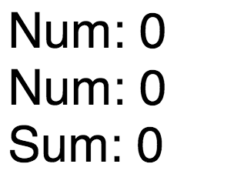 | 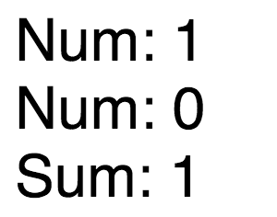 | 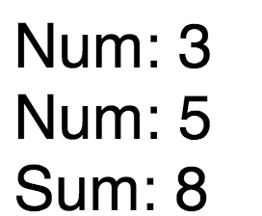
Assume the following components are already present. Use es6 classes or createClass to implement the parent Adder component:
class NumBox extends React.Component {  render() {  return <div onClick={this.props.onClick}>Num: {this.props.num}</div>;  }  } | class Sum extends React.Component {  render() {  return <div>Sum: {this.props.sum}</div>;  }  }

- Create a realtime, multi-user web application that displays 10 numbers in a single row:
  - if a user clicks on one of the numbers, it disappears from the user's screen as well as any other users' screens in real time
  - if a new user loads the page, the page will only show the remaining numbers (the numbers that haven't been clicked on yet)
  - write out the (1) server code and (2) client code (including DOM manipulation to create elements)
  - elements must be created programmatically, though assume that the following code is already present for you:
// ON THE SERVER  const express = require('express');  const app = express();  const server = require('http').Server(app);  const io = require('socket.io')(server);  app.use(express.static('public'));  // TODO: fill out server code  server.listen(3000); | // ON THE CLIENT  // assume that span elements are styled with borders  // assume that there is no markup (only html, head, body)  // /socket.io/socket.io.js is already included  const socket = io();  document.addEventListener('DOMContentLoaded', function()) {  // TODO: fill out client side code  }

  - see example interaction below:
Initial page when 2 browser load application  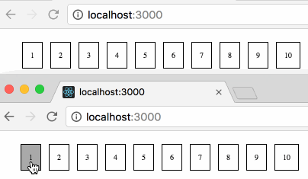 | Use clicks on number 1, 1 disappears from both screens  