//defining region of interest(ROI) in an image
// define image ROI
cv::Mat imageROI;
imageROI= image(cv::Rect(385,270,logo.cols,logo.rows));

// define image ROI
Mat imgROI;
imgROI= img(cv::Rect(0,0,img.cols/3,img.rows/3));

//convert the colour space of image (#include<cv.h>)
cvtColor(src,dst, COLOR_BGR2HSV);
(COLOR_BGR2HSV , COLOR_RGB2HSV , COLOR_HSV2BGR , and COLOR_HSV2RGB .)

//to threshold an hsv image
inRange(imgHSV, Scalar(iLowH, iLowS, iLowV), Scalar(iHighH, iHighS, iHighV), imgThresholded);

//to threshold a grey image
cvtColor(img,output, COLOR_BGR2GRAY);
threshold(output,threshold1,0,150,THRESH_BINARY);

//Create trackbars in "window1" window
// This below function will create a bars on Control window using that you can change value

int LowH = 0;
int HighH = 179;

int LowS = 0;
int HighS = 255;

int LowV = 0;
int HighV = 255;

cvCreateTrackbar("LowH", "window1", &LowH, 179); //Hue (0 - 179)
cvCreateTrackbar("HighH", "window1", &HighH, 179);

cvCreateTrackbar("LowS", "window1", &LowS, 255); //Saturation (0 - 255)
cvCreateTrackbar("HighS", "window1", &HighS, 255);

cvCreateTrackbar("LowV", "window1", &LowV, 255); //Value (0 - 255)
cvCreateTrackbar("HighV", "window1", &HighV, 255);

//morphological opening or closing
erode(src, dst, getStructuringElement(MORPH_ELLIPSE, Size(5, 5)) );
dilate( src, dst,getStructuringElement(MORPH_ELLIPSE, Size(5, 5)) );

erosion_type = MORPH_ELLIPSE (structuring element)
erosion_type = MORPH_CROSS
erosion_type = MORPH_RECT
(size is shape inside a matrix of 5x5)

// open the video file for reading

VideoCapture cap("/media/pranay/New Volume/tutorials/scilab/Scilab tutorial 5 Matrices.mp4");

if ( !cap.isOpened() ) // if not success, exit program
{
cout << "Cannot open the video file" << endl;
return -1;
}

//capture the video from laptop web cam

VideoCapture cap(0);

if ( !cap.isOpened() ) // if not success, exit program
{
cout << "Cannot open the web cam" << endl;
return -1;
}

// read a new frame from video
while (true)
{

Mat Original;

bool bSuccess = cap.read(Original);

if (!bSuccess) //if not success, break loop
{
cout << "Cannot read a frame from video stream" << endl;
break;
}

.....
.....
.....

if(waitKey(3)==27)
{
break;
}
}

//to match the template(patch) with an image
//method=CV_TM_CCORR_NORMED 1
//method=CV_TM_SQDIFF 2 black
//method=CV_TM_SQDIFF_NORMED 1 black shade (less background)
//method=CV_TM_CCORR 1
//method=CV_TM_CCOEFF 4
//method=CV_TM_CCOEFF_NORMED 5
Mat result;

matchTemplate(img2,img1,result,CV_TM_SQDIFF);

img1 (template)

operations with images:

Set matrix values
img.setTo(Scalar(0)); // for 1-channel img
img.setTo(Scalar(B,G,R)); // 3-channel img

MATLAB-style matrix

initialization
Mat m3 = Mat::zeros(100, 100, CV_8UC1);
(how to fill matrix with zeros)

Mat m1 = Mat::eye(100, 100, CV_64F);



//use of Mat eye

Mat m2 = Mat::ones(100, 100, CV_8UC1)*255;

// to define point
Point PointAB,
where A can be 2(x and y) or 3(x,y,z) and
B can be i(integer), f(float), or d(double)
Point3d p;
p.x=0;
p.y=0;
p.z=0;
//to define vector
vector
VecAB, where A can
be 2,3,4,5 or 6,
B can be b(uchar type),s(short type),i(integer),f(float), or d(double)
Vec3b rgb;
rgb[0]=255;
or
Vec3d v;
v[0]=1.2;
v[1]=2.3;
v[2]=3.6;
or
Vec3d u(1.2,2.3,3.6);

Pixel-level access
To process images, we have to know how to access each pixel independently. OpenCV provides a number of ways to do this. In this section, we cover two methods; the first one is easy for the programmer, while the second one is more efficient.
The first method uses the at<> template function. In order to use it, we have to
specify the type of matrix cells, such as in this short example:

Mat src1 = imread("lena.jpg", IMREAD_GRAYSCALE);
uchar pixel1=src1.at<uchar>(0,0);
cout << "Value of pixel (0,0): " << (unsigned int)pixel1 << endl;

Mat src2 = imread("lena.jpg", IMREAD_COLOR);
Vec3b pixel2 = src2.at<Vec3b>(0,0);
cout << "B component of pixel (0,0):" << (unsigned int)pixel2[0] << endl;

The example reads an image in both grayscale and color and accesses the first pixel at (0,0). In the first case, the pixel type is unsigned char (that is, uchar ). In the second case, when the image is read in full color, we have to use the Vec3b type, which refers to a triplet of unsigned chars. Of course, the at<> function can also appear on the left-hand side of an assignment, that is, to change the value of a pixel. The following is another short example in which a floating-point matrix is initialized to the Pi value using this method:

Mat M(200, 200, CV_64F);
for(int i = 0; i < M.rows; i++)
for(int j = 0; j < M.cols; j++)
M.at<double>(i,j)=CV_PI;
Note that the at<> method is not very efficient as it has to calculate the exact
memory position from the pixel row and column. This can be very time consuming
when we process the whole image pixel by pixel. The second method uses the ptr
function, which returns a pointer to a specific image row. The following snippet
obtains the pixel value of each pixel in a color image:

uchar R, G, B;
for (int i = 0; i < src2.rows; i++)
{
Vec3b* pixrow = src2.ptr<Vec3b>(i);
for (int j = 0; j < src2.cols; j++)
{
B = pixrow[j][0];
G = pixrow[j][1];
R = pixrow[j][2];
}
}
In the example above, ptr is used to get a pointer to the first pixel in each row.
Using this pointer, we can now access each column in the innermost loop

//use of waitkey (from the highgui module)
int waitKey(int delay=0)
This function waits for a key pressed during a number of milliseconds ( delay > 0 ) returning the code of the key or -1 if the delay ends without a key pressed. If delay is 0 or negative, the function waits forever until a key is pressed.

waitKey(0);

Image Normalization
• normalize (imagein, imageout, low, high, method);
• Image normalization is the process of
stretching the range of an image from [a, b]
to [c, d].
• This is incredibly important for visualization
because if the image is beyond [0,255] it will
cause truncation or unsightly effects.
Note the use of cvNormalize() in this code, which allows us to display the results in a can return negative-valued
results.
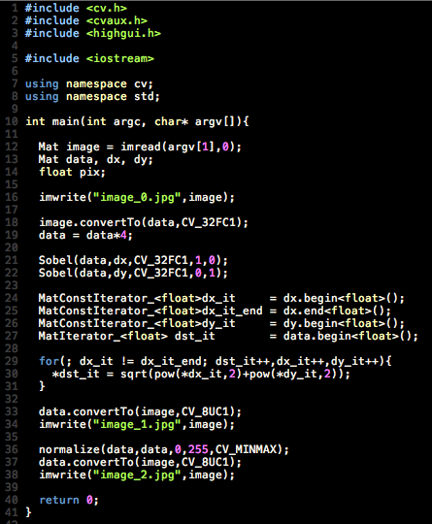

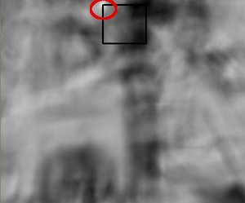
R matrix:
result matrix:

• In practice, we use the function minMaxLoc to locate the highest value (or lower, depending of the type of matching method) in the R matrix.
minMaxLoc

double min_val=0, max_val=0;
Point min_loc, max_loc;
minMaxLoc(result, &min_val, &max_val, &min_loc, &max_loc);

//size of image
The image size can be obtained with the rows and cols attributes.
Mat img;
int r=img.rows;
int c=img.cols;

There is also a size attribute that retrieves both:
MatSize s = img.size;
int r=l[0];
int c=l[1];

//change the size of image
1 The Mat class is used for dense n-dimensional single or multichannel arrays.
Mat img=Mat(nrows, ncols, type, fillValue);
type= CV_8U, CV_8S, CV_16U, CV_16S,
CV_32S, CV_32F, CV_64F
(U , S , and F stand for unsigned , signed , and float)
{ CV_8UC1,CV_8UC2,CV_8UC3 C3 shows no. Of channel=3}

fillvalue=Scalar(255); //(255)shows white

fillvalue=Scalar(0); //(0)shows black

see example mat.cpp mat2.cpp

2
Mat reducedImage,increasedImage; // to contain reduced image and increasedImage
pyrDown(image,reducedImage); // reduce image size by half
pyrUp(image,increasedImage); // increase image size by half

3
Mat resizedImage; // to contain resized image
resize(image,resizedImage, Size(image.cols/3,image.rows/3)); // 1/3 resizing

//convert the image
Mat img = imread("lena.png", IMREAD_GRAYSCALE);
Mat fp;
img.convertTo(fp,CV_32FC3);
//3 channel
• CV_8U, 8-bit unsigned integers (0..255)
• CV_8S, 8-bit signed integers (-128..127)
• CV_16U, 16-bit unsigned integers (0..65,535)
• CV_16S, 16-bit signed integers (-32,768..32,767)
• CV_32S, 32-bit signed integers (-2,147,483,648..2,147,483,647)
• CV_32F, 32-bit floating-point numbers
• CV_64F, 64-bit floating-point numbers
Note that the most common image depth will be CV_8U for both grayscale
and color images. It is possible to convert from one depth to another using the
convertTo method:

//flipping of image
flip(imgsrc,imgdst, code);
// code=0 =>vertical flipping
// code>0 =>horizontal flipping
// code<0 =>vertical & horizontal flipping

// split channel in rgb
Mat channel[3];
split(img, channel);
imshow("B", channel[0]); // show blue
imshow("G", channel[0]); // show green
imshow("R", channel[0]); // show red

OpenCV offers a simple function which extracts the contours of an thresholded image.
findContours function:
vector<vector<Point> > contours;
findContours(image,
contours, // a vector of contours
CV_RETR_EXTERNAL, // retrieve the external contours
CV_CHAIN_APPROX_NONE); // all pixels of each contours

Fortunately, there is a very convenient
function that can draw those contours on an image (here, a white image):
// Draw black contours on a white image
Mat result(image.size(),CV_8U,Scalar(255));
drawContours(result,contours,
-1, // draw all contours
Scalar(0), // in black
2); // with a thickness of 2
If the third parameter of this function is a negative value, then all contours are drawn.
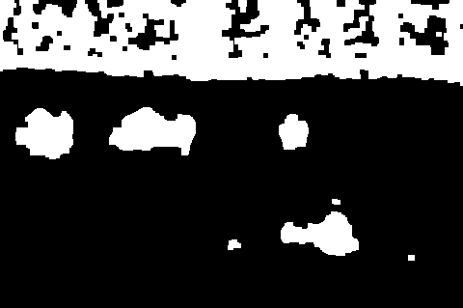
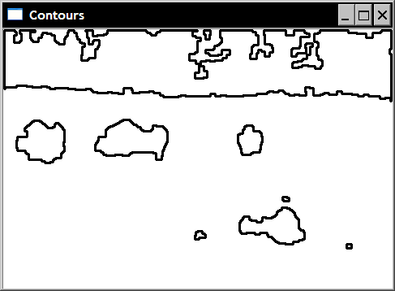

//shape discription

In particular, we will use our vector of four contours corresponding to the four buffaloes we previously identified. In the following code snippets, we compute a shape descriptor on the contours ( contours[0] to contours[3] ) and draw the result (with a thickness of 2) over the image of the contours (with a thickness of 1). This image is shown at the end of this section.

The first one is the bounding box, applied to the bottom right component:
// testing the bounding box
Rect r0= boundingRect(Mat(contours[0]));
rectangle(result,r0,Scalar(0),2);

The minimum enclosing circle is similar. It is applied on the upper-right component:
// testing the enclosing circle
float radius;
Point2f center;
minEnclosingCircle(Mat(contours[1]),center,radius);
circle(result,Point(center),
static_cast<int>(radius),Scalar(0),2);

The polygonal approximation of a component's contour is computed as follows (on the left component):
// testing the approximate polygon
vector<Point> poly;
approxPolyDP(Mat(contours[2]),poly,
5,
// accuracy of the approximation
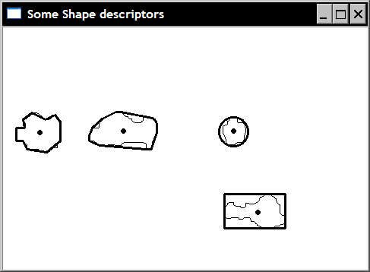
true); // yes it is a closed shape

/// Get the moments
vector<Moments> mu(contours.size() );
for( int i = 0; i < contours.size(); i++ )
{ mu[i] = moments( contours[i], false ); }

/// Get the mass centers:
vector<Point2f> mc( contours.size() );
for( int i = 0; i < contours.size(); i++ )
{ mc[i] = Point2f( mu[i].m10/mu[i].m00 , mu[i].m01/mu[i].m00 ); }

//use of pushback
vector<mat> images;
images.push_back(imread("example.jpg"))

This creates an array (vector is a C++ STL wrapper around arrays) of matrices and puts the image "example.jpg" into a matrix and
pushes that matrix onto the first position of the array.

//Linear Image Filters

Homogeneous Smoothing(Smoothing by averaging)(box filter )

void blur(InputArray src, OutputArray dst, Size ksize, Point anchor=Point(-1,-1), int borderType=BORDER_DEFAULT )

The parameters are:
- src - input image; it can have any number of channels, which are processed independently, but the depth should be CV_8U, CV_16U, CV_16S, CV_32F or CV_64F.
- dst - output image of the same size and type as src.
- ksize - blurring kernel size.
- anchor - anchor point; default value Point(-1,-1) means that the anchor is at the kernel center.
- borderType - border mode used to extrapolate pixels outside of the image.

Eg for (int i=1; i<51; i=i+2)
{
//smooth the image in the "src" and save it to "dst"
blur(src, dst, Size(i,i));

//show the blurred image with the text
imshow( "Smoothing by avaraging", dst );

//wait for 3 seconds
waitKey(3000);
}
kernel size we're using increased from 1x1 to 49x49. We see the smoothed image (more blurred)when we increase the kernel size

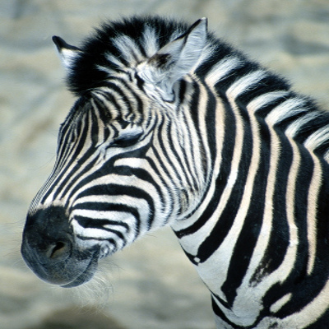
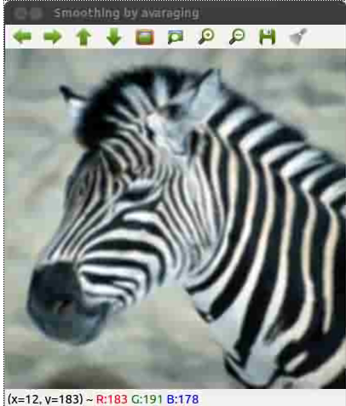

Smoothing (Blurring) by Gaussian
(We can use this filter to eliminate noises in an image.)

void GaussianBlur(InputArray src, OutputArray dst, Size ksize, double sigmaX, double sigmaY=0, int borderType=BORDER_DEFAULT )

Parameters:
- src - input image; the image can have any number of channels, which are processed independently, but the depth should be CV_8U, CV_16U, CV_16S, CV_32F or CV_64F.
- dst - output image of the same size and type as src.
- ksize - Gaussian kernel size. ksize.width and ksize.height can differ but they both must be positive and odd. Or, they can be zeroÃ¢Â€Â™s and then they are computed from sigma*.
- sigmaX - Gaussian kernel standard deviation in X direction.
- sigmaY - Gaussian kernel standard deviation in Y direction; if sigmaY is zero, it is set to be equal to sigmaX, if both sigmas are zeros, they are computed from ksize.width and ksize.height , respectively; to fully control the result regardless of possible future modifications of all this semantics, it is recommended to specify all of ksize, sigmaX, and sigmaY.
- borderType - pixel extrapolation method.
Eg.
for (int i=1; i<51; i=i+2)
{
// smooth the image in the "src" and save it to "dst"
// blur(src, dst, Size(i,i));

// Gaussian smoothing
GaussianBlur( src, dst, Size( i, i ), 0, 0 );

//show the blurred image with the text
imshow( "Gaussian filter", dst );

//wait for 5 seconds
waitKey(5000);
}
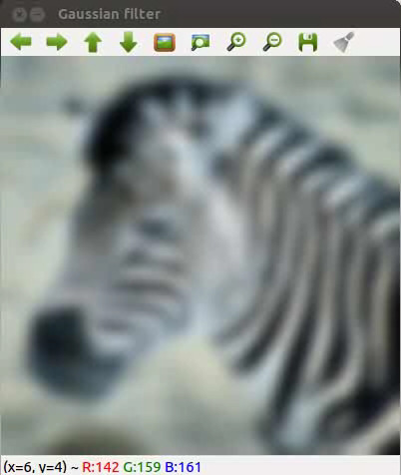

Median filter
(Median smoothinging is widely used in edge detection algorithms because under certain conditions, it preserves edges while removing noise.)

void medianBlur(InputArray src, OutputArray dst, int ksize)
The parameters are:
- src - input 1-, 3-, or 4-channel image; when ksize is 3 or 5, the image depth should be CV_8U, CV_16U, or CV_32F, for larger aperture sizes, it can only be CV_8U.
- dst - destination array of the same size and type as src.
- ksize - aperture linear size; it must be odd and greater than 1, for example: 3, 5, 7 ...
eg. for (int i=1; i<51; i=i+2)
{
// smooth the image in the "src" and save it to "dst"
// blur(src, dst, Size(i,i));

// Gaussian smoothing
// GaussianBlur( src, dst, Size( i, i ), 0, 0 );

// Median smoothing
medianBlur( src, dst, i );

// show the blurred image with the text
imshow( "Median filter", dst );

// wait for 5 seconds
waitKey(5000);
}
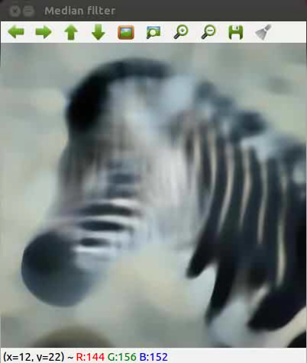

Smoothing (Blurring) by Bilateral
(Bilateral blurring is one of the most advanced filter to smooth an image and reduce noise. The other three filters will smooth away the edges while removing noises, however, this filter can reduce noise of the image while preserving the edges. The drawback of this type of filter is that it takes longer to filter the input image.)

void bilateralFilter(InputArray src, OutputArray dst, int d, double sigmaColor, double sigmaSpace, int borderType=BORDER_DEFAULT )
Parameters:
- src - Source 8-bit or floating-point, 1-channel or 3-channel image.
- dst - Destination image of the same size and type as src.
- d - Diameter of each pixel neighborhood that is used during filtering. If it is non-positive, it is computed from sigmaSpace.
- sigmaColor - Filter sigma in the color space. A larger value of the parameter means that farther colors within the pixel neighborhood will be mixed together, resulting in larger areas of semi-equal color.
- sigmaSpace - Filter sigma in the coordinate space. A larger value of the parameter means that farther pixels will influence each other as long as their colors are close enough. When d>0 , it specifies the neighborhood size regardless of sigmaSpace . Otherwise, d is proportional to sigmaSpace.

for (int i=1; i<51; i=i+2)
{
// smooth the image in the "src" and save it to "dst"
// blur(src, dst, Size(i,i));

// Gaussian smoothing
GaussianBlur( src, dst, Size( i, i ), 0, 0 );

//show the blurred image with the text
imshow( "Gaussian filter", dst );

//wait for 5 seconds
waitKey(5000);
}
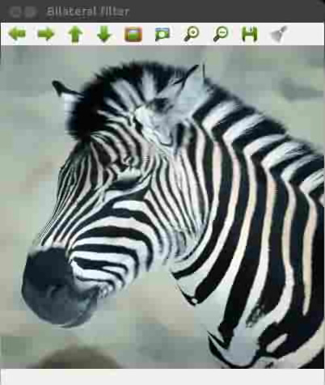

Feature Detection

canny

void Canny(InputArray image, OutputArray edges, double threshold1, double threshold2, int apertureSize=3, bool L2gradient=false )

Parameters | - image – single-channel 8-bit input image.  - edges – output edge map; it has the same size and type as image .  - threshold1 – first threshold for the hysteresis procedure.  - threshold2 – second threshold for the hysteresis procedure.  aperture_size ( a bit complicated :( but try to grasp it or use default-3 in most cases)  - apertureSize – aperture size for the Sobel() operator.  - L2gradient – a flag, indicating whether a more accurate norm should be used to calculate the image gradient magnitude ( L2gradient=true ), or whether the default norm is enough ( L2gradient=false ).
The smallest value between threshold1 and threshold2 is used for edge linking. The largest value is used to find initial segments of strong edges.
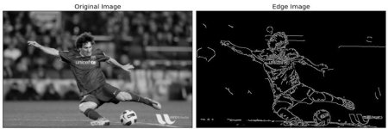
// Run the edge detector on grayscale
Canny(edge, edge, edgeThresh, edgeThresh*3, 3);

HISTOGRAM

The image histogram represents the frequency of occurrence of the various gray levels in the image(gray image).

void calcHist(const Mat* images , int nimages , const int* channels ,
InputArray mask , OutputArray hist , int dims , const int* histSize , const
float** ranges , bool uniform=true , and bool accumulate=false) .

• const Mat* images : The first parameter is the address of the first image
from a collection. This can be used to process a batch of images.
• int nimages : The second parameter is the number of source images.
• const int* channels : The third input parameter is the list of the channels
used to compute the histogram. The number of channels goes from 0 to 2.
• InputArray mask : This is an optional mask to indicate the image pixels
counted in the histogram.
• OutputArray hist : The fifth parameter is the output histogram.
• int dims : This parameter allows you to indicate the dimension of the
histogram.
• const int* histSize : This parameter is the array of histogram sizes in
each dimension.
• const float** ranges : This parameter is the array of the dims arrays of
the histogram bin boundaries in each dimension.
• bool uniform=true : By default, the Boolean value is true . It indicates that
the histogram is uniform.
• bool accumulate=false : By default, the Boolean value is false. It indicates
that the histogram is nonaccumulative

eg.
int histSize = 255;

// Set the ranges ( for B,G,R) )
float range[] = { 0, 256 } ;

const float* histRange = { range };

bool uniform = true;
bool accumulate = false;
Mat b_hist, g_hist, r_hist;

vector<Mat> bgr_planes;

split(Image, bgr_planes );

// Compute the histograms:
calcHist( &bgr_planes[0], 1, 0, Mat(), b_hist, 1, &histSize,
&histRange, uniform, accumulate );
//Mat() no mask is used
calcHist( &bgr_planes[1], 1, 0, Mat(), g_hist, 1, &histSize,
&histRange, uniform, accumulate );
calcHist( &bgr_planes[2], 1, 0, Mat(), r_hist, 1, &histSize,
&histRange, uniform, accumulate );

// Draw the histograms for B, G and R
int hist_w = 512; int hist_h = 400;

int bin_w = cvRound( (double) hist_w/histSize );
Mat histImage( hist_h, hist_w, CV_8UC3, Scalar( 0,0,0) );

// Normalize the result to [ 0, histImage.rows ]
normalize(b_hist, b_hist, 0, histImage.rows, NORM_MINMAX, -1, Mat()
);
normalize(g_hist, g_hist, 0, histImage.rows, NORM_MINMAX, -1, Mat()
);
normalize(r_hist, r_hist, 0, histImage.rows, NORM_MINMAX, -1, Mat()
);
// Draw for each channel
for( int i = 1; i < histSize; i++ )
{
line( histImage, Point( bin_w*(i-1), hist_h - cvRound(b_hist.
at<float>(i-1)) ) , Point( bin_w*(i), hist_h - cvRound(b_hist.
at<float>(i)) ), Scalar( 255, 0, 0), 2, 8, 0 );

line( histImage, Point( bin_w*(i-1), hist_h - cvRound(g_hist.
at<float>(i-1)) ) , Point( bin_w*(i), hist_h - cvRound(g_hist.
at<float>(i)) ), Scalar( 0, 255, 0), 2, 8, 0 );

line( histImage, Point( bin_w*(i-1), hist_h - cvRound(r_hist.
at<float>(i-1)) ) , Point( bin_w*(i), hist_h - cvRound(r_hist.
at<float>(i)) ), Scalar( 0, 0, 255), 2, 8, 0 );
}

imshow("Colour Image Histogram", histImage );

// Equalized Image
// Apply Histogram Equalization to each channel
equalizeHist(bgr_planes[0], bgr_planes[0]);
equalizeHist(bgr_planes[1], bgr_planes[1]);
equalizeHist(bgr_planes[2], bgr_planes[2]);
// Merge the equalized image channels into the equalized image
merge(bgr_planes, imageq );
// Display Equalized Image
imshow( "Equalized Image ", imageq );
// Calculate the histogram to each channel of the equalized image
histogramcalculation(imageq, histImage);
// Display the Histogram of the Equalized Image
imshow("Eq

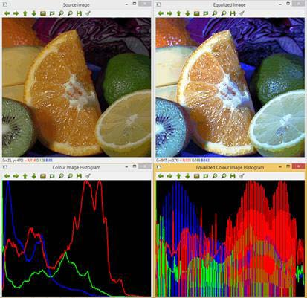

equalized image>
histogram>
equalized histogram>

It is possible to calculate the histogram of more than one input image. This allows you to compare image histograms and calculate the joint histogram of several images.

The comparison of two image histograms, histImage1 and histImage2 , can
be performed with

void compareHist(InputArray histImage1, InputArray histImage2, method)

The Method metric is the used to compute the matching between both histograms. There are four metrics implemented in OpenCV, that is, correlation ( CV_COMP_CORREL ), chi-square ( CV_COMP_CHISQR ), intersection or minimum distance ( CV_COMP_INTERSECT ), and Bhattacharyya distance ( CV_COMP_BHATTACHARYYA )

It is possible to calculate the histogram of more than one channel of the same color image.

The image histogram represents the frequency of occurrence of the various gray levels in the image. The histogram can be modeled so that the image may change its contrast levels. This is known as histogram equalization.
The equalization allows for image areas of lower contrast to gain a higher contrast
void equalizeHist(InputArray src, OutputArray dst)

//HOW TO ROTATE A MATRIX
Mat M = getRotationMatrix2D(Point2f center, double angle, double scale)
warpAffine(src,dst,M,src.size());

As the names of the parameters indicate, center is the center point of the rotation, angle is the rotation angle (in a counter-clockwise direction), and scale is the scale factor.

The following Rotate example shows you how to use the warpAffine function
to rotate an image. A 45-degree centered rotation matrix is firstly obtained by
getRotationMatrix2D( Point2f( src.cols/2, src.rows/2 ), 45, 1 ) .

The example code is:

#include "opencv2/opencv.hpp"
using namespace cv;
int main( int argc, char** argv )
{
// Read the source file
Mat src;
src = imread(argv[1]);
// Apply the rotation
Mat dst;
Mat M = getRotationMatrix2D(Point2f(src.cols/2,src.rows/2),45,1);
warpAffine(src,dst,M,src.size());
// Show the results
namedWindow( " ORIGINAL ", WINDOW_AUTOSIZE );
imshow( " ORIGINAL ", src );
namedWindow( " ROTATED ", WINDOW_AUTOSIZE );
imshow( " ROTATED ", dst );
waitKey();
return 0;
}

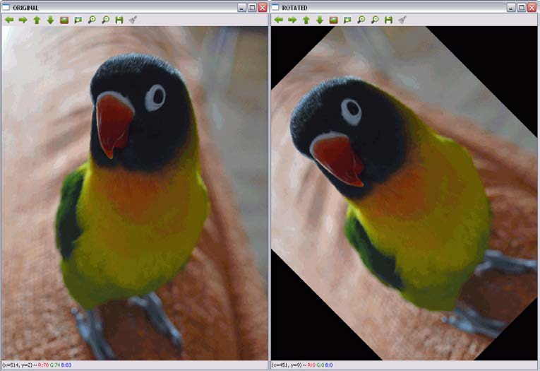

DRAWING

circle(image, Point(x,y),int rad, Scalar(0,255,0), int thickness=1)
//green

ellipse(image, RotatedRect box, Scalar(0,255,0), int thickness=1)

line(image, Point(x,y), Point(x,y), Scalar(0,255,0), int thickness= 1)

rectangle(img, Point(x,y), Point(x,y), Scalar(0,255,0), int thickness)

NOTE: negative thickness will fill in the rectangle

HOMOGRAPHY
homography is a transformation (a 3x3 matrix) that maps the points in one image to the corresponding points in the other image.

object detection:The easiest way to detect and segment an object from an image is the color based methods . The object and the background should have a significant color difference in order to successfully segment objects using color based methods.

OpenCV usually captures images and videos in 8-bit, unsigned integer, BGR format. In other words, captured images can be considered as 3 matrices; BLUE, GREEN and RED (hence the name BGR) with integer values ranges from 0 to 255.
The following image shows how a color image is represented using 3 matrices.
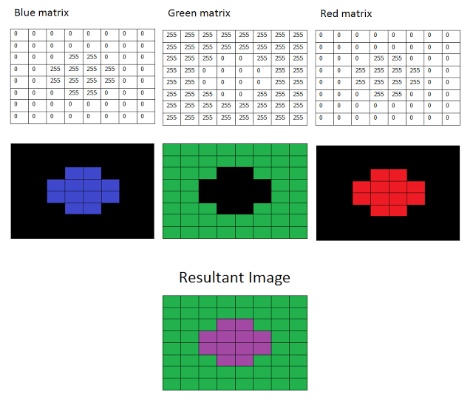
How BGR image is formed
In the above image, each small box represents a pixel of the image. In real images, these pixels are so small that human eye cannot differentiate.
Usually, one can think that BGR color space is more suitable for color based segmentation. But HSV color space is the most suitable color space for color based image segmentation. So, in the above application, I have converted the color space of original image of the video from BGR to HSV image.
HSV color space is also consists of 3 matrices, HUE, SATURATION and VALUE. In OpenCV, value range for HUE, SATURATION and VALUE are respectively 0-179, 0-255 and 0-255. HUE represents the color, SATURATION represents the amount to which that respective color is mixed with white and VALUE represents the amount to which that respective color is mixed with black.
In the above application, I have considered that the red object has HUE, SATURATION and VALUE in between 170-180, 160-255, 60-255 respectively. Here the HUE is unique for that specific color distribution of that object. But SATURATION and VALUE may be vary according to the lighting condition of that environment.
Hue values of basic colors
  - Orange 0-22
  - Yellow 22- 38
  - Green 38-75
  - Blue 75-130
  - Violet 130-160
  - Red 160-179
These are approximate values. You have to find the exact range of HUE values according to the color of the object. I found that the range of 170-179 is perfect for the range of hue values of my object(red object detection) . The SATURATION and VALUE is depend on the lighting condition of the environment as well as the surface of the object.
How to find the exact range of HUE, SATURATION and VALUE for a object is discussed later in this post.
After thresholding the image, you'll see small white isolated objects here and there. It may be because of noises in the image or the actual small objects which have the same color as our main object. These unnecessary small white patches can be eliminated by applying morphological opening. Morphological opening can be achieved by a erosion, followed by the dilation with the same structuring element.
Thresholded image may also have small white holes in the main objects here and there. It may be because of noises in the image. These unnecessary small holes in the main object can be eliminated by applying morphological closing. Morphological closing can be achieved by a dilation, followed by the erosion with the same structuring element.
Now let's discuss new OpenCV methods in the above application.
- void inRange(InputArray src, InputArray lowerb, InputArray upperb, OutputArray dst);
Checks that each element of 'src' lies between 'lowerb' and 'upperb'. If so, that respective location of 'dst' is assigned '255' , otherwise '0'. (Pixels with value 255 is shown as white whereas pixels with value 0 is shown as black)

Arguments -
  - InputArray src - Source image
  - InputArray lowerb - Inclusive lower boundary (If lowerb=Scalar(x, y, z), pixels which have values lower than x, y and z for HUE, SATURATION and VALUE respectively is considered as black pixels in dst image)
  - InputArray upperb - Exclusive upper boundary (If it is upperb=Scalar(x, y, z), pixels which have values greater or equal than x, y and z for HUE, SATURATION and VALUE respectively is considered as black pixels in dst image)
  - OutputArray dst - Destination image (should have the same size as the src image and should be 8-bit unsigned integer, CV_8U)

- void erode( InputArray src, OutputArray dst, InputArray kernel, Point anchor=Point(-1,-1), int iterations=1, int borderType=BORDER_CONSTANT, const Scalar& borderValue=morphologyDefaultBorderValue() )
This function erode the source image and stores the result in the destination image. In-place processing is supported. (which means you can use the same variable for the source and destination image). If the source image is multi-channel, all channels are processed independently and the result is stored in the destination image as separate channels.

Arguments -
  - InputArray src - Source image
  - OutputArray dst - Destination image (should have the same size and type as the source image)
  - InputArray kernel - Structuring element which is used to erode the source image
  - Point anchor - Position of the anchor within the kernel. If it is Point(-1, -1), the center of the kernel is taken as the position of anchor
  - int iterations - Number of times erosion is applied
  - int borderType - Pixel extrapolation method in a boundary condition
  - const Scalar& borderValue - Value of the pixels in a boundary condition if borderType = BORDER_CONSTANT

- void dilate( InputArray src, OutputArray dst, InputArray kernel,
- Point anchor=Point(-1,-1), int iterations=1,
- int borderType=BORDER_CONSTANT,
- const Scalar& borderValue=morphologyDefaultBorderValue() );

This function dilate the source image and stores the result in the destination image. In-place processing is supported. (which means you can use the same variable for the source and destination image). If the source image is multi-channel, all channels are processed independently and the result is stored in the destination image as separate channels.
  - InputArray src - Source image
  - OutputArray dst - Destination image (should have the same size and the type as the source image)
  - InputArray kernel - Structuring element which is used to dilate the source image
  - Point anchor - Position of the anchor within the kernel. If it is Point(-1, -1), the center of the kernel is taken as the position of anchor
  - int iterations - Number of times dilation is applied
  - int borderType - Pixel extrapolation method in a boundary condition
  - const Scalar& borderValue - Value of the pixels in a boundary condition if borderType = BORDER_CONSTANT

- void cvtColor( InputArray src, OutputArray dst, int code, int dstCn=0 )
This function convert a source image from one color space to another. In-place processing is supported. (which means you can use the same variable for the source and destination image)
  - InputArray src - Source image
  - OutputArray dst - Destination image (should have the same size and the depth as the source image)
  - int code - Color space conversion code (e.g - COLOR_BGR2HSV, COLOR_RGB2HSV, COLOR_BGR2GRAY, COLOR_BGR2YCrCb, COLOR_BGR2BGRA, etc)
  - int dstCn - Number of channels in the destination image. If it is 0, number of channels is derived automatically from the source image and the color conversion code.

