Steps :-

1. Add the control to a text field like mentioned below.

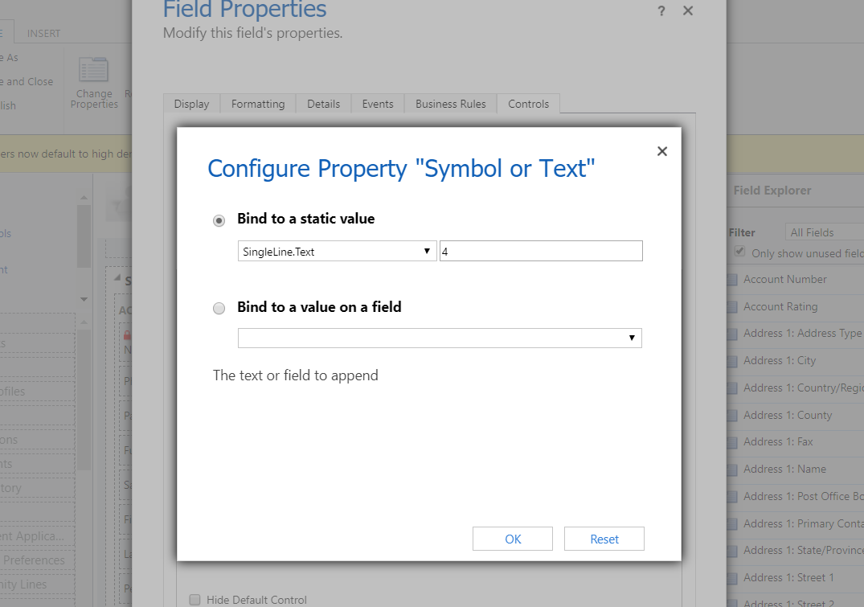

The Control can be bound to a static value or another field on the form.

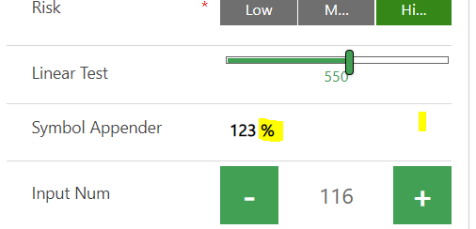

In the example above, a % sign is appended to the field on which the PCF rests. One can also edit and save values.

Note – Since the Aggregator appends immediately on Tab change or loosing focus, one needs to completely empty the textbox while manually entering a new value, else the control keeps appending symbol on loosing focus.