23CSE304 – Embedded Systems
Case Study Review – 1
HASTHA – A Multi-Modal Assistive Robotic Arm
An STM32F401-based 4-DOF robotic arm with IR wireless control, ADC teleoperation, and Morse-to-text handwriting for assistive communication
Team Member | Roll Number | Role
<Name 1> | <Roll No> | Team Leader
<Name 2> | <Roll No> | Member
<Name 3> | <Roll No> | Member
<Name 4> | <Roll No> | Member

HASTHA is an STM32F401-based 4-DOF robotic arm that can be operated through multiple input modes — an infrared (IR) remote, an analog potentiometer, and a host-PC link — to perform pick-and-place tasks and to physically write text on paper. Its primary application is as an assistive device that lets people with severe motor or speech impairment communicate by converting simple inputs, such as eye blinks decoded on a host PC, into Morse code that the arm writes as capital letters. The system also performs pick-and-place, using its gripper to pick up small objects and place them at a target position, so one arm supports both communication and everyday object handling.
What is the Problem?
People with severe motor and speech impairments — such as those with ALS, locked-in syndrome, or quadriplegia — are often unable to speak, write, or physically manipulate objects, even though their cognition is intact. Assistive communication and manipulation devices that could restore some independence are usually expensive, bulky, or require fine motor input the user does not have.
At the same time, most low-cost robotic arms are single-mode (only one control method), are not designed for accessibility, and include no safety mechanism, which makes them unsuitable for use around a person. There is a need for a compact, affordable embedded system that can be controlled through several simple modalities, can write and manipulate objects, and operates safely near people.
Who faces this problem?
- Persons with severe motor / speech impairment
Individuals with paralysis or speech loss need a way to communicate and to interact with objects that does not depend on fine, continuous motor control.
- Caregivers and rehabilitation centres
Caregivers need affordable assistive tools that reduce dependence and support therapy and day-to-day communication.
- People needing help handling everyday objects
Picking up or moving small items such as medicine, a cup, or stationery is difficult or impossible for someone with limited mobility, and currently needs a caregiver every time.
- Small workshops and labs
Low-cost, teleoperated pick-and-place is useful for repetitive light handling tasks where a full industrial arm is not justified.
Why is this a Problem?
The core issue is the lack of an affordable, accessible, multi-modal way to both communicate and manipulate the physical world. For a person who can only blink or make a small movement, the inability to write a message or move a small object removes basic independence and places the full burden on caregivers. Existing solutions rarely combine communication (writing) and manipulation (pick-and-place) in one safe, low-cost device, and single-mode controllers exclude users whose available input may change over time. A flexible embedded system that accepts several input methods and writes real text directly addresses this gap.
Proposed Solution
HASTHA is an STM32F401-based system that drives a 4-DOF robotic arm (base, shoulder, elbow, and gripper) using timer-generated PWM signals. The arm can be commanded in several ways: an IR remote provides wireless selection of joints and pre-set routines (decoded through an external interrupt handled by the NVIC); an analog potentiometer read through the ADC gives fine manual control of a joint; and a UART link to a host PC enables advanced assistive modes.
A 7-segment display continuously shows the active joint, the current angle, and the operating mode. An HC-SR04 ultrasonic sensor provides an emergency-stop safety feature by detecting obstacles or a hand near the arm. On the host-PC side, simple inputs such as eye blinks are decoded into Morse code and streamed over UART; the STM32F401 then converts each decoded character, using inverse-kinematics angle formulas, into servo movements that write the letter on paper. All time-critical events — the servo update loop, IR decoding, ultrasonic echo capture, and UART reception — are handled through interrupts using the NVIC.
For pick-and-place, the arm runs a sequence of joint angles: it positions the gripper above an object, lowers onto it, closes the gripper to grasp, lifts, rotates the base to the drop location, and opens the gripper to release. The same angle-control method is reused whether the target is an object to pick or a point on the paper to write.
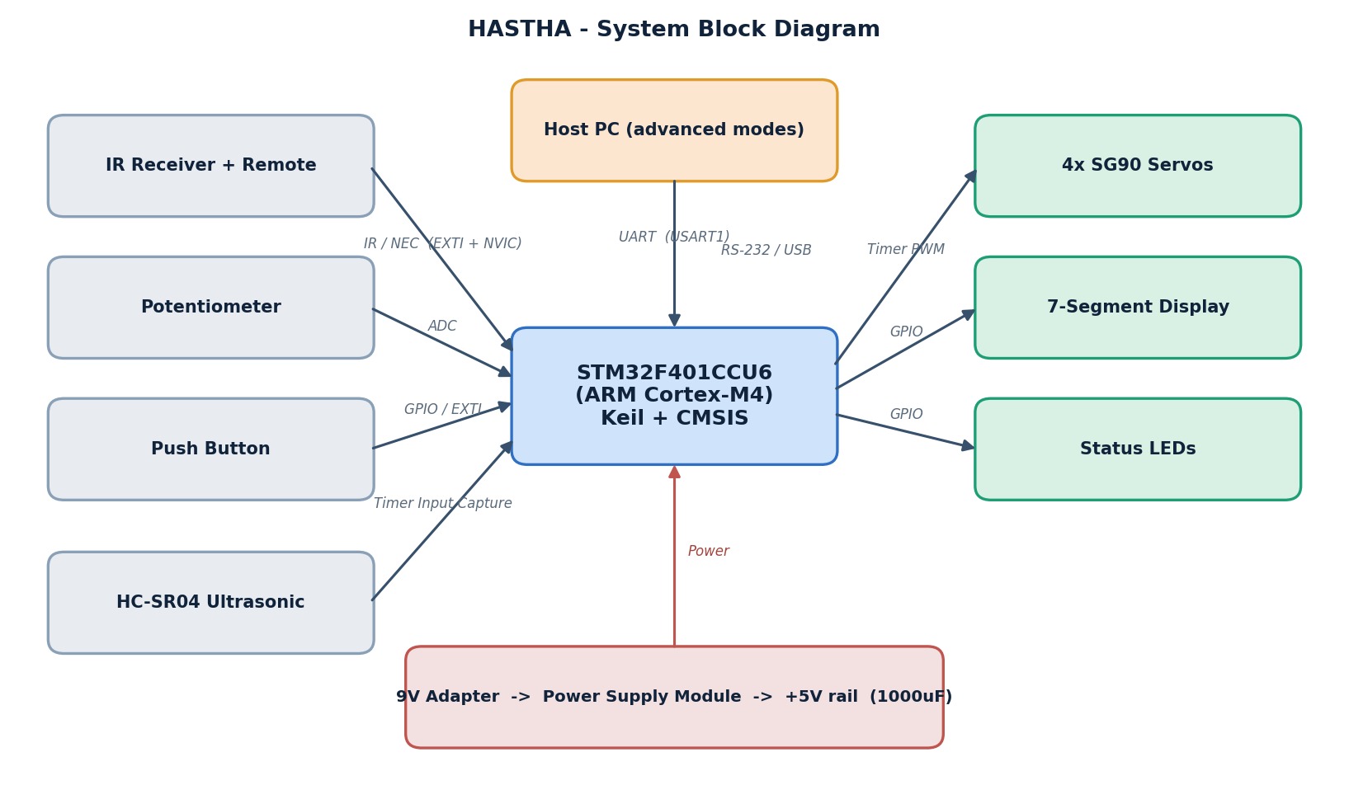
Figure 1: HASTHA system block diagram.
Real-time data flow:
Input (IR remote / potentiometer / PC-Morse) → STM32F401 (decode & compute angles) → Servo actuation + 7-segment display → Ultrasonic safety check
Control Equations Used
1. Servo rotation (angle → PWM):
Each servo is set by the width of a pulse repeated every 20 ms (50 Hz PWM). The required angle (0°–180°) is converted to a pulse width in microseconds and loaded into the timer compare register (CCR):
pulse (µs) = 500 + ( angle × 2000 / 180 )
So 0° → 500 µs, 90° → 1500 µs, 180° → 2500 µs. A larger angle gives a wider pulse, and the servo rotates further. This is the basic equation used to “rotate accordingly”.
2. Reaching a position — pick-and-place (inverse kinematics):
To move the gripper to a target point, the arm computes the joint angles from the point's coordinates. For the two links (upper arm L1, forearm L2) reaching a horizontal distance r and height z:
cos(θ_elbow) = ( r² + z² − L1² − L2² ) / ( 2 · L1 · L2 )
θ_shoulder = atan2( z , r ) − atan2( L2·sin θ_elbow , L1 + L2·cos θ_elbow )
The base rotation sets the left–right (lateral) position of the point:
θ_base = 90° + atan2( x_lateral , y_forward )
These give the base, shoulder and elbow angles, which are then turned into pulses using the equation in step 1.
3. Writing capital letters:
Each capital letter is stored as a set of straight strokes on a small writing grid (for example, A = two slanted lines + one cross-bar). Every stroke is a list of points (x, y) on the paper. Each point is scaled to the letter size and passed through the same inverse-kinematics equations above, so the pen tip traces the stroke:
(x, y) on paper → inverse kinematics → (θ_base, θ_shoulder, θ_elbow) → PWM pulses
The pen is lifted between strokes by raising the target height z (pen up) and lowered to touch the paper while drawing (pen down). A word is written by repeating this for each letter and shifting the start point across the paper.
Impact of the Problem
- Loss of independent communication
Without an accessible writing/communication aid, the user cannot convey needs or thoughts without constant human assistance.
- Dependence on caregivers
Every communication and manipulation task must be performed by another person, increasing caregiver load and reducing the user's autonomy.
- High cost of assistive technology
Commercial assistive manipulators and communication aids are expensive and out of reach for many families and institutions.
- Inability to handle everyday objects
Without assistance the user cannot pick up or move small items — a cup, medicine, or a pen — which removes basic day-to-day independence.
Hardware Components being Used
The system is built around the STM32F401CCU6 and a set of standard, low-cost modules, each mapped to a specific embedded interface required for the project. The complete list is given in Table 1, and the interfaces used are summarised in Table 2.
Implementation Feasibility
Suitable Microcontroller
STM32F401CCU6 (ARM Cortex-M4) is used as the central controller. It provides the timer/PWM channels for four servos, ADC for the potentiometer, multiple GPIO for the display and status LEDs, USART for the PC link, external-interrupt lines for the IR receiver and button, and the NVIC for interrupt handling — all the peripherals HASTHA needs, on a single low-cost board.
Compatible Peripheral Interfaces
Every selected module uses a standard interface that connects directly to the STM32F401 (PWM, ADC, GPIO, UART, IR/EXTI, timer input capture), so no separate controller is needed for any module.
Real-Time Event Processing
The STM32F401 continuously reads its inputs and reacts through interrupts, so the arm responds to a remote press, a potentiometer change, or a PC command without a separate processing system, while the ultrasonic safety check runs in the background.
Local Feedback and Safety
The 7-segment display shows live status, status LEDs indicate mode and emergency-stop, and the ultrasonic sensor freezes the arm when an obstacle is too close — giving clear local feedback and safe operation near people.
Application of the Project
HASTHA can be applied wherever a low-cost, multi-modal, and safe robotic manipulator or assistive communication aid is useful:
- Assistive communication — a paralysed user's eye blinks are decoded to Morse and the arm writes the message as capital letters on paper.
- Pick-and-place handling — the arm picks up a small object and places it at a target position using stored joint-angle sequences or computed inverse-kinematics angles, commanded by the IR remote, the potentiometer, or the PC.
- Assisted daily object handling — fetching or relocating small everyday items such as medicine, a cup, or stationery for a user with limited mobility.
- Rehabilitation and occupational therapy — a controllable, safe arm for guided exercises and interaction.
Table 1 — Hardware Components
Component | Purpose in HASTHA | Interface / Feature | Guideline Requirement
STM32F401CCU6 | Central ARM controller: computes joint angles, decodes inputs, drives all peripherals | ARM MCU / GPIO | Required MCU
SG90 Servo x4 | The 4 arm joints — base, shoulder, elbow, gripper | Timer PWM (GPIO AF) | Peripheral / PWM control
IR Receiver + Remote | Wireless command input — select joint / trigger routine | IR NEC via EXTI + NVIC | Wireless Communication (IR)
Potentiometer | Analog manual control of a joint angle | ADC | ADC Interface
7-Segment Display | Shows active joint, angle and operating mode | GPIO | Display Interface
HC-SR04 Ultrasonic | Obstacle detection / emergency stop | Timer Input Capture + NVIC | Digital / Interrupt
USB-to-Serial (RS-232/CP2102) | Host-PC link for advanced modes and telemetry | UART (USART1) | External Peripheral (UART)
Push Button | Mode change / manual emergency-stop input | GPIO + EXTI (NVIC) | Digital Input
Status LEDs | Power / mode / emergency-stop indication | GPIO | Status Indication
Power Supply Module | Regulated +5 V for servos and logic | Power | Power Regulation
9 V 1 A Adapter | Primary power source | Power | Power Source
1000 uF Capacitors | Power-rail smoothing (anti-brownout) | Power | Power Stability
ST-Link V2 | Programming and debugging of the STM32 | SWD | Programming Tool

Table 2 — Interfaces Used
Interface | HASTHA Components | Purpose
Timer PWM / GPIO | 4x SG90 servos | Joint actuation
ADC | Potentiometer | Analog manual joint control
UART (USART1) | USB-to-Serial to PC | Advanced modes + telemetry
IR (NEC) / EXTI | IR receiver + remote | Wireless remote commands
Timer Input Capture | HC-SR04 ultrasonic | Distance / echo measurement
GPIO (digital I/O) | 7-seg display, LEDs, button, ultrasonic trigger | I/O and status
NVIC (interrupts) | TIM update, IR EXTI, echo capture, UART RX, button EXTI | Real-time event handling

Development Tools
Firmware is developed in Keil uVision using CMSIS register-level functions on the STM32F401. The host-PC assistive layer (blink / Morse decoding) communicates with the board over UART. The circuit is assembled on a breadboard.

