**IKABot User Guide**

Author: Pranay Sahota

As part of selection process, I have implemented a Chatbot based on the requirements conveyed via e-mail.

**Cloud Platform Used:**

AWS

**ML Platform Used:**

Amazon ML

**Programming Language Used:**

C++

This Chatbot was developed using Amazon Lex (A Machine Learning API from Amazon for speech and text recognition).

Model of the chatbot designed on Amazon console.  
Client code written in C++.

**Google Drive Link:**

<https://drive.google.com/file/d/1W5qzyZegon7lsjNMRJX2omqb7BIDpH0U/view?usp=sharing>

**Source Code Link on Github:**

<https://github.com/pranaysahota/IKABot>

On the above mentioned link you will find, a zip folder with name – IKABot.zip

The **zip** folder contains the following files:

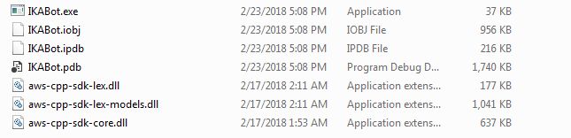

**SDK Used:**

**AWS SDK for C++**

Link: <https://github.com/aws/aws-sdk-cpp>

**DLLs Used:**

DLLs created after building the project for Release are mentioned in the image above (zip file contents)

**aws-cpp-sdk-lex.dll** facilitates runtime service client.

**aws-cpp-sdk-lex-models.dll** facilitates chatbot model creation

**aws-cpp-sdk-core** facilitates basic APIs provided by Amazon to carry out development.

***To run the program please open IKABot.exe*** and below mentioned questions will be answered by the chatbot.

* Who are you?
* What is IKA?
* Where is Staufen?
* How can you help me?
* What is your name?

**Design Technique:**  
Chatbot designed using Intent technique. Intents are conversational contexts that are fulfilled based on the input provided by user and responding with appropriate response.

Response to utterances by user are set to Chatbot in Lex Console, responding to basic questions like Who are you? etc.

Since this is a basic version. Slots weren’t applied in this implementation as they can be used to question back the user for more input and then carry out a task as per user’s wish.

Also, current build only supports Text input from console.

And the Request used to hit AWS for response is **PostText**.

*To carry out the development for speech input, voice input will be taken from user and* ***PostContent*** *request will be used which supports both text and speech input.*