Convolutional Neural Network (CNN) in Machine Learning

CNNs are tools used in machine learning, basically related to vision and image processing (grid like data). It is type of deep learning algorithm which is well designed for image recognition and processing tasks.
It consists of various layers such as-

1.) Convolutional Layers
2.) Fully Connected Layers
3.) Pooling Layers

-WHAT DO CONVOLUTIONS SHOW UP?

It is a concept of basically combining two functions, not simply adding or multiplying something but making a new function out of the two. It tells us about applying the concept to image processing using kernels(In image processing context the 3 x 3 grid chosen is called kernel.
with different kernels, you get different effects.) and filters.

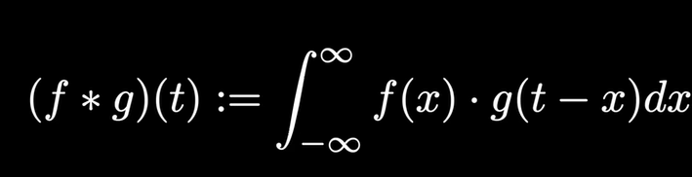

To understand the concept of convolution,let's take an example given in the video of a pair of dicewhere each number on a die has its own probability.Now to find out the probability of the numbers adding up to a particular number, we use convolution.

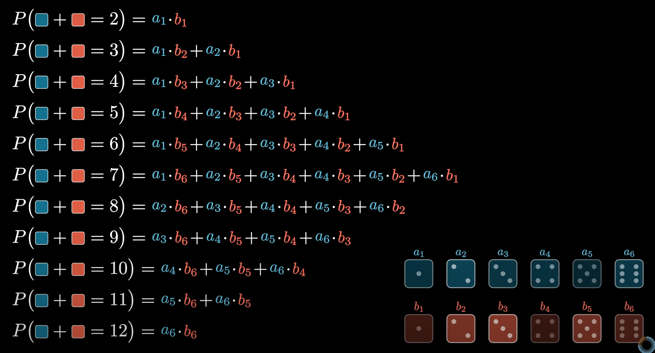

Other application of Convolution is to smoothen out an image.Let's say, we take a group of 4 number numbers each having some value.After convolving the original function, we get a smoother version.

FFT Convolve

It has been seen that when we multiply two polynomials together, the coefficients of the product can be find out by convolving the product of their polynomials.

The degree n of a polynomial can be found if we know the value of the polynomial at n different points, but with n tending to a very large number this method is not so efficient so we use discrete fourier transformation.

The time complexity of a convolution is $O(n^2)$ wher n is the size of input, for FFTs we use the concept of polynomial multiplication analogy in which we multiply
the lists to find out the polynomial and putting the values at different points to find out the function.

