**M.Sc. Sem-IV (CS)**

**Paper-IV (Parallel Computing)**

**Unit-IV**

1. A________________________is a single stream of control in the flow of a program

**A. thread**

B. hyperthread

C. hypothread

D. multithread

Ans: A

2. A________________________variable is a data object used for synchronizing threads. This variable allows a thread to block itself until specified data reaches a predefined state.

A. Critical

B. shared

**C. condition**

D. pointer

Ans: C

3. OpenMP directives in C and C++ are based on which compiler directives.

A. #include

**B. #pragma**

C. Using namespace std

D. #OpenMP

Ans: B

3. Threaded APIs provide support for implementing critical sections and atomic operations using mutex-locks. What is mutex locks?

A. exclusive lock

**B. mutual exclusion locks**

C. shared lock

D. shared exclusive lock

Ans: B

4. What is recursive mutex?

A. A recursive mutex allows a multiple thread to lock a mutex multiple times

B. A recursive mutex allows a single thread to lock a mutex single time

C. A recursive mutex allows a multiple thread to lock a mutex single time **D. A recursive mutex allows a single thread to lock a mutex multiple times**

Ans: D

5. Match the following directives in OpenMP

1. Barrier A. Single thread execution

2. Single and master B. Synchronization point

3. Critical and atomic C. In-Order execution

4. Ordered D. Critical sections

Ans: 1-B, 2-A, 3-D, 4-C

6. These are OMP_NUM_THREADS, OMP_DYNAMIC, OMP_NESTED, OMP_SCHEDULE________________________.

A. Thread

**B. Environmental variables**

C. Variables

D. Directives

Ans: B

7. A________________________call is used to hold a thread until all other threads participating in the barrier have reached the barrier. These can be implemented using a counter, a mutex and a condition variable.

**A. Barrier**

B. Remote

C. Function

D. Interrupt

Ans: A

8. Which of the following formulations are used for matrix vector multiplication (i) Rowwise 1- D partitioning (ii) Cloumnwise 1-D partitioning (iii) 2-D partitioning

A. (i) and (ii) are correct

B. (ii) and (iii) are correct

C. (i) and (iii) are correct

**D. All of the above are correct**

Ans: D

9. Which is a distributed algorithm for matrix multiplication for two-dimensional meshes?

**A. Cannon’s algorithm**

B. capsule algorithm

C. cap algorithm

D. cat algorithm

Ans: A

10. Name the directive.

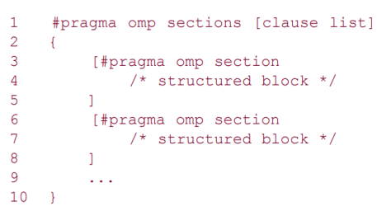A. pragma directive

B. parallel directive

C. omp directive

**D. Sections directive**

Ans: D

11. Name the directive

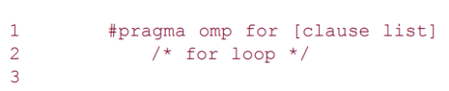A. omp directive

B. parallel directive

C. sections directive

**D. for directive**

Ans: D

12. Write the correct syntax of directive.

A. #pragma [clause list] omp directive

B. #pragma [clause list] directive omp

C. #pragma directive [clause list] omp

**D. #pragma omp directive [clause list]**

Ans: D

13. OpenMP is not a standard for directive based parallel programming

A. True

**B. False**

Ans: B

14. What does following thread do? A. creation

**B. cancel**

C. open

D. close

Ans: B

15. What is OpenMP?

A.

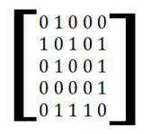B.

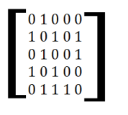

C. 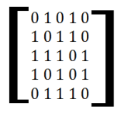

D. 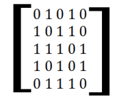

Ans: A

16. Find minimum spanning tree of the following graph 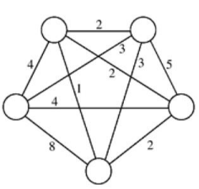A.

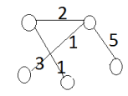

B.

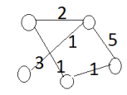

C.

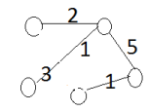

D.

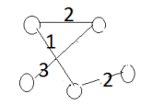

Ans: D

17. A________________________of an undirected graph G is a subgraph of G that is a tree containing all the vertices of G

A. tree

**B. spanning tree**

C. span tree

D. spam tree

Ans: B

18. A________________________for a weighted undirected graph is a spanning tree with minimum weight.

A. minimal tree

B. minimal spanning tree

C. minimum tree

**D. minimum spanning tree**

Ans: D

19. Which of the following are shortest path algorithm?

A. Distance algorithm

B. Design algorithm

**C. Dijkastra's algorithm**

D. Dijastra's algorithm

Ans: C

20. Which of the following is a minimum spanning tree algorithm

A. Floyd's algorithm

**B. Prim's minimum spanning tree**

C. Dijkastra's algorithm

D. Prism minimum spanning tree

Ans: B

21. Which algorithm works with graphs having negative-weight edges provided they contain no negative-weight cycles?

**A. Floyd's algorithm**

B. Dijkastra's algorithm

C. Prim's algorithm

D. all of the above

Ans: A

22. Dijkstra’s Algorithm is used to solve________________________problems

A. All pair shortest path

**B. Single source shortest path**

C. Network flow

D. Sorting

Ans: B

23. What is the minimum number of spanning tree in a connected graph?

**A. 1**

B. 2

C. 3

D. 4

Ans: A

24. We use Dijkstra’s Algorithm to________________________.

A. non-weighted non-negative

B. weigthed non-negative

**C. weighted positive**

D. non-weighted positve

Ans: C

25. Which of the following are matrix-matrix multiplication algorithms DNS algorithm Block matrix multiplication algorithm Simple parallel algorithm Cannon’s algorithm

A. (i) and (iii) are correct

B. (i) and (ii) are correct

C. (ii) and (iii) are correct

**D. All of the above are correct**

Ans: D

26. What does following algorithm find?

A. A parallel algorithm for multiplying an n x n matrix A with an n x 1 vector x to yield an n x 1 product vector y.

B. A DNS algorithm for multiplying an n x n matrix A with an n x n vector x to yield an n x 1 product vector y.

**C. A serial algorithm for multiplying an n x n matrix A with an n x 1 vector x to yield an n x n product vector y.**

D. A Canon algorithm for multiplying an n x n matrix A with an n x n vector x to yield an n x n product vector y.

Ans: C

27. Parallel algorithm based on partitioning intermediate data that can use up to n3 processes and that performs matrix multiplication in time Q(log n) by using W(n3/log n) processes. This algorithm is known as the________________________.

**A. DNS algorithm**

B. block matrix multiplication algorithm

C. simple parallel algorithm

D. Cannon’s algorithm

Ans: A

28. Gauss elimination method is use to solve System of linear equations The statement is

**A. True**

B. False

Ans: A

29. Multiplication of an n x n matrix with an n x 1 vector using rowwise block is a

**A. 1-D partitioning**

B. 2-D partitioning

C. 3-D partitioning

D. 4-D partitioning

Ans: A

30. Find adjacency matrix of the following graph?

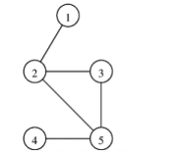**A.**

****B.

C.



D.



Ans: A

31. Parallel matrix-vector multiplication for the case in which the matrix is distributed among the processes using a block ___________________

A. 1-D partitioning

**B. 2-D partitioning**

C. 3-D partitioning

D. 4-D partitioning

Ans: B

32. A discrete optimization problem can be expressed as a tuple (S, f). The set S is a finite or countably infinite set of all solutions that satisfy specified constraints. This set is called the set of feasible solutions. The statement is

**A. True**

B. False

Ans: A

33. A________________________is a commonly used technique for solving a wide variety of discrete optimization problems such as scheduling, string-editing, packaging, and inventory management

A. programming

B. static programming

**C. Dynamic Programming**

D. program

Ans: C

34. Name the directive?

A. for directive

**B. parallel directive**

C. omp directive

D. Sections directive

Ans: B

35. The Pthreads API allows a programmer to change the default attributes of entities using________________________. It is a data-structure that describes entity (thread, mutex, condition variable) properties.

A. Class

B. Object

C. Attribute

**D. Attribute objects**

Ans: D

36. A thread reading a shared data item acquires a _________________ lock on the variable. A ___________ lock is granted when there are other threads that may already have read locks. If there is a write lock on the data , the thread performs a condition wait.

**A. read, read**

B. read, write

C. write,read

D. write,write

Ans: A

37. What does following functions perform?

A. destroy thread

**B. set and monitor thread creation**

C. update thread

D. None of the above

Ans: B

38. Dijkstra's all-pairs shortest paths problem can be parallelized in two distinct ways - source partitioned formulation and source-parallel formulation

**A. True**

B. False

Ans: A