R_CaseStudy_Visualization

Pranay

17/11/2020

library(dplyr)

## Warning: package 'dplyr' was built under R version 4.0.3

##   
## Attaching package: 'dplyr'

## The following objects are masked from 'package:stats':  
##   
## filter, lag

## The following objects are masked from 'package:base':  
##   
## intersect, setdiff, setequal, union

library(ggplot2)  
library(sqldf)

## Loading required package: gsubfn

## Loading required package: proto

## Loading required package: RSQLite

## Warning: package 'RSQLite' was built under R version 4.0.3

library(tidyr)  
library(readr)

## Warning: package 'readr' was built under R version 4.0.3

SalesData = read.csv('D:\\Study\\AnalytixLabs\\Case Studies\\R\\R case study 3 (Visualization)\\SalesData.csv')  
  
################################## Q1 ##################################  
  
Saless=SalesData %>%  
 group_by(Region) %>%  
 summarise(Total_sales2015=round(sum(Sales2015) ), Total_sales2016=round(sum(Sales2016)))

## `summarise()` ungrouping output (override with `.groups` argument)

df2= tidyr::pivot_longer(Saless,cols=c('Total_sales2015','Total_sales2016'),  
 names_to='Year',values_to='Sales')  
  
  
ggplot(df2, aes(x=Region, y=Sales, fill=Year)) +  
 geom_bar(stat='identity', position='dodge') +  
 geom_text(aes(label=Sales))

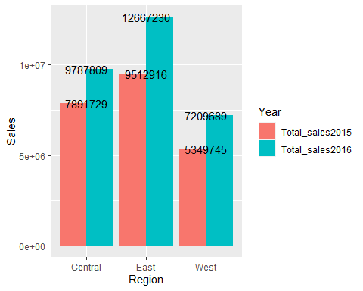

################################## Q2 ##################################  
  
# a ---------------------------------------------------------------------  
Saless1=SalesData %>%  
 group_by(Region) %>%  
 summarise(Total_sales2016=(sum(Sales2016) )) %>%  
 mutate(percnt=round(Total_sales2016/sum(Total_sales2016)*100)) %>%  
 mutate(percnt1=paste(percnt,"%",Region))

## `summarise()` ungrouping output (override with `.groups` argument)

pie(Saless1$percnt,labels = Saless1$Region)

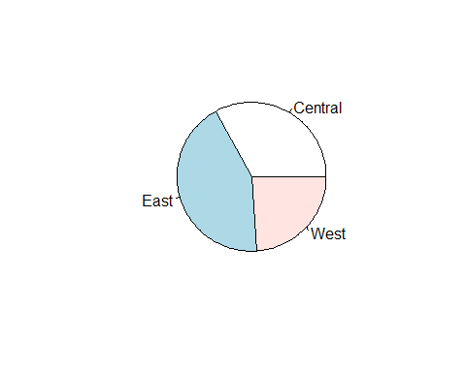

# b ---------------------------------------------------------------------  
  
library(plotrix)  
  
Saless1=SalesData %>%  
 group_by(Region) %>%  
 summarise(Total_sales2016=(sum(Sales2016) )) %>%  
 mutate(percnt=round(Total_sales2016/sum(Total_sales2016)*100)) %>%  
 mutate(percnt1=paste(percnt,"%",Region))

## `summarise()` ungrouping output (override with `.groups` argument)

pie3D(Saless1$percnt,labels= Saless1$percnt1,explode = 0.1,  
 radius = 1.5,main="Pie Chart Of Sales 2016",  
 col = rainbow(length(Saless1$percnt)))  
  
pie3D(Saless1$percnt,labels= Saless1$percnt1,explode = 0.1,  
 radius = 1.5,main="Pie Chart Of Sales 2016",  
 col = rainbow(length(Saless1$percnt)))

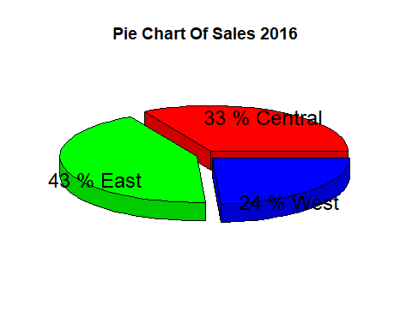

# c ---------------------------------------------------------------------  
  
Saless1=SalesData %>%  
 group_by(Region) %>%  
 summarise(Total_sales2016=(sum(Sales2016) )) %>%  
 mutate(percnt=round(Total_sales2016/sum(Total_sales2016)*100))

## `summarise()` ungrouping output (override with `.groups` argument)

ggplot(Saless1,aes(x="",y=percnt,fill=Region))+  
 geom_bar(width = 1,stat = "identity")+  
 coord_polar("y",start = 0)+  
 # theme_void()+  
 # theme(legend.background = "black")  
 geom_text(aes( label=paste0(round(percnt),"%")),  
 position = position_stack(vjust =0.2))+  
   
 labs(title = "Pie Chart Of Sales 2016")+  
 guides(fill=guide_legend(reverse = TRUE))+  
 scale_fill_manual(values = c("#FF3366","#999999","#33cc99"))+  
 theme_classic()+  
 theme(axis.line = element_blank(),  
 axis.text = element_blank(),  
 axis.ticks = element_blank(),  
 axis.title = element_text(hjust = 0.5))

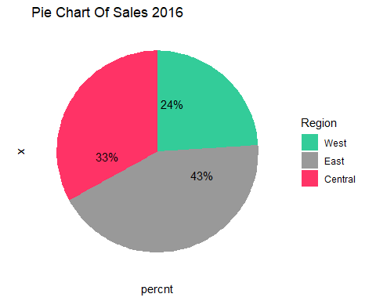

################################## Q3 ##################################  
  
Saless=SalesData %>%  
 group_by(Region,Tier) %>%  
   
 summarise(Total_sales2015=(sum(Sales2015) ),Total_sales2016=(sum(Sales2016)))

## `summarise()` regrouping output by 'Region' (override with `.groups` argument)

df2= tidyr::pivot_longer(Saless,cols=c('Total_sales2015','Total_sales2016'),  
 names_to='Year',values_to='Sales')  
  
  
ggplot(df2, aes(x=Tier, y=Sales, fill=Year)) +  
 geom_bar(stat='identity', position='dodge') +  
 facet_wrap(~ Region)

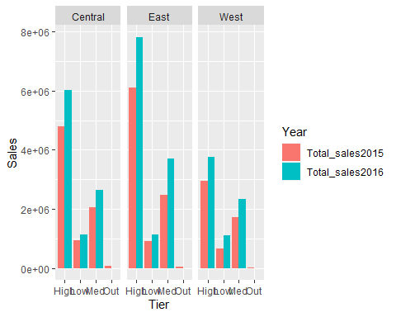

################################## Q4 ##################################  
  
Saless=SalesData %>%  
 group_by(Region,State) %>%  
 filter(Region=='East') %>%  
   
 summarise(Total_sales2015=(sum(Sales2015) ),Total_sales2016=(sum(Sales2016)))

## `summarise()` regrouping output by 'Region' (override with `.groups` argument)

df2= tidyr::pivot_longer(Saless,cols=c('Total_sales2015','Total_sales2016'),  
 names_to='Year',values_to='Sales')  
  
  
ggplot(df2, aes(x=State, y=Sales, fill=Year)) +  
 geom_bar(stat='identity', position='dodge')

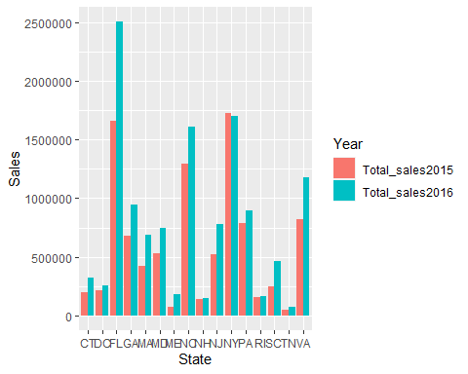

################################## Q5 ##################################  
  
Q_5 = sqldf('select Tier, Division, sum(Units2015) Total_sales2015, sum(Units2016) Total_sales2016  
 from SalesData  
 where Tier = "High"  
 group by Tier, Division  
 ')  
  
Q_5_i = tidyr::pivot_longer(Q_5, cols = c(Total_sales2015, Total_sales2016),   
 names_to='Year',values_to='Units')  
  
ggplot(Q_5_i, aes(x = Division, y = Units, fill = Year)) +   
 geom_bar(stat='identity', position='dodge')

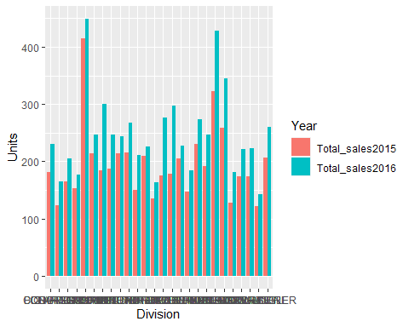

################################## Q6 ##################################  
  
  
SalesData$Qtr=ifelse(SalesData$Month %in% c('Jan','Feb','Mar'),'Q1',  
 ifelse(SalesData$Month %in% c('Apr','May','Jun'),'Q2',  
 ifelse(SalesData$Month %in% c('Jul','Aug','Sep'),'Q3','Q4')))   
View(SalesData)  
  
  
################################## Q7 ##################################  
  
df7 = sqldf('select Qtr,sum(Sales2015) "Total_Sales_2015",  
sum(Sales2016) "Total_Sales_2016"  
 from SalesData  
 group by Qtr')  
  
df7_i = tidyr::pivot_longer(df7,cols = c(Total_Sales_2015, Total_Sales_2016),  
 names_to = "Year", values_to = "Sales")  
  
  
  
ggplot(df7_i, aes(x = Qtr, y =Sales, fill = Year)) +   
 geom_bar(stat = "identity", position = "dodge")

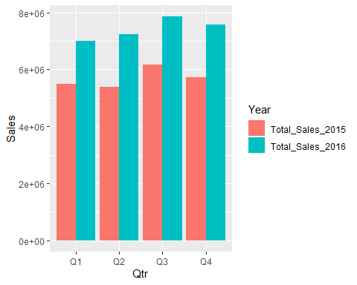

################################## Q8 ##################################  
  
Saless=SalesData %>%  
 group_by(Tier) %>%  
 summarise(Total_sales2015=(sum(Sales2015) ))

## `summarise()` ungrouping output (override with `.groups` argument)

pie(Saless$Total_sales2015,labels = Saless$Tier,main = 'Qtr1',radius = 0.5)

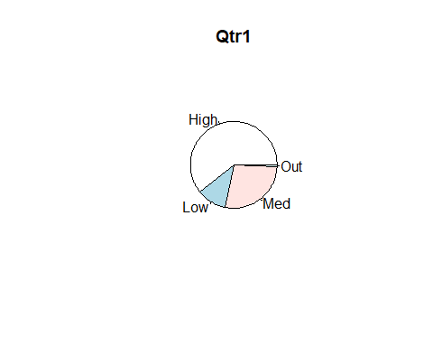

pie(Saless$Total_sales2015,labels = Saless$Tier,main = 'Qtr2',radius = 0.5)

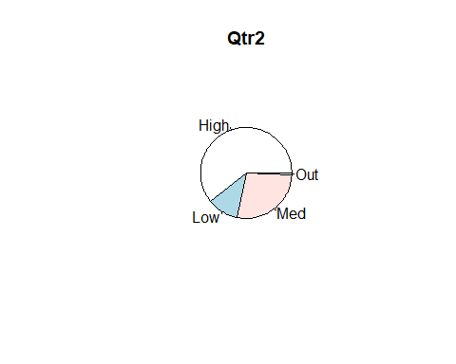

pie(Saless$Total_sales2015,labels = Saless$Tier,main = 'Qtr3',radius = 0.5)

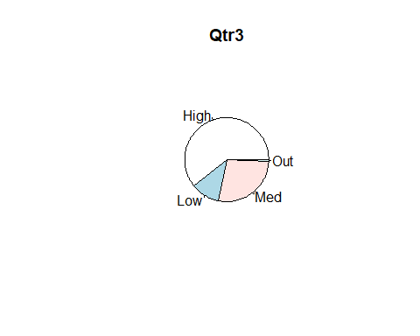

pie(Saless$Total_sales2015,labels = Saless$Tier,main = 'Qtr4',radius = 0.5)

