SentinelTwin
AI-native physical security digital twin for reviewing coverage in a live scene.
Hackathon Update
The current submission shows an in-progress but coherent studio workflow.
- Map-first scene editing
- Camera, replay, and comparison review modes
- Coverage and blind-spot feedback
- Visual exploration of security risk in the scene
- This is a progress update, not a full product reveal. The visuals below show the current shape of the experience.
What is next
The next phase is about tightening the studio experience, finishing the remaining review flows, and making the security feedback easier to read at a glance.
Repo structure
- apps/studio - main studio app
- Docs/ - architecture, decisions, exploration, and progress notes
Core studio views
Studio map view
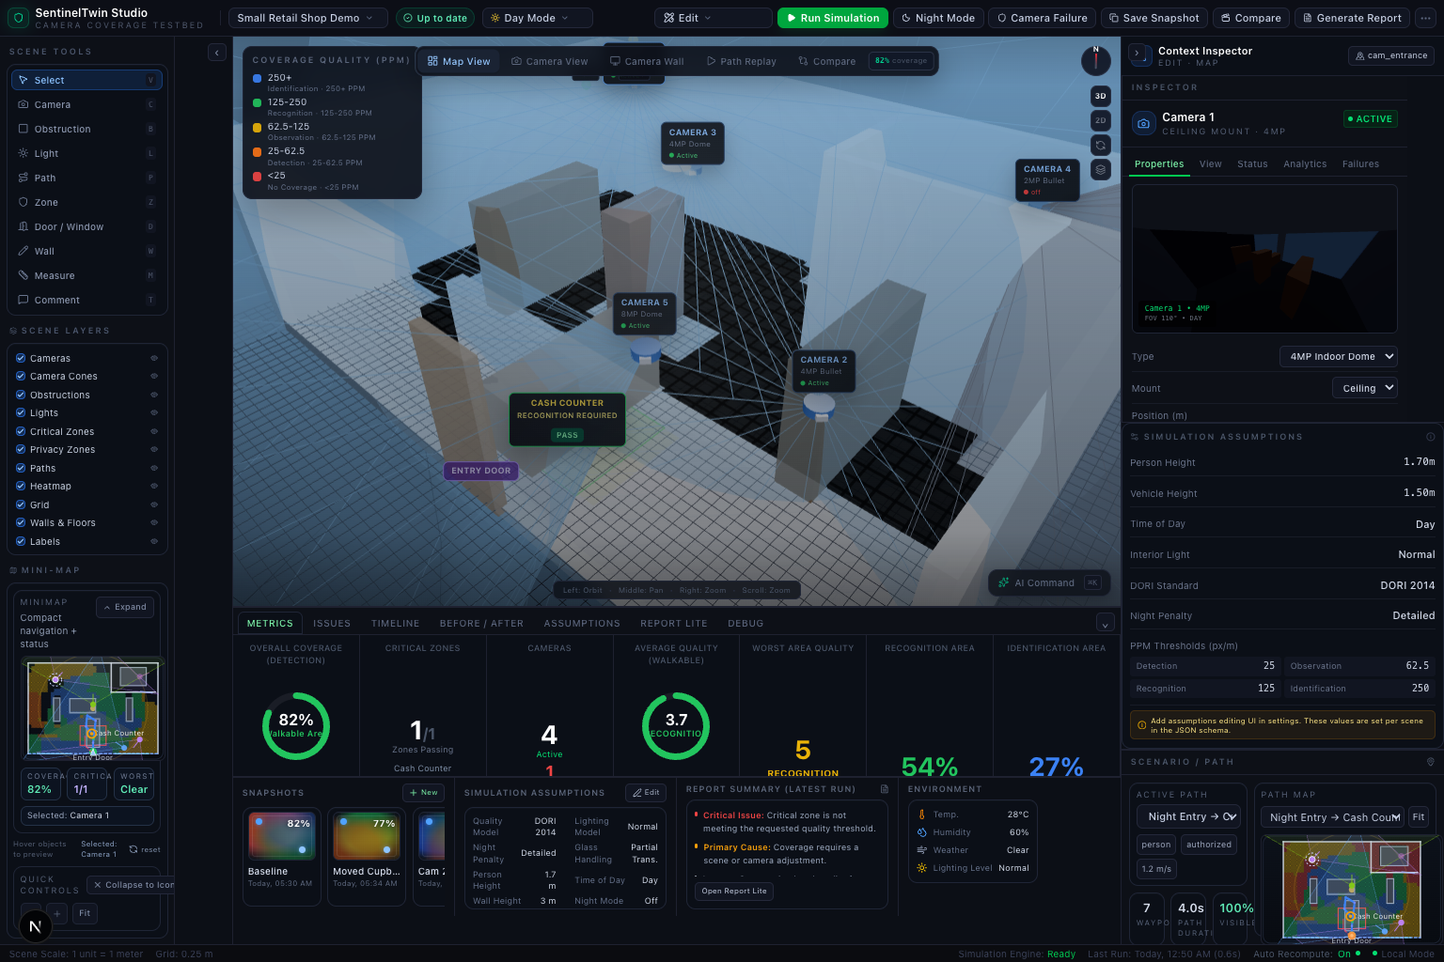

Camera view
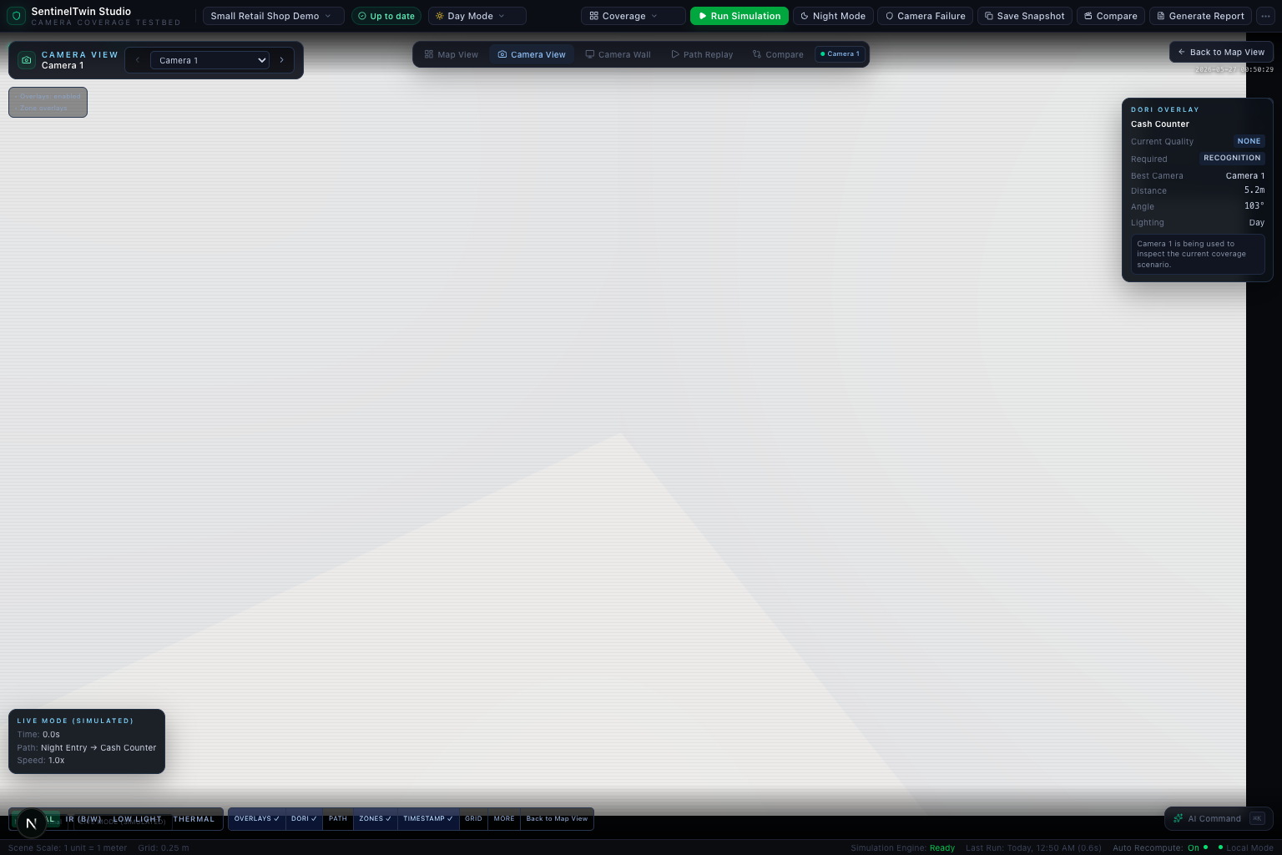

Path replay view
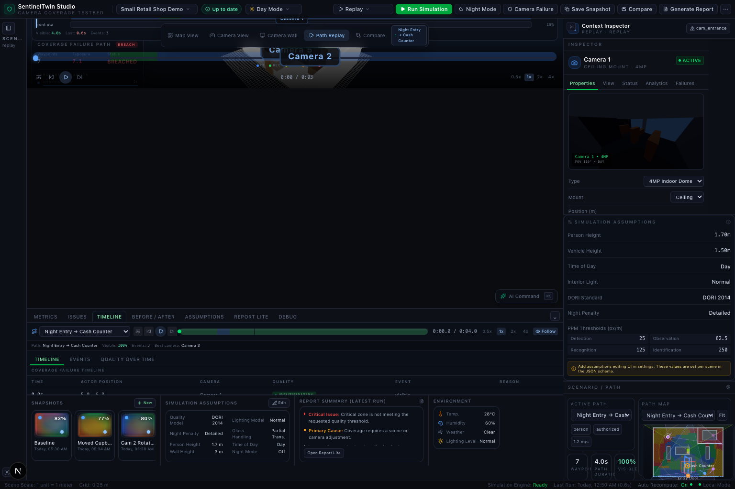

Camera wall view
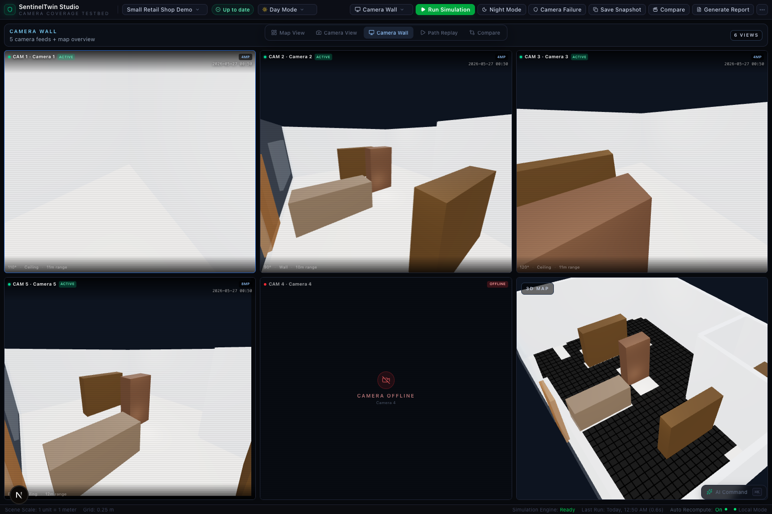

Compare view
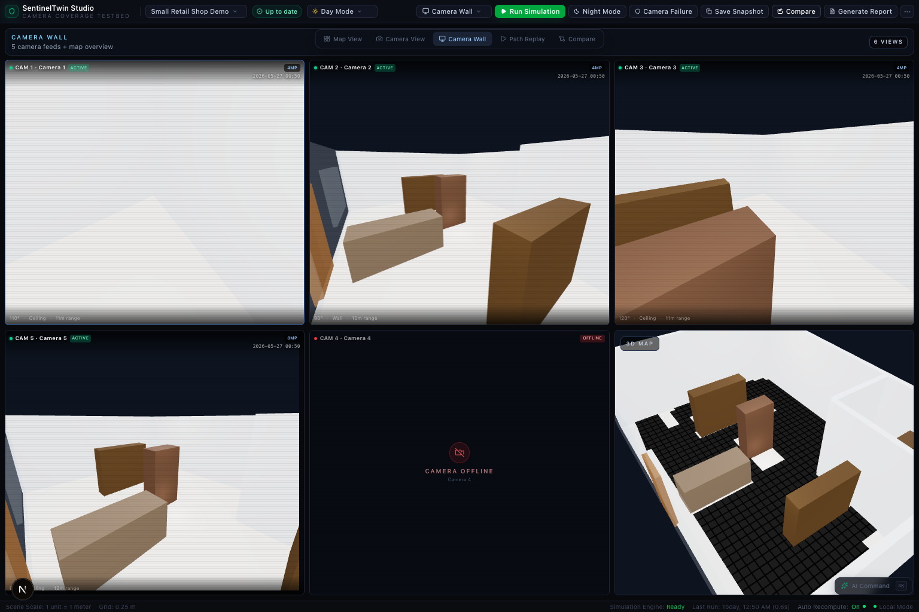

Final studio check
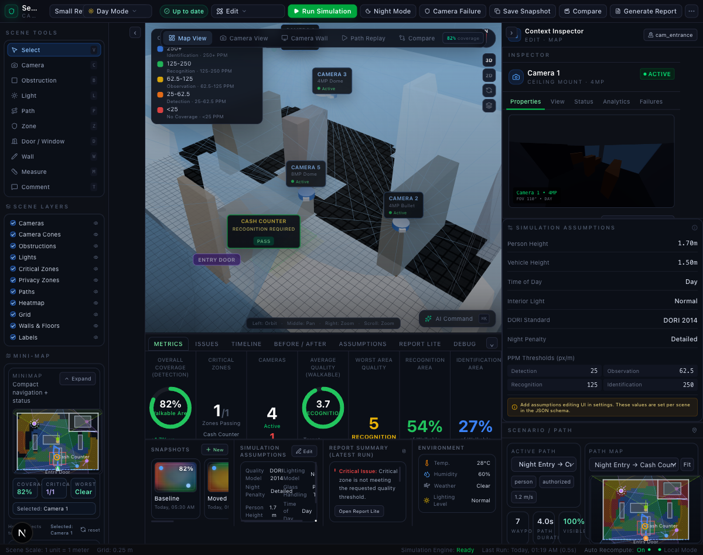

Design direction
Studio map design
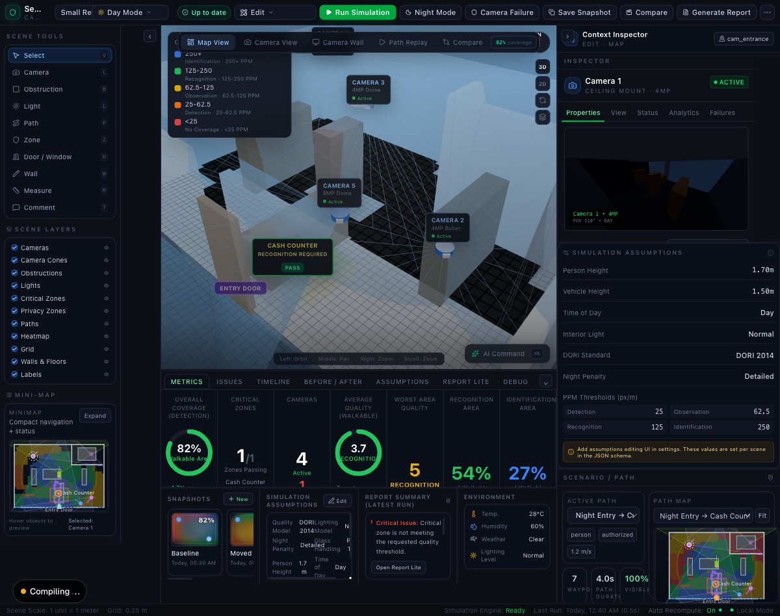

Expanded studio design
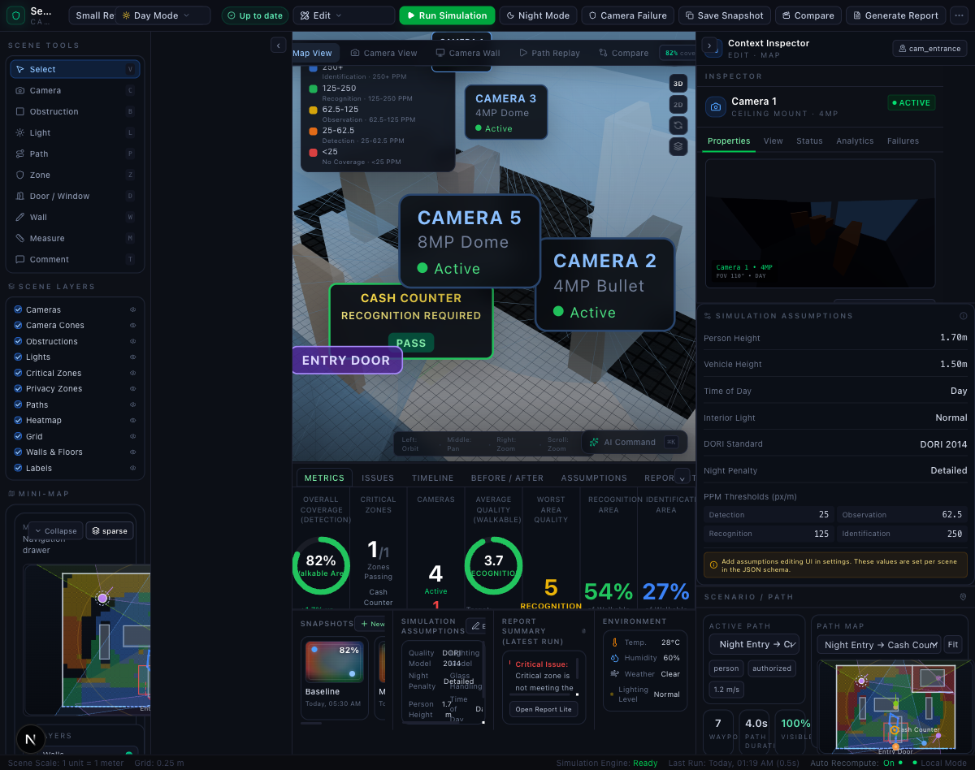

Notes
This document is intentionally high-level for the hackathon submission update. The detailed architecture and working notes live in Docs/.

