**FOOTPRINTING ON AMAZON WEBSITE.**



<https://www.linkedin.com/company/amazon/?originalSubdomain=in>

<https://www.amazon.com/>

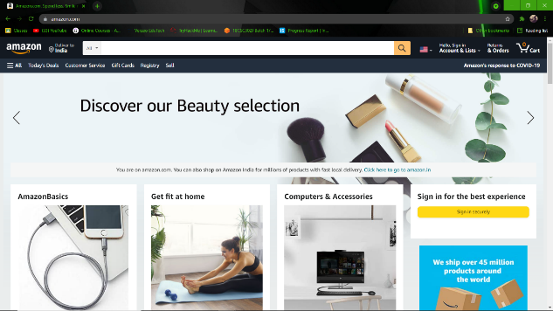

|  |  |
| --- | --- |
| **Registrant** | Hostmaster, Amazon Legal Dept. |
| **Registrant Org** | Amazon Technologies, Inc. |
| **Registrant Country** | us |
| **Registrar** | MarkMonitor, Inc. MarkMonitor Inc. IANA ID: 292 URL: http://www.markmonitor.com Whois Server: whois.markmonitor.com  (p) |
| **Registrant** | Hostmaster, Amazon Legal Dept. | |
| **Registrant Org** | Amazon Technologies, Inc. | |
| **Registrant Country** | us | |
| **Registrar** | MarkMonitor, Inc. MarkMonitor Inc. IANA ID: 292 URL: http://www.markmonitor.com Whois Server: whois.markmonitor.com  (p) | |
| **Registrar Status** | clientDeleteProhibited, clientTransferProhibited, clientUpdateProhibited, serverDeleteProhibited, serverTransferProhibited, serverUpdateProhibited | |
| **Dates** | 9,785 days old Created on 1994-10-31 Expires on 2024-10-30 Updated on 2019-08-26 |  |
| **Name Servers** | NS1.P31.DYNECT.NET (has 227,159 domains) NS2.P31.DYNECT.NET (has 227,159 domains) NS3.P31.DYNECT.NET (has 227,159 domains) NS4.P31.DYNECT.NET (has 227,159 domains) PDNS1.ULTRADNS.NET (has 93,571 domains) PDNS6.ULTRADNS.CO.UK (has 3,221 domains) |  |
| **Tech Contact** | Hostmaster, Amazon Legal Dept. Amazon Technologies, Inc. P.O. Box 8102, Reno, NV, 89507, us  (p) (f) | |
| **IP Address** | 52.84.168.188 - 2 other sites hosted on this server |  |
| **IP Location** | Brazil - Sao Paulo - Sao Paulo - Amazon.com Inc. | |
| **ASN** | Brazil AS16509 AMAZON-02, US (registered May 04, 2000) | |
| **Domain Status** | Registered And Active Website | |
| **IP History** | 455 changes on 455 unique IP addresses over 17 years |  |
| **Registrar History** | 2 registrars with 1 drop |  |

|  |  |
| --- | --- |
| **The Amazon Spheres, part of the Amazon headquarters in Seattle, U.S.** | |
| Total equity | US$93.404 billion (2020) |
| Number of employees | **1,298,000** (Dec. 2020) U.S.: 810,000 (Oct. 2020) |

# Officers and directors

**Jeffrey P. Bezos**Executive Chair



|  |  |
| --- | --- |
| **Jeff Bezos Contact Address, Phone Number, Email ID, Website** |  |
| Phone Number | **1-888-280-4331** or 1-206-266-1000 |
| House address (residence address) | c/o Amazon, Inc. P.O. Box 907 Bellevue, WA 98009 |

Jeff Bezos founded [Amazon.com](http://amazon.com/) in 1994. Amazon’s mission is to be Earth's most customer-centric company. Amazon offers low prices and fast delivery on millions of items, provides thousands of movies and TV shows through Prime Video, designs and builds the bestselling Kindle, Fire and Echo devices and Alexa voice recognition service, and empowers companies and governments in over 190 countries around the world with the leading cloud computing infrastructure through Amazon Web Services. Bezos is also the founder of aerospace company Blue Origin, which is working to lower the cost and increase the safety of spaceflight, and he is owner of the Washington Post. Bezos has launched two philanthropic organizations. The Bezos Earth Fund helps fund nonprofits preserving and protecting the natural world, and The Bezos Day One Fund provides grants to nonprofits to help homeless families and is creating a network of preschools in low-income communities. Bezos graduated summa cum laude, Phi Beta Kappa in electrical engineering and computer science from Princeton University in 1986, and was named TIME Magazine’s Person of the Year in 1999.

**Andy Jassy**President and Chief Executive Officer

**Brian T. Olsavsky**Senior Vice President and Chief Financial Officer

**David H. Clark**Chief Executive Officer, Worldwide Consumer

**Shelley L. Reynolds**Vice President, Worldwide Controller

**Adam N. Selipsky**Chief Executive Officer, Amazon Web Services

**David A. Zapolsky**Senior Vice President, General Counsel and Secretary

## Directors

**Jeffrey P. Bezos**Executive Chair

**Andy Jassy**President and Chief Executive Officer

**Keith B. Alexander**IronNet Cybersecurity, Inc.

**Jamie S. Gorelick**Wilmer Cutler Pickering Hale and Dorr LLP

**Daniel P. Huttenlocher**MIT Schwarzman College of Computing

**Judith A. McGrath**Former Chair and CEO of MTV Networks

**Indra K. Nooyi**

**Jonathan J. Rubinstein**

**Thomas O. Ryder**

**Patricia Q. Stonesifer**

**Wendell P. Weeks**Corning Incorporated

SCREENSHOTS :

