**BIOMETRICS**

**MINI PROJECT REPORT**

*Title* ***Fingerprint Recognition***

**ABSTRACT**

The minutiae found in human fingerprints may serve as identifying markings throughout the fingerprint verification process. Human fingerprints are full of these minute characteristics. Through the process of collecting and matching minute details, the purpose of this research is to establish a comprehensive system for authenticating fingerprints. Before fingerprints are examined, pre-processing in the form of image enhancement and binarization is first applied to them. This is done in order to improve the quality of the minutiae extraction that may be performed on fingerprints of different quality. A minutia extractor and a minutia matcher have both been constructed by combining a variety of different approaches. The study involves the use of techniques for minutia marking, including false minutia removal and triple branch counting with specific care given to both of these. For the purpose of minutia matching, an algorithm that is based on alignment and elastic matching has been devised. Without having to resort to an extensive search, this method is able to locate the correspondences that exist between the input minutia pattern and the template minutia pattern that has been saved. The effectiveness of the newly established system is then assessed using a database that contains fingerprints taken from a variety of individuals.

**Objective**

The goal is to develop a fingerprint recognition biometric system relying on fingerprint spatial characteristics and carry out a thorough performance evaluation in verification mode.

The quality of each acquired image is enhanced and the features are extracted by the crossing number technique. A postprocessing algorithm is used to remove false positives and the extracted features are matched

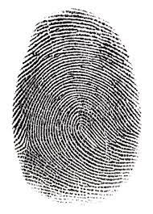

**INTRODUCTION**

**What is fingerprint?**

Ridges and troughs in the skin that covers human fingers combine to generate unique patterns. These patterns reach their full maturity during pregnancy and remain consistent throughout an individual's whole existence. Fingerprints are the names given to the prints made of certain patterns. Damage to the quality of fingerprints may be temporarily caused by injuries such as cuts, burns, and bruises; however, after the injury has completely healed, the patterns will be restored.

It has been shown in a number of investigations that no two people have identical fingerprints; hence, fingerprints are one-of-a-kind for each and every individual.

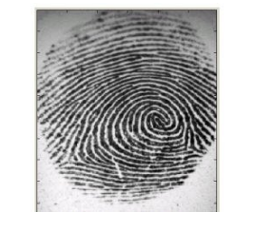

The use of fingerprints as a form of biometric identification is quite widespread for the reasons outlined above. measurements. Particularly in the field of law enforcement, where they have been used for more than a century

to aid in the solving of a crime. Unfortunately, comparing fingerprints is a complicated process of pattern recognition problem. Not only does manual fingerprint matching take a lot of time, but it also requires the knowledge and training of achieving a level of expertise requires a great deal of time. As a result, since the 1960s, a significant amount of work has been put towards the development of technologies that can automatically recognise fingerprints.

The automation of the process of fingerprint identification ended up being a successful endeavour in applications in forensic science The use of automated analysis saw increased use as a result of forensic advancements.

the incorporation of fingerprint recognition into civilian applications Fingerprints exhibit remarkable permanence and uniqueness during the course of time. The findings demonstrated that fingerprints provide a higher level of security.

identity of a person that is more secure than what can be provided by keys, passwords, or identification cards. Examples suchas mobile phones and PCs increasingly come equipped with fingerprint sensor technologies for fingerprint-based authentication purposes new techniques of password security are now being developed to replace traditional methods of password protection. Those

are just a small portion of the civilian uses that fingerprints may be put to.

**Fingerprint recognition:**

Sir Francis Galton was the one who first devised the technique that is now used for matching fingerprints. 1888 was the year that he made the observation that fingerprints contain a wealth of information, sometimes known as minutiae, in the form of discontinuities in ridges. He also observed that the placement of those little details did not change over the course of time. Due of this, comparing the minutiae of two fingerprints is an effective method for determining whether or not they belong to the same individual.

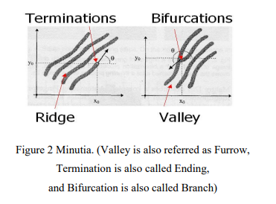

The two most significant details are known as termination and bifurcation. Termination refers to the point at which a ridge abruptly ends, while bifurcation refers to the place on the ridge from where two branches originate.

The challenge of fingerprint recognition may be broken down into two distinct sub-domains: the first of these is fingerprint verification, and the second is fingerprint identification.

**SYSTEM ARCHITECTURE**

A fingerprint recognition system constitutes of fingerprint acquiring device, minutia extractor and minutia matcher.

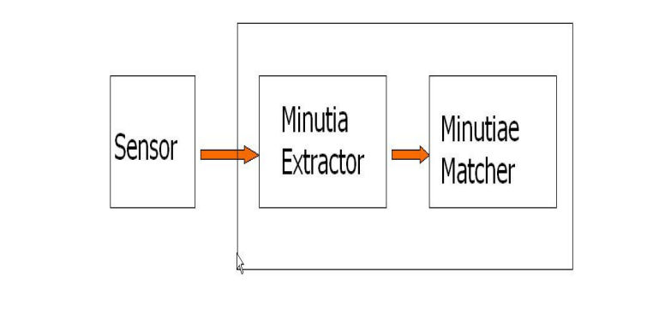

It is common practise to employ optical or semi-conductor sensors for the purpose of fingerprint acquisition. They have a high level of efficiency and an accuracy that is satisfactory, with the exception of situations in which the user's finger is either too unclean or too dry. On the other hand, the testing database that is being used for this project comes from the fingerprints that are made accessible by FVC2002 (Fingerprint Verification Competition 2002). Therefore, there has been no implementation of the acquisition step.

In the next portion for algorithm design and other later parts, the minutia extractor and minutia matcher modules have both been thoroughly detailed in depth.

**Pre-processing**

A few preprocessing techniques will be applied to the fingerprint images which consists of the following steps:

* Intensity scaling
* Contrast Enhancement
* Histogram Equalization
* Gauss smoothing
* Binarization using dynamic thresholding
* Thinning

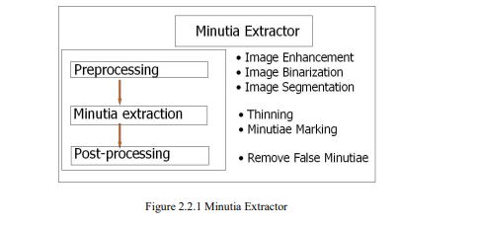

Histogram Equalization and Fourier Transform have been used for the purpose of picture improvement during the pre-processing step of the fingerprint image. After that, the fingerprint image is binarized using the locally adaptive threshold approach. Lastly, the fingerprint is extracted.

The job of picture segmentation is accomplished via the use of a three-step methodology, which includes the estimate of block direction, segmentation based on direction intensity, and extraction of Region of Interest by Morphological procedures.

An iterative parallel thinning technique is utilised for the stage that is dedicated to the extraction of minutia. The marking of the minutia is a job that's not too difficult.

In the step known as postprocessing, a more stringent algorithm is devised to eliminate unnecessary minutia. In addition, a fresh representation for bifurcations is presented as a means of bringing terminations and bifurcations under a single umbrella.

**Module and screenshots**

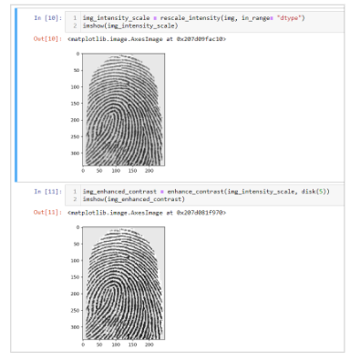

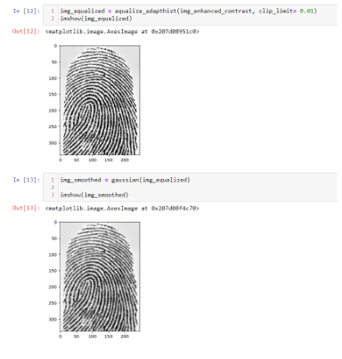

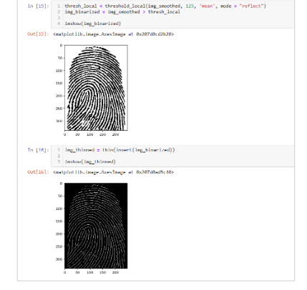

**Feature extractor**

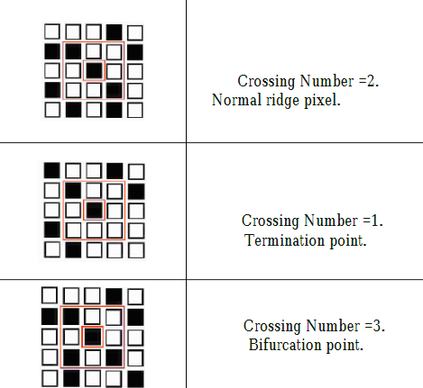

**Screenshots**

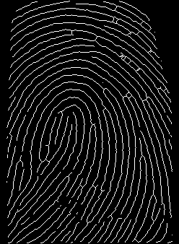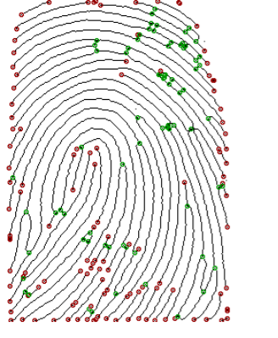

**Matching algorithm**

The point matching method is dependent on the spatial properties of the fingerprints and makes use of the relative distances between a single core point and the minute features.

The statistics that were obtained for the purpose of evaluating and analysing the performance of the suggested method were the False Match Rate (FMR), the False Non-Match Rate (FNMR), and the Average Matching Time (AMT).

