HOSPITAL MANAGEMENT SYSTEM
Github repo link: https://github.com/ganjirohith/hospital-management-system.git

Complete System Guide — Administrative & Patient Modules
A comprehensive reference covering all modules, workflows, and system features

PART 1: ADMINISTRATIVE MODULE

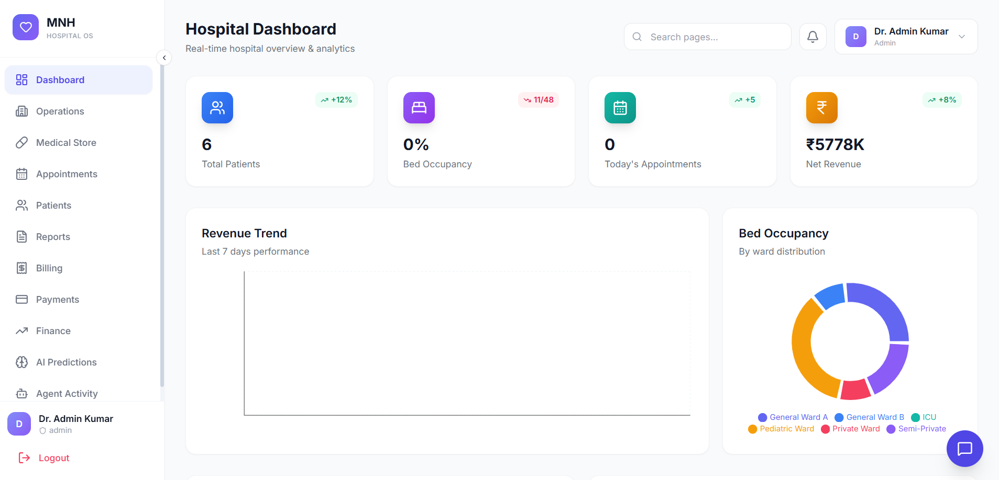

1. ADMIN SIDE — SYSTEM MANAGEMENT

The Admin Side module provides system-wide administrative functions and management capabilities for hospital operations.

1.1 Overview and Purpose
- Centralized control panel for all administrative functions
- Manage user roles, permissions, and access controls
- Monitor system performance and generate administrative reports
- Configure system settings and hospital-wide parameters

1.2 Key Features and Functionality
- User Management: Create, edit, and deactivate user accounts with role-based access
- Department Configuration: Set up and manage hospital departments with staff assignments
- System Settings: Configure hospital parameters including working hours, holidays, and policies
- Audit Logs: Track all system activities and user actions for compliance
- Security Management: Configure backup, recovery, and data protection protocols

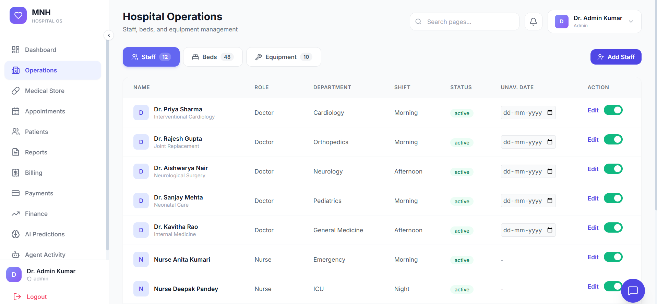

2. OPERATIONS STAFF SIDE — DAY-TO-DAY OPERATIONS

The Operations Staff Side module handles daily operational tasks performed by hospital staff members across different departments.
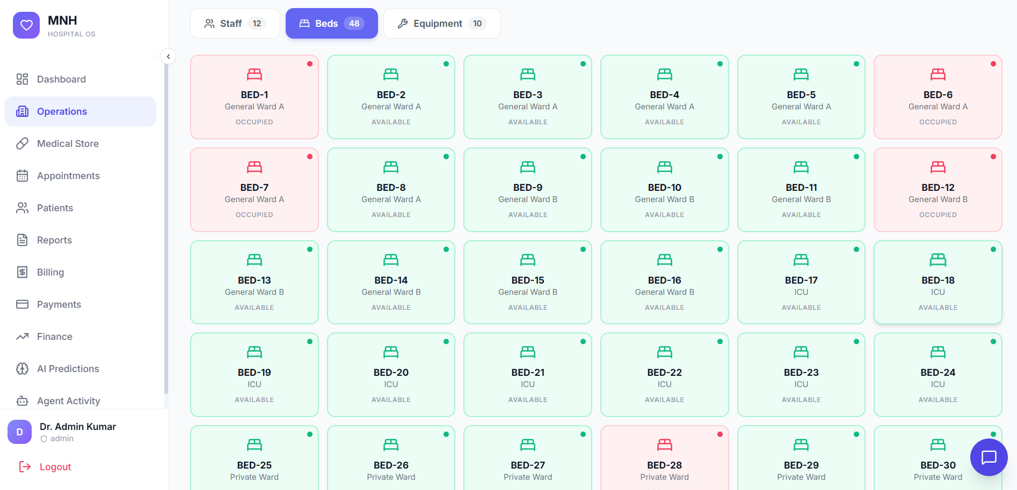

2.1 BEDS BOOKING — Ward and Bed Management
Overview:
The Beds Booking module allows staff to manage bed allocation, occupancy status, and ward assignments for hospital patients.
Step-by-Step Process:
- Navigate to the Beds Booking section from the main operations dashboard
- View the Hospital Ward Layout with color-coded bed status indicators:
- Green — Bed is available and unoccupied
- Red — Bed is occupied by a patient
- Yellow — Bed is reserved or under maintenance
- To Book a Bed for a New Patient:
- Click on an available (green) bed in the desired ward
- Enter the patient ID or search by patient name from the system database
- Select bed type (Standard, Semi-Private, Private, ICU) based on patient requirements
- Enter expected stay duration and any special requirement notes
- Assign the attending doctor and nursing staff to the bed
- Click 'Confirm Booking' to complete the bed allocation
- To Discharge a Patient:
- Select the occupied (red) bed containing the patient to be discharged
- Click 'Discharge Patient' button
- Confirm discharge date and time
- Bed status automatically updates to available (green)
- System automatically updates bed availability across all departments in real time

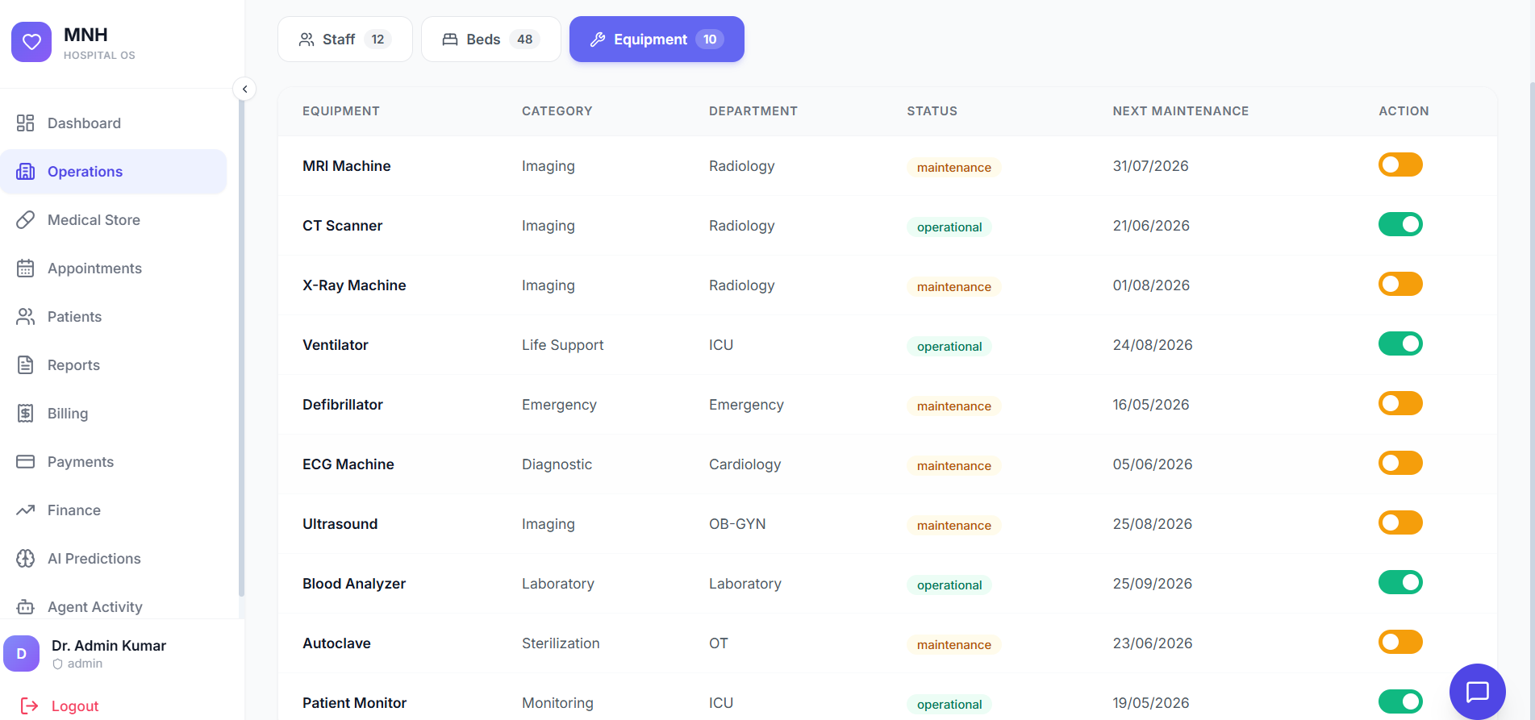

2.2 EQUIPMENT — Medical Device Management
Overview:
The Equipment module manages all medical devices, diagnostic equipment, and hospital machinery including maintenance schedules, usage logs, and availability tracking.
Step-by-Step Process:
- Access the Equipment Management dashboard
- View the Equipment Inventory List showing all hospital equipment
- To Add New Equipment:
- Click 'Add Equipment' button
- Enter equipment details: Name, Model Number, Serial Number, Manufacturer
- Assign equipment to a specific department and location
- Set purchase date and warranty expiration date
- Configure maintenance schedule (daily, weekly, monthly, quarterly, yearly)
- Save the equipment record
- To Track Equipment Usage:
- Select an equipment item from the inventory list
- View usage history showing all instances of use
- Check last maintenance date and upcoming maintenance due date
- To Schedule Maintenance:
- Click on the equipment record and select 'Schedule Maintenance'
- Choose maintenance type: Preventive, Corrective, or Emergency
- Select maintenance date and assign a technician
- Mark equipment as 'Under Maintenance' until work is completed

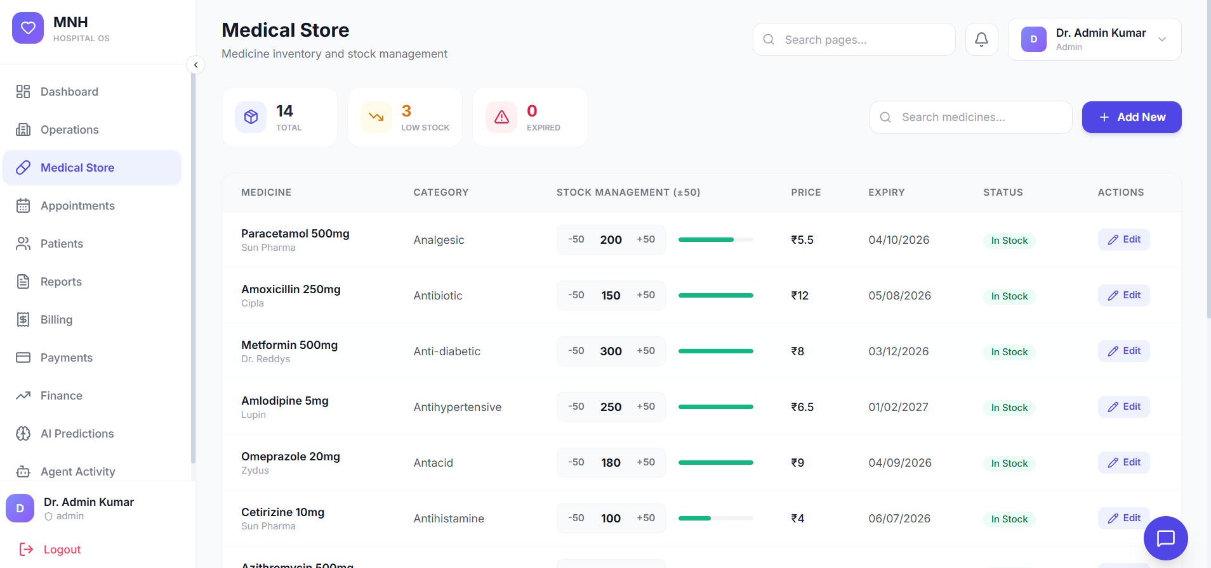

2.3 MEDICAL STORE — Pharmacy and Inventory Management
Overview:
The Medical Store module manages pharmaceutical inventory, medicines, supplies, and their distribution to different wards and departments.
Step-by-Step Process:
- Open the Medical Store Management system
- Review the Medicine Inventory showing all medicines with current stock levels
- To Add New Medicines to Inventory:
- Click 'Add Medicine' in the inventory panel
- Enter medicine details: Name, Generic Name, Strength (mg/ml), Manufacturer
- Input quantity received and cost per unit
- Set expiry date and storage location
- Set minimum stock level and reorder point
- Save medicine record
- To Issue Medicines to Wards:
- Receive medicine requisition requests from ward staff
- Verify availability in inventory
- Select medicines and quantities to issue
- Generate distribution slip with ward name and medicine details
- Record issue date and receiving signature
- To Monitor Expiry Dates:
- System automatically flags medicines nearing expiry (within 30 days)
- Review expiry alerts on the dashboard
- Remove expired medicines and generate disposal reports

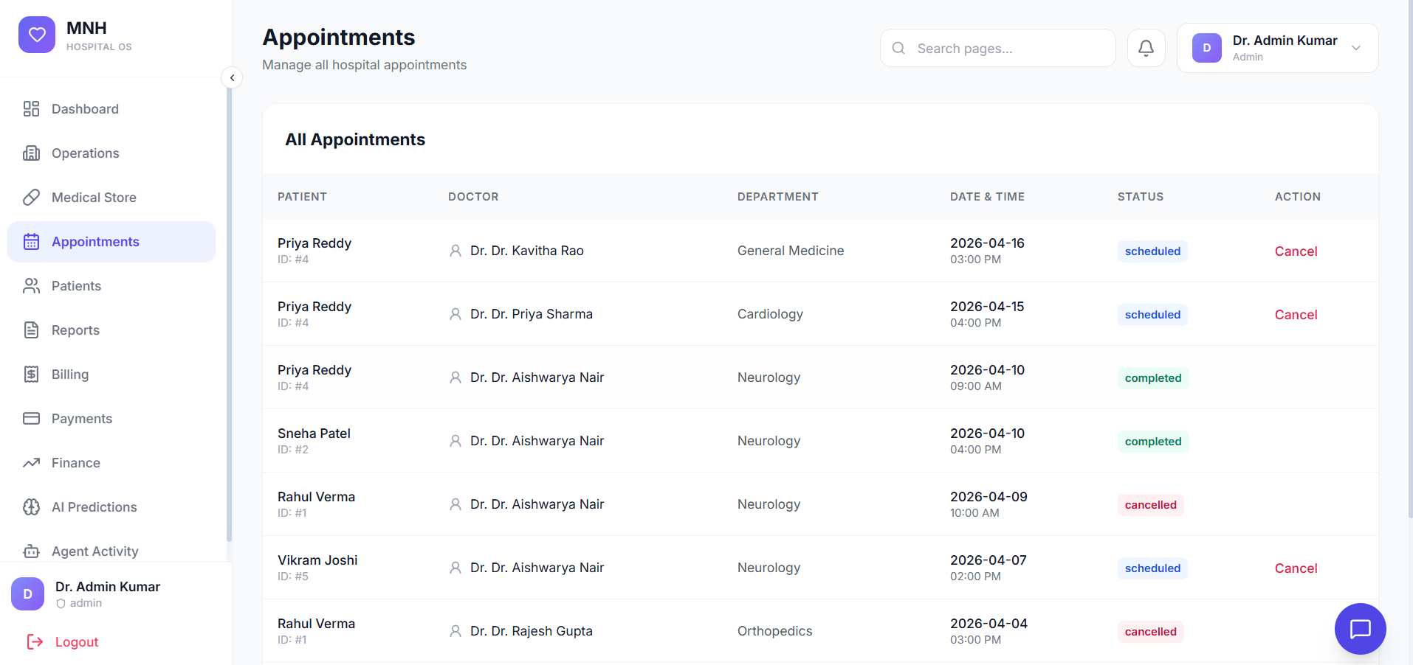

3. APPOINTMENTS — Schedule and Patient Consultations

The Appointments module handles scheduling doctor consultations, managing patient queues, and tracking appointment history.
Overview:
- Manage doctor availability and consultation schedules
- Book appointments for patients with specific doctors
- Track appointment status and manage cancellations
- Generate appointment reports and analytics
Step-by-Step Process:
- Navigate to the Appointments module
- To View Doctor Schedules:
- Select the specific doctor from the doctor list
- View their weekly or monthly availability calendar
- Check consultation duration (15, 30, 45, or 60 minutes)
- To Book a New Appointment:
- Click 'Book Appointment' button
- Select the patient (existing patient or register as new patient)
- Choose the doctor and department
- Select appointment date and available time slot
- Select consultation type: Regular, Follow-up, or Emergency
- Enter reason for consultation
- Confirm and save the appointment
- To Manage Appointments:
- View today's appointments in queue or list format
- Mark patients as 'Checked In' when they arrive
- Update appointment status: Completed, Cancelled, No-Show, or Rescheduled
- Generate appointment history and analytics reports

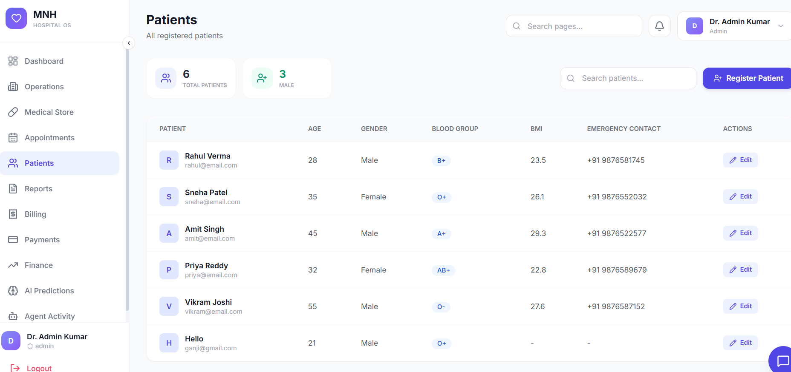

4. LIST OF PATIENTS — Patient Database and Records

The List of Patients module provides centralized management of all patient records, medical history, and personal information.
Overview:
- Maintain a comprehensive patient database
- Access medical history and treatment records
- Search and retrieve patient information quickly
- Manage patient contacts and emergency information
Step-by-Step Process:
- Access the Patient List module
- View all patients in a table with basic demographic information
- To Add a New Patient:
- Click 'Add New Patient' button
- Enter personal details: Full Name, Date of Birth, Age, Gender
- Input contact information: Phone Number, Email, Address
- Add emergency contact person and their relationship to the patient
- Enter insurance details and policy number
- Record medical allergies and pre-existing conditions
- Save patient record — system generates a unique Patient ID
- To View Patient Details:
- Click on a patient name from the list
- View complete patient profile with demographics
- Access medical history and past treatments
- Review current medications and allergies
- To Search for Patients:
- Use the search bar to find patients by: Patient ID, Full Name, Phone Number, or Date of Birth

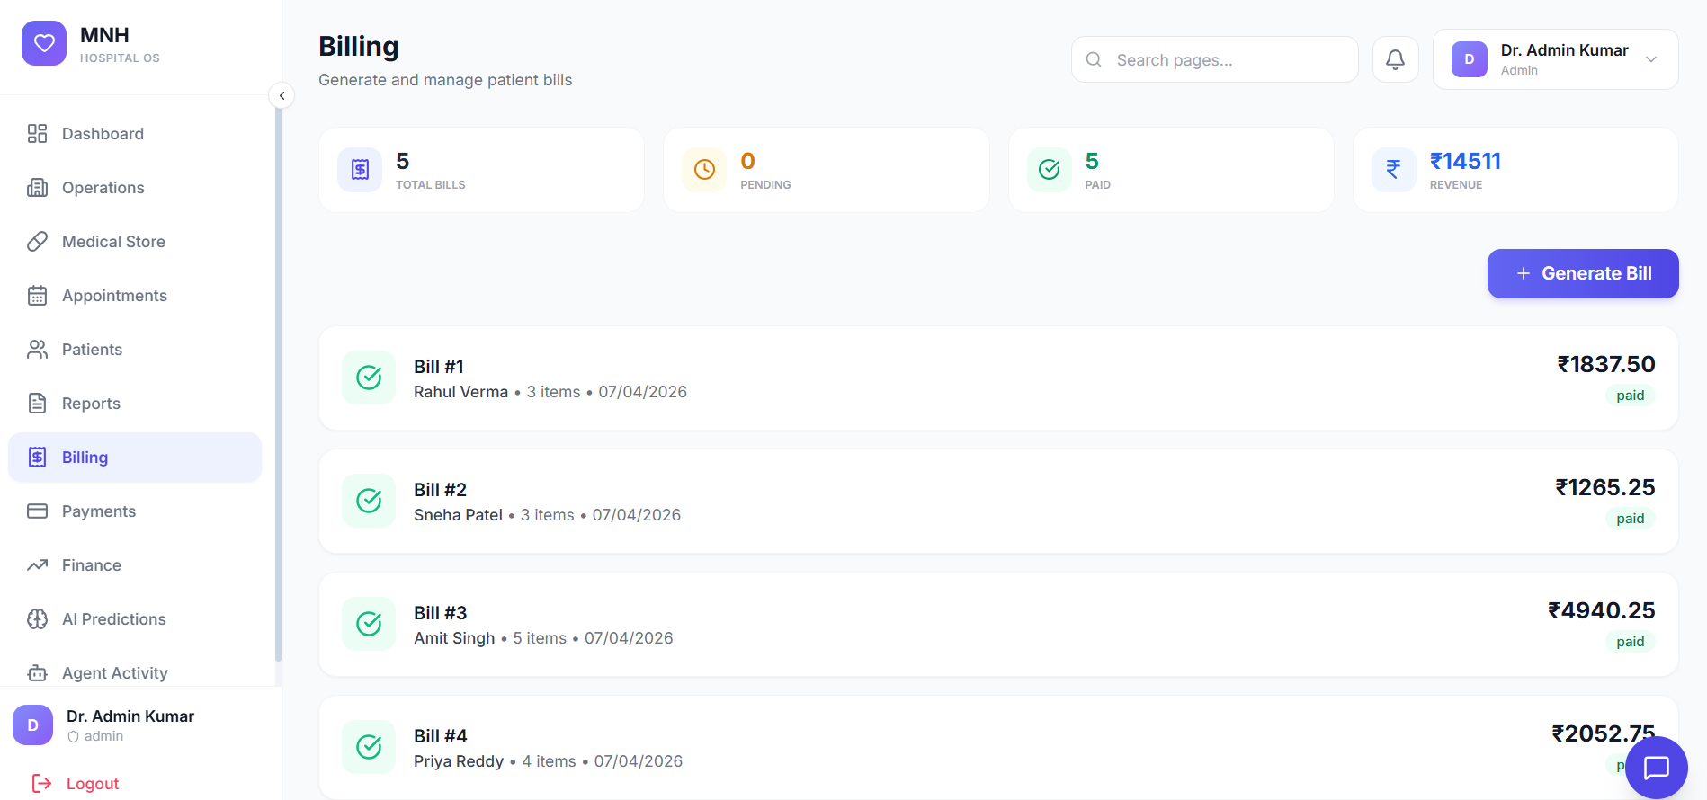

5. GENERATE BILLING — Invoice and Account Management

The Generate Billing module creates invoices for patient services, tracks charges, and manages hospital billing operations.
Overview:
- Automatically calculate charges for services and medicines
- Generate itemized invoices for patients
- Apply discounts and manage payment methods
- Track outstanding payments and send reminders
Step-by-Step Process:
- Open the Generate Billing module
- To Create a New Invoice:
- Click 'Create New Bill' button
- Select the patient from the database
- Choose billing period (admission date to discharge date)
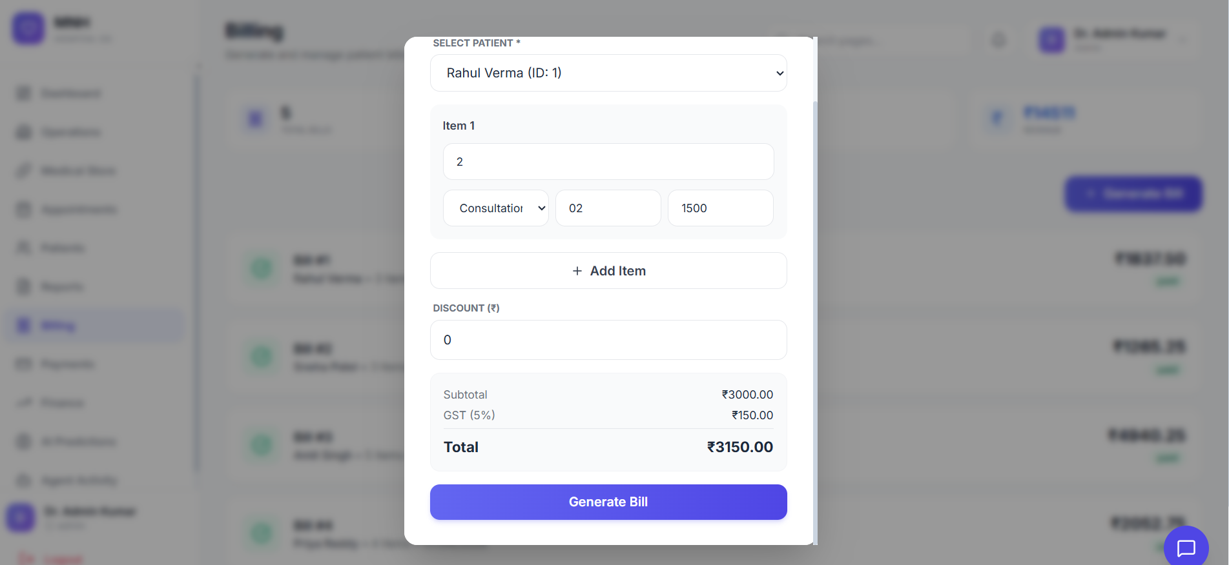
- System Automatically Adds:
- Bed charges (daily rate × number of days)
- Doctor consultation fees
- Medicine charges (from dispensed medicine records)
- Diagnostic test charges (X-ray, blood tests, etc.)
- Surgical charges if applicable
- To Modify Bill:
- Review itemized charges in the bill
- Apply authorized discounts (percentage or fixed amount)
- Add notes or special charges as required
- Calculate and display total amount due
- To Generate and Send Invoice:
- Click 'Generate Invoice'
- System generates unique invoice number with date stamp
- Print or email invoice to patient
- Mark bill as 'Sent' in the system

6. PAYMENTS — Payment Processing and Receipts

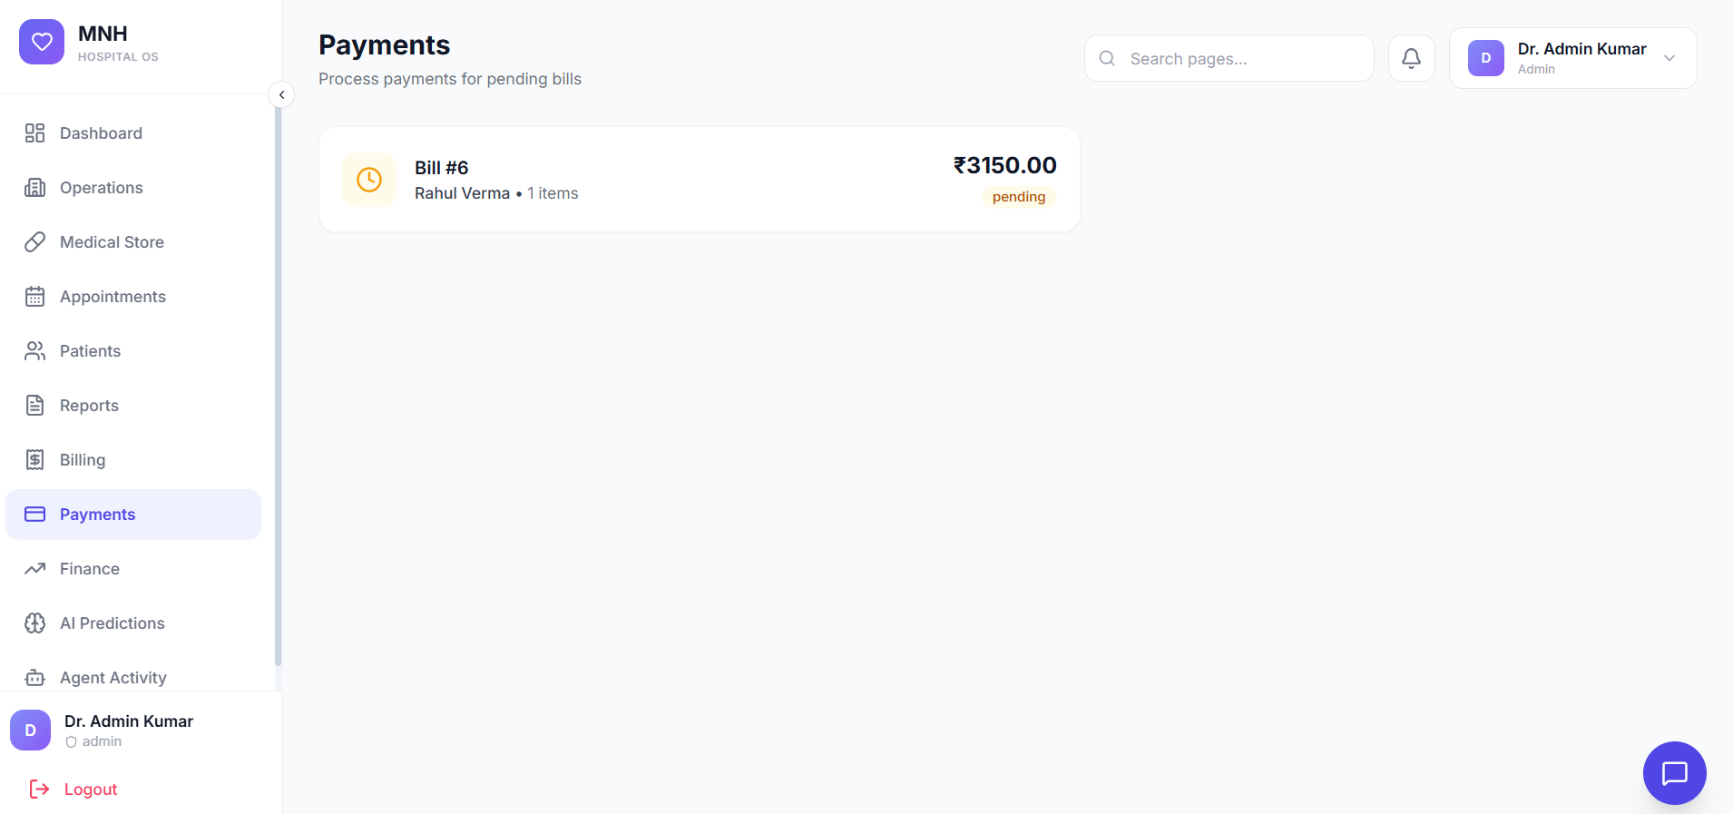
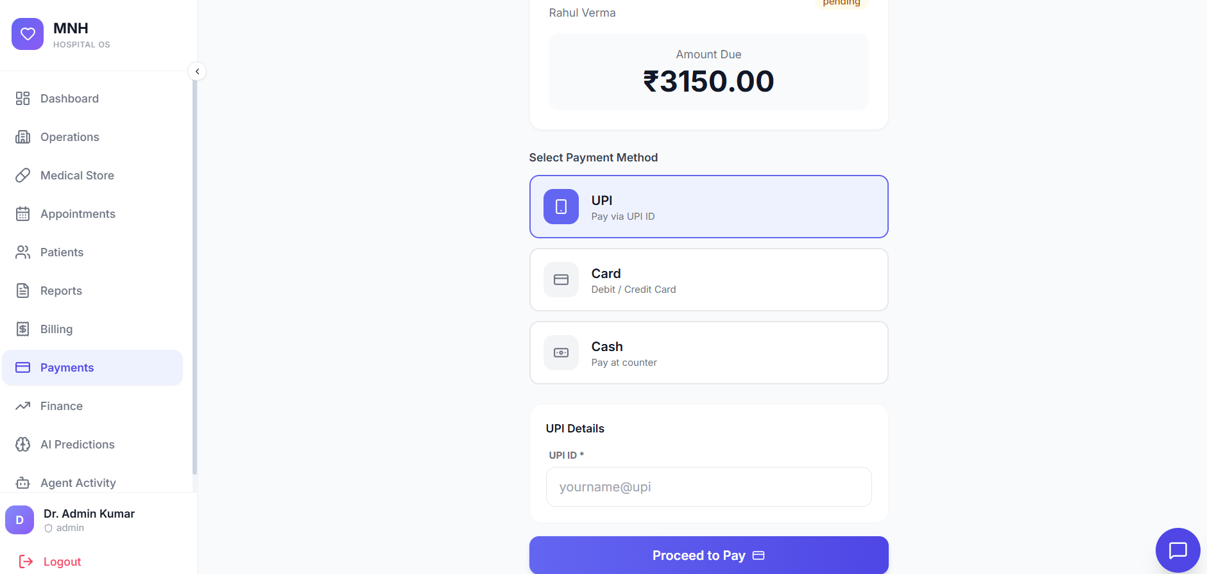
The Payments module handles payment receipt, tracking, and financial reconciliation for patient bills.
Overview:
- Record patient payments in multiple formats
- Generate payment receipts automatically
- Track partial payments and outstanding balances
- Generate payment reports and reconciliation statements
Step-by-Step Process:
- Navigate to the Payments module
- To Record a Payment:
- Click 'Record Payment' button
- Select the patient and their invoice
- Display outstanding amount due
- Enter payment amount
- Select Payment Method:
- Cash
- Credit/Debit Card
- Bank Transfer
- Cheque
- Insurance Coverage
- For Card Payments: process through secure payment gateway and collect authorization confirmation
- Confirm Payment and Generate Receipt:
- Click 'Confirm Payment'
- System generates a receipt with unique receipt number and date
- Display itemization and payment details
- Print or email receipt to patient
- If partial payment: calculate and display remaining balance
- System updates patient account and invoice status automatically

7. FINANCE SECTOR — Financial Management and Reporting

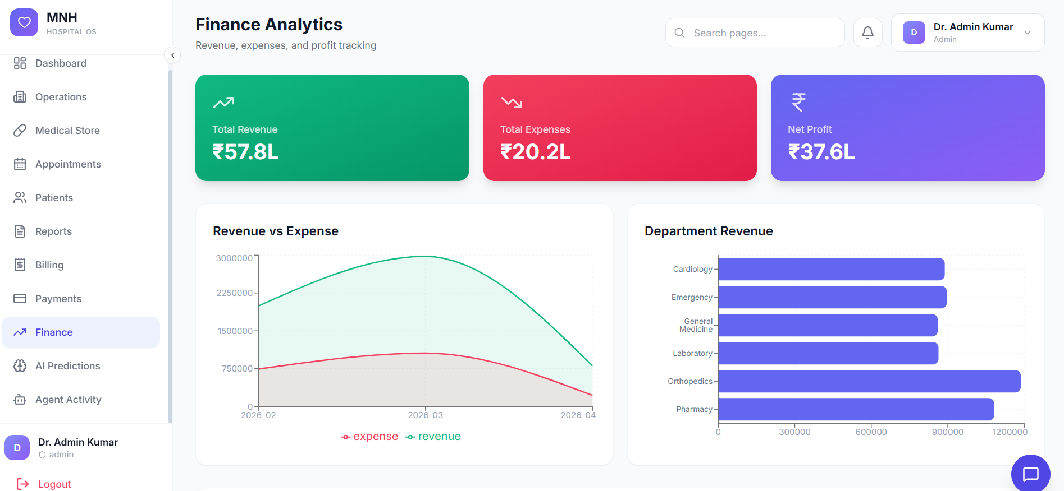
The Finance Sector module provides comprehensive financial management, accounting, and reporting functions for hospital operations.
Overview:
- Track revenue and expenses in real time
- Generate financial reports and statements
- Manage accounts payable and receivable
- Monitor cash flow and overall financial health
- Create budgets and conduct financial analysis
Step-by-Step Process:
- Access the Finance Sector dashboard
- To View Financial Overview:
- Check Total Revenue (current month, quarter, year)
- Review Total Expenses breakdown
- View Net Profit/Loss calculation
- Monitor Outstanding Receivables amount
- To Generate Financial Reports:
- Click 'Generate Report' button
- Select report type: Income Statement, Balance Sheet, Cash Flow Statement, Revenue Analysis by Department, or Expense Breakdown
- Choose date range: weekly, monthly, quarterly, yearly, or custom
- Generate and download report as PDF or Excel
- To Manage Accounts:
- Navigate to Accounts Payable — view outstanding vendor invoices and record bill payments
- Navigate to Accounts Receivable — monitor patient bill payments and send reminders for overdue invoices

8. AI PREDICTIONS — Intelligent Analytics and Forecasting

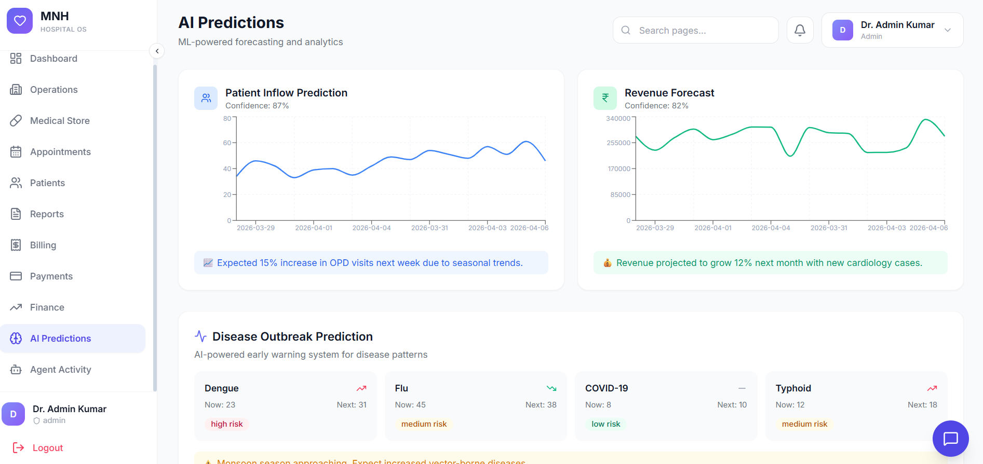
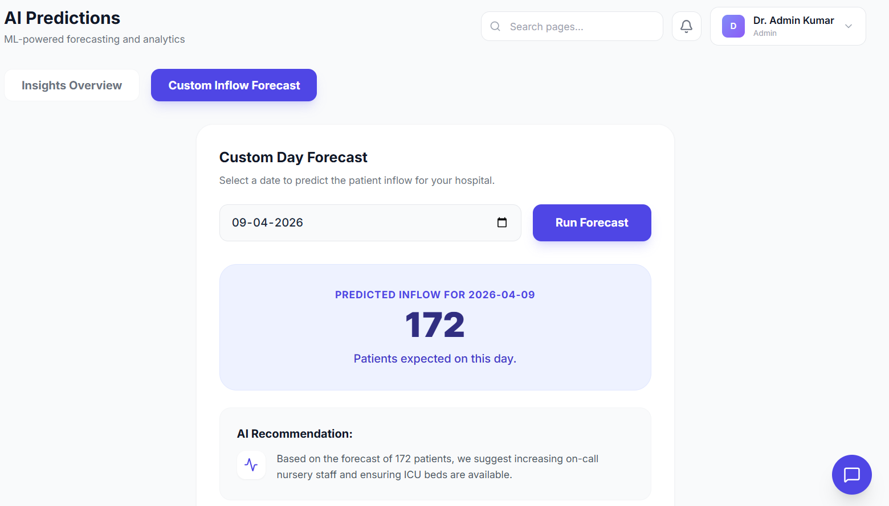
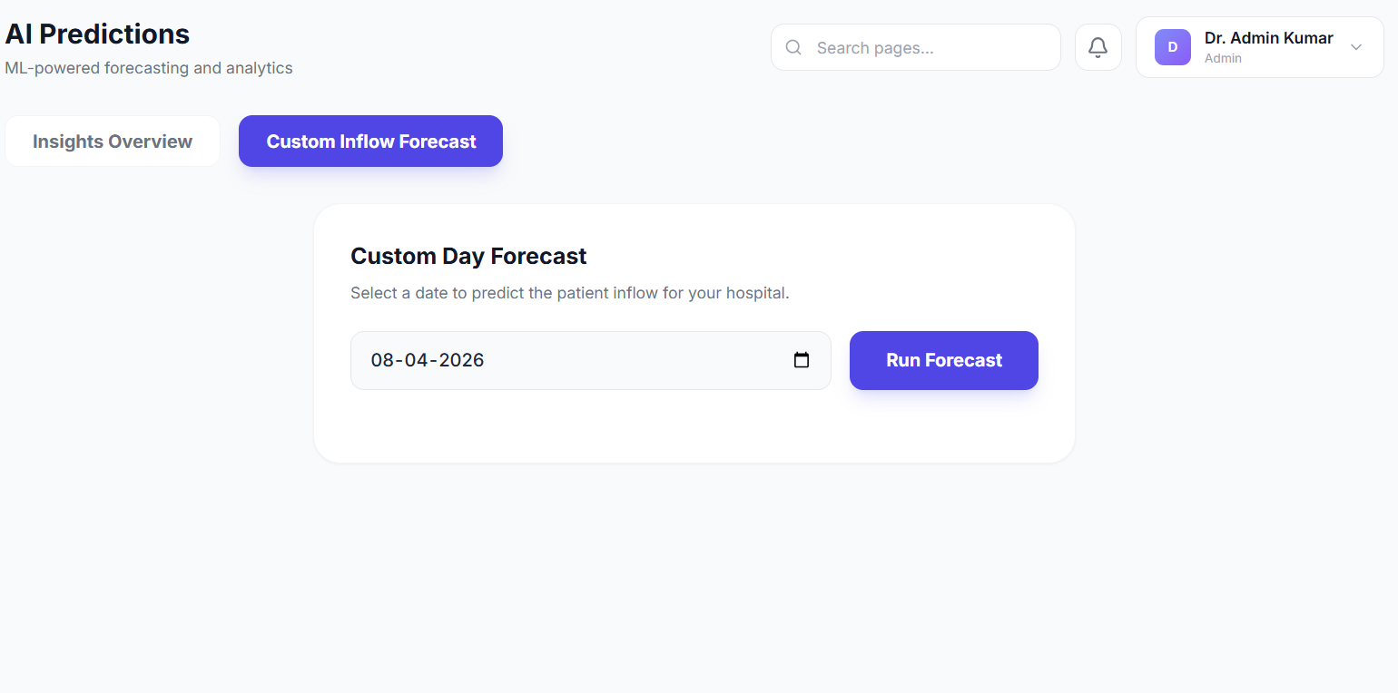
The AI Predictions module uses machine learning algorithms to analyze hospital data and provide predictive insights for better decision-making.
Overview:
- Predict patient readmission risk
- Forecast equipment maintenance requirements
- Predict patient no-show rates for appointments
- Revenue forecasting for upcoming periods
- Bed occupancy prediction and trend analysis
- Disease outbreak risk analysis
Step-by-Step Process:
- Access the AI Predictions dashboard
- View Predictive Analytics:
- Patient Readmission Risk: AI identifies high-risk patients who may require follow-up care
- Appointment No-Show Prediction: Predicts which patients are likely to miss appointments
- Equipment Failure Forecasting: Predicts equipment requiring preventive maintenance
- Revenue Forecast: Projects revenue for upcoming months based on historical data
- Bed Occupancy Trends: Predicts future bed occupancy rates
- To Use Predictions:
- Review AI-generated recommendations on the dashboard
- Identify patients requiring additional care or follow-up
- Schedule preventive maintenance based on equipment failure predictions
- Plan staffing and resources based on occupancy forecasts
- Make informed financial decisions based on revenue forecasts

9. CHATBOT — AI-Powered Assistant

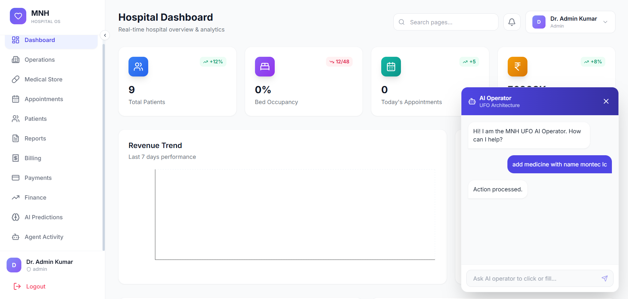
The Chatbot feature provides an AI-powered assistant accessible throughout the system to help users with inquiries and provide guidance.
Overview:
- 24/7 automated support for common inquiries
- Answer frequently asked questions instantly
- Provide system navigation guidance
- Assist with patient information lookup
- Escalate complex issues to human support staff
Step-by-Step Process:
- Access the Chatbot via the chat icon (bottom-right corner of the interface)
- Common Chatbot Functions:
- Ask general questions: 'How do I book a bed?' or 'Where is the medication inventory?'
- Request patient information: 'Search for patient [Name]'
- Get navigation help: 'How do I access the billing module?'
- Receive system alerts and notifications
- Chatbot Capabilities:
- Understands natural language queries
- Provides immediate responses to common issues
- Can perform simple tasks such as retrieving patient data
- Escalates complex issues to human support staff
- Self-improving learning system that refines responses over time

9.1 Medicine Added to Database

Overview:
The system maintains a comprehensive medicine database that supports all medical store operations and prescription functions.
Step-by-Step Process:
- When medicines are added to the Medical Store inventory, the Chatbot automatically indexes them
- Medicine information stored includes: Name, Generic Name, Strength & Dosage, Manufacturer, Batch Number, Expiry Date, Available Quantity, Usage Warnings, and Contraindications
- Chatbot can then:
- Provide medicine information when doctors query
- Check medicine availability in real time
- Alert about critical drug interactions
- Notify about medicines approaching expiry
- Recommend alternative medicines if the required medicine is unavailable

9.2 Adding Patients via Chatbot
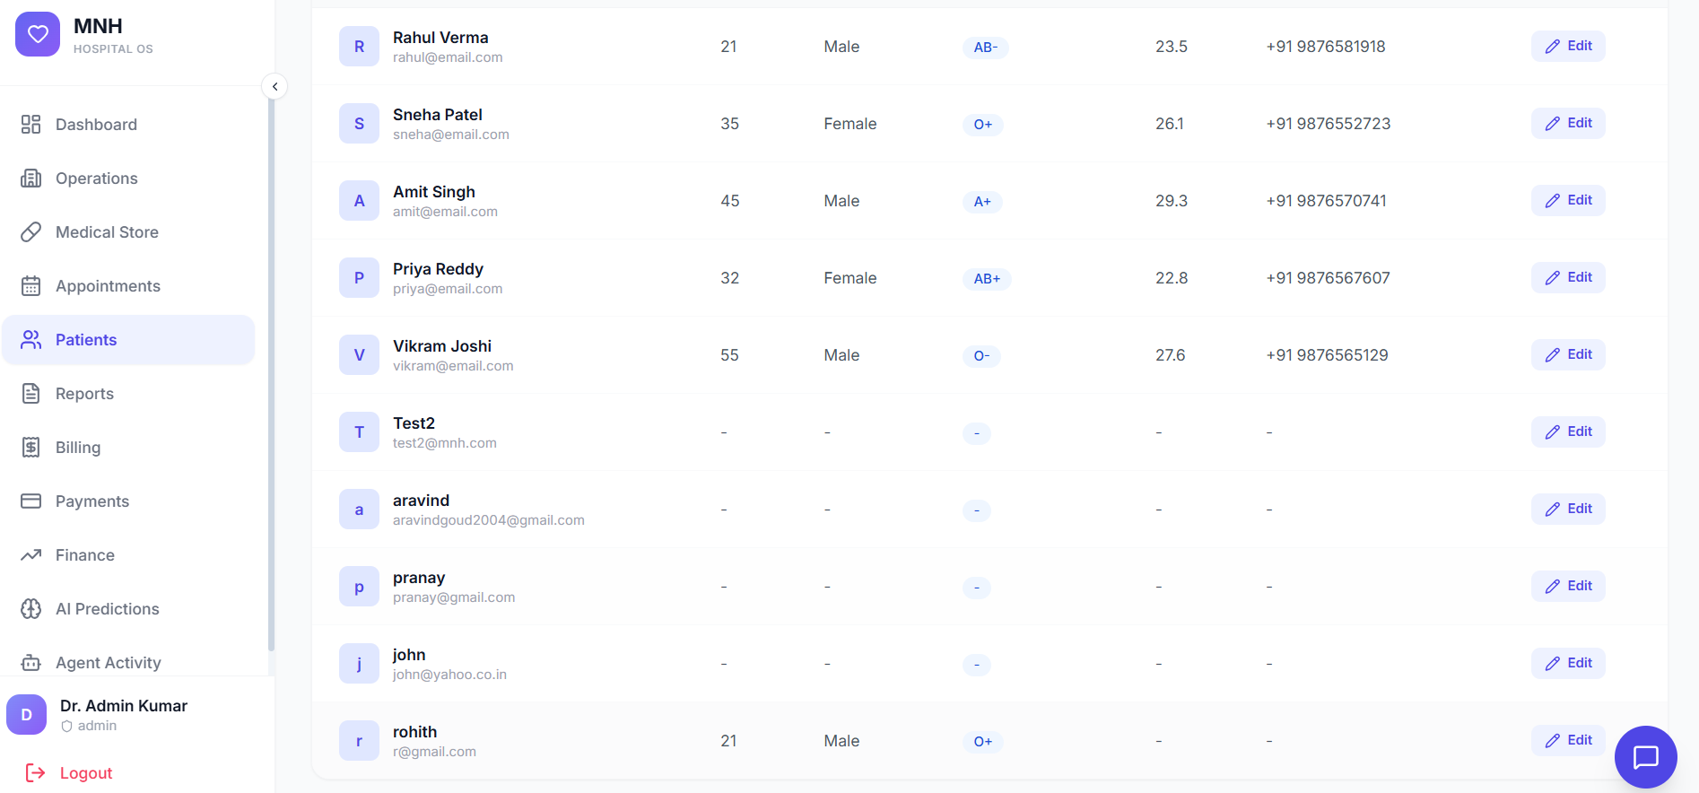
Overview:
The Chatbot can assist with patient registration and data entry to streamline the admission process.
Step-by-Step Process:
- User initiates a patient addition request via the Chatbot
- Chatbot guides through patient registration by collecting:
- Patient's full name
- Date of birth and age
- Gender and contact information
- Emergency contact details
- Insurance information
- Medical allergies and pre-existing conditions
- Chatbot validates information:
- Checks for duplicate records in the system
- Confirms all required fields are filled
- System creates the patient record:
- Generates a unique Patient ID automatically
- Stores patient data securely
- Provides confirmation with the generated Patient ID to the user

9.3 Patient Added Successfully — Confirmation
Overview:
Once a patient is successfully added to the system, the Chatbot provides confirmation and next-step guidance.
Confirmation Process:
- Chatbot displays success message: 'Patient Added Successfully'
- Shows patient details summary: Patient ID (auto-generated), Name, Date of Birth, and Contact Information
- Chatbot provides next-step options:
- 'Would you like to book a bed for this patient?'
- 'Schedule an appointment with a doctor?'
- 'View patient medical record?'
- Patient record is now fully accessible in the system and can be: searched in the patient list, assigned to beds, scheduled for appointments, receive medical services, and billed for hospital services

CONCLUSION — Administrative Module

This comprehensive Hospital Management System encompasses all essential functions required for efficient hospital operations. Each module is designed to streamline specific processes while maintaining data integrity and providing seamless integration across all departments. Regular training and updates ensure that staff can maximize the system's capabilities for improved patient care and operational efficiency.

PART 2: PATIENT SIDE MODULE
1: Book a New Appointment — Select Department
The patient navigates to the Appointments section and begins the appointment booking process. The screen presents a 5-step progress indicator (Department → Doctor → Date → Time Slot → Confirm) and prompts the patient to first choose a department.

Step-by-Step Process:
- Log in to the MNH Hospital OS patient portal as Rahul Verma (Patient).
- Click on 'Appointments' from the left-hand navigation menu.
- The 'Book a New Appointment' section appears with a 5-step progress bar at the top — Step 1 (Department) is currently active and highlighted in blue.
- Select a department from the available options displayed as cards:
- Cardiology
- Orthopedics
- Neurology
- Pediatrics
- General Medicine
- Click the arrow (→) on the desired department card to proceed to Step 2 — Doctor selection.
- The 'Your Appointments' section below shows all previously booked appointments for the patient's reference.
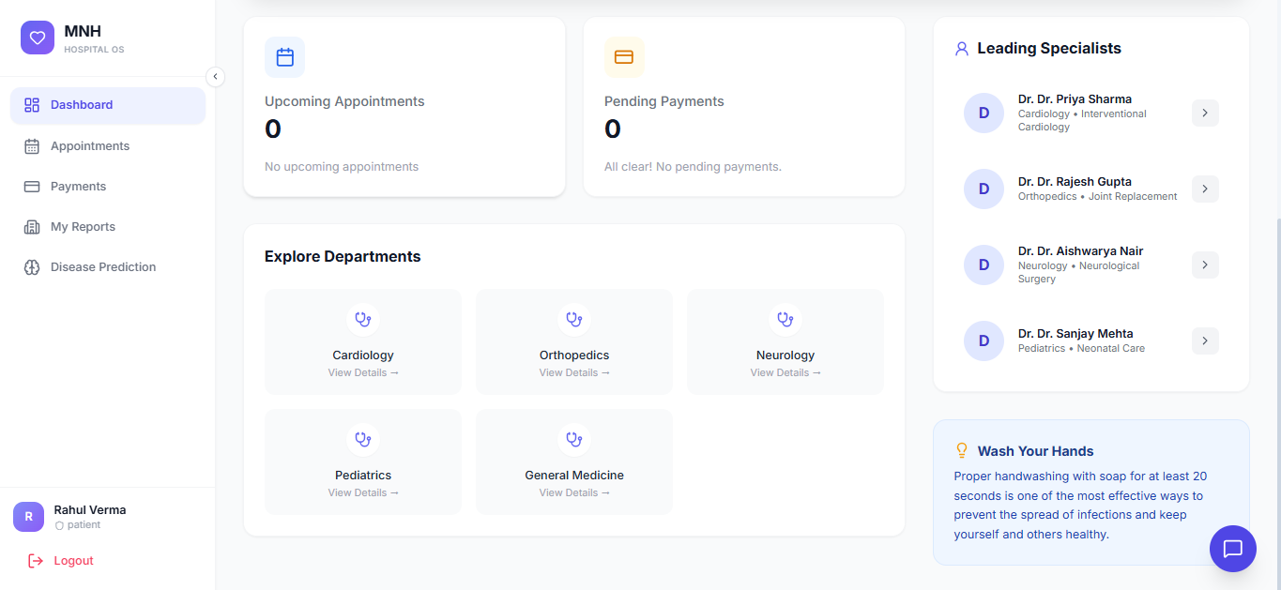

2: Book a New Appointment — Select Doctor
After selecting a department, the progress bar advances to Step 2. The system displays the available doctors within the chosen department for the patient to select.

Step-by-Step Process:
- Step 1 (Department) is now marked as completed with a checkmark (✓) on the progress bar.
- Step 2 (Doctor) becomes active and is highlighted in blue on the progress bar.
- A '← Back to Departments' link is displayed at the top of the section, allowing the patient to go back and re-select a department if needed.
- The screen lists available doctors for the selected department. Each doctor card displays:
- Doctor's name (e.g., Dr. Priya Sharma)
- Specialization (e.g., Interventional Cardiology)
- Avatar / initials icon for visual identification
- Click on the desired doctor's card to select them and advance to Step 3 — Date selection.
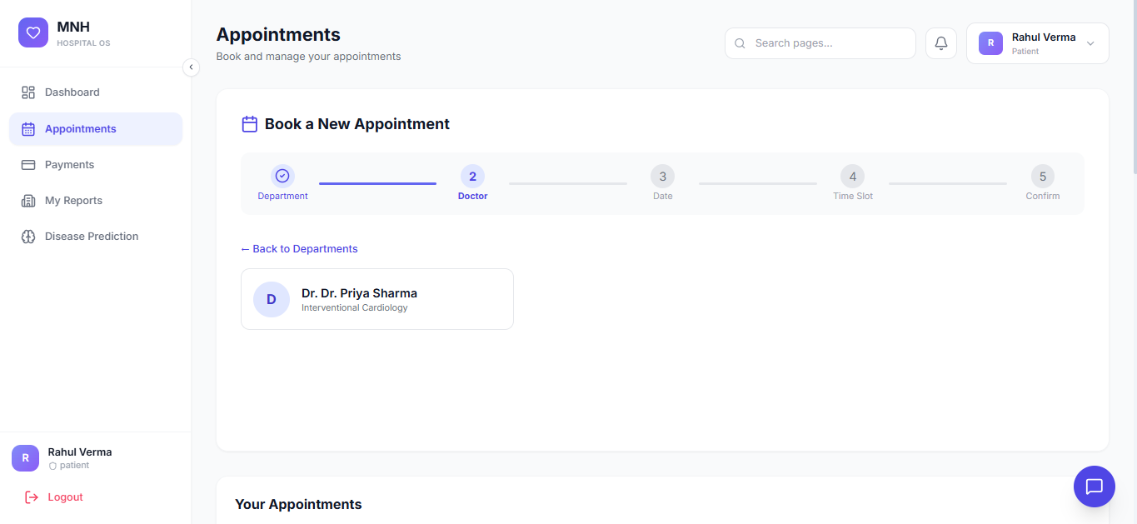
3: Book a New Appointment — Select Date
After choosing a doctor, the patient advances to Step 3 where they select a preferred appointment date using a calendar interface.

Step-by-Step Process:
- Steps 1 (Department) and 2 (Doctor) are now marked as completed with checkmarks on the progress bar.
- Step 3 (Date) is highlighted as the active step.
- A calendar widget is displayed showing the current month.
- Navigate between months using the left (‹) and right (›) arrow buttons at the top of the calendar.
- Click on an available date to select it:
- The selected date is highlighted with a blue circle/highlight.
- Past dates and unavailable dates are greyed out and not selectable.
- After selecting the desired date, click 'Next' or the date card advances automatically to Step 4 — Time Slot selection.

4: Book a New Appointment — Select Time Slot
With the date chosen, the patient proceeds to Step 4 to select an available time slot for the appointment from those offered by the selected doctor on that date.

Step-by-Step Process:
- Steps 1, 2, and 3 are now completed and shown with checkmarks on the progress bar.
- Step 4 (Time Slot) is highlighted as active.
- Available time slots are displayed as selectable buttons/cards (e.g., 09:00 AM, 10:00 AM, 11:00 AM, etc.).
- Unavailable or already-booked time slots are greyed out and cannot be selected.
- Click on a preferred available time slot — it highlights in blue to indicate selection.
- Click 'Next' to proceed to Step 5 — Confirm Appointment.
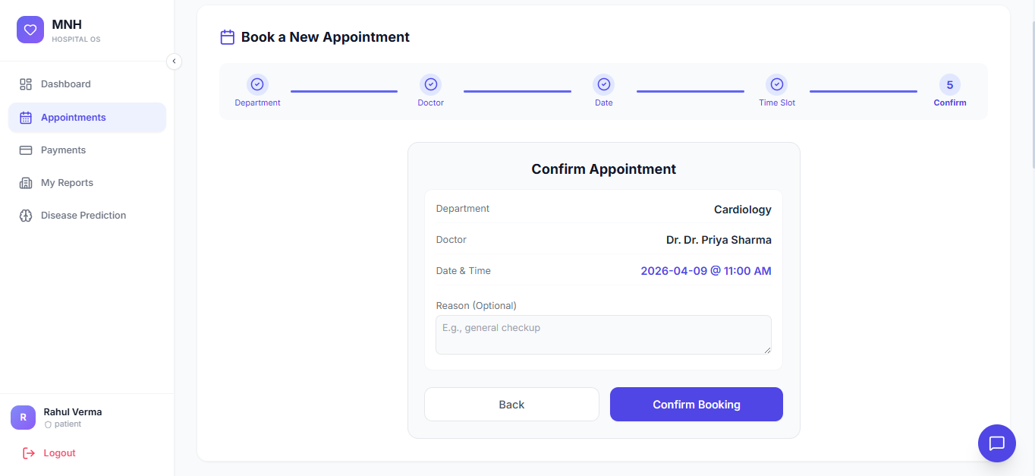

5: Book a New Appointment — Confirm Appointment
The final step in the booking process presents a full summary of the appointment details for the patient to review before confirming the booking.

Step-by-Step Process:
- Step 5 (Confirm) is now the active and final step on the progress bar.
- A confirmation summary card is displayed showing all selected appointment details:
- Department selected
- Doctor name and specialization
- Selected date
- Selected time slot
- Review the summary carefully to ensure all details are correct.
- Click 'Confirm Appointment' to finalize the booking.
- A success confirmation message is displayed and the appointment is added to the 'Your Appointments' list.
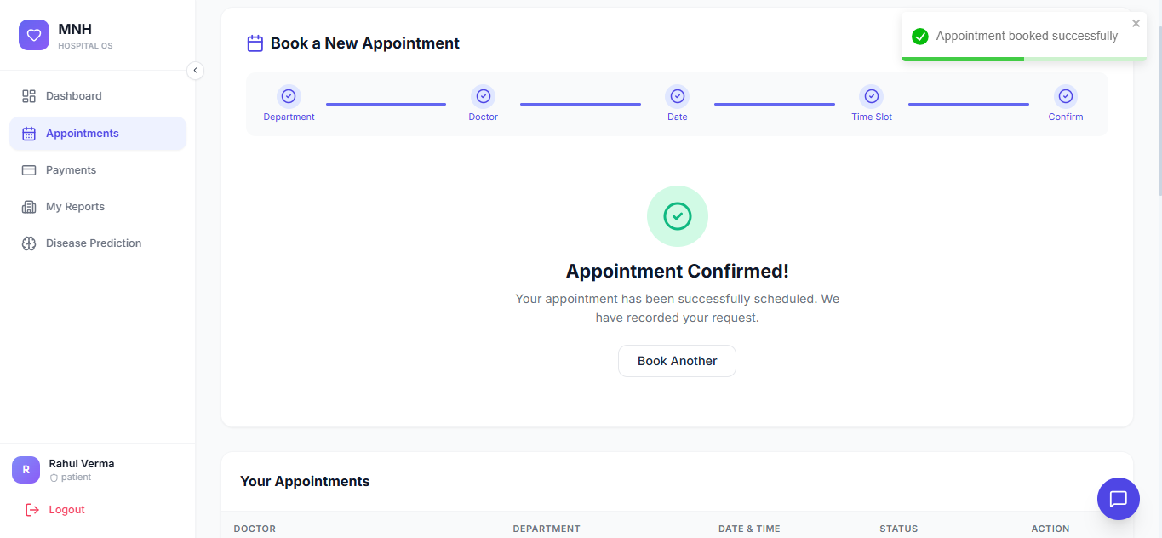
6: Your Appointments — Appointment List View
The Appointments screen displays all of the patient's booked appointments in a list format, allowing them to view status and details at a glance.

Step-by-Step Process:
- Navigate to the 'Appointments' section from the left navigation menu.
- Scroll down past the 'Book a New Appointment' section to view 'Your Appointments'.
- Each appointment entry in the list displays:
- Doctor's name and specialty
- Appointment date and time
- Status badge (e.g., Scheduled, Completed, Cancelled)
- Department name
- Click on any appointment card to open the detailed view of that appointment.
- Use the 'Book a New Appointment' section at the top to schedule additional appointments.
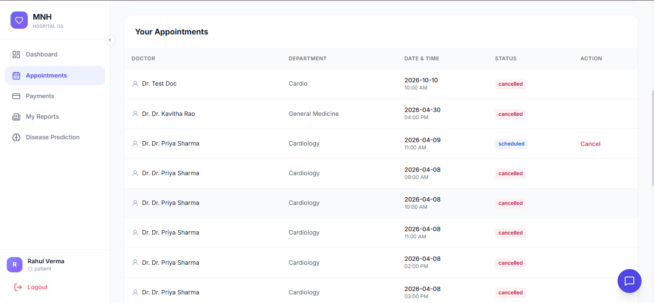
7: Payments — Payment History
The Payments section provides the patient with a complete view of all financial transactions related to their appointments and hospital services.

Step-by-Step Process:
- Click on 'Payments' from the left-hand navigation menu.
- The Payments screen loads displaying the heading 'Payments' with the subtitle 'View and manage your payments'.
- The payment history table is displayed with the following columns:
- Payment ID — unique identifier for each transaction
- Date — date on which the payment was made
- Description — reason or service for the payment (e.g., appointment fee, lab test)
- Amount — the payment amount in currency
- Status — payment status badge (e.g., Paid, Pending, Failed)
- Click on any payment row to view the full payment receipt or invoice details.
- For pending payments, an action button (e.g., 'Pay Now') may appear to complete the transaction.
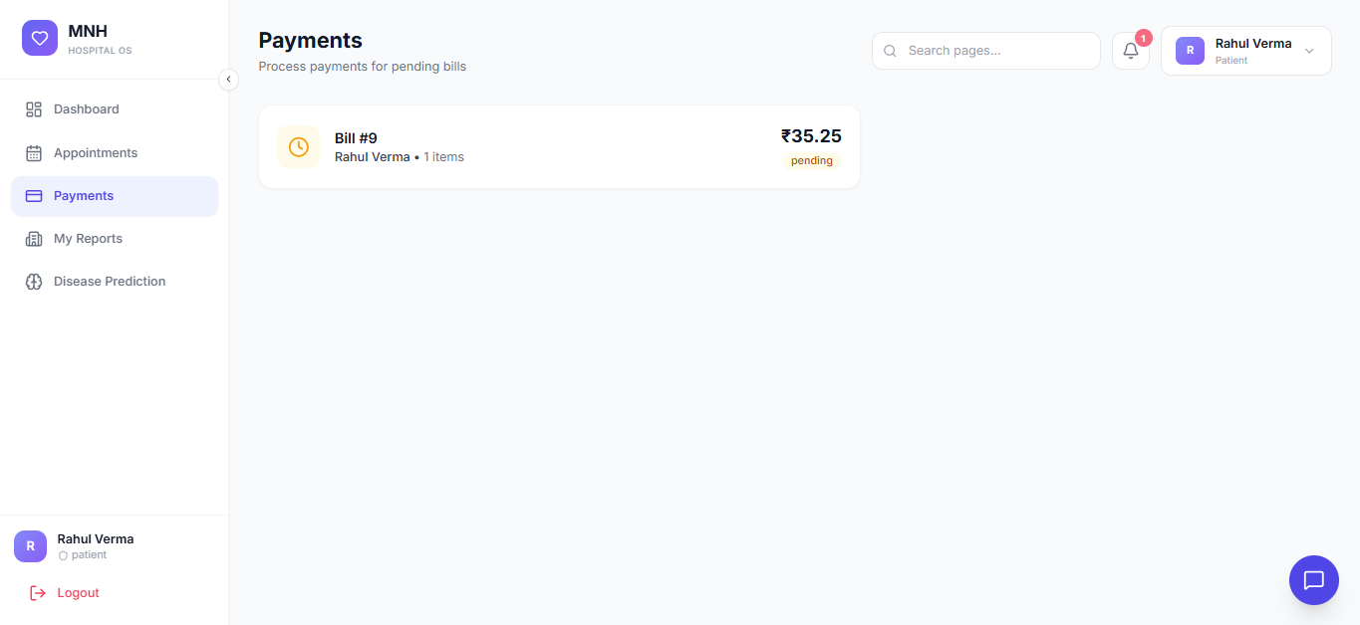
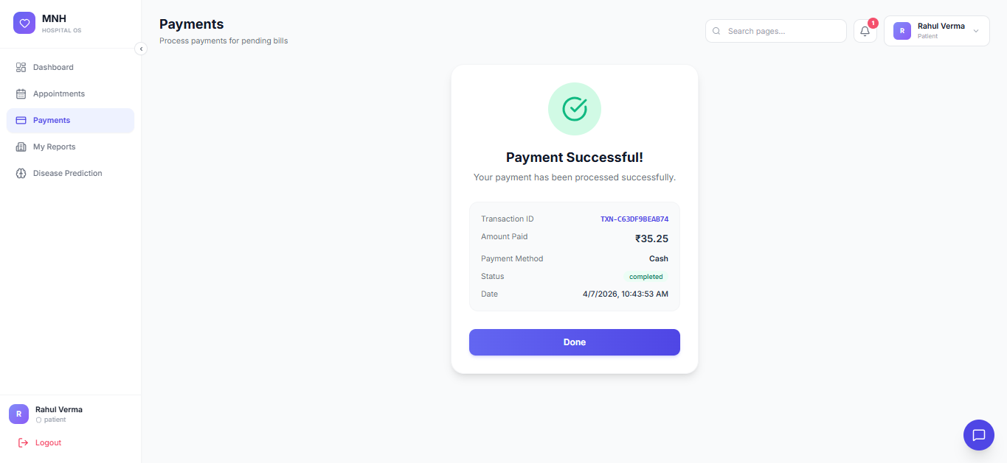
8: My Reports — Reports List
The My Reports section allows patients to access and view their medical reports, test results, and other clinical documents uploaded or generated through the hospital system.

Step-by-Step Process:
- Click on 'My Reports' from the left-hand navigation menu.
- The My Reports screen displays the heading 'My Reports' with the subtitle 'View your medical reports and test results'.
- All available reports are listed with the following details per entry:
- Report name / title (e.g., Blood Test Report, ECG Report)
- Date the report was generated or uploaded
- Doctor or department that issued the report
- Report type or category
- Click on any report entry to open and view the report document in detail.
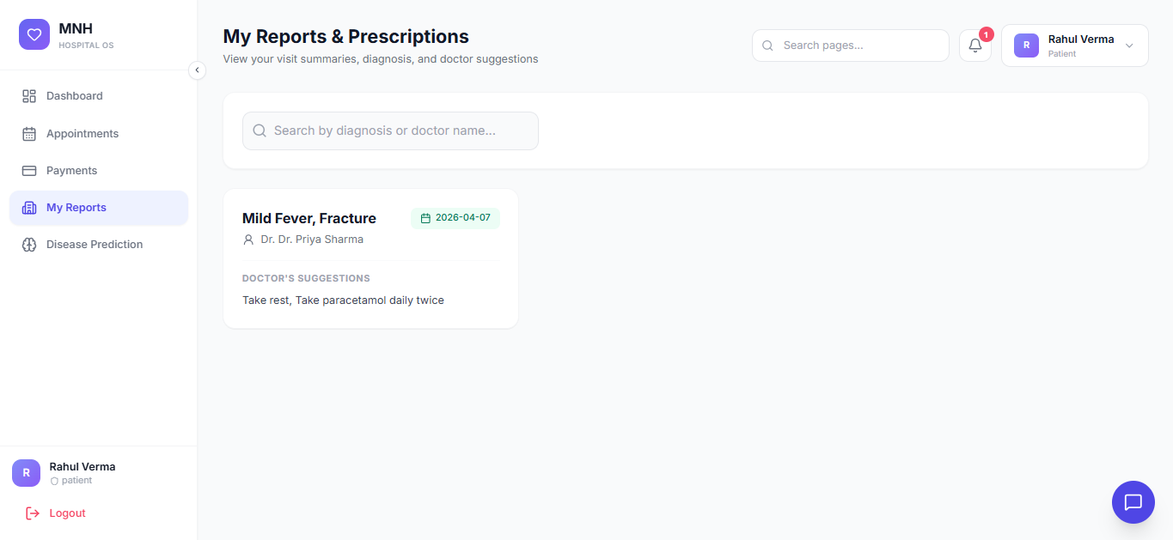
9: Disease Prediction — Input Symptoms
The Disease Prediction feature allows patients to enter their current symptoms and receive an AI-assisted preliminary disease prediction to guide their next steps.

Step-by-Step Process:
- Click on 'Disease Prediction' from the left-hand navigation menu.
- The Disease Prediction screen loads with a description explaining the feature and its purpose.
- In the 'Enter Your Symptoms' input area, type or select the symptoms currently being experienced:
- Type individual symptoms into the input field (e.g., 'fever', 'headache', 'cough').
- Selected symptoms appear as removable tags/chips below the input field.
- Click the 'x' on any symptom tag to remove it.
- Once all relevant symptoms have been entered, click 'Predict Disease' to submit.
- The system processes the symptom input and displays the prediction results on the same screen.

10: Disease Prediction — Prediction Results
After submitting symptoms, the system displays a list of possible disease predictions ranked by likelihood, along with recommended actions.

Step-by-Step Process:
- After clicking 'Predict Disease', the results section appears below the input area.
- The prediction results are displayed as ranked cards, each showing:
- Predicted disease / condition name
- Confidence / match percentage
- A brief description of the predicted condition
- Recommended department or specialist to consult
- A disclaimer note is shown below the results reminding the patient that predictions are AI-assisted and not a substitute for a doctor's diagnosis.
- Click 'Book Appointment' shortcut (if shown) to directly proceed with booking a consultation for the predicted condition.
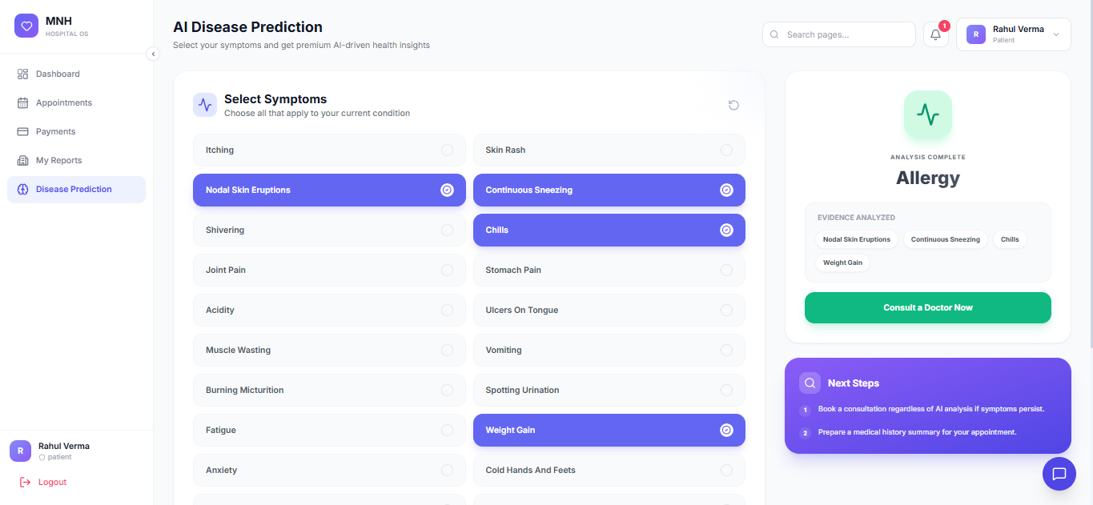
11: Dashboard — Patient Home Overview
The Dashboard is the home screen of the patient portal, providing a consolidated overview of upcoming appointments, recent reports, payments summary, and quick-access features.

Step-by-Step Process:
- Click on 'Dashboard' from the left-hand navigation menu.
- The Dashboard loads with a welcome banner showing the logged-in patient's name (e.g., 'Welcome, Rahul Verma').
- Summary stat cards are displayed at the top of the dashboard, showing:
- Total Appointments — count of all appointments booked
- Upcoming Appointments — count of scheduled future appointments
- Total Reports — count of medical reports available
- Pending Payments — amount or count of outstanding dues
- The 'Upcoming Appointments' section below the stat cards lists the next scheduled appointment with doctor name, date, and time.
- Quick-action links on the dashboard allow navigation directly to Appointments, Payments, Reports, and Disease Prediction.

12: Live Chat Support
The patient can initiate a real-time chat conversation with hospital support staff or a virtual assistant by clicking the chat icon available throughout the portal.

Step-by-Step Process:
- Click the chat bubble icon (💬) located at the bottom-right corner of any screen in the portal.
- The Live Chat panel slides in from the bottom-right corner of the screen.
- The chat panel displays:
- Chat header with the hospital name / support agent name and online status indicator
- Message history area showing all previous messages in the conversation
- A text input field at the bottom to compose new messages
- A send button (➤) to dispatch the typed message
- Type the query or message in the input field and click the send button or press Enter.
- The support agent or chatbot responds in real time within the chat window.
- Click the close (✕) button or click outside the chat panel to minimise or close the chat window.

13: Search — Search Pages
The Search functionality allows patients to quickly locate any page, feature, or information within the portal using a keyword-based search bar accessible from the top navigation.

Step-by-Step Process:
- Click on the search bar ('Search pages...') located in the top navigation bar of any screen.
- The search input becomes active and a search dropdown panel appears.
- Type a keyword related to the desired page or feature (e.g., 'appointment', 'report', 'payment').
- Matching results appear in real time as the patient types, showing:
- Page or section name
- Icon representing the section
- Brief description or path of the result
- Click on the desired search result to navigate directly to that section or page.
- Press Escape or click outside the search panel to dismiss it without navigating.

14: Notifications Panel
The Notifications panel provides the patient with a real-time feed of alerts and updates related to their appointments, reports, payments, and system announcements.

Step-by-Step Process:
- Click on the bell icon (🔔) in the top navigation bar to open the Notifications panel.
- A notification count badge on the bell icon indicates the number of unread notifications.
- The Notifications dropdown panel opens, displaying the list of recent notifications.
- Each notification entry shows:
- Notification title (e.g., 'Appointment Confirmed', 'Report Available')
- Brief message body describing the notification
- Timestamp (e.g., '2 minutes ago', 'Yesterday')
- Unread notifications are visually distinguished (bold text or highlighted background)
- Click on any notification entry to navigate to the relevant section (e.g., clicking an appointment notification takes the patient to the Appointments screen).
- All notifications are marked as read automatically once the panel is opened, and the count badge resets to zero.
- Click outside the notifications panel to close it and return to the current page.
