SMART RETAIL ASSISTANT
Detailed Screenshot Descriptions

1. Authentication Pages

1.1 Login Page
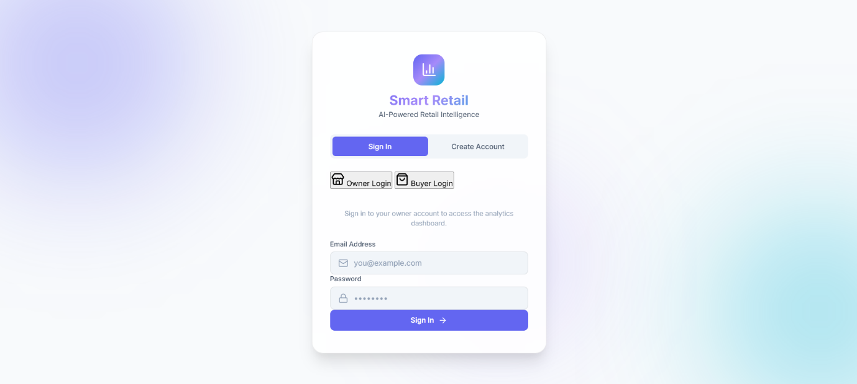
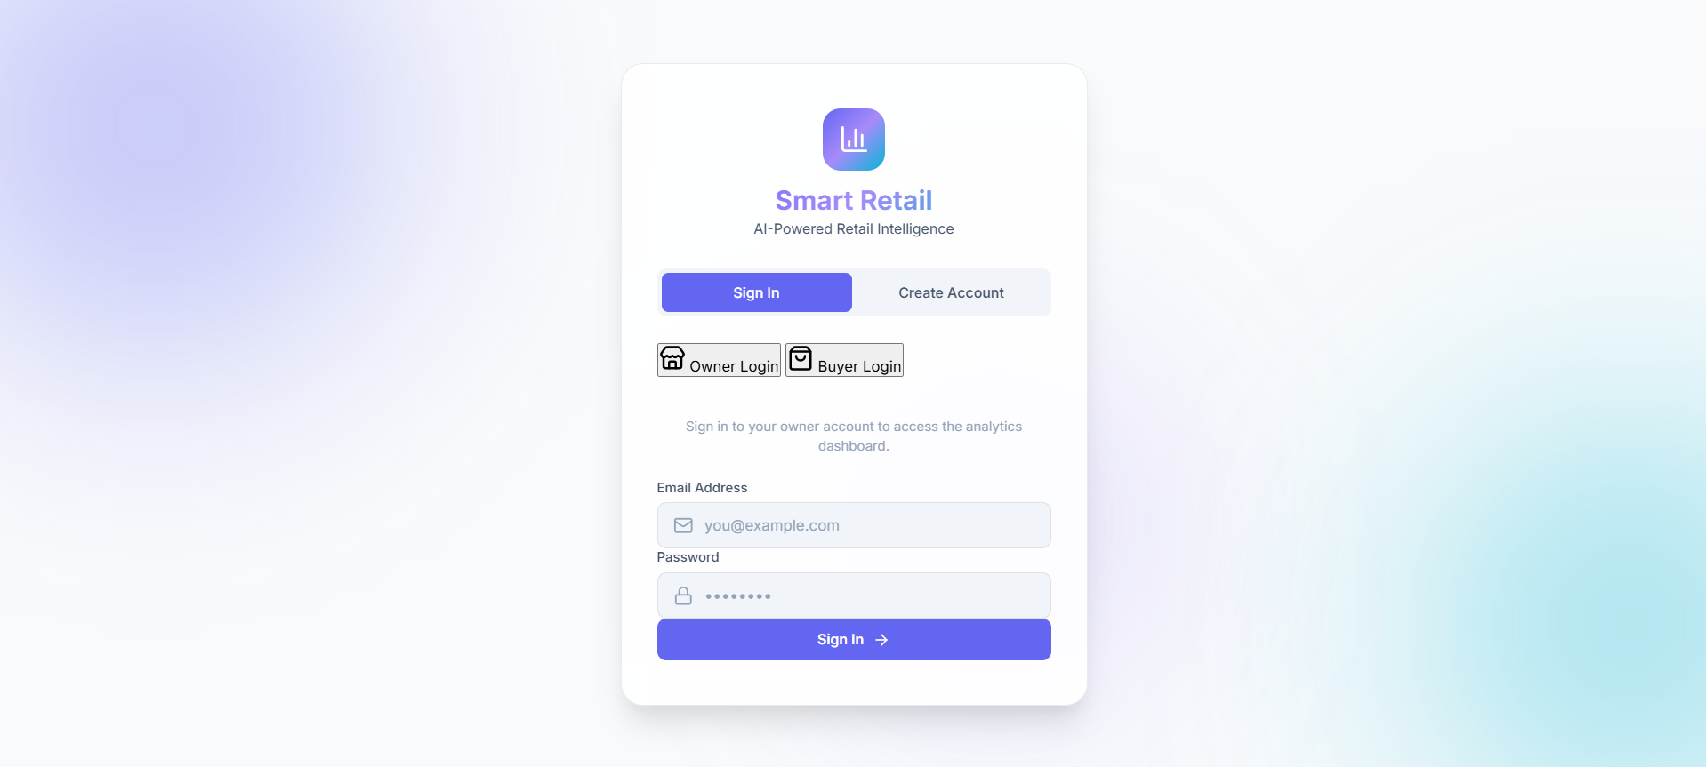

The login page serves as the primary entry point for both store owners and buyers to access the Smart Retail platform. Below the authentication section, there is a 'Create Account' button for new users.

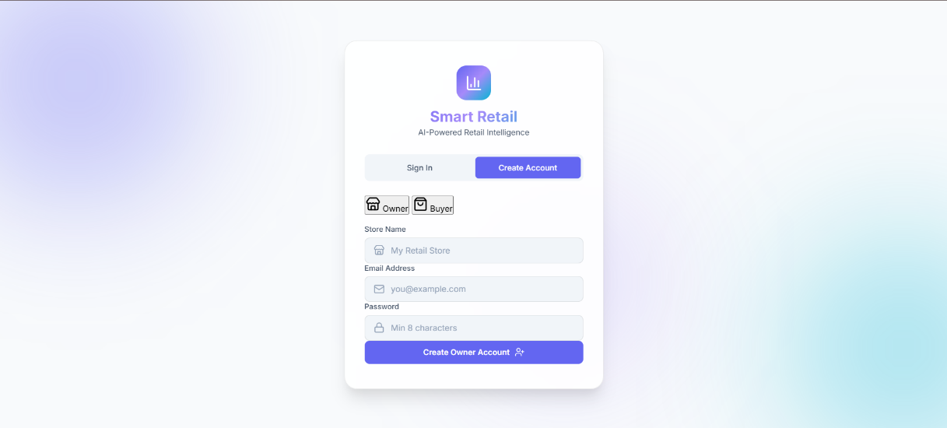
1.2 Create Account - Owner Registration
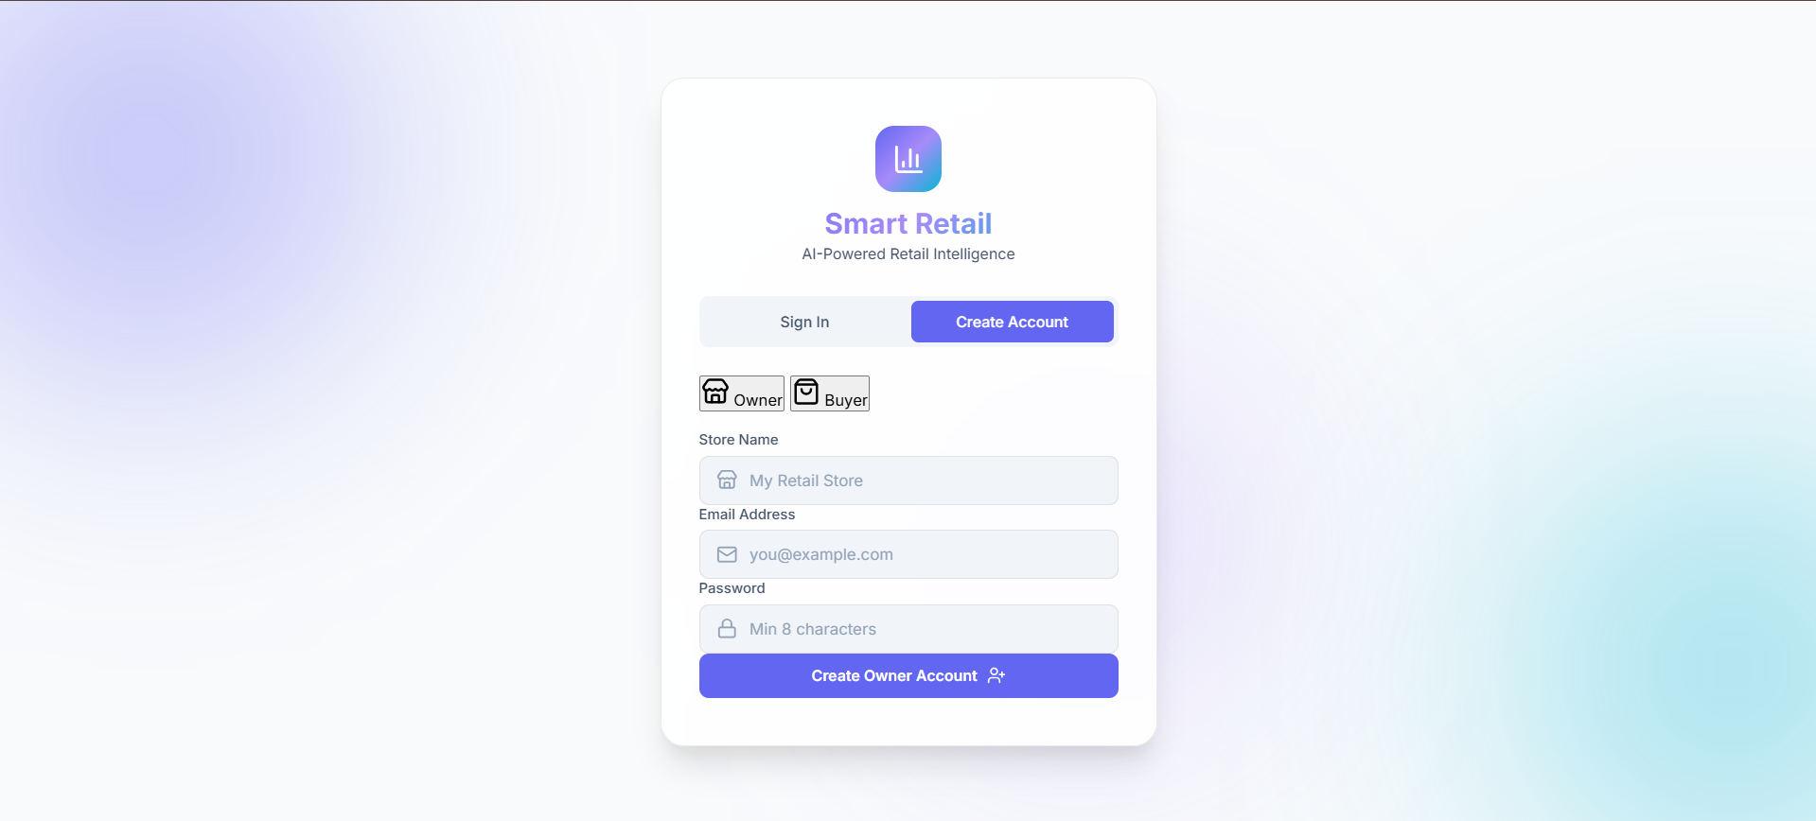
The owner registration page allows new store owners to create their account within the platform. The form is clearly labeled with role selection between 'Owner' and 'Buyer' options, with Owner pre-selected.

2. Owner Dashboard

2.1 Main Dashboard Overview
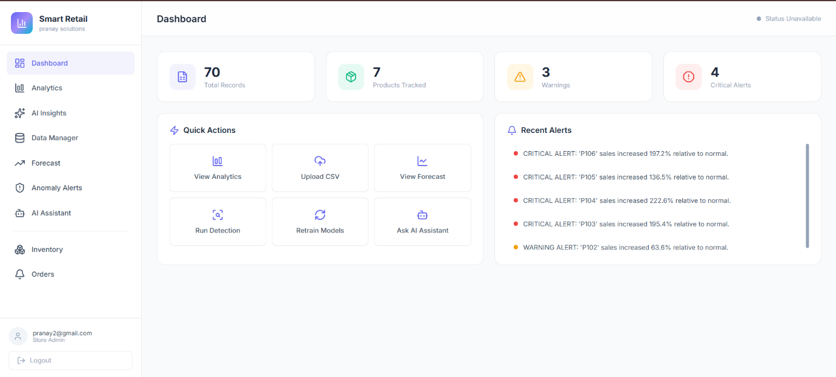
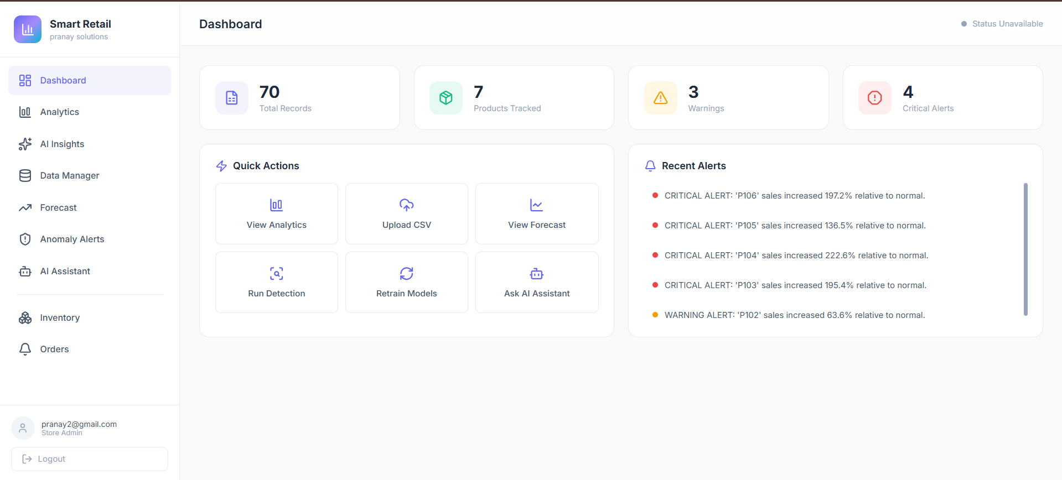

The main owner dashboard provides an at-a-glance view of critical business metrics and quick access to all platform features. The left sidebar navigation includes clearly labeled sections: Dashboard (active), Analytics, AI Insights, Data Manager, Forecast, Anomaly Alerts, AI Assistant, Inventory, and Orders. Each navigation item has an associated icon for visual recognition. These buttons provide direct access to the most commonly used features. The right panel shows 'Recent Alerts' with a scrollable list of critical and warning-level anomalies.

3. Data Management

3.1 Sales Data Upload Interface
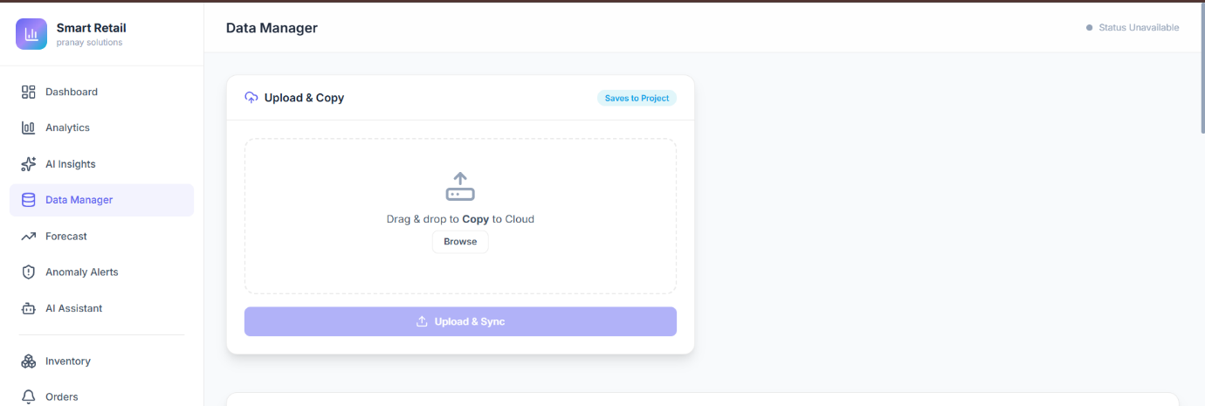
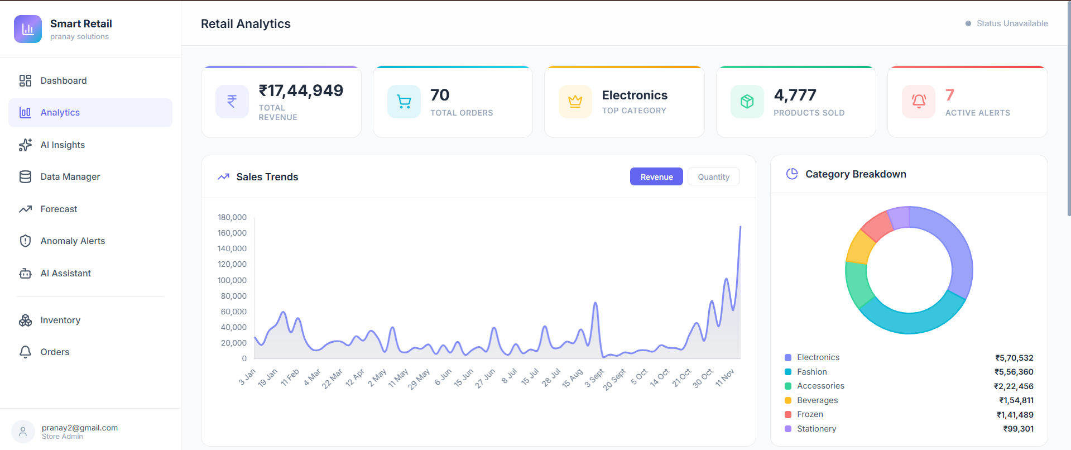

The Data Manager section (image not visible but referenced) provides a streamlined interface for uploading sales data in CSV format. This upload functionality is critical for populating the analytics engine with transaction records. The upload interface typically includes: a drag-and-drop zone for easy file selection, file type validation to ensure only CSV files are accepted, visual feedback during the upload process with progress indicators, and clear error messages if validation fails. Once uploaded, the system automatically processes the CSV through a cleaning and normalization pipeline, removing duplicates and standardizing data formats. The uploaded data is stored in MongoDB's sales_records collection and simultaneously exported to Azure Blob Storage in Parquet format for long-term analysis. The system displays confirmation messages upon successful upload and provides options to immediately view the imported data or trigger model retraining.

4. Analytics & Insights

4.1 Analytics Dashboard
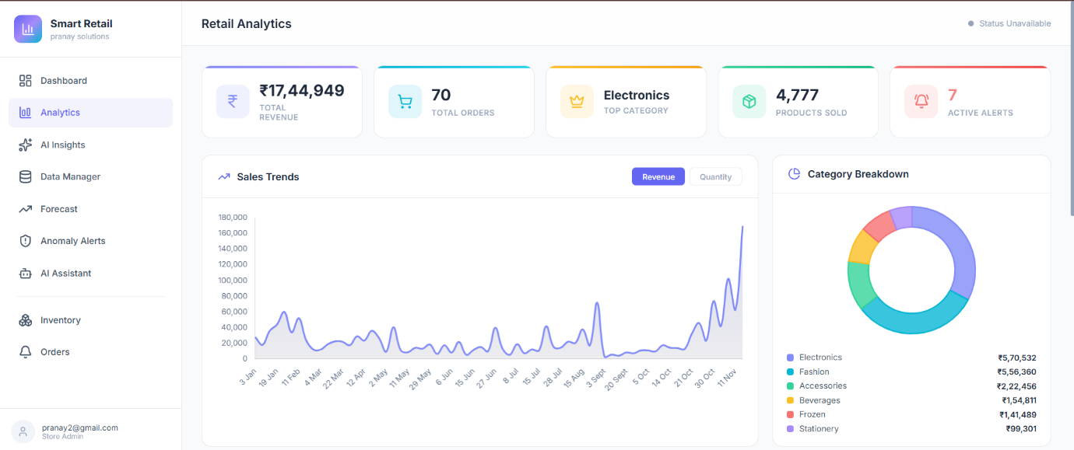
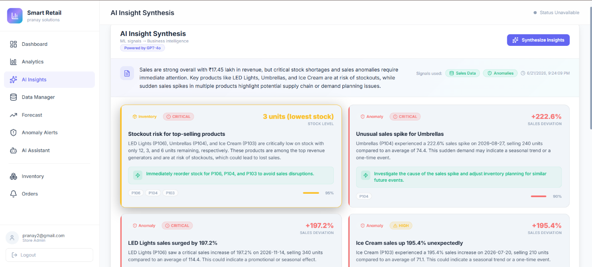

The Analytics section provides comprehensive access to processed sales records with powerful filtering and visualization capabilities. This view displays all transactions imported or generated through order injection in a structured table format. Users can filter records by date range, product category, and store to focus on relevant data subsets. The interface includes pagination controls for managing large datasets and export functionality to download records in standard formats. Visual charts are integrated to show sales trends over time, category-wise revenue distribution, and top-performing products. The analytics view supports time-series analysis, allowing store owners to identify patterns, seasonal trends, and growth trajectories. Each record is timestamped and tagged with metadata (product ID, category, quantity, revenue, cost, stock level), enabling detailed business analysis and informed decision-making.


4.2 AI Synthesis & Business Insights
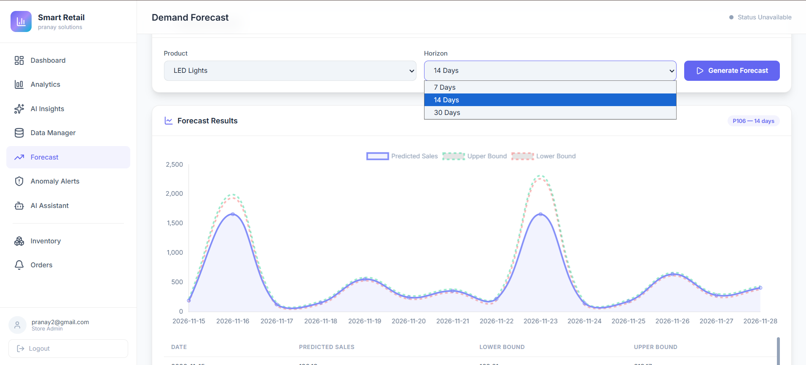
The AI Insights feature leverages machine learning models and large language models to generate actionable business recommendations. This page displays structured insights automatically generated from sales data, forecasts, and anomaly analysis. Each insight is categorized by domain (inventory management, demand planning, revenue optimization, operational efficiency, anomaly response) and assigned a priority level (critical, high, medium, low). The insights include: a concise title describing the finding, a detailed explanation in business language (not technical jargon), the underlying data signals that triggered the insight (e.g., 'sales of Product X increased 150% in the last week'), recommended actions the store owner should consider, and confidence scores indicating the reliability of the recommendation. For example, an insight might suggest: 'Category Electronics has declining trend - consider promotional campaign to boost sales.' The system updates insights daily based on fresh data, helping store owners stay informed of changing business conditions.

5. Forecasting & Demand Planning

5.1 Demand Forecast View
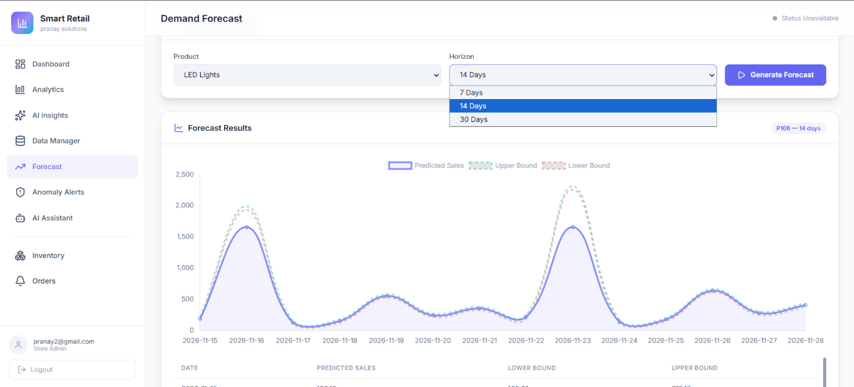
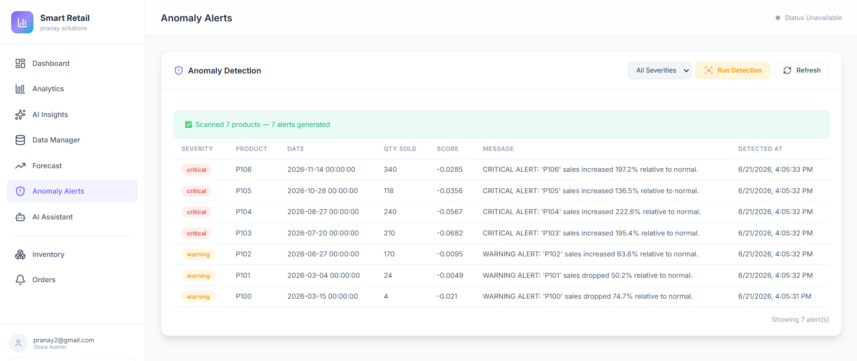

The Forecast section provides demand predictions for each product tracked in inventory, powered by Facebook's Prophet time-series forecasting algorithm. Store owners can select any product and view its predicted sales for 7, 14, or 30 days into the future. The forecast display includes multiple informative elements: a line chart showing historical sales (in blue), the forecasted trend (in a contrasting color), and confidence bands (typically 80% confidence interval) showing the range of likely outcomes. Each forecast point displays the predicted quantity, the date, and trend direction (increasing, stable, or decreasing). External factors influencing the forecast are highlighted: weekend flags, holiday indicators, and seasonal classifications (monsoon, festive, summer, winter). The interface allows owners to drill down into specific products, compare multiple product forecasts side-by-side, and understand forecast accuracy through MAPE (Mean Absolute Percentage Error) metrics. The system retrains models automatically whenever new sales data is uploaded, ensuring forecasts remain accurate and responsive to changing market conditions.

6. Anomaly Detection & Alerts

6.1 Anomaly Detection Alerts
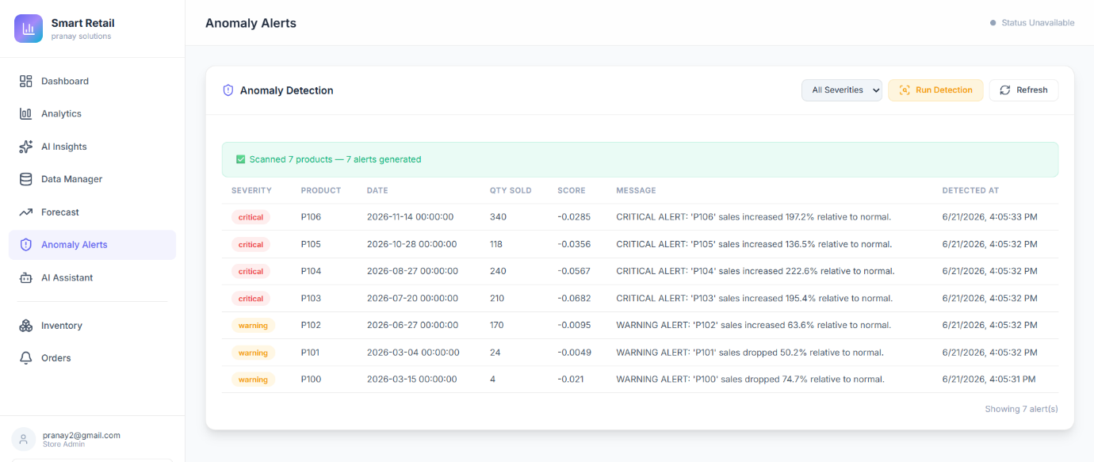
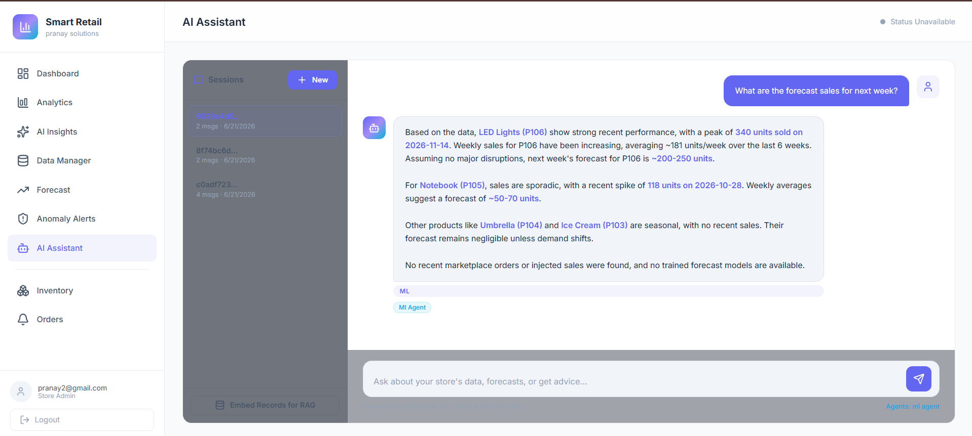

The Anomaly Alerts section displays real-time notifications of unusual sales patterns detected by the Isolation Forest machine learning model. Each alert is presented with clear visual indicators: red badges for CRITICAL severity (requiring immediate action) and orange badges for WARNING severity (review recommended). The alerts panel shows product identifiers (e.g., 'P106', 'P105', 'P104') along with specific deviation metrics such as 'sales increased 197.2% relative to normal' or 'sales increased 136.5% relative to normal'. The dashboard maintains a scrollable recent alerts list, allowing owners to quickly review emerging issues. Each alert is timestamped so owners know how recent the anomaly is. The alerts are context-aware, understanding seasonal patterns and not flagging legitimate seasonal spikes (e.g., increased sales during festival season). Some alerts are automatically acknowledged when the system determines the anomaly was expected or explained, while others remain open until the owner investigates. Store owners can click through to see detailed analysis including: the exact data points triggering the alert, historical comparison, potential causes, and recommended actions (increase stock, investigate supply chain, etc.).

7. AI Chat Assistant

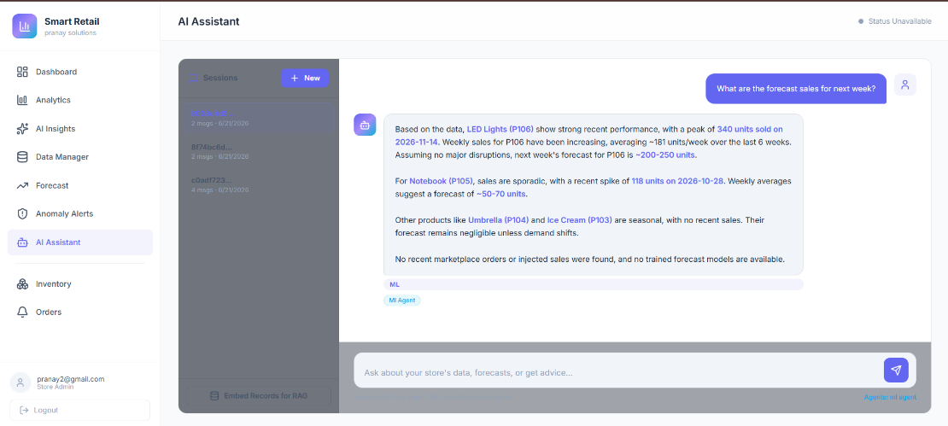
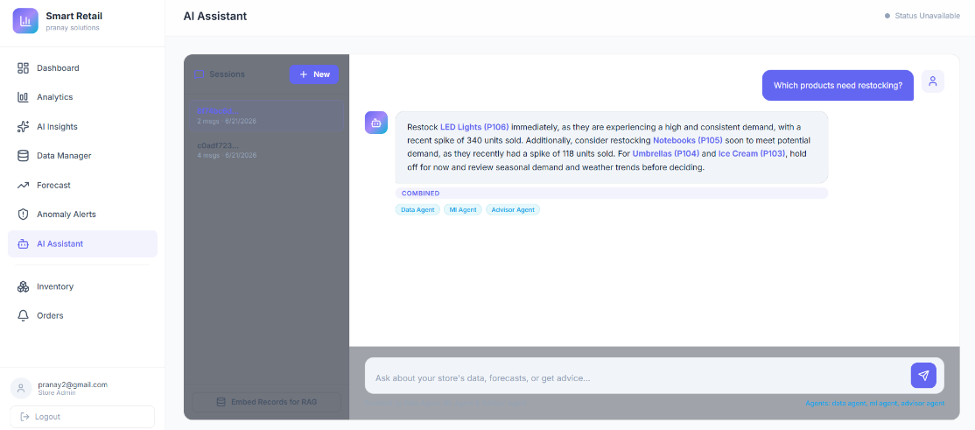
7.1 Conversational AI Interface
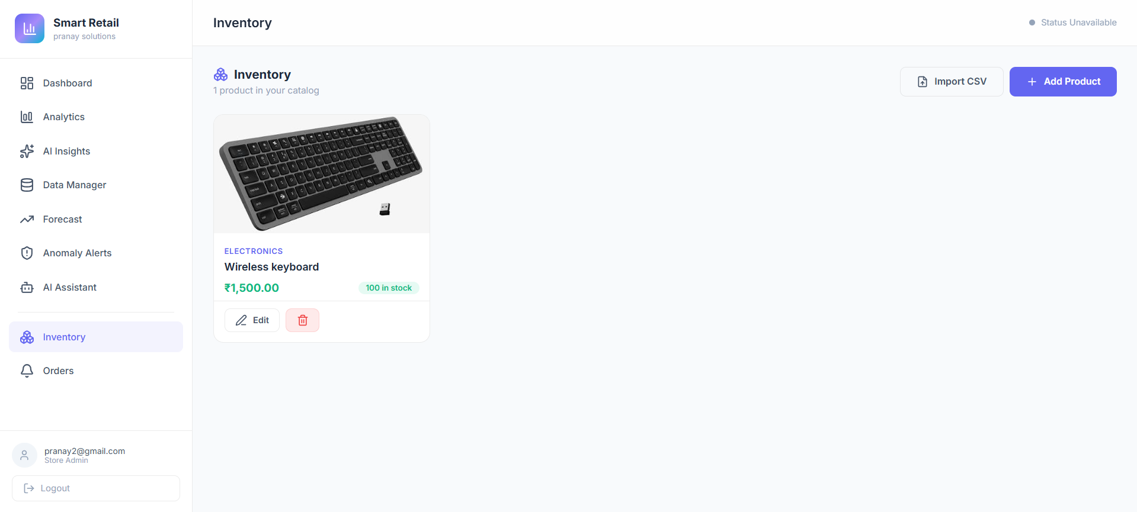
The AI Assistant provides a conversational interface for store owners to query business data, get insights, and take actions using natural language. Owners can ask questions like: 'What are my top-selling products?', 'Show me sales trends for Electronics', 'How much revenue did I make last week?', 'Increase stock for Product A by 50 units', or 'What products need restocking?'. The system uses intent classification to route queries to appropriate specialist agents: Data Agent (for sales statistics and inventory), ML Agent (for forecasts and anomalies), or Advisor Agent (for strategic recommendations). The assistant provides responses in business language, not technical jargon, making insights accessible to non-technical users. When the owner gives inventory commands like 'Add 100 units of Mouse', the system automatically executes the action and confirms completion ('✓ Successfully updated Product stock').

7.2 History & Session Management
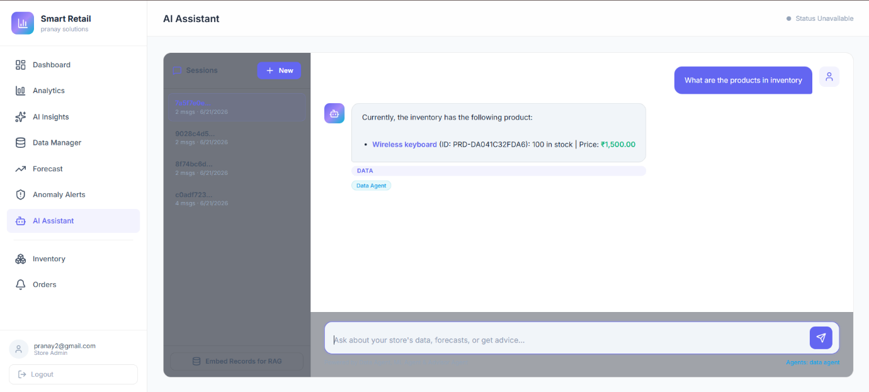
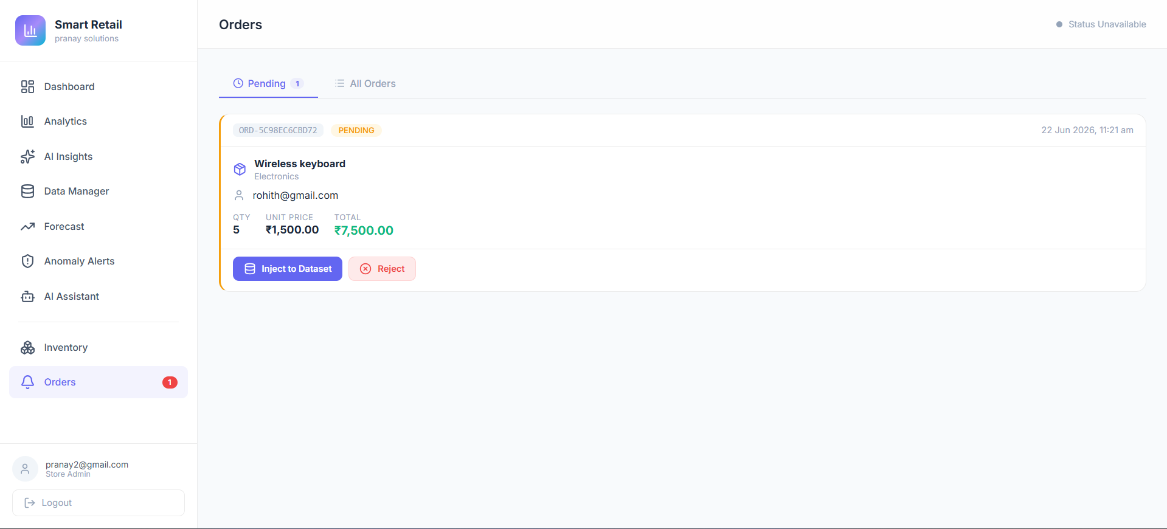

The Chat History view provides a searchable archive of all conversations between the owner and the AI assistant. Each session is timestamped and summarized with key topics discussed. Owners can: browse previous conversations organized by date, search conversations by keyword, view complete transcripts of past sessions, and manage sessions (delete old conversations to manage storage). The session management interface displays session metadata: creation date, number of messages exchanged, primary topic (analytics, inventory, forecasting), and key actions taken during the session. When reviewing past sessions, owners can see the complete context of decisions that were made, creating an audit trail and historical reference. This feature is particularly valuable for understanding how inventory and sales strategies evolved over time. Sessions can be tagged with custom labels (e.g., 'Holiday Planning', 'Demand Surge Response') for easy future retrieval. The system uses these sessions to provide better contextual responses in future conversations, as the AI learns about the owner's typical concerns and decision patterns.

8. Inventory Management

8.1 Manual Product Entry
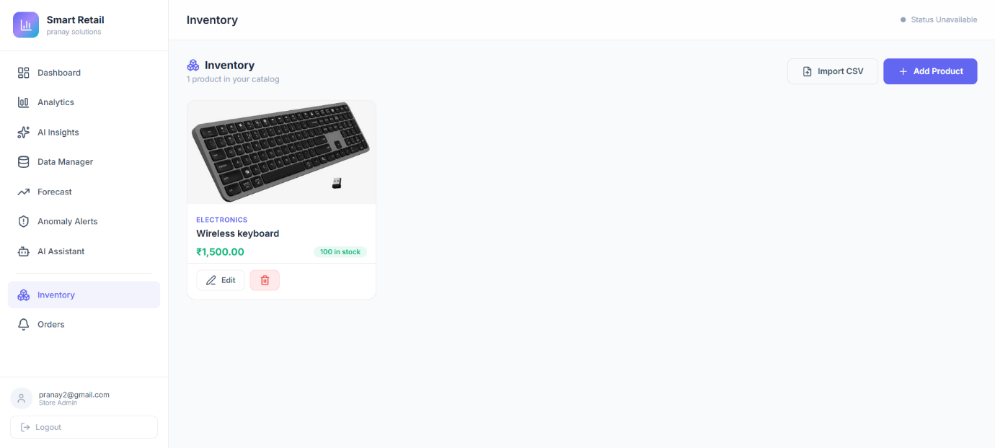
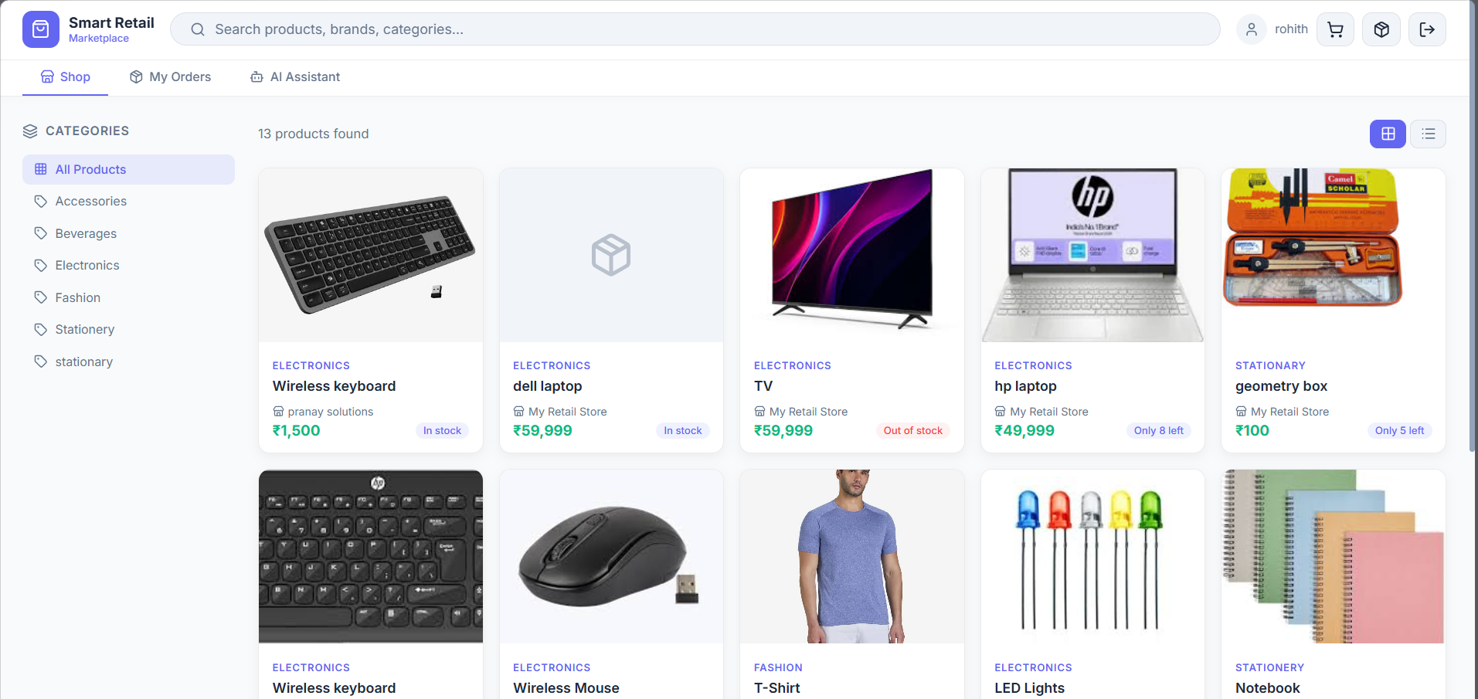

The manual product creation interface allows store owners to add individual products to their inventory one at a time. The form includes comprehensive fields: Product Name (required, e.g., 'Wireless Mouse'), Category (dropdown selection from predefined categories like Electronics, Groceries, Fashion), Price (selling price in local currency), Cost (cost to the store for calculating margins), Stock Level (current units available), Description (detailed product information for marketplace display), and Image URL (link to product image). Each field includes helpful placeholders and validation. The interface calculates and displays profit margin automatically based on cost and selling price, providing immediate feedback on pricing strategy. Product images can be uploaded directly or linked from URL. Once created, the product is immediately available in the store's catalog and visible to potential buyers in the marketplace. The owner retains the ability to edit or delete products at any time.

8.2 Bulk CSV Import for Products
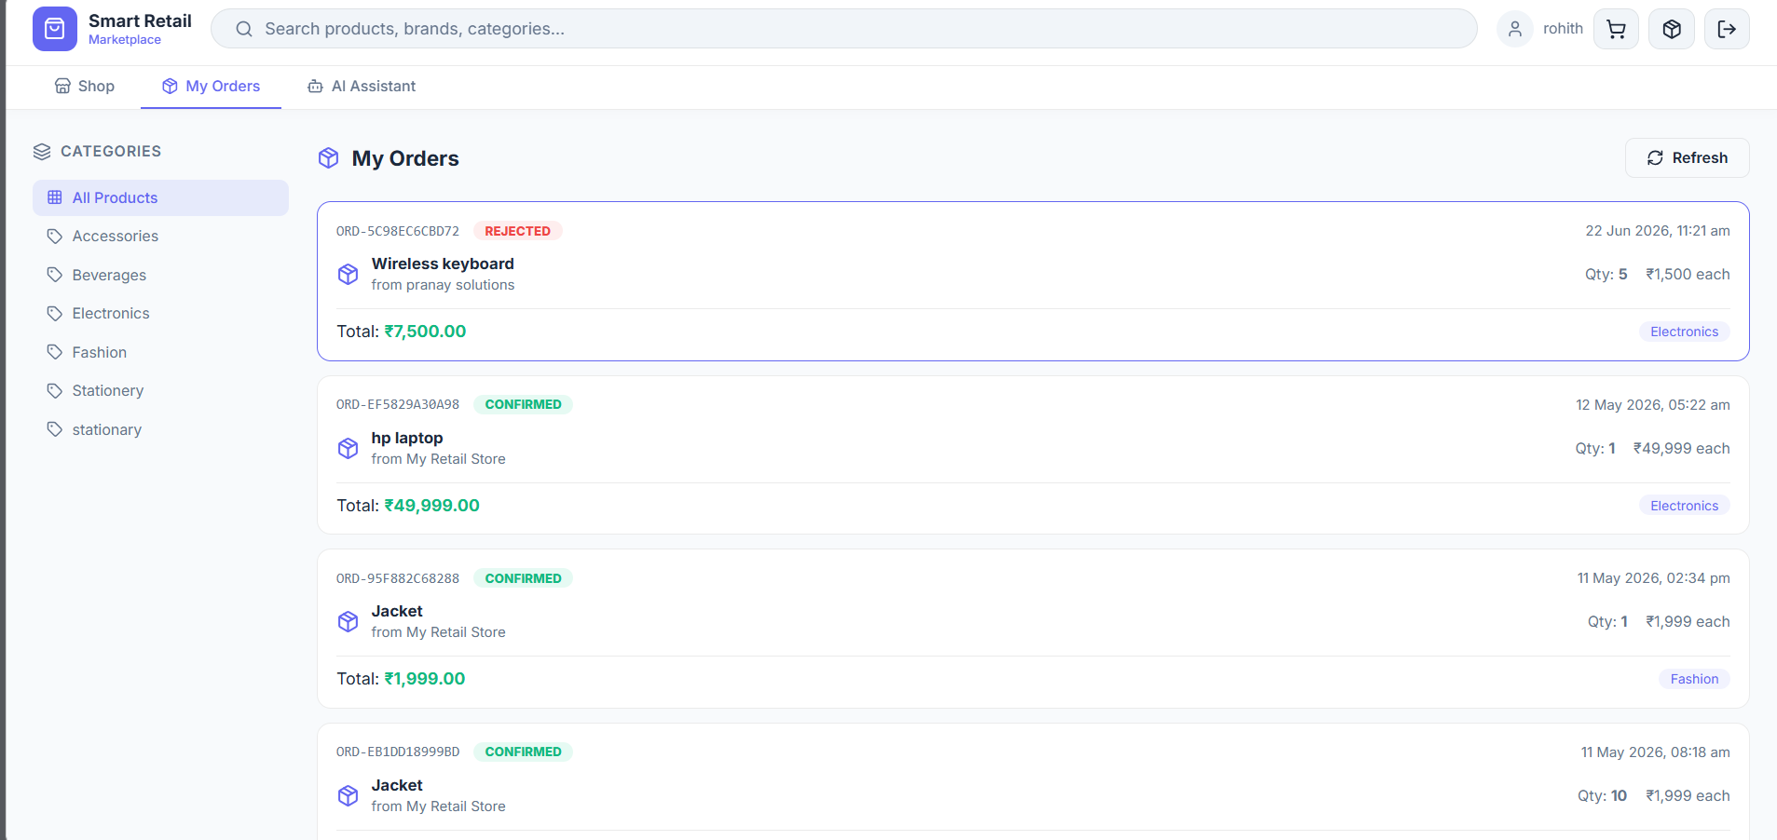
The bulk import feature enables store owners to upload an entire product catalog or large updates from a CSV file, dramatically reducing time compared to manual entry. Owners download a CSV template with standard columns: product_id, product_name, category, price, cost, stock_level, description, and image_url. They populate this template with their products using any spreadsheet application (Excel, Google Sheets, etc.) and upload it back to the platform. The system validates each row, reporting any errors or inconsistencies. Owners can choose the import mode: 'Upsert' (update existing products or add new ones) or 'Insert New' (only add completely new products, skipping any that already exist). This prevents accidental overwriting of recent updates. The import process is asynchronous—owners are notified via email when the import completes, with a summary of how many products were added, updated, or skipped due to errors.

8.3 Product Catalog Management
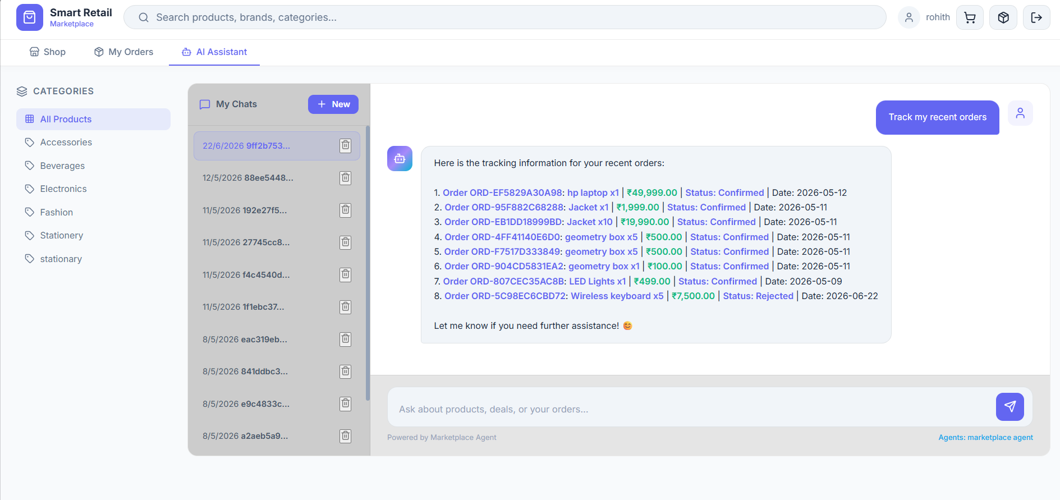
The product listing view displays all products in the store's inventory in a searchable, filterable table format. Each row shows essential product information: product name and ID, category, current stock level (color-coded: green for healthy stock, yellow for low stock, red for out-of-stock), current price, and profit margin percentage. Owners can: search products by name or ID using a text search box, filter by category using dropdown selectors, sort by any column (name, stock, price, margin), and view detailed product information by clicking on any item. Each product row includes action buttons: 'Edit' (to update price, stock, or description), 'View' (to see marketplace listing as buyers see it), and 'Delete' (with confirmation to prevent accidents). The interface supports batch operations: owners can select multiple products and perform actions on all of them simultaneously (e.g., apply a discount to all Electronics items). Stock level alerts are integrated—products with stock below a threshold are visually highlighted, prompting owners to reorder. The table is paginated for performance with large catalogs, and owners can adjust the number of items displayed per page.

9. Order Management

9.1 Pending Orders & Notifications
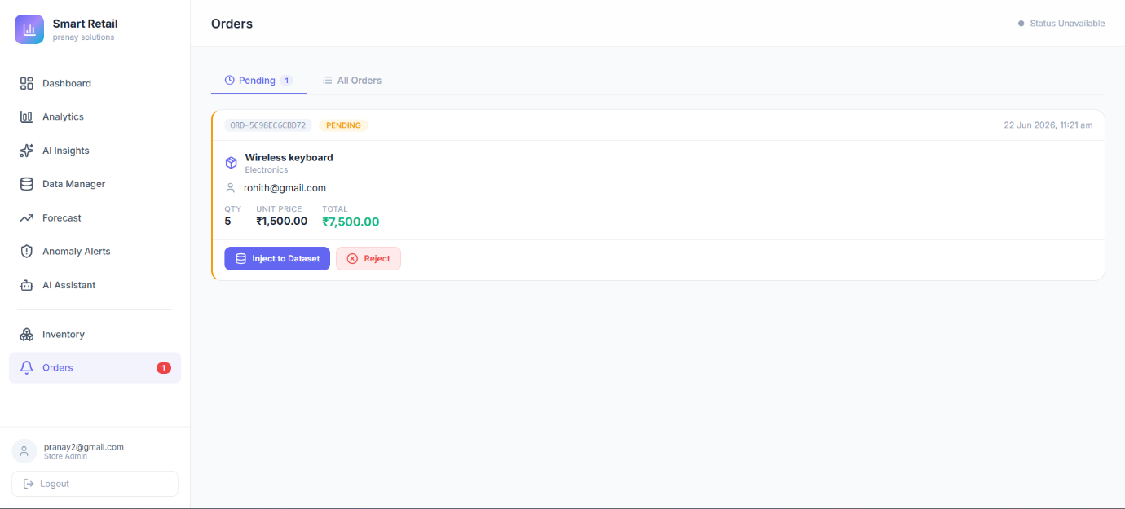
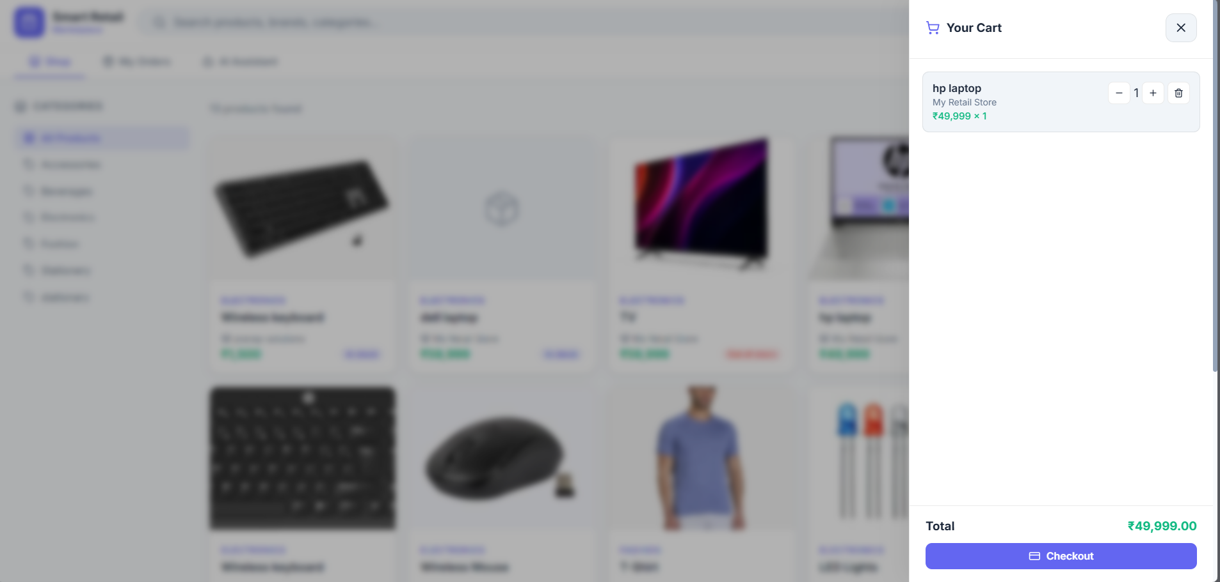

The Pending Orders section displays a notification feed of all orders placed by buyers that require the owner's attention. Each pending order shows: the buyer's name, the products ordered with quantities, the order total amount, the order timestamp, and the current status. Orders are presented in reverse-chronological order (newest first) so the most urgent orders are immediately visible. Owners can click on any order to view full details including: buyer contact information, complete item list with unit prices and totals, delivery address, payment method used, and any special notes from the buyer. For each order, owners have two primary actions: 'Approve & Inject' (accept the order and add it to the sales dataset for analytics) or 'Reject' (decline the order, typically with a reason that's communicated to the buyer). Approving an order updates the inventory stock levels (deducting the purchased quantities), records the transaction in the sales_records collection, and triggers email notifications to the buyer. Rejecting an order restores product stock if it was already deducted and notifies the buyer of the cancellation.

9.2 Order Injection to Analytics Dataset
The order injection interface presents a detailed view of a pending order and walks the owner through the approval process. When an owner clicks 'Inject Order', the system: records the order as accepted, deducts the ordered quantities from inventory stock levels, creates a new row in the sales_records collection with all order data (date, product_id, quantity_sold, revenue, cost, category, stock_level remaining), exports the new record to the staged Parquet dataset in Azure Blob Storage, and triggers automatic model retraining to incorporate the new transaction into demand forecasts and anomaly detection. The owner receives immediate confirmation that the injection succeeded ('✓ Order injected successfully'). This step is critical because only injected orders are included in analytics and ML models—pending orders are visible in the dashboard but don't influence insights or forecasts until they're approved.

9.3 Order History & Complete Record
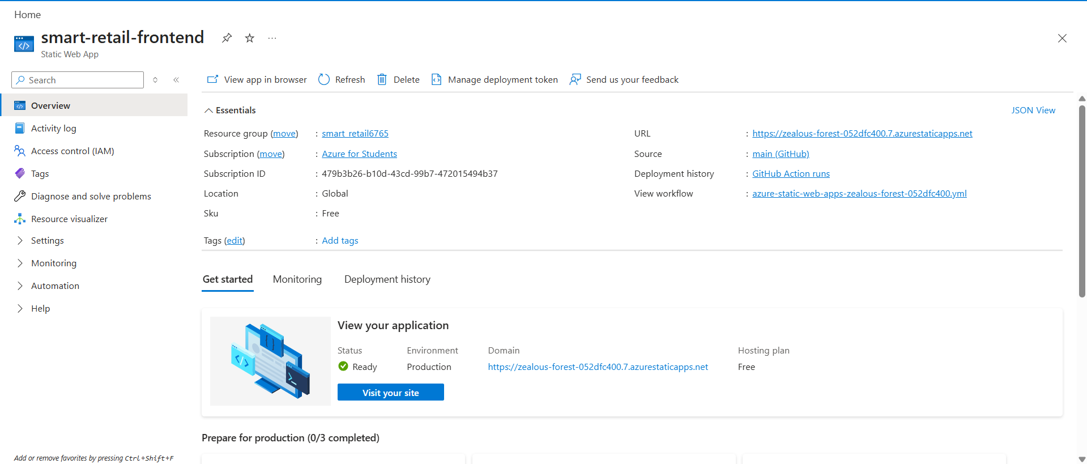
The order history view provides a comprehensive, paginated list of all orders processed through the platform, regardless of status (pending, injected, rejected). The table displays key information for each order: order ID, buyer name, order date and time, items ordered with quantities, total amount, current status, and action timestamp. Owners can filter by status to focus on specific order subsets (show only pending, or show only injected). Each order row is clickable, revealing full details in an expanded view including: complete item listing with unit prices, subtotals and total, delivery address, payment method and confirmation, buyer contact information, any notes or special requests, and timeline of status changes. The interface supports bulk operations: owners can select multiple orders and perform actions like 'Approve All', 'Download as CSV', or 'Print Invoices'. Search functionality allows finding specific orders by order ID, buyer name, or product name. This historical record is essential for customer service (answering order status questions), inventory management (understanding product movement patterns), and business analysis (order frequency, average order value trends).

10. Buyer Marketplace

10.1 Marketplace Browse & Discover
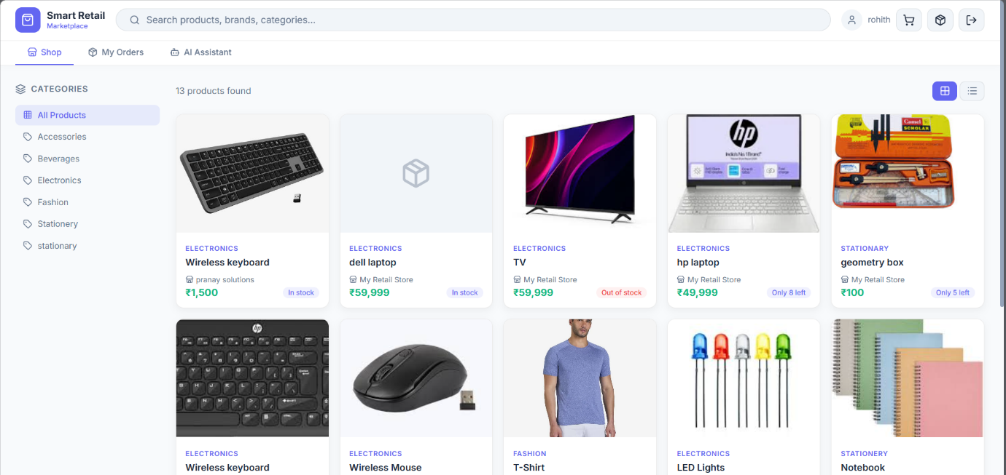
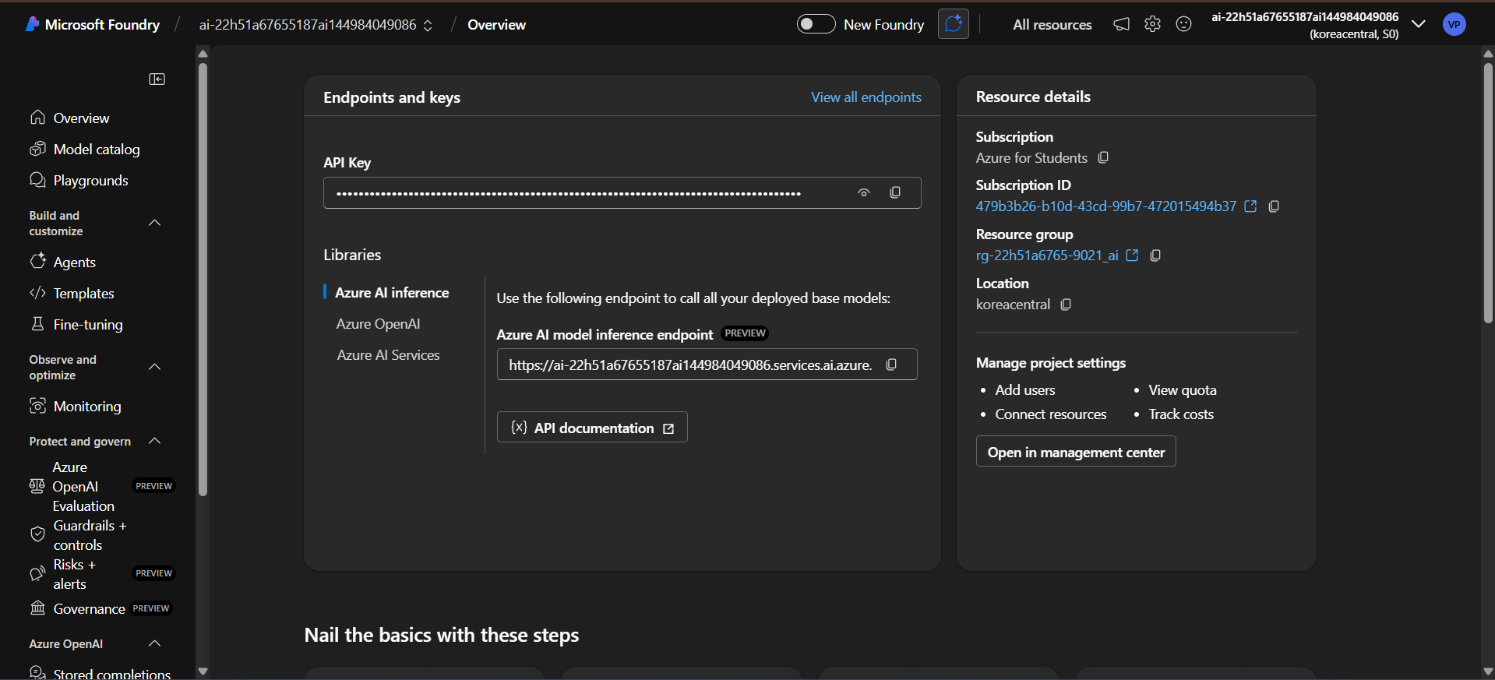

The marketplace homepage provides buyers with a dynamic interface to discover products from all store owners on the platform. The main content area displays a grid or list of featured products, each showing: product image, product name, category, seller's store name, current price, stock availability status (in stock / low stock / out of stock.Above the product grid, a search bar allows buyers to search by product name, category, or store name. Filter options let buyers narrow results by: category (Electronics, Groceries, Fashion, etc.), price range (minimum and maximum), availability (in stock only), and store (to shop from specific dealers). The marketplace aggregates products from all active sellers, providing buyers with comprehensive selection and competitive pricing across vendors. As buyers apply filters, the product grid updates in real-time without page refreshes. Each product card includes an 'Add to Cart' button for quick shopping, and clicking the product shows additional details: full product description, detailed images.

10.2 Shopping Cart Interface
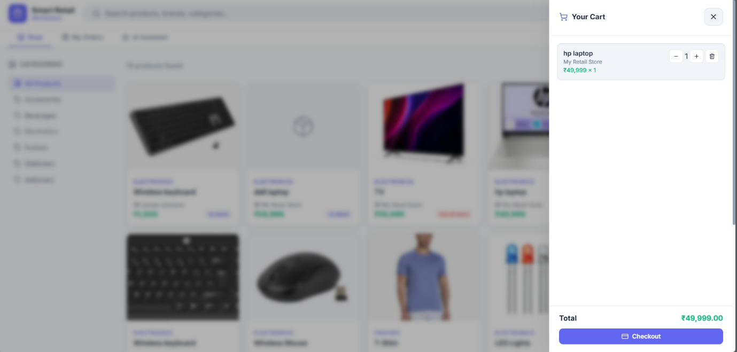
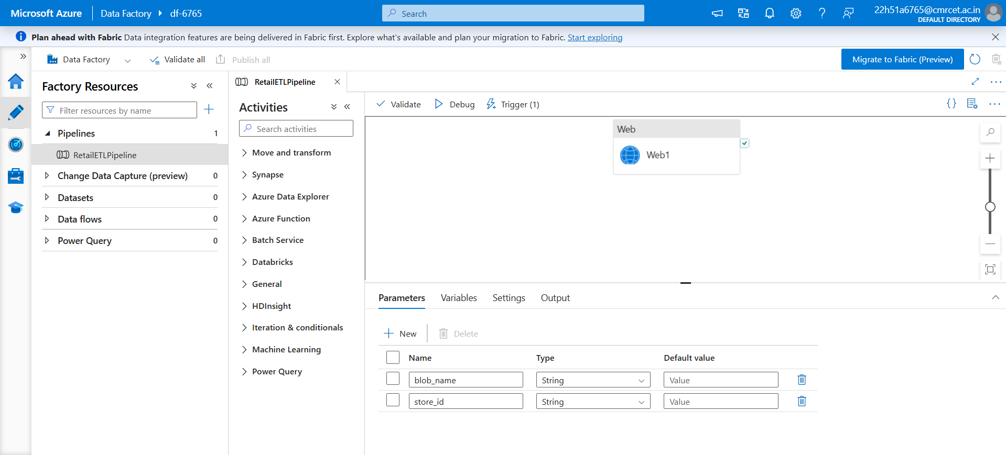

The shopping cart provides a dedicated space for buyers to review selected items before purchase. The cart displays a list of items in a table format showing: product image, product name, seller name, unit price, quantity (with +/- buttons for easy adjustment), subtotal (unit price × quantity), and a remove button for each item. At the bottom, a summary section shows: subtotal (sum of all item subtotals), applicable taxes or discounts, estimated shipping cost, and the final total amount due. Buyers can: change quantities for any item by clicking +/- buttons, remove items entirely, apply coupon codes if available, continue shopping (returns to marketplace), or proceed to checkout. The interface preserves cart contents even if the buyer leaves and returns later (within session), ensuring they don't lose their selections. For each item, the interface confirms availability ('In Stock - Ready to ship') and delivery timeframe ('Ships in 1-2 days'). If an item quantity requested exceeds available stock, the cart alerts the buyer and suggests ordering the maximum available. The cart view also recommends complementary products based on the items already selected, encouraging cross-selling.

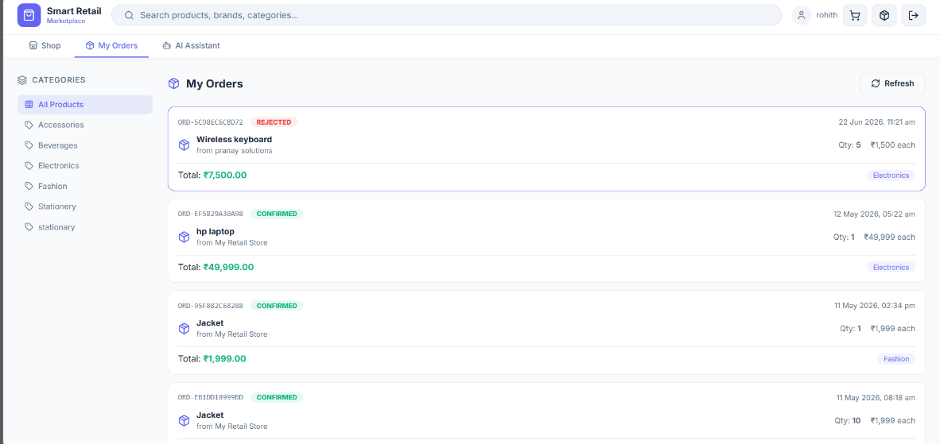
10.3 Buyer Order Tracking
The buyer's order history page displays all past and current orders in a timeline format. Each order entry shows: order number, order date, items purchased (product names and quantities), order total amount, and current status (pending approval, confirmed, shipped, delivered). Buyers can click on any order to expand and view full details: complete itemization with individual prices, delivery address, estimated delivery date or actual delivery date if already delivered, tracking information if applicable, and payment receipt. For orders in transit, the interface shows a progress indicator: pending → confirmed → shipped → out for delivery → delivered. Buyers can contact sellers through an integrated messaging system for order inquiries. The interface allows filtering by status (show all, show pending, show delivered) and date range.

11. Buyer AI Shopping Assistant

11.1 Conversational Shopping Support
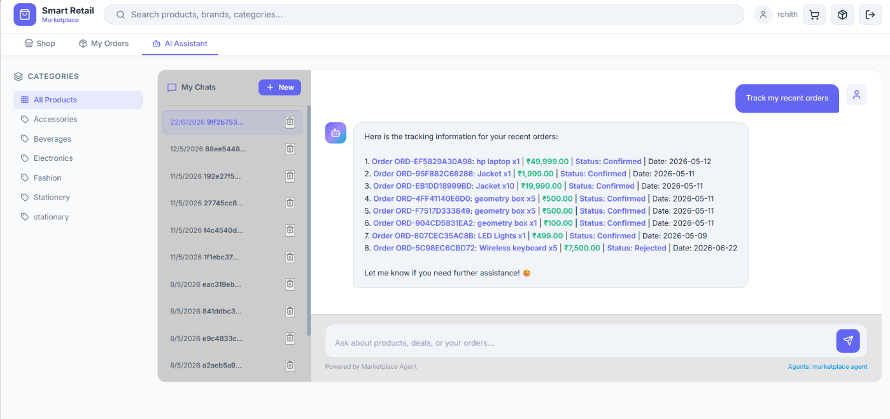
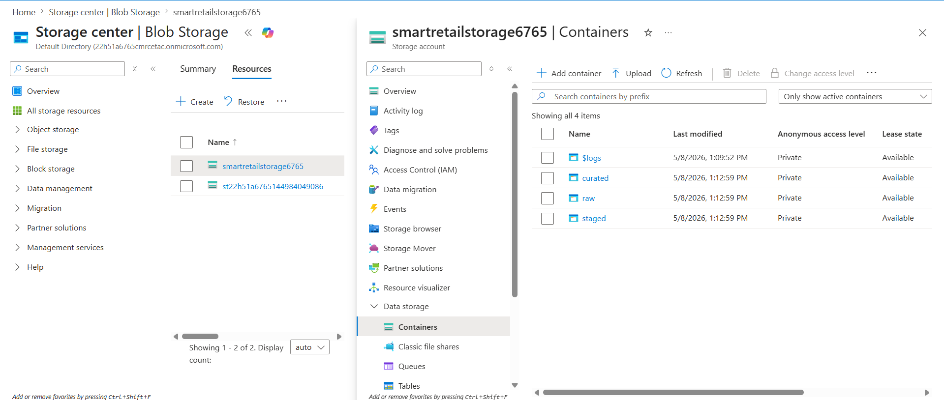

The buyer AI assistant provides conversational support for shopping-related queries and transactions. Buyers can ask questions like: 'Show me the best wireless mice', 'What's available in the Electronics category under 500 rupees?', 'Recommend a laptop', or 'Add 2 units of the Wireless Mouse to my cart'. The assistant provides: product recommendations based on interests or budget, answers about product availability and pricing, comparisons between similar products, information about seller ratings and delivery options, and ability to place orders through natural language. When a buyer says 'I want to buy 2 units of Wireless Mouse priced under 2000 rupees', the assistant identifies matching products, confirms the selection, and can place the order with a single confirmation click. The chat interface displays conversation history with clear visual distinction between buyer messages and assistant responses. The assistant maintains context across multiple messages, understanding follow-up questions without repetition. For complex queries, the assistant can show product cards with images and detailed information, then directly add them to the buyer's cart. This feature transforms shopping from a task into a conversational experience, making it accessible to buyers of all technical skill levels and accelerating the path from discovery to purchase.

12. Payment & Checkout

12.1 Secure Payment Page
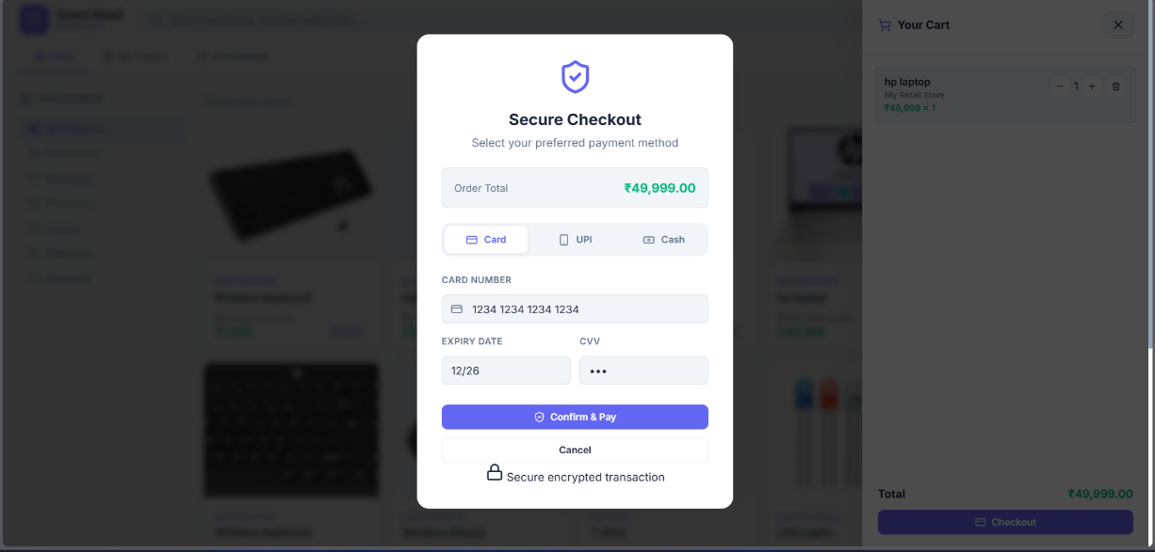
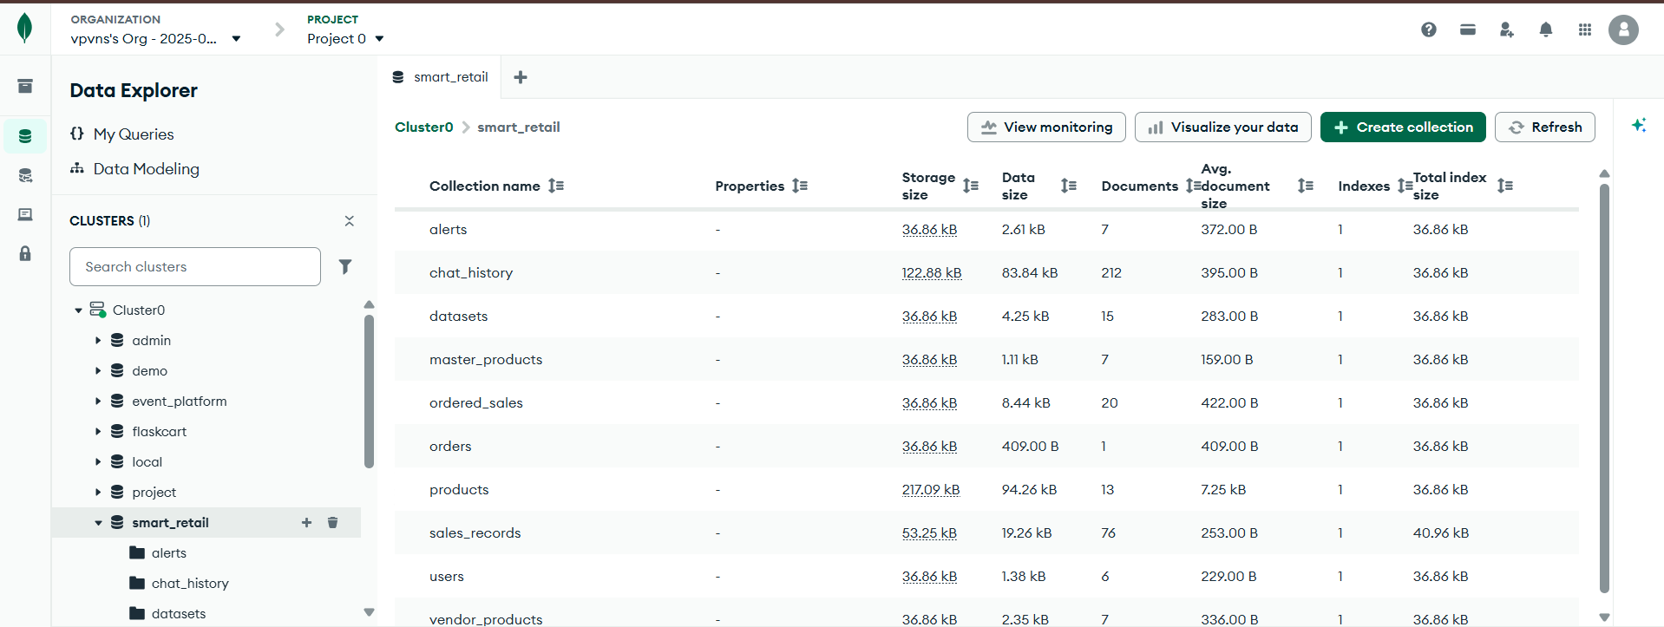

The payment page is the final step in the buyer's order flow. The interface displays: a comprehensive order summary (all items with quantities and individual prices), delivery address (with option to change), payment method selection (credit card, debit card, digital wallet, bank transfer), and a large 'Complete Purchase' button. The payment section is secured with industry-standard encryption (indicated by security badges and HTTPS protocol). Buyers enter or select payment details securely, with PCI-DSS compliance to protect sensitive financial information. The page displays the order total prominently and breaks it down into components: subtotal, taxes, shipping costs, and any applied discounts, ensuring transparency in pricing. Before finalizing payment, buyers can review and modify: delivery address, payment method, or cart contents (option to 'Return to Cart'). Once the buyer confirms, payment is processed through a secure gateway. A confirmation page appears with: order number, order summary, estimated delivery date, and confirmation that a receipt has been sent to their email. Failed payment attempts are handled gracefully with clear error messages and options to retry or select a different payment method. This secure, transparent checkout experience builds buyer confidence and reduces payment-related support issues.

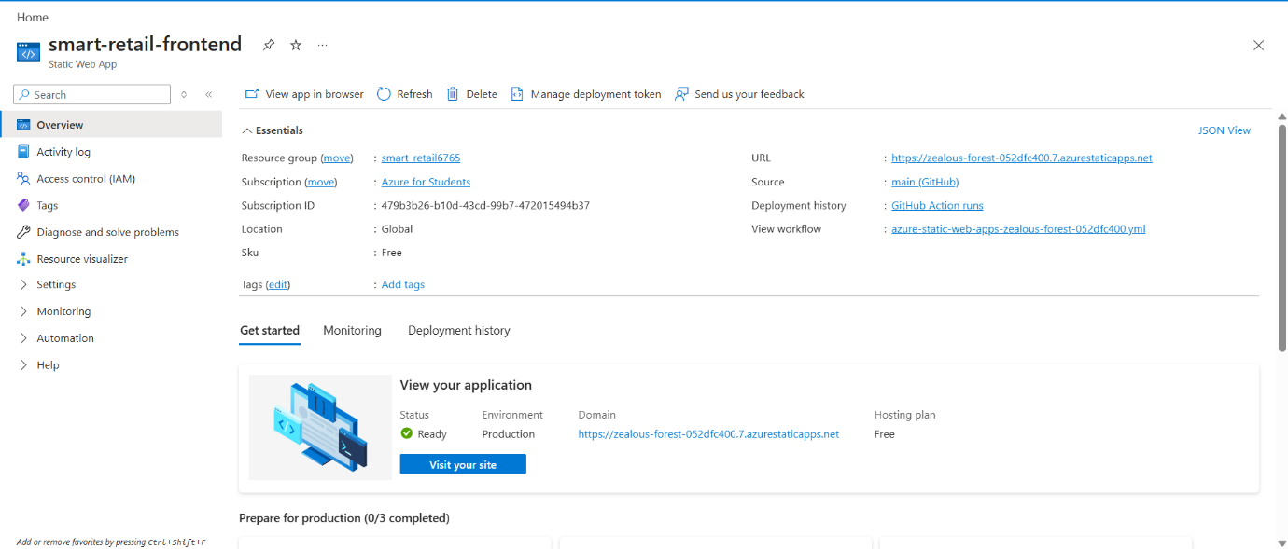
13. Azure Static Web App

The frontend of Smart Retail — the owner dashboard and the buyer marketplace — is deployed as an Azure Static Web App. It is connected to the main branch of the GitHub repository, so every push automatically triggers a deployment through GitHub Actions. The site is globally distributed and runs on the Free tier.
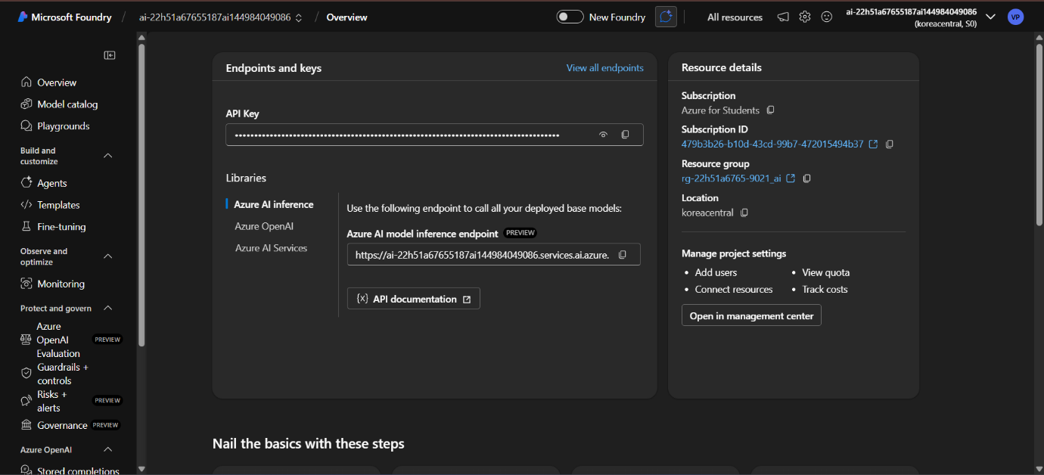
14. Azure AI Foundry

Azure AI Foundry is used to access GPT-4o for all AI features in the project — the chat assistant, intent classification, business insight generation, and agent responses. It also provides the text-embedding model used to generate vector embeddings for the RAG pipeline. The API key and inference endpoint from this resource are configured in the backend environment variables.

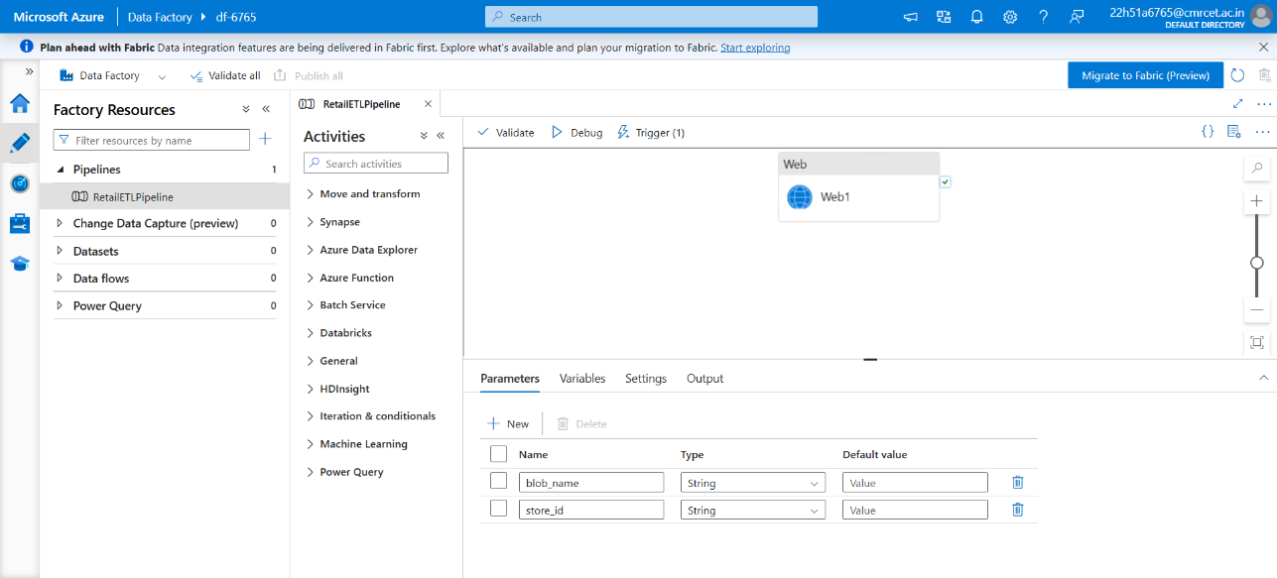
15. Azure Data Factory — Pipeline

Azure Data Factory hosts the RetailETLPipeline, which is responsible for triggering the ETL process. When a sales CSV is uploaded, the pipeline calls the backend API using a Web Activity, passing the blob name and store ID as parameters. The actual data transformation — cleaning, encoding, and Parquet export — is handled by PySpark running inside the backend container.
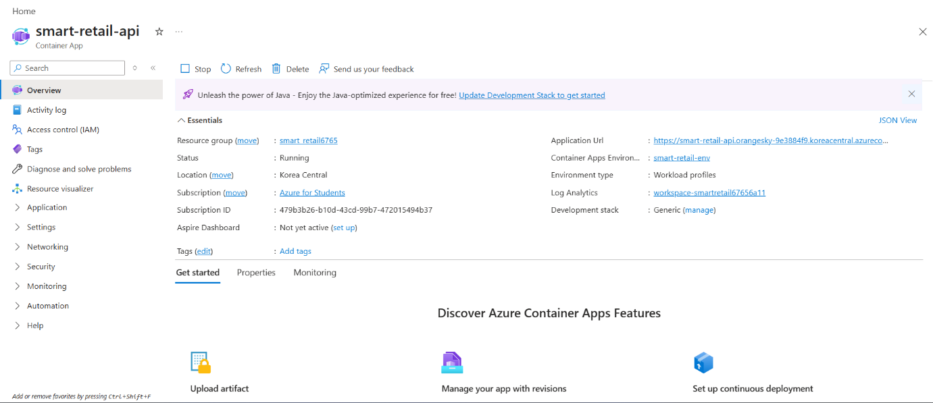
16. Azure Container App
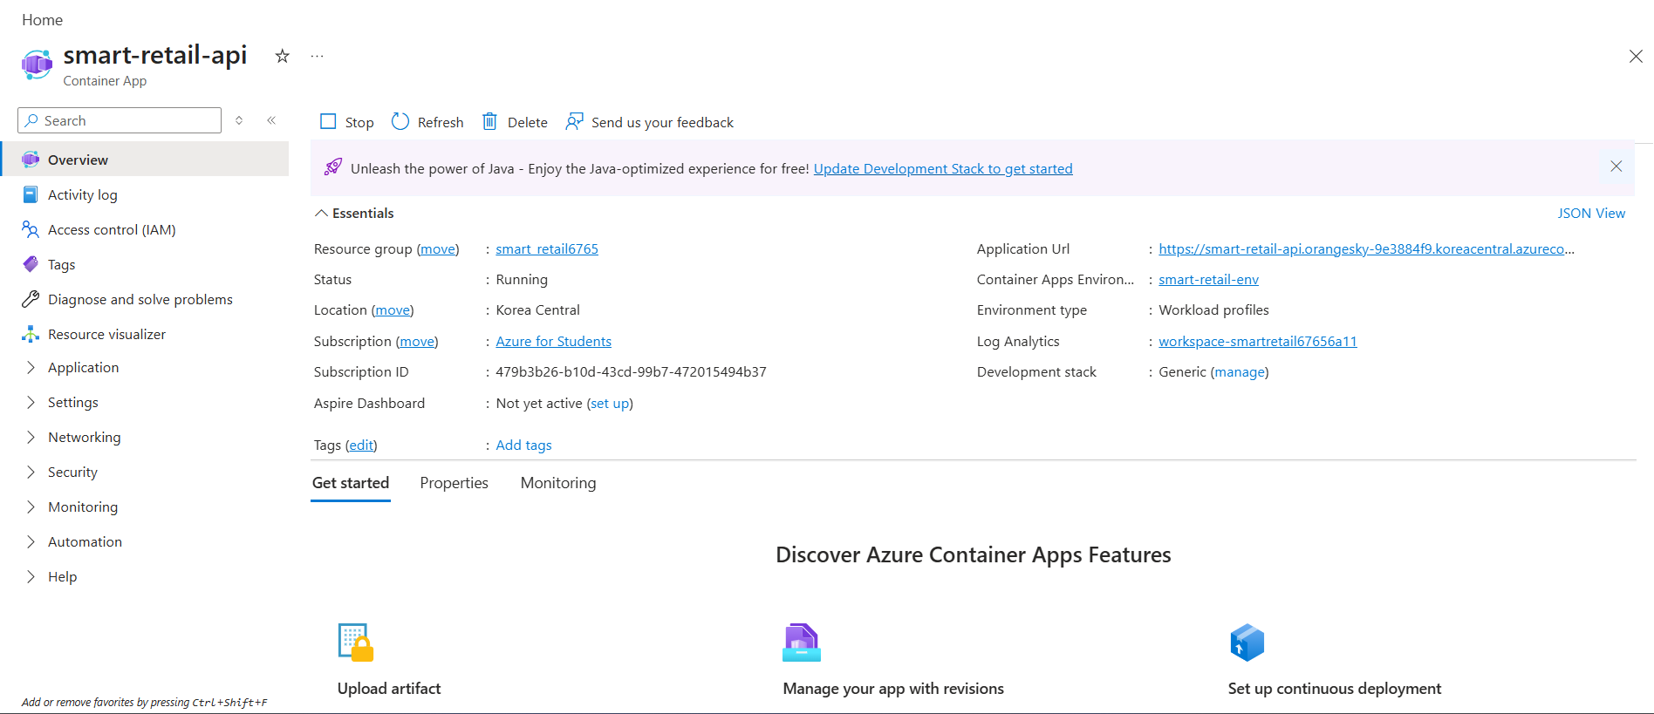
The Flask backend API is deployed as an Azure Container App named smart-retail-api. This is the core of the project — it handles all REST endpoints, runs the AI agents, serves the ML models, and connects to MongoDB and Azure Blob Storage. The app is currently running in the Korea Central region and is accessible via its public HTTPS URL.

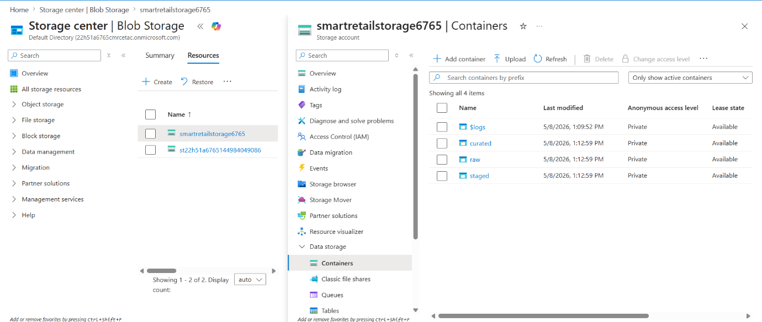
17. Azure Blob Storage

Azure Blob Storage is used to store sales data at each stage of the pipeline. The raw container holds the original CSV files uploaded by store owners. The staged container holds the data after initial cleaning and validation. The curated container holds the final analytics-ready Parquet files. This three-layer structure keeps the data organized and traceable throughout the pipeline.

18. MongoDB Atlas — Database

MongoDB Atlas is the database for the project. The smart_retail database holds all application data across multiple collections: users (owners and buyers), products (store inventory), sales_records (processed transactions used for analytics and ML training), ordered_sales (buyer orders), alerts (anomaly detections), chat_history (AI assistant conversations), and datasets (metadata for uploaded CSV files).

