CUSTOMER SALES & REVENUE ANALYTICS DASHBOARD
Power BI | Data Analyst Project | Gamma PPT Content
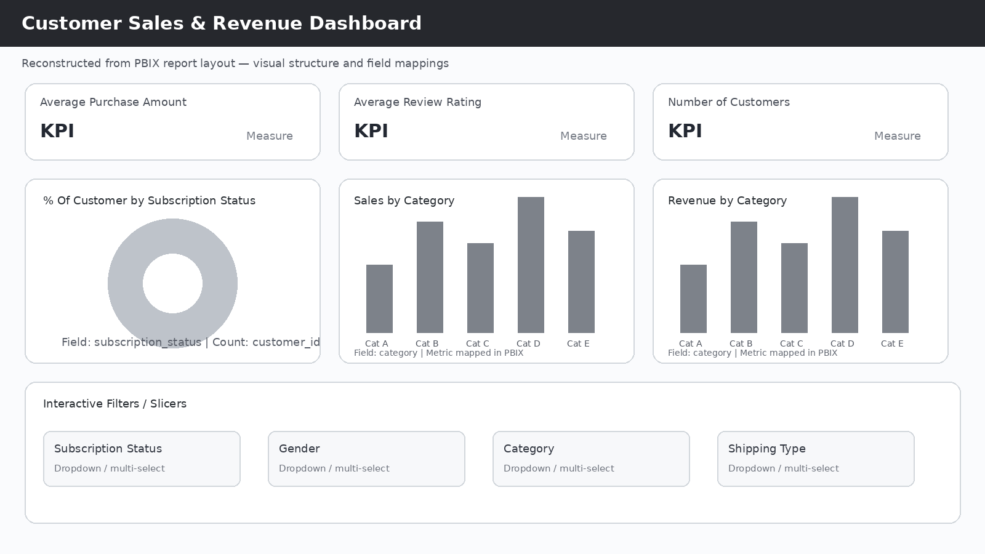
Dashboard visual — reconstructed from the uploaded PBIX report structure. Replace with the actual Power BI Desktop screenshot if available.

Slide 1 — Title
- Customer Sales & Revenue Analytics Dashboard
- Tool: Microsoft Power BI
- Role: Data Analyst
- Focus: Customer Segmentation • Sales Analysis • Revenue Analysis • Interactive Dashboard

Slide 2 — Project Objective
- Build an interactive Power BI dashboard to analyze customer purchasing behaviour, sales and revenue performance, subscription status, category performance and age-group performance.
- Goal: Convert raw customer data into actionable business insights.

Slide 3 — Dataset & Key Fields
- Dataset: Customer Sales Data
- Key fields: Customer ID, Purchase Amount, Review Rating, Category, Subscription Status, Gender, Shipping Type, Age Groups.
- Dimensions: Category, Gender, Subscription Status, Shipping Type, Age Group.
- Measures: Purchase Amount, Review Rating, Customer Count.

Slide 4 — Data Analyst Workflow
- Raw Data → Data Preparation → Data Modeling → Measures/KPIs → Visualizations → Interactive Dashboard → Business Insights.
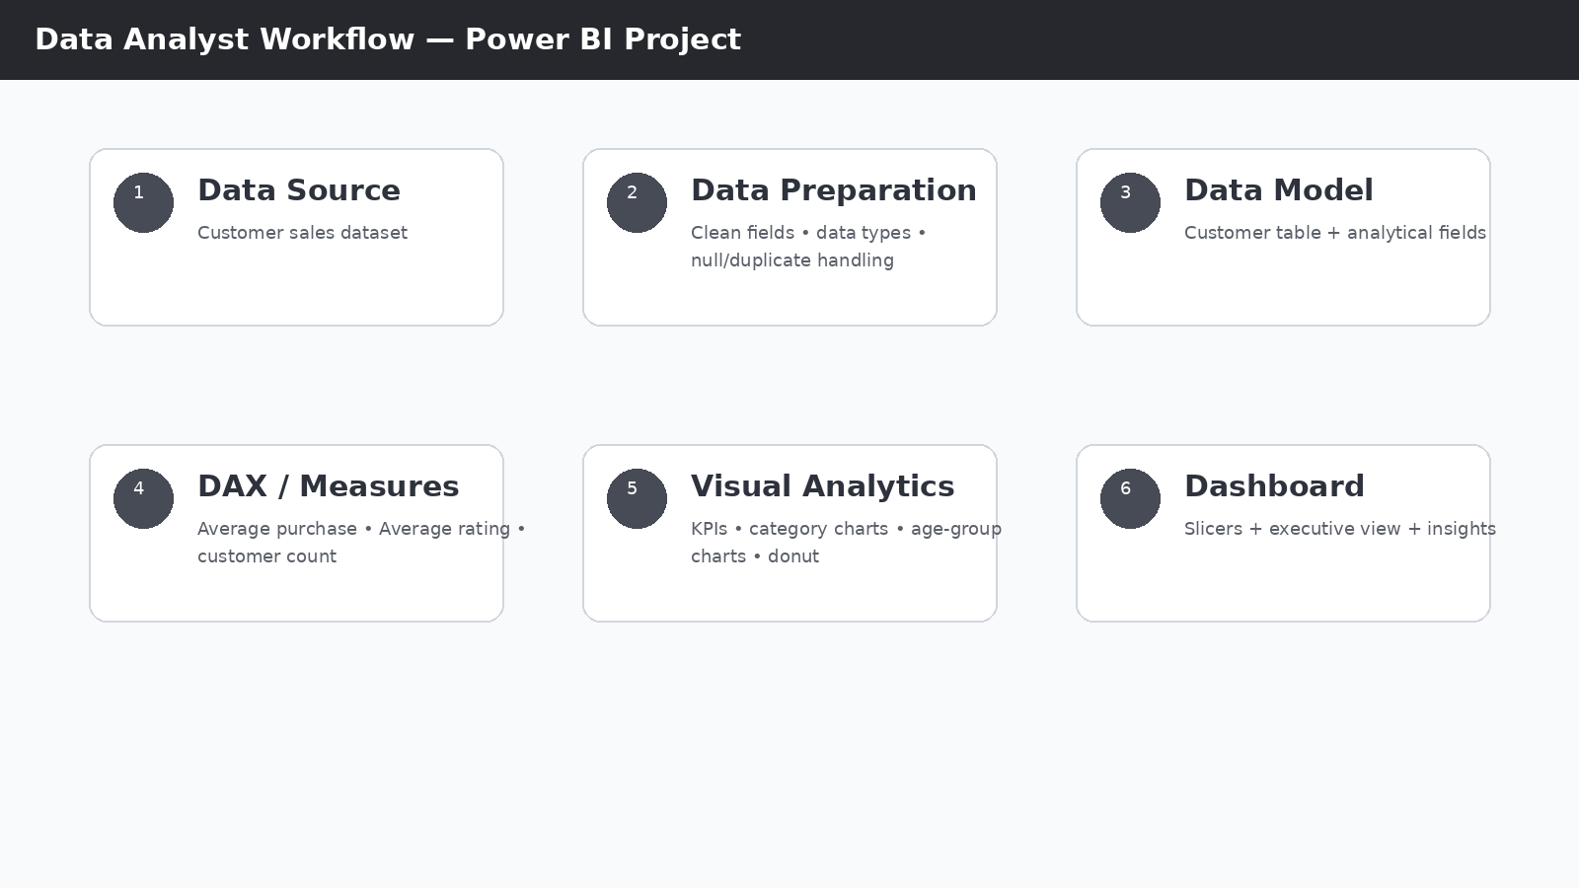
Working visual: end-to-end Data Analyst workflow.

Slide 5 — Dashboard Overview
- KPI Cards: Average Purchase Amount, Average Review Rating, Number of Customers.
- Visuals: Customer % by Subscription Status, Sales by Category, Revenue by Category, Sales by Age Group, Revenue by Age Group.

Dashboard working visual.

Slide 6 — Customer Segmentation
- Subscription analysis through customer distribution by subscription status.
- Interactive slicers: Subscription Status, Gender, Category, Shipping Type.
- Business value: analyze specific customer segments through interactive filtering.
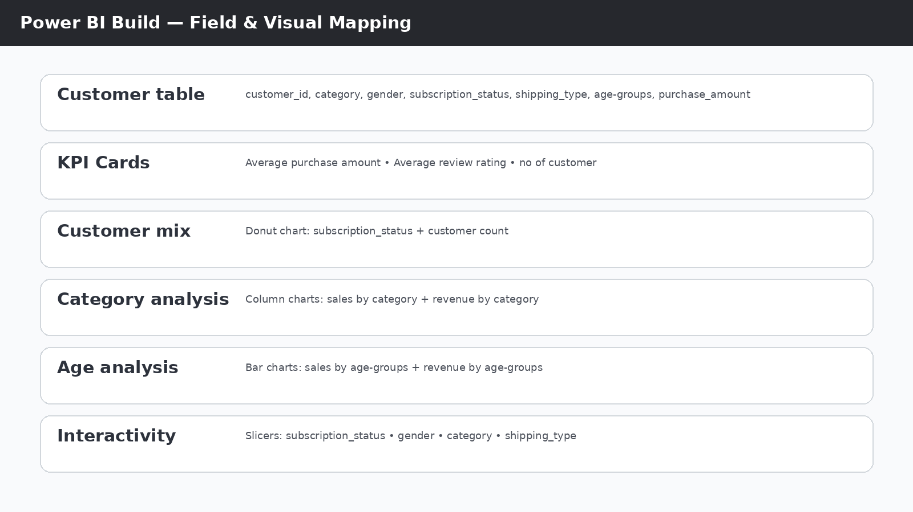
Working visual: fields mapped to dashboard visuals and filters.

Slide 7 — Category Performance Analysis
- Sales by Category compares sales/customer volume across categories.
- Revenue by Category compares purchase revenue across categories.
- Business value: identify strong-performing categories and compare volume with revenue.

Working visual: category-level analytical mapping.

Slide 8 — Age Group Analysis
- Sales by Age Group analyzes sales/customer volume across age segments.
- Revenue by Age Group compares revenue contribution across age segments.
- Business value: identify high-value customer segments and support targeted decisions.
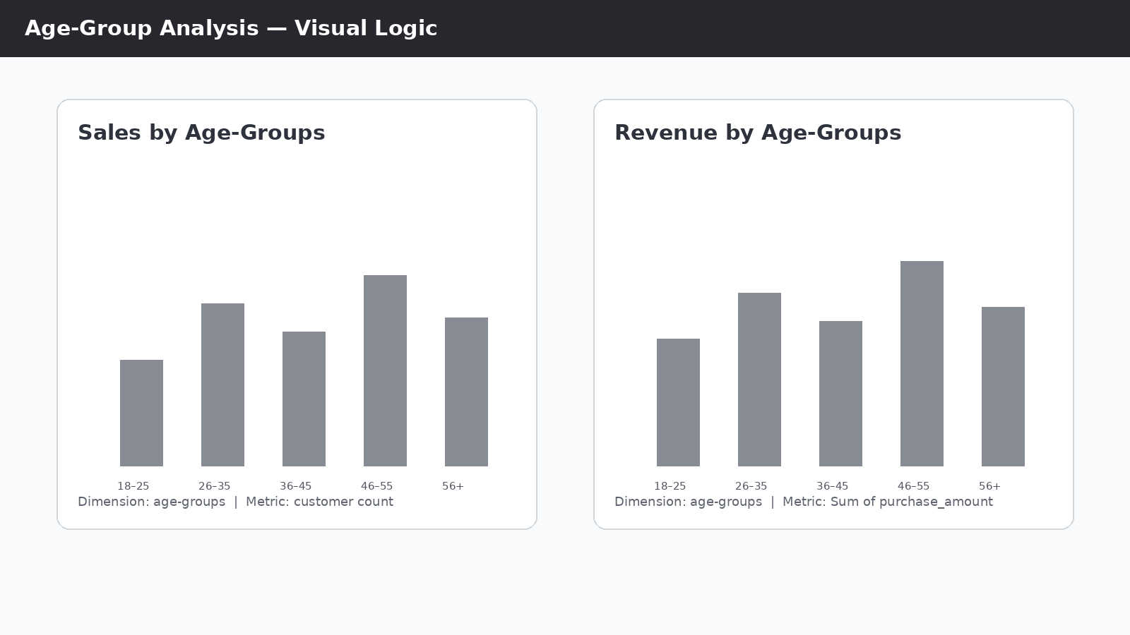
Working visual: age-group sales and revenue analysis.

Slide 9 — Interactive Dashboard
- Slicers: Subscription Status, Gender, Category, Shipping Type.
- Selecting a slicer dynamically changes the dashboard visuals.
- Example: select a subscription status → compare category performance → analyze revenue → identify the strongest segment.

Working visual: interactive dashboard and slicer layout.

Slide 10 — Key Business Insights
- Customer performance can be analyzed at multiple segmentation levels.
- Subscription status provides insight into customer composition.
- Category analysis helps compare sales volume and revenue.
- Age-group analysis identifies valuable customer segments.
- Interactive slicers enable focused segment-level analysis.
- Customer volume and revenue should be evaluated together for better decisions.

Slide 11 — Business Recommendations
- Focus on high-revenue customer segments.
- Compare subscribed vs non-subscribed customers.
- Identify categories with strong revenue contribution.
- Target high-value age groups with personalized campaigns.
- Use slicers for segment-specific decision making.
- Add a date/time dimension in future versions for monthly/yearly trend analysis.

Slide 12 — Skills Demonstrated
- Power BI • Data Cleaning & Transformation • Data Modeling • DAX/Measures • KPI Development • Data Visualization • Interactive Slicers • Customer Segmentation • Business Insights • Data Storytelling

Slide 13 — Conclusion
- Raw Data → Analysis → Visualization → Insights → Business Decisions.
- The dashboard enables stakeholders to understand customer behaviour, category performance, revenue contribution and customer segments.

