Reg no: 18BCE7147

Name: V. Hari Praneeth

**Lab 14 – Project**

Application selected: COVI-need Helper

Concepts applied: Multiple types of Views and Buttons, Activities and Intents, ListView, Data storage in text file (reading and writing), CoordinatorLayout, Music player, and miscellaneous.

Tried to include many concepts by spending many hours

Full code on GitHub - <https://github.com/vh-praneeth/COVI-neeD_helper>

I added only 2 pages codes in document as per the instructions by the faculty in a mail.

MainActivity.java

**package** com.example.covineedhelper;  
  
**import** androidx.appcompat.app.AppCompatActivity;  
  
**import** android.content.Intent;  
**import** android.media.MediaPlayer;  
**import** android.os.Bundle;  
**import** android.view.View;  
**import** android.widget.*;  
  
**public class** MainActivity **extends** AppCompatActivity {  
 Button **cowinTracker**, **requestItems**, **appDetails**;  
  
 @Override  
 **protected void** onCreate(Bundle savedInstanceState) {  
 **super**.onCreate(savedInstanceState);  
 setContentView(R.layout.***activity_main***);  
  
 MediaPlayer player = MediaPlayer.*create*(  
 MainActivity.**this**, R.raw.***guitar***);  
 player.start();  
  
 bindViews();  
  
 **cowinTracker**.setOnClickListener(**new** View.OnClickListener() {  
 @Override  
 **public void** onClick(View v) {  
 **try** {  
 Intent intent = **new** Intent(MainActivity.**this**,  
 CowinTrackerActivity.**class**);  
 startActivity(intent);  
 } **catch** (Exception e) {  
 showToast(e.toString());  
 }  
 }  
 });  
 **requestItems**.setOnClickListener(**new** View.OnClickListener() {  
 @Override  
 **public void** onClick(View v) {  
 **try** {  
 Intent intent = **new** Intent(MainActivity.**this**,  
 ItemRequestActivity.**class**);  
 startActivity(intent);  
 } **catch** (Exception e) {  
 showToast(e.toString());  
 }  
 }  
 });  
 **appDetails**.setOnClickListener(**new** View.OnClickListener() {  
 @Override  
 **public void** onClick(View v) {  
 **try** {  
 Intent intent = **new** Intent(MainActivity.**this**,  
 AppDetailsActivity.**class**);  
 startActivity(intent);  
 } **catch** (Exception e) {  
 showToast(e.toString());  
 }  
 }  
 });  
 }  
 **void** showToast(String txt) {  
 Toast.*makeText*(MainActivity.**this**, txt,  
 Toast.***LENGTH_SHORT***).show();  
 }  
 **void** bindViews() {  
 **cowinTracker** = findViewById(R.id.***cowinTracker***);  
 **requestItems** = findViewById(R.id.***requestItems***);  
 **appDetails** = findViewById(R.id.***appDetails***);  
 }  
}

ItemRequestActivity.java

**package** com.example.covineedhelper;  
  
**import** androidx.appcompat.app.AppCompatActivity;  
  
**import** android.content.Context;  
**import** android.os.Bundle;  
**import** android.view.*;  
**import** android.widget.*;  
  
**public class** ItemRequestActivity **extends** AppCompatActivity {  
 ListView **listView**;  
 ImageView **backBtn**;  
  
 @Override  
 **protected void** onCreate(Bundle savedInstanceState) {  
 **super**.onCreate(savedInstanceState);  
 setContentView(R.layout.***activity_item_request***);  
 **backBtn** = findViewById(R.id.***backBtn***);  
 **backBtn**.setOnClickListener(**new** View.OnClickListener() {  
 @Override  
 **public void** onClick(View v) {  
 finish();  
 }  
 });  
  
 **listView** = findViewById(R.id.***listView***);  
 **listView**.setAdapter(**new** MyAdapter(**this**));  
 }  
  
 **private class** MyAdapter **extends** BaseAdapter {  
 Context **mycontext1**;  
 String[] **namesArr** = {**"Oxygen Concentrator"**, **"Oxygen cylinder"**,  
 **"Blood - Group A+"**, **"Blood - Group B-"**, **"Paracetamol"**, **"Vitamin tablets"**};  
 String[] **priceArr** = {**"₹ 49"**, **"₹ 39"**, **"₹ 44"**, **"₹ 41"**, **"₹ 10 (Including GST)"**, **"₹ 12 (Excluding GST)"**};  
 **public** MyAdapter(ItemRequestActivity ma) { **mycontext1** = ma; }  
 @Override  
 **public int** getCount() { **return namesArr**.**length**; }  
 @Override  
 **public** Object getItem(**int** position) { **return null**; }  
 @Override  
 **public long** getItemId(**int** position) { **return** 0; }  
 @Override  
 **public** View getView(**int** position, View convertView, ViewGroup parent) {  
 View view = LayoutInflater.*from*(**mycontext1**).inflate(  
 R.layout.***my_list_item***, parent, **false**);  
 TextView textView1 = view.findViewById(R.id.***textView***);  
 textView1.setText(**namesArr**[position]);  
 view.setOnClickListener(**new** View.OnClickListener() {  
 @Override  
 **public void** onClick(View v) {  
 setContentView(R.layout.***item_details***);  
 TextView textView1 = findViewById(R.id.***textView***);  
 TextView price = findViewById(R.id.***price***);  
 textView1.setText(**namesArr**[position]);  
 price.setText(**priceArr**[position]);  
  
 ImageView backBtn1;  
 backBtn1 = findViewById(R.id.***backBtn***);  
 backBtn1.setOnClickListener(**new** View.OnClickListener() {  
 @Override  
 **public void** onClick(View v) {  
 finish();  
 }  
 });  
 }  
 } );  
 **return** view;  
 }  
 }  
}

activity_main.xml

*<?***xml version="1.0" encoding="utf-8"***?>*  
<**RelativeLayout**  
 **xmlns:android="http://schemas.android.com/apk/res/android"**  
 **xmlns:app="http://schemas.android.com/apk/res-auto"**  
 **xmlns:tools="http://schemas.android.com/tools"**  
 **android:layout_width="match_parent"**  
 **android:layout_height="match_parent"**  
 **tools:context=".MainActivity"**>  
  
  
 <**TextView**  
 **android:layout_width="wrap_content"**  
 **android:layout_height="wrap_content"**  
 **android:layout_alignParentTop="true"**  
 **android:layout_marginTop="50dp"**  
 **android:layout_centerHorizontal="true"**  
 **android:text="COVI-neeD helper"**  
 **android:textColor="@android:color/holo_green_dark"**  
 **android:textSize="24dp"**/>  
  
 <**TextView**  
 **android:layout_width="wrap_content"**  
 **android:layout_height="wrap_content"**  
 **android:layout_alignParentTop="true"**  
 **android:layout_marginTop="90dp"**  
 **android:layout_centerHorizontal="true"**  
 **android:text="Supports everyone during COVID times"**  
 **android:textSize="18dp"** />  
  
 <**Button**  
 **android:id="@+id/cowinTracker"**  
 **android:layout_width="200dp"**  
 **android:layout_height="70dp"**  
 **android:layout_marginTop="180dp"**  
 **android:textSize="18dp"**  
 **android:text="CoWIN Tracker"**  
 **android:backgroundTint="@android:color/holo_orange_dark"**  
 **android:layout_centerHorizontal="true"**/>  
  
 <**Button**  
 **android:id="@+id/requestItems"**  
 **android:layout_width="200dp"**  
 **android:layout_height="70dp"**  
 **android:textSize="18dp"**  
 **android:text="Request items"**  
 **android:layout_marginTop="250dp"**  
 **android:layout_centerHorizontal="true"**  
 **android:textColor="#000088"**  
 **android:backgroundTint="@android:color/white"**  
 **app:strokeColor="@android:color/holo_blue_light"**  
 **app:strokeWidth="2dp"**/>  
  
 <**Button**  
 **android:id="@+id/appDetails"**  
 **android:layout_width="200dp"**  
 **android:layout_height="70dp"**  
 **android:textSize="18dp"**  
 **android:text="App details"**  
 **android:layout_marginTop="320dp"**  
 **android:layout_centerHorizontal="true"**  
 **android:backgroundTint="#128807"**/>  
  
</**RelativeLayout**>

activity_item_request.xml

*<?***xml version="1.0" encoding="utf-8"***?>*  
<**RelativeLayout**  
 **xmlns:android="http://schemas.android.com/apk/res/android"**  
 **xmlns:app="http://schemas.android.com/apk/res-auto"**  
 **xmlns:tools="http://schemas.android.com/tools"**  
 **android:layout_width="match_parent"**  
 **android:layout_height="match_parent"**  
 **tools:context=".MainActivity"**>  
  
 <**ImageView**  
 **android:id="@+id/backBtn"**  
 **android:layout_width="wrap_content"**  
 **android:layout_height="wrap_content"**  
 **android:src="@drawable/back"**  
 **android:translationX="10dp"**  
 **android:translationY="10dp"**/>  
  
 <**TextView**  
 **android:layout_width="wrap_content"**  
 **android:layout_height="wrap_content"**  
 **android:text="Select your requirement/availability(for donation)"**  
 **android:textSize="15dp"**  
 **android:layout_margin="10dp"**  
 **android:translationY="50dp"**/>  
  
 <**ListView**  
 **android:id="@+id/listView"**  
 **android:padding="10dp"**  
 **android:layout_centerHorizontal="true"**  
 **android:layout_marginTop="90dp"**  
 **android:layout_width="500dp"**  
 **android:layout_height="500dp"**/>  
  
</**RelativeLayout**>

Screenshots:

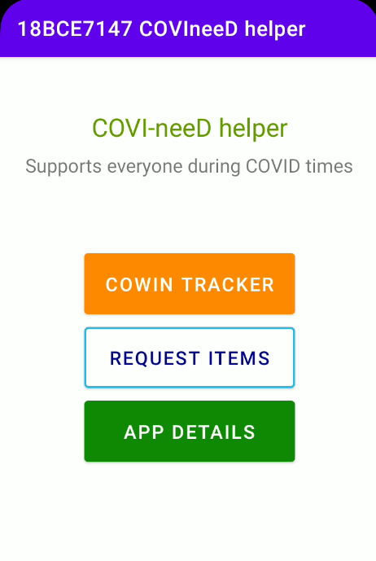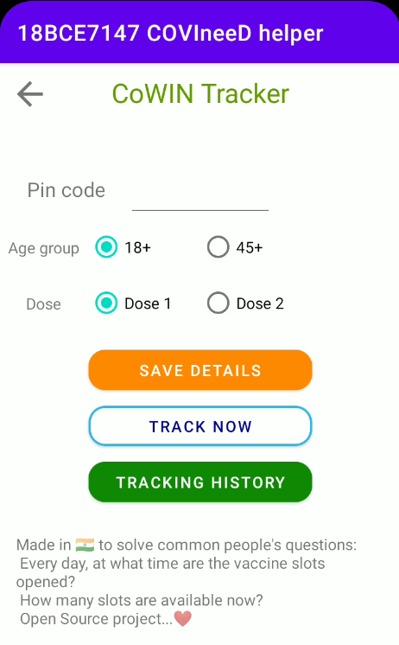

**Track now**

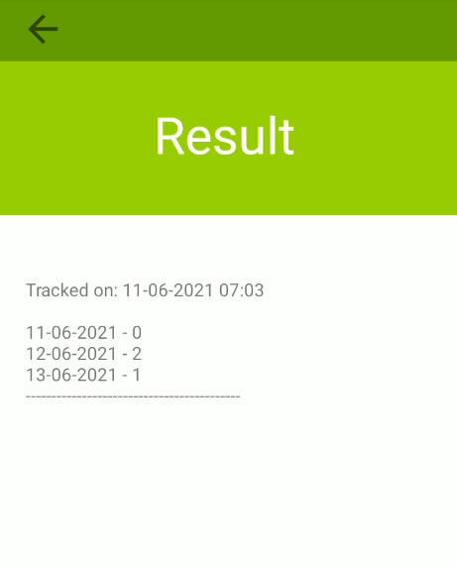

**Tracking history**

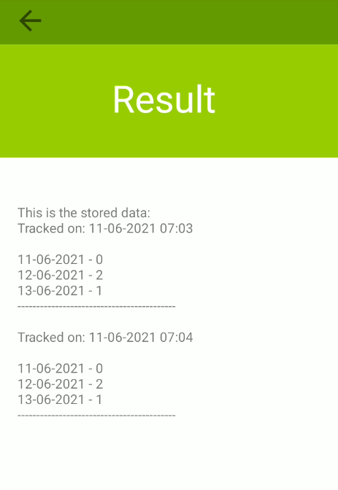

**Request Items / Donate**

