**KINGS COFFEE PROJECT REPORT**

**Topic Name**

Kings Coffee Data Analysis

**Problem Statement**

Kings Coffee, a rapidly growing coffee shop, lacked proper insights into its sales, feedback, and supplier performance. There was a need to organize the data collected daily in a meaningful way that could help them understand trends, forecast revenue, manage supplies, and ultimately make better business decisions. This project aims to solve these challenges using Python, Pandas, Matplotlib, and Tkinter to design a data analysis and visualization system tailored for Kings Coffee.

**Index**

1. Description  
2. Data and Output Information  
3. Solution Plan  
4. Design  
5. Implementation  
6. Code and Explanation  
7. Output Screenshots  
8. Closure  
9. Bibliography

**Description**

This project revolves around building a complete data-driven system for Kings Coffee. The purpose is to take in the shop’s daily sales and feedback data and then transform it into meaningful insights through visualizations and statistics. The system handles tasks like identifying the best-selling coffee types, comparing sweetener usage, tracking sales over dates, analyzing supplier performance, forecasting daily revenue, generating restock alerts, and summarizing customer feedback. A GUI was built using Tkinter to make this system user-friendly and interactive, where each analysis can be accessed through simple button clicks.

**Data within the problem and relevant info and the O/P, purpose and outcome and benefits.**

The dataset includes daily sales records of coffee sold, the type of sweetener used, total sales, dates, and feedback ratings. Relevant information such as coffee type, quantity, and supplier are also tracked. The outcome is a clearer view of business performance – what sells best, which days generate most revenue, how supplies are consumed, and what customers think. Benefits include smarter restocking decisions, better forecasting, and data-backed management choices.

**Solution Plan**

We split the project into three major parts: data analytics, object-oriented backend structure, and frontend GUI. Each analysis was written as a modular function, then tied together using an OOP class (`KingsCoffee`) that loads and manages the data. Finally, a GUI menu using Tkinter was created to allow user interaction. A special 'Summary' button displays four charts at once for an overview.

**Design**

The system uses a layered architecture:  
- Data Layer: Loads CSVs using Pandas  
- Logic Layer: Handles analysis through custom functions  
- OOP Wrapper: KingsCoffee class centralizes access  
- UI Layer: Tkinter-based GUI with buttons mapped to analyses  
  
Graphs used include bar plots, line plots, and subplots for combined analysis views.

**Implementation**

Implementation began with loading and understanding the dataset. Each analysis was first written in isolation and tested thoroughly. Later, the object-oriented `KingsCoffee` class was built to house the core functionalities. The Tkinter UI included menu-style buttons and a startup welcome screen. Every function is triggered via `if-elif` logic on button clicks, keeping the interface simple for users.

**Code & explanation**

The code is separated into helper files and analytics modules:  
  
- `main.py`: Entry point that initializes data and class.  
- `generate_sales_data.py`: Simulates sample data.  
- `data_analytics/`: Folder with individual analysis scripts like `forecast_analysis`, `restock_alert_system`, `top_coffee`, etc.  
- `KingsCoffee` class: Wraps all analytics as methods.  
- `tkinter_ui.py`: UI with buttons for each feature, including a Summary view combining four plots.  
  
Every function includes comments and uses descriptive naming for clarity. External libraries like Pandas and Matplotlib are used extensively.

Data Analytics:

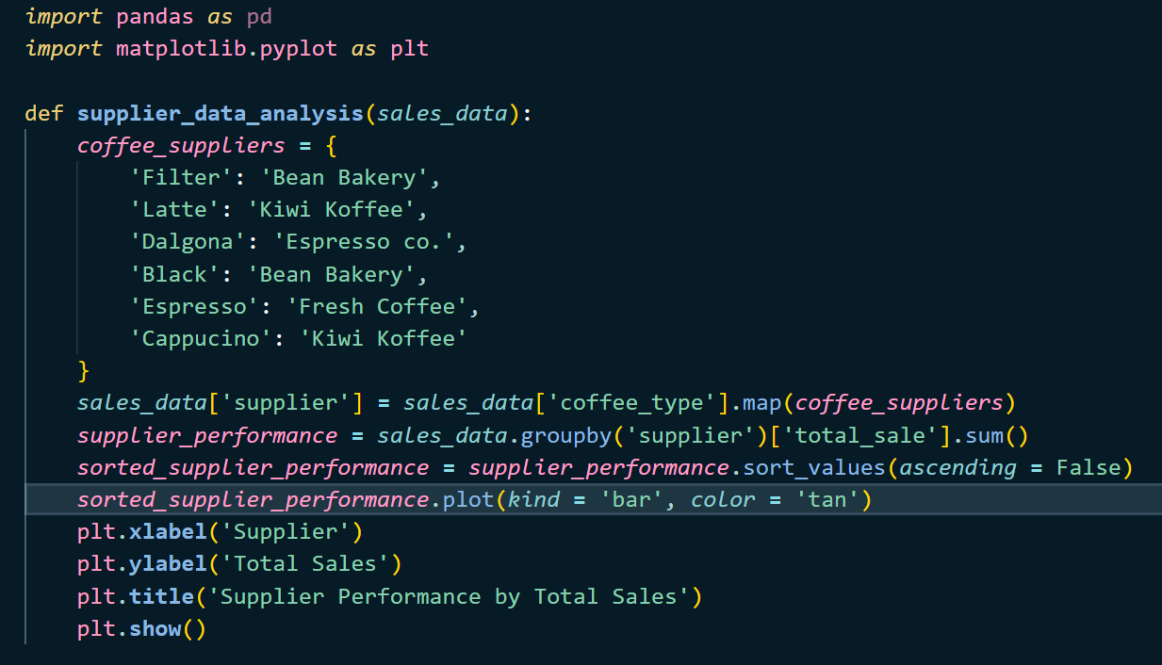

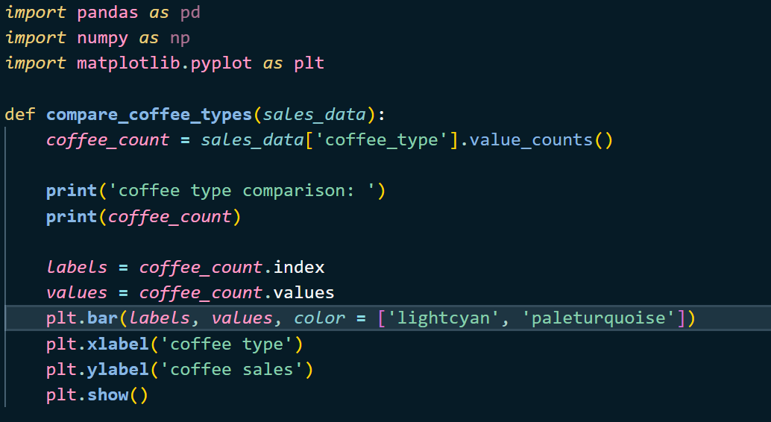

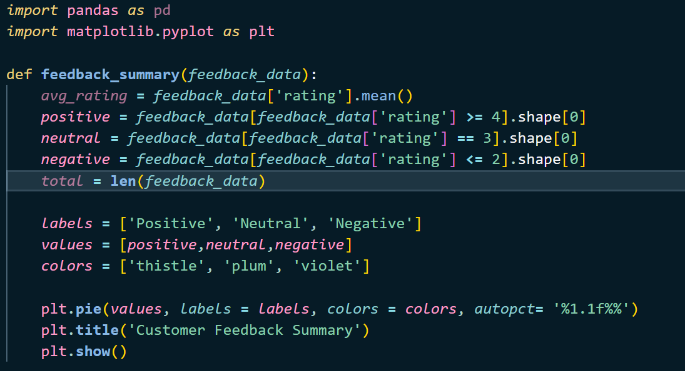

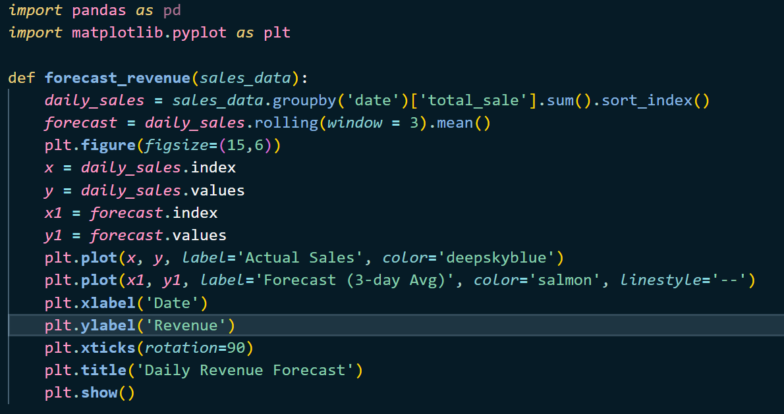

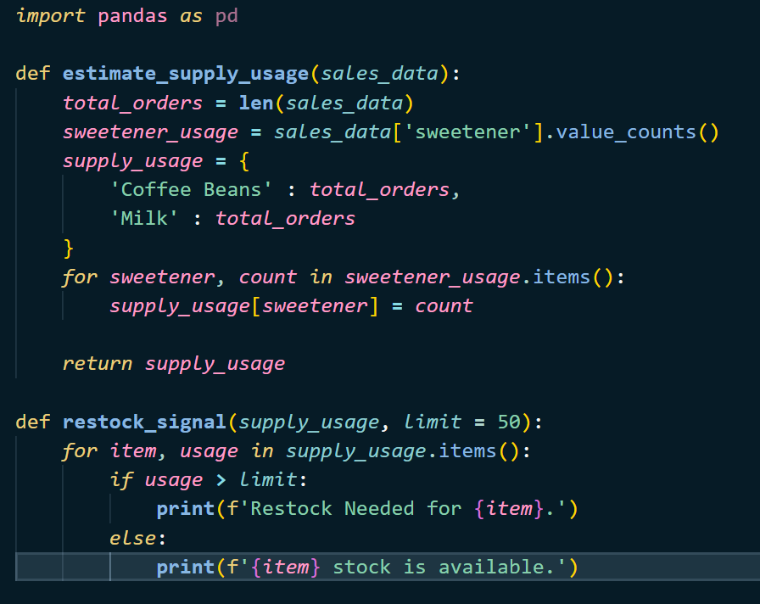

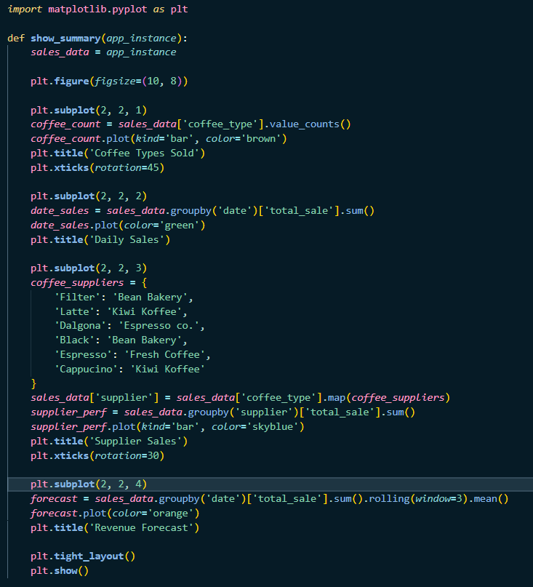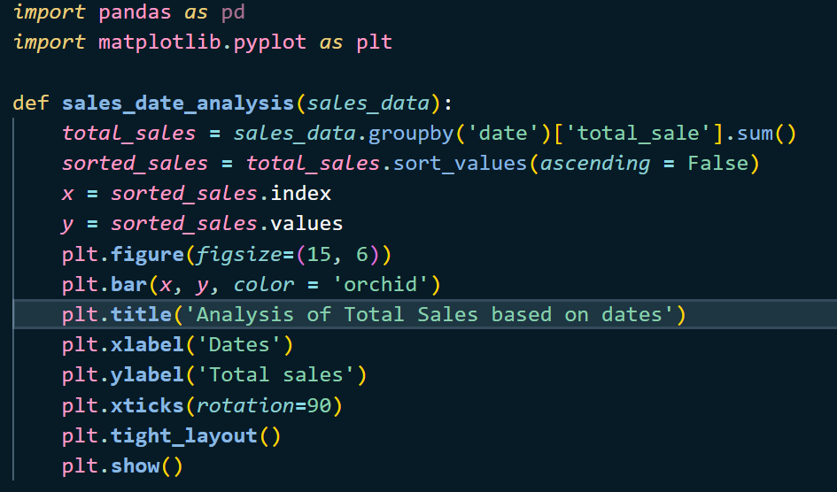

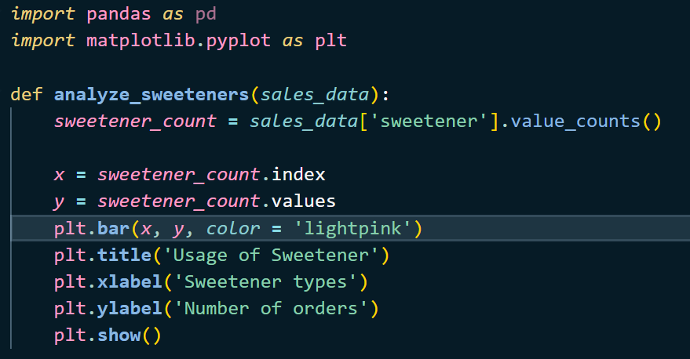

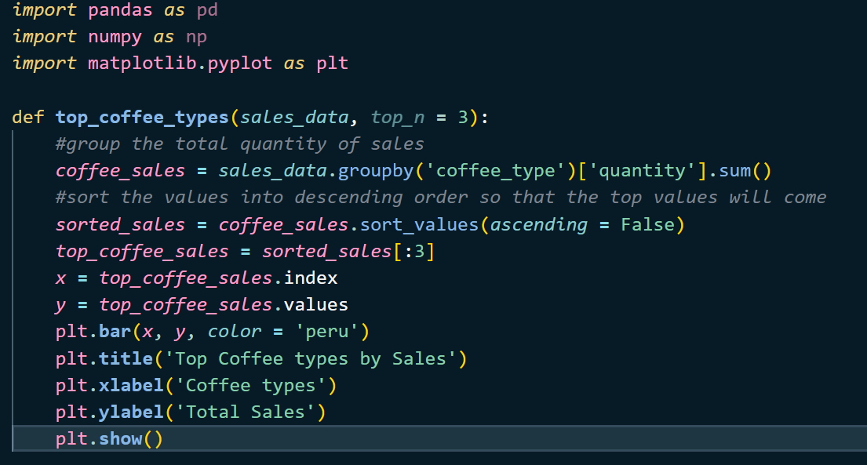

Generating data:

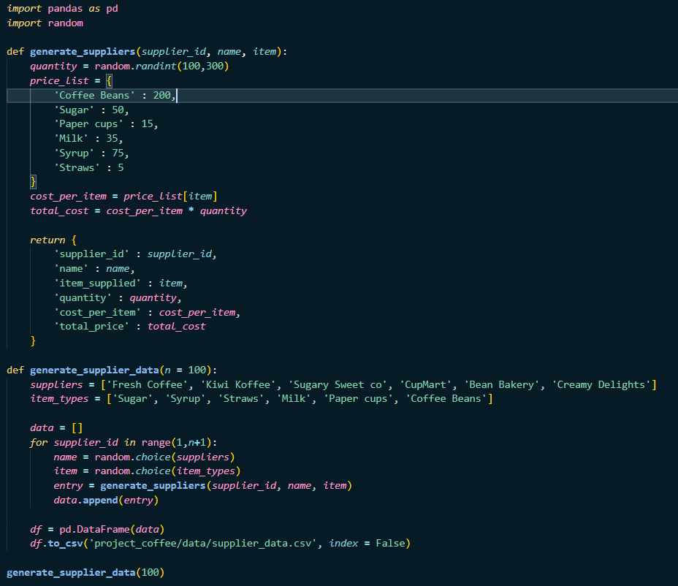

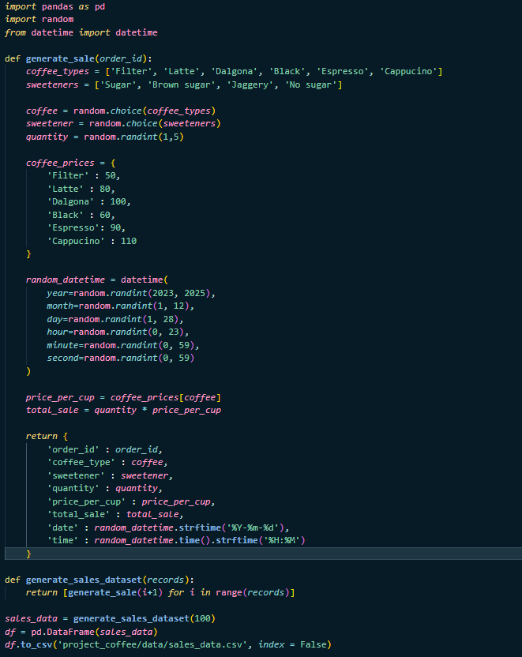

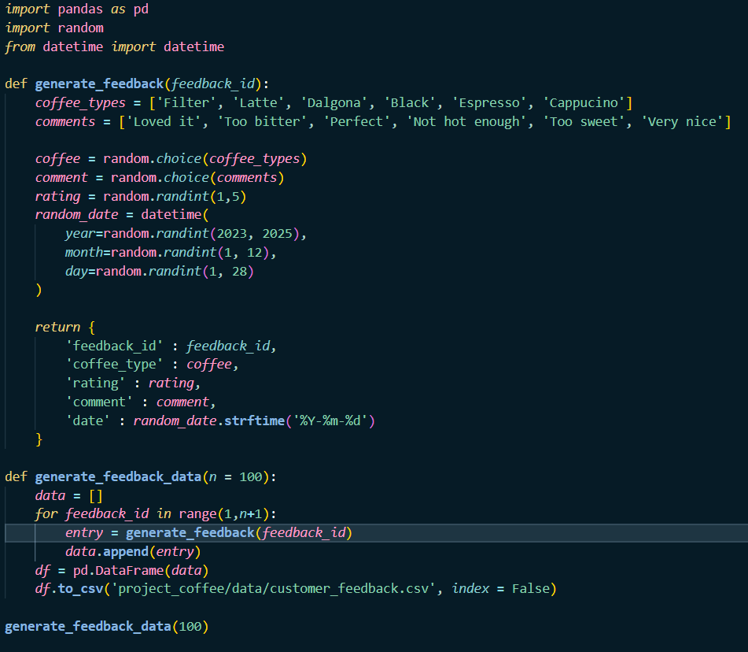

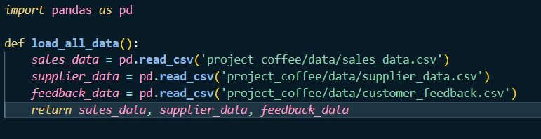

Main Programs:

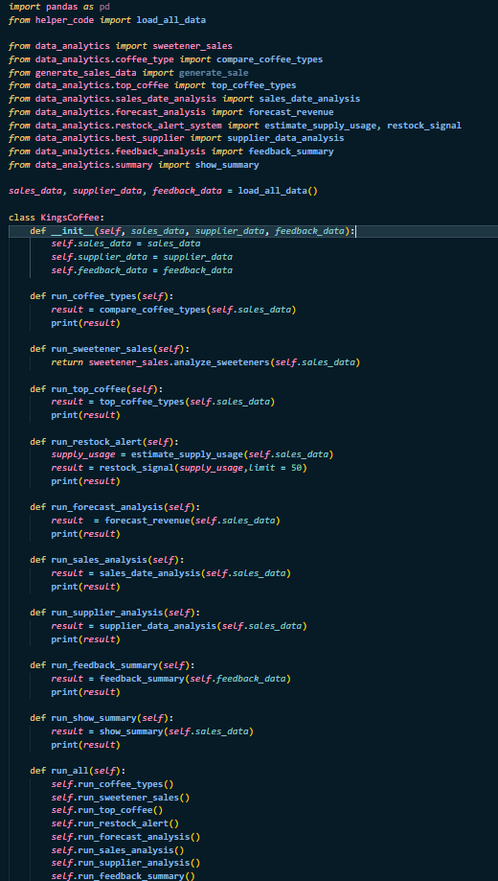

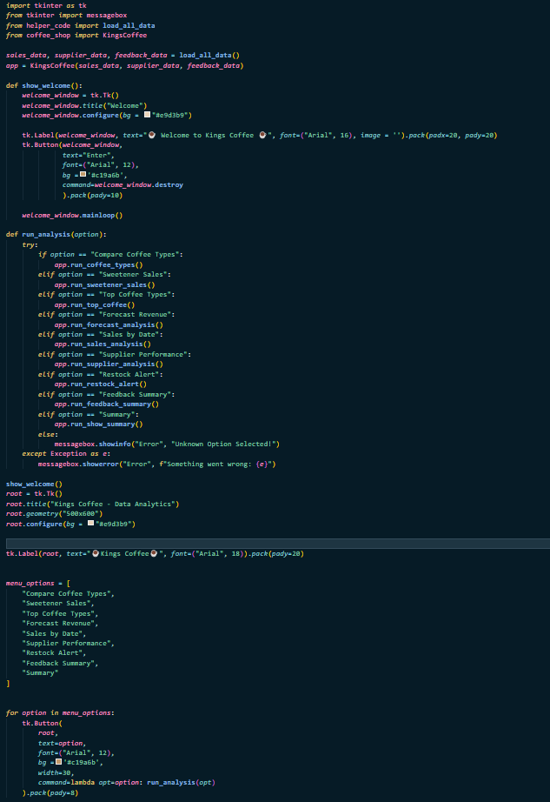

**O/P screenshots**

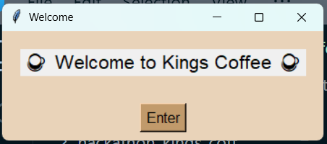

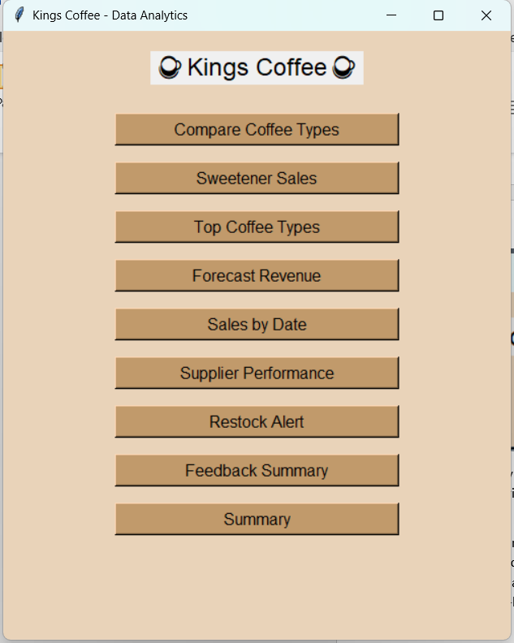

The system outputs visual graphs for every analysis:  
- Coffee type comparison (bar chart)

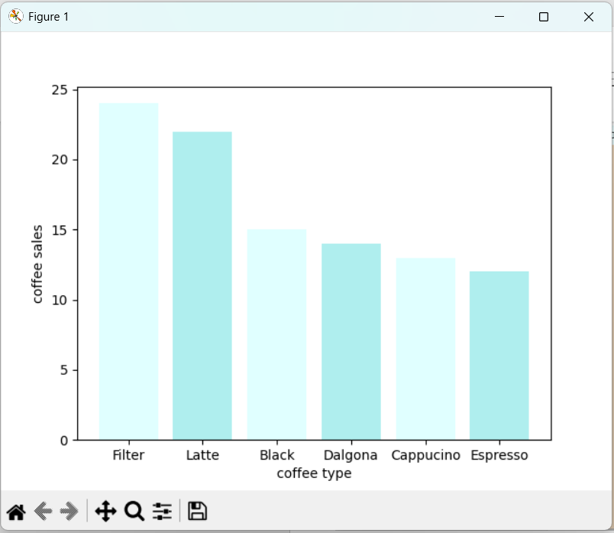

- Revenue forecast (line graph with moving average)

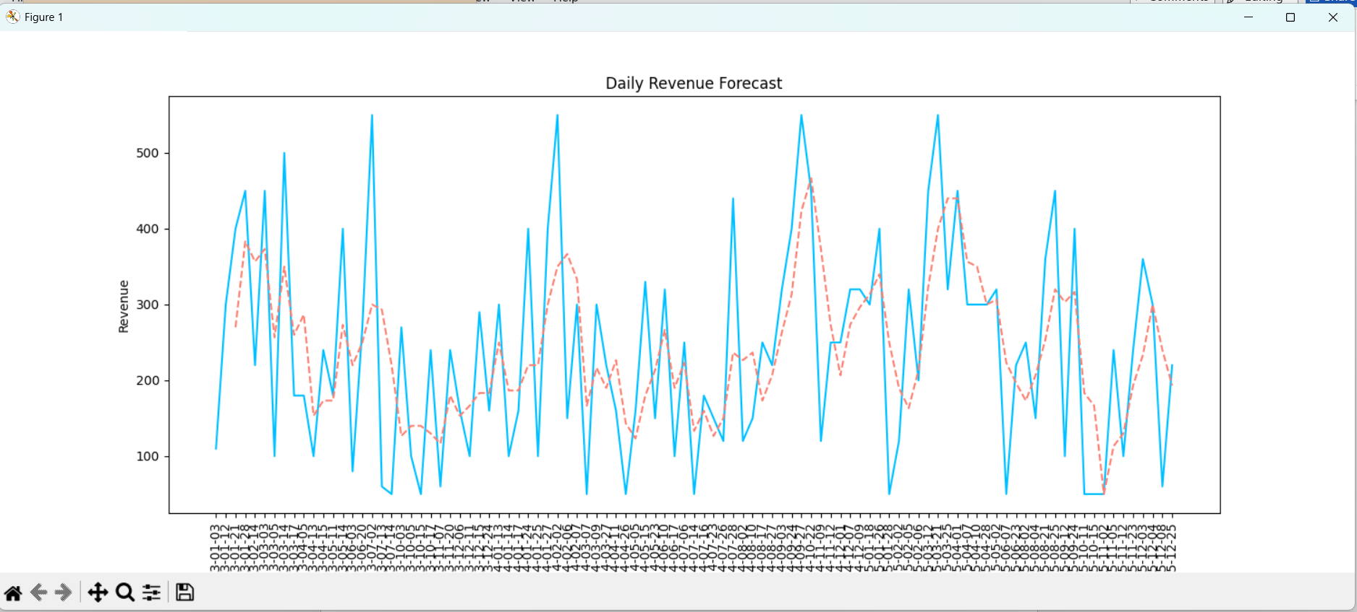  
- Supplier performance (bar chart)

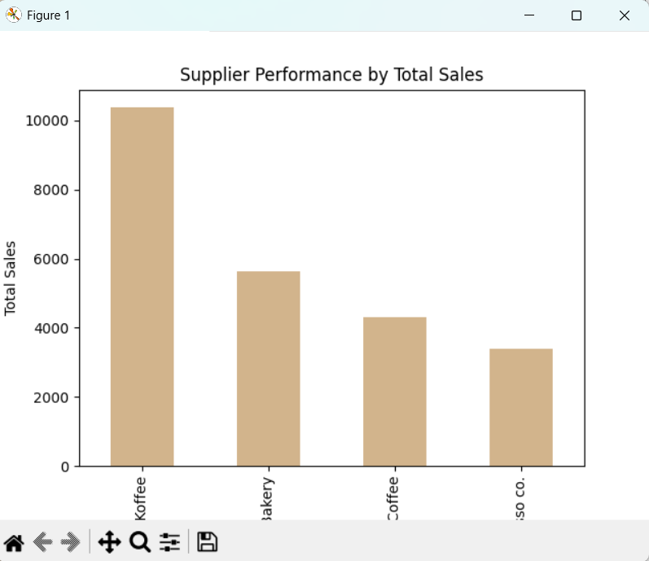  
- Sweetener usage (bar chart)

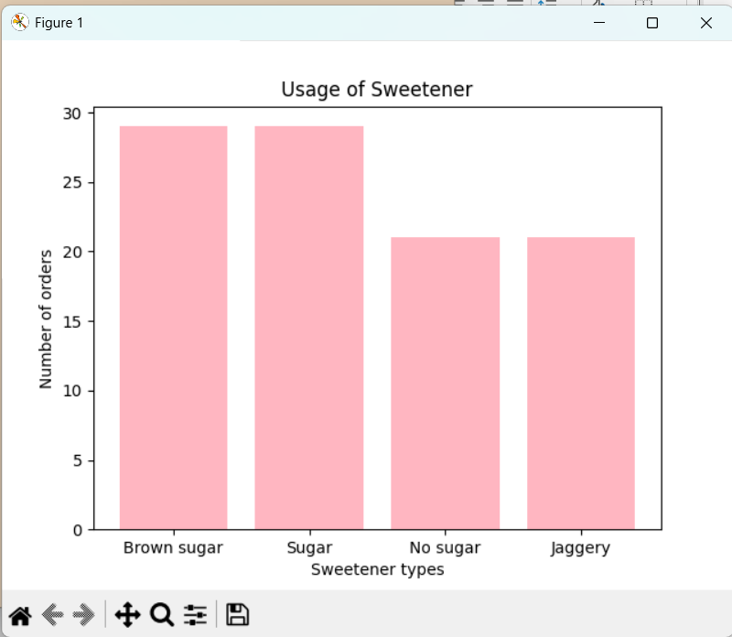

- Restock alerts (text-based output)

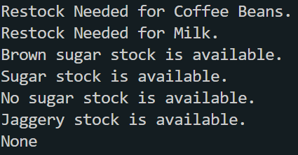  
- Summary view (2x2 subplot window with 4 graphs)

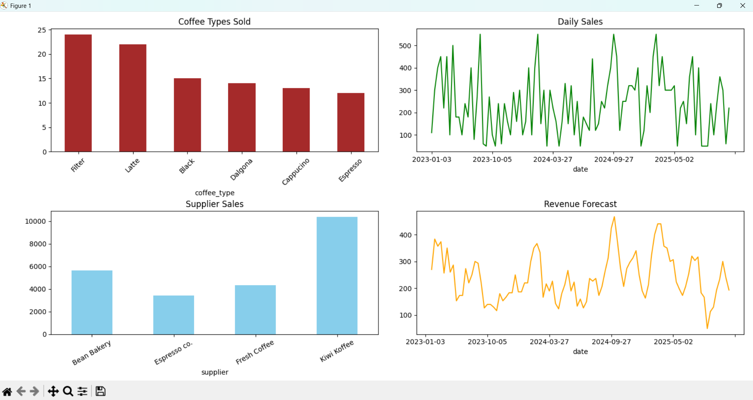

**Closure**

Kings Coffee now has a complete data analysis tool customized for their business. It provides smart visualizations, revenue forecasting, supply tracking, and customer feedback analysis. The UI allows staff to access insights easily without needing to write any code. The project demonstrates the power of combining Python, data analytics, and simple GUI to make data useful.

**Bibliography**

- https://pandas.pydata.org/  
- https://matplotlib.org/  
- https://docs.python.org/3/library/tkinter.html  
- https://realpython.com/