PROFILE SUMMARY:

Bachelor of engineering graduate with 7.11 years of experience in Software testing

PROFESSIONAL SUMMARY

- 7.11 years of total experience in manual testing of web and desktop applications.
- Hands on experience in Automation Framework Design and Test Automation of web applications using Selenium Web Driver and Java.
- Expertise in various types of testing activities like Functional Testing, System Testing, Regression Testing and Automation Testing.
- Strong experience in test planning, test estimation, analysing requirements and writing detailed test scenarios & test cases.
- Hands on experience in test management and defect tracking tools - QA Complete, VSTS and Red mine.
- Managed multiple teams and coordinated multiple releases/deliveries for Rail Road products.
- Well-versed with all stages of Software Development Life Cycle (SDLC) and different levels of Software Testing Life Cycle (STLC).
- Co-ordination with end users to conduct user acceptance testing.
- Designed and implemented Page Object Model with Page Factory framework.
- Expertise in using core java concepts to write Selenium Web Driver automation scripts.
- Hands on experience in writing basic SQL queries.
- Expertise in implementing best processes across various projects.

QUALIFICATION

- Bachelor Of Engineering - Tontadarya College of Engineering, VTU Belgaum
- Pre-university course – J.T. College, Gadag, Karnataka
- SSLC – Loyola High School, Gadag, Karnataka

PROFESSIONAL EXPERIENCE

- Xorail Inc from July 2010 - Till Date

CERTIFICATION

ISTQB Foundation Level Certification from Indian Testing Board (December 2014)

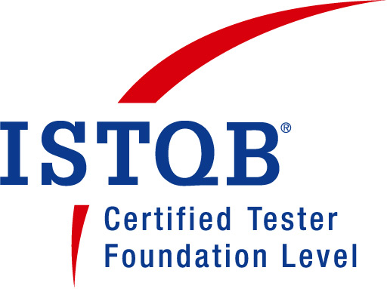

TECHNICAL SKILLS

Automation Testing tools | Selenium Web Driver
Defect Tracking Tools | Red mine, VSTS and QA Complete
Test management | QA Complete
Frameworks | Test NG
Languages | Core Java
Build Tool | Maven
Configuration management | Subclipse, GitHub

Projects

Wabtec One
Client : MRS, Brazil
Technology : Dotnet
Database : SQL server
Team Size : 5
Process : Agile

WabtecONE™ is the name under which Wabtec markets services to provide railway asset management and data analytics to customers. There are various modules through which different sets of data are displayed to end users: Locomotive monitoring, Office monitoring, Signal monitoring, Alarms monitoring and Communications monitoring. Specific data patterns are captured and displayed in various dashboards for end users to make decisions related to the safety of the train.

Role:
- Preparing Test plan.
- Participate in sprint planning and daily standup meetings.
- Assigning the user stories to the team members.
- Test cases execution, defect tracking and reporting.
- Provide QA Signoff for each release.

Talon
Client : NICTD, USA
Technology : Java
Database : SQL server
Team Size : 3
Process : Waterfall

TALON is a repository to store rail road information and its assets like equipments, FRA test details, drawings etc. The application allows end user to store survey information on track locations, equipments, available software’s etc. The data serves as preliminary input for PTC technology.

Role:
- Preparing Test plan.
- Test cases execution, defect tracking and reporting.
- Involved in framework design and automation of regression test suites using page object model with page factory.
- Assigning the tasks to the team members.
- Provide QA Signoff for each release.

PTC
Client : CSX, USA
Technology : Java
Database : SQL server
Team Size : 4
Process : Waterfall

PTC is a predictive collision avoidance technology that can stop a train before an accident occurs. This web based application supports the back office operations by providing a database which collects information on all the components involved in implementing the technology. The software provides information and geographic location of all locations and its components like signal, switch, equipment, hazard etc. The processed information was sent to customer’s applications through web services.

Role:
- Analyzing requirements and obtaining clarifications from Business analysts.
- Test cases execution, defect tracking and reporting.
- Preparing test evaluation summary reports for each release.
- Involved in production testing.

Intranet
Client : Xorail LLC, USA
Technology : Coldfusion
Database : SQL server
Team Size : 8
Process : Waterfall

Intranet is a web based application used by various departments and all employees of XORAIL. The application is mainly used by accounting and HR departments. Also this application provides a way to create expenses, timesheets, company projects, store project related information and track them in a customized manner.

Roles and responsibilities:
- Manual testing of the web application.
- Defect tracking and reporting.
- Peer peview of test cases.

Track Verify System
Client : Florida East Coast, USA
Technology : Dotnet
Database : SQL server
Team Size : 4
Process : Waterfall

A web based application which allows the personnel to input track verify data, inspection data, missed inspection data, milepost and yard information on a daily basis. The supervisor generates various reports on weekly and daily basis to determine the safety of tracks.

Roles and responsibilities:
- Manual testing of the web application.
- Defect tracking and reporting.

Track Builder

A web application to input the raw survey track data and build the .mdb file. The .mdb file contains meaningful assets data which is used further to build subdivision file. The subdivision file is used in locomotive’s onboard system to guide the crew.

Roles and responsibilities:
- Manual testing of the web application.
- Defect tracking and reporting.

PERSONAL DETAILS

Date of Birth : 18/03/1984
Gender : Male
Passport No : K2606218
Address : #15, Panchakutira, 18th Main, Sri Maruthi Layout,
Marenahalli, Vijayanagar, Bangalore-560040

