In below screen we modified code to add genetic algorithm with Euclidean Distance formula and in below screen you can see we used various GA functions

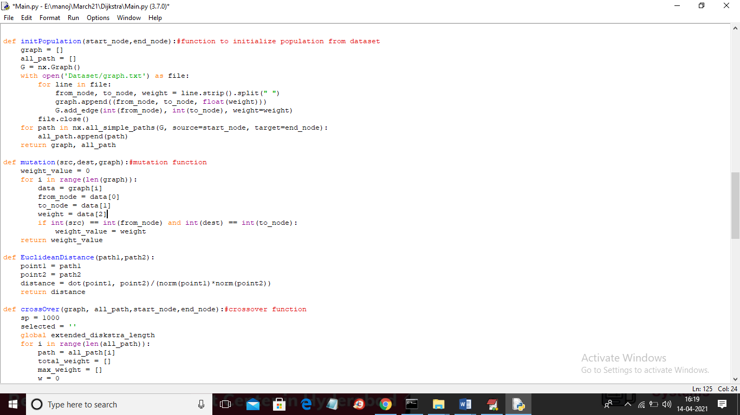

In above screen read red colour comments which we used for different GA functions such as Euclidean distance, crossover, initialize population etc.

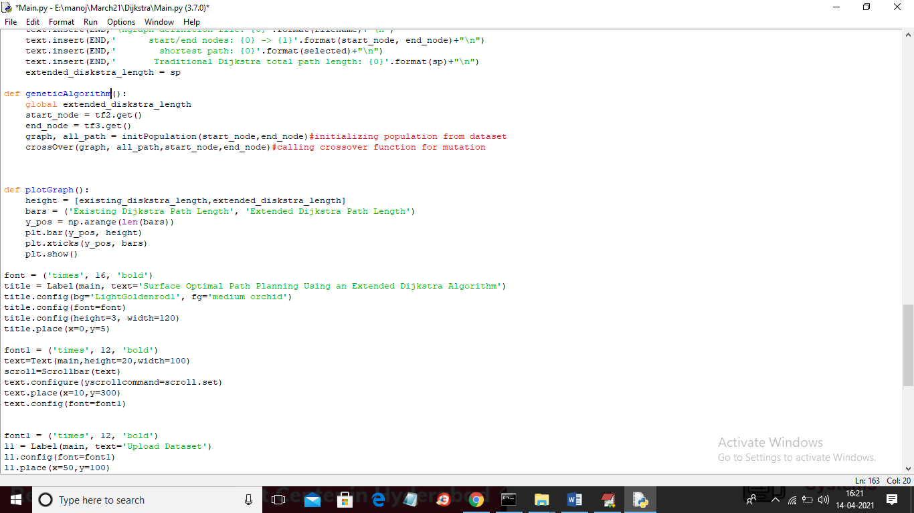

In above screen we used Genetic Algorithm function to call INITIALIZATION FUNCTION and CROSS OVER function.

To run code you follow previous screen shots as output is same only algorithm is changed

To convert code to JUPYTER you just install jupyter and then create new file and copy and paste code from ‘Main.py’ file