Surface Optimal Path Planning Using an Extended Dijkstra Algorithm

In this paper author is enhancing existing Dijkstra algorithm to get optimal path in surface area as existing Dijkstra is not giving proper optimal path in surface area due to distance calculation with Euclidean Distance. To get optimal path in surface area author is saying surface area has to be divided into triangles by using ‘Delaunay triangulation’ algorithm which divide surface area into triangles and then calculate weight for each path and this weight will be input to Dijkstra algorithm to get optimal path.

Existing algorithm does not support ‘Delaunay triangulation’ and extended Dijkstra has support for ‘Delaunay triangulation’ algorithm due to which we will get shortest and optimal path length.

To implement this project author has not used any dataset or publish any dataset so we are using below sample graph data

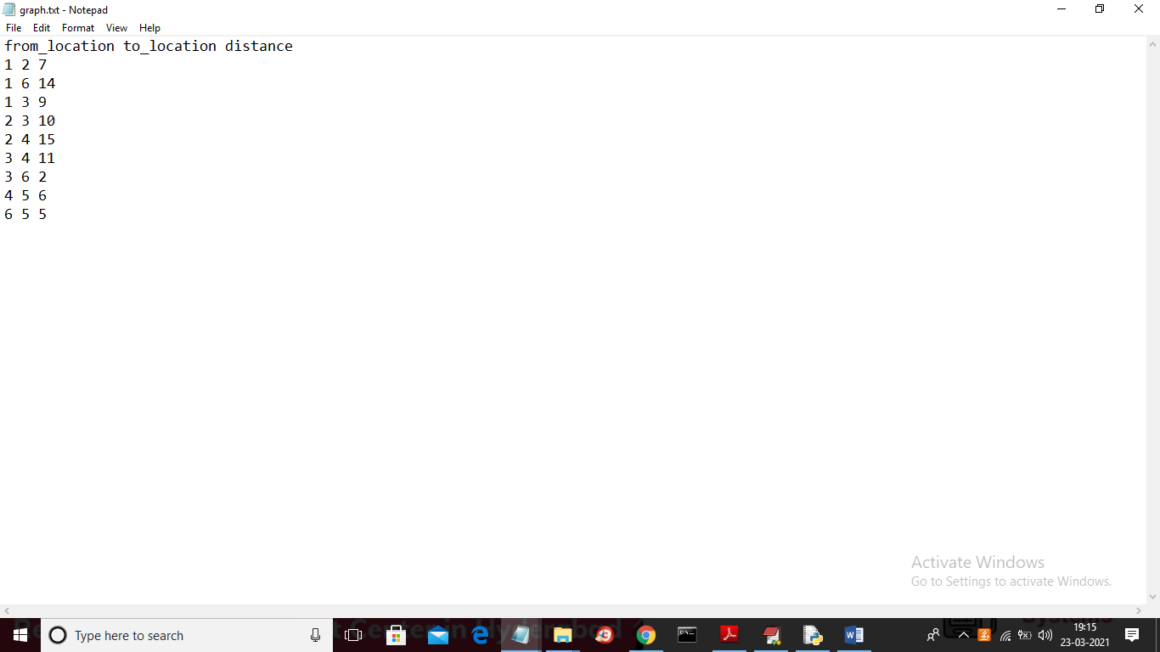

In above screen dataset we have 3 values separated by spaces such as from location, to location and distance between from and to location and we will use above dataset to build graph and then apply Dijkstra algorithm to find shortest path between given source and destination node. Above dataset will give below graph

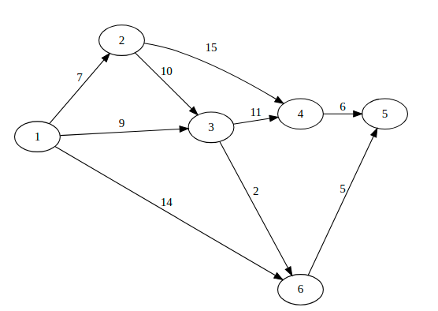

In above graph if u want to travel from source 1 to destination 5 then 1, 3, 6, 5 will be shortest path as its edges values represents distance and you sum all edges then you will get path length or distance value as 16 and another path is 1, 6, 5 whose distance value is 19

Below code showing how we are using ‘Delaunay triangulation’ on graph data to divide into triangle and then apply Dijkstra algorithm to get optimal path

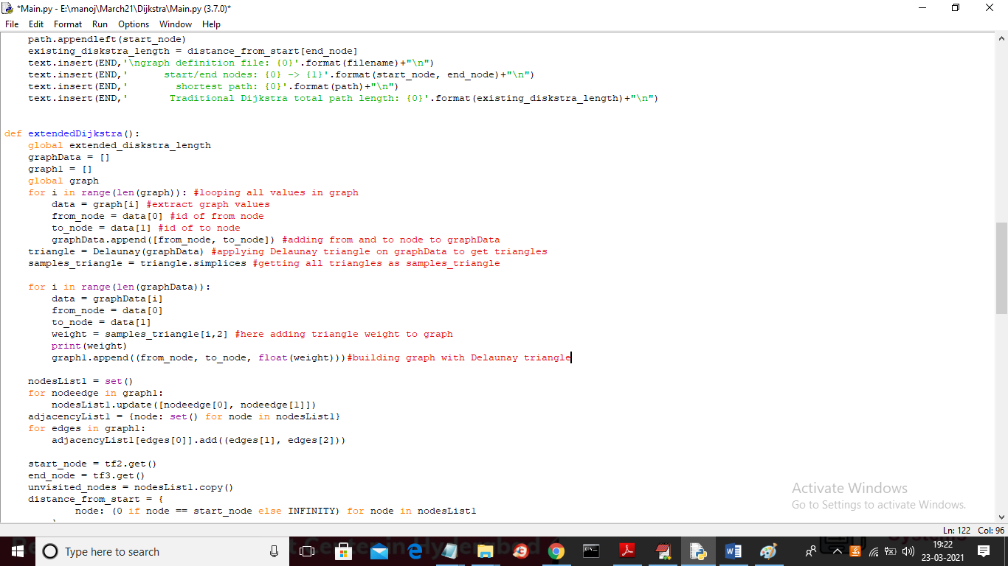

In above screen read red colour comments to understand concept of triangle creation

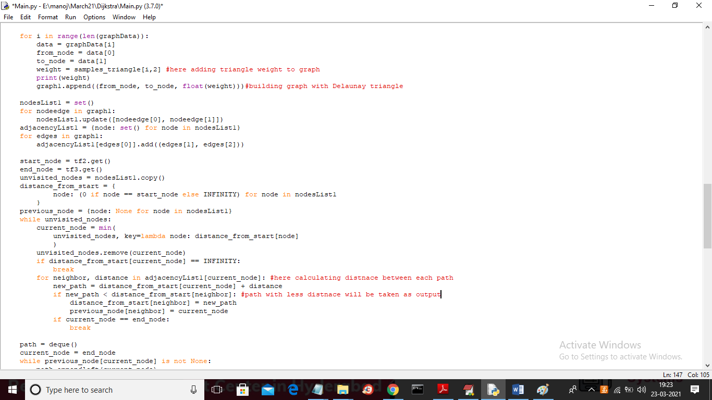

In above screen read last two red colour comments where we are applying Dijkstra algorithm to check path distance and path with minimum distance will be taken as output.

SCREEN SHOTS

To run project double click on ‘run.bat’ file to get below screen



In above screen click on ‘Browse’ button and upload dataset



In above screen selecting and uploading ‘graph.txt’ file and then click on ‘Open’ button to get below screen



In above screen dataset loaded and now enter source and destination path id



In above screen I gave source as 1 and destination as 5 and now click on ‘Generate Graph’ button to get below graph

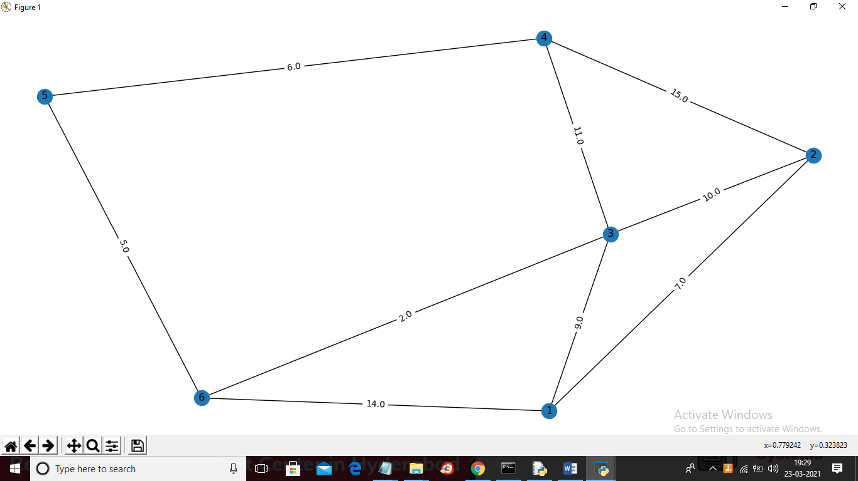

In above graph each circle represents one location and then connection between them represents distance and now close above graph and click on ‘Run Traditional Dijkstra Algorithm’ button to get shortest path from source 1 to destination 5



In above screen in selected text from 1 to 5 the shortest path is 1, 3, 6 and 5 and the path length distance is 16 and now click on ‘Run Extended Dijkstra Algorithm’ button to run extended algorithm



In above screen for same source and destination we got same shortest path but distance is 6 Kilo meter which means if we follow path from triangle then we can reach destination with shortest distance. Similarly you can enter any other source and destination to get shortest path and u can give source and destination from number between 1 to 6 and now click on ‘Path Length Graph’ button to get path length using both algorithms

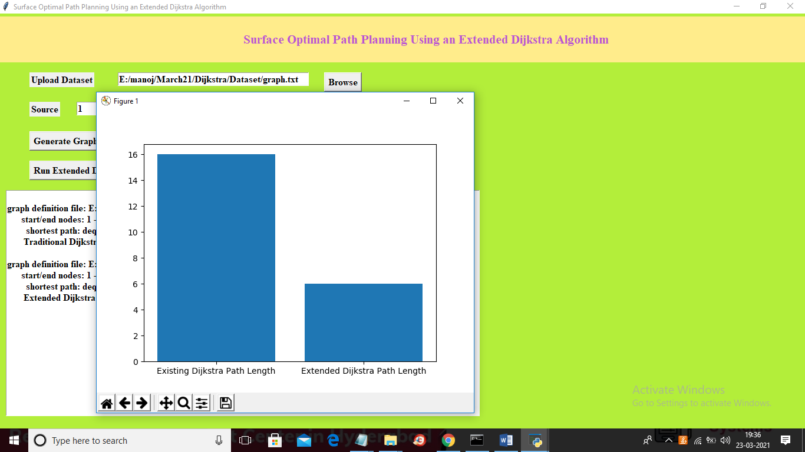

In above graph x-axis represents algorithm name and y-axis represents path length of both algorithms and from above graph we can conclude that extended algorithms giving shortest distance path