1. Write a Python code to calculate the sum of odd and even numbers in a given list using GitHub Copilot along with VS Code. Use zero shot prompting

Prompt: Generate a Python program that take a list of numbers from the user and calculates the sum of even numbers and similarly sum of odd numbers and display them on to the screen.

Output:

1. Write a Python code for given a list of integers, remove duplicates and print the sorted result. GitHub Copilot along with VS Code. Use one shot prompting.

Prompt: Generate a Python program that takes a list of integers from the user as input. Remove duplicates and sort them in ascending order and display it on to the screen. Example test case.

Enter the integers with space : 9 9 8 6 1 3 3 2

After sorting and removing duplicates : [1, 2, 3, 6, 8, 9]

Output:

1. Write a Python function that converts the temperature between Celsius, Fahrenheit, and Kelvin based on user choice. Use the Cursor AI tool. Use few shot prompting.

Prompt: Generate a Python function that takes temperature as input from the user, then next asks which is unit you taken (Celsius, Fahrenhiet and kelvin) and for which unit you are willing to convert (Celsius, Fahrenhiet and kelvin) and display the output based on the user requirments upon the function . Sample test cases:

1. Enter the temperature : 100

Enter the units you are (c,f,k) : c

Enter the units you are willing to convert (c,f,k) : k

Temperature in kelvin : 373.15

1. Enter the temperature : 34

Enter the units you are (c,f,k) : k

Enter the units you are willing to convert (c,f,k) : c

Temperature in Celsius : -239.1499

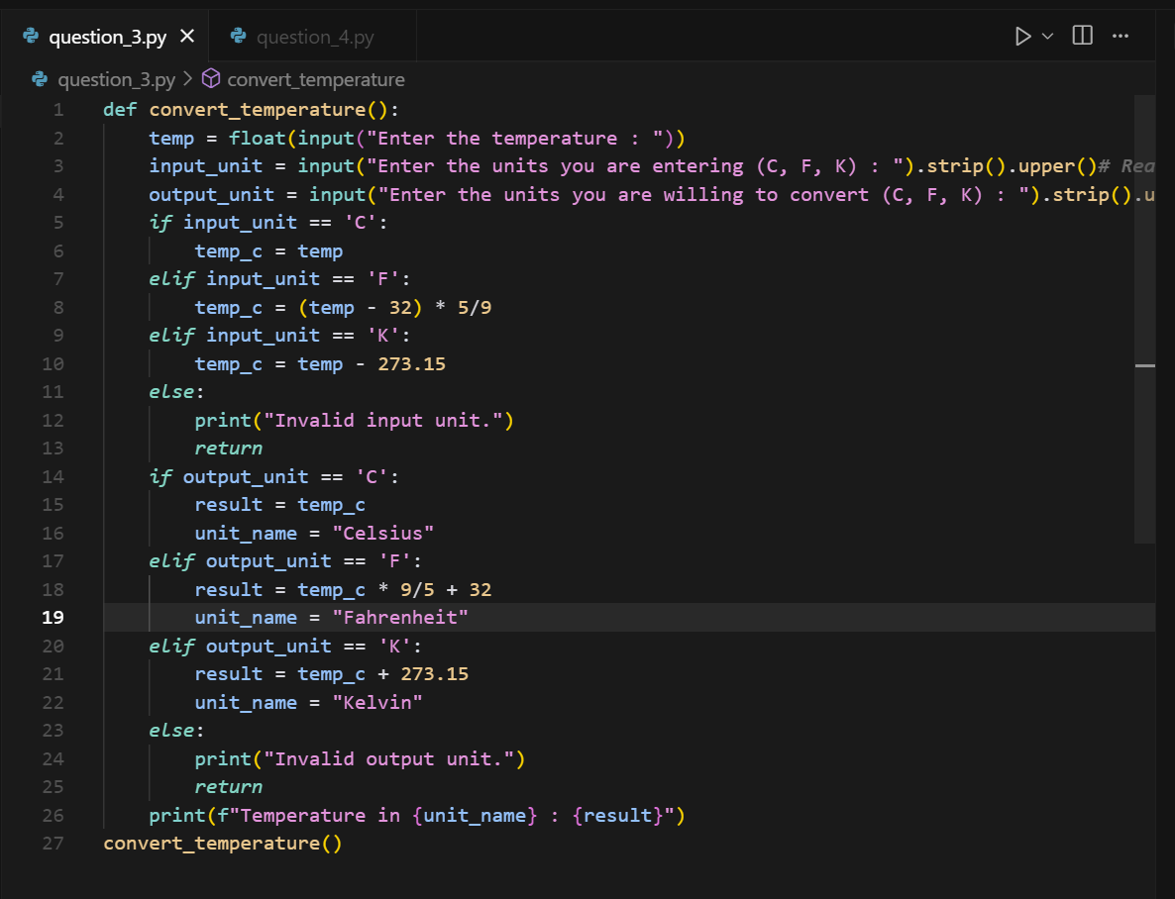

Output:

1. Write a Python function to remove punctuation, convert to lowercase, and remove stop words from a given text. Use the Cursor AI tool. Use zero shot prompting

Prompt: Generate a Python function that takes a text from the user as input and removes all punctuations, convert all uppercase letters to lowercase letters and remove all the stop words. And display the resulted text on to the screen.

Output:

