Name: EeezTrip

githubUrl: https://github.com/CharanAI143/EeezTrip
Description: An AI-powered multi-modal travel ecosystem that enables users to plan, book, and experience journeys across flights, trains, buses, taxis, metro systems, and ride-sharing services through a single conversational interface.
The platform combines Conversational AI, Machine Learning, Mood Analysis, Real-Time APIs, and Cloud-Native Architecture to provide personalized travel recommendations, emotion-aware itineraries, smart transport optimization, emergency assistance, and real-time journey companionship.
Unlike traditional travel platforms, the system continuously adapts based on user mood, preferences, budget, travel history, and live travel conditions, creating a deeply personalized and intelligent travel experience.

Functional Requirements
Authentication
- Register, login, logout with JWT authentication
- Role-based access control (Admin, User, Premium User)
- Session management and token refresh
- Secure API Gateway authorization
Conversational AI Assistant
- Natural language trip planning
- AI-generated travel suggestions
- Real-time conversational journey guidance
- Context-aware memory retention
Multi-Modal Transport Booking
- Flight booking integration
- Train ticket recommendations
- Bus booking suggestions
- Route comparison across all transport types
- Smart route optimization based on:
- time
- budget
- comfort
- sustainability

Mood Detection Engine
- Detect:
• stress
• excitement
• relaxation
• adventure
• romance
• family mode
• business urgency
• Dynamically personalize:
• destinations
• activities
• restaurants
• transport types
• music playlists
• schedules

AI Itinerary Generator
- Generate personalized itineraries
- Day-wise planning
- Mood-based scheduling

Non-Functional Requirements
- Bundle size under 150 KB gzipped
- Page load under 2 seconds
- API response under 3 seconds
- Support 50+ concurrent users
- 99.5% uptime target
- All traffic encrypted via HTTPS/TLS
- Credentials never stored in plain text
- Lighthouse accessibility score 90+
- Minimum 70% test coverage

Problem_statement: The core problem is the gap between planning and the actual travel experience caused by a lack of local knowledge in new destinations. Travelers are currently forced into a "static and manual" process—searching across fragmented platforms for hotels, sights, and logistics—which leads to a disorganized, hectic journey characterized by high decision fatigue and a lack of real-time adaptability.
Proposed_solution: Our solution is an autonomous "travel operating system" that replaces hectic manual searching with real-time, AI-driven orchestration. By proactively managing every variable—from hidden local gems to iconic landmarks—it transforms travel from a logistical burden into a seamless, high-quality experience, making it the mandatory intelligence for any traveler who wants to experience the world instead of just managing it.
Technologies_used: Next.js 15 (React 19), Tailwind CSS, Mongodb Atlas, Docker, Google Gemini 1.5 Flash, FastAPI, Vertex AI.
System_Architecture: EeezTrip uses a microservices architecture with five Docker-containerized services behind a Nginx API gateway. The Next.js 15 frontend handles the UI with Tailwind CSS and Framer Motion, communicating via REST APIs to a FastAPI backend that manages trip planning, chat, and group travel logic. The backend connects to MongoDB Atlas for storage and Google Gemini 1.5 Flash for AI-powered itinerary generation. A Node.js WebSocket service enables real-time group collaboration, while dedicated AI and ML services handle personalization and recommendations. Nginx routes all traffic — HTTP to frontend/backend, WebSocket upgrades to the Node.js service. Authentication is Firebase-based with all credentials managed via environment variables.
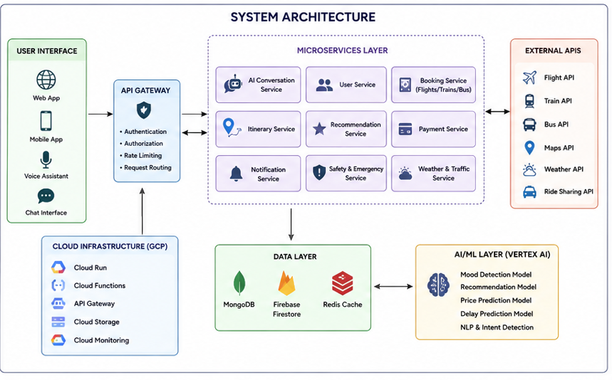
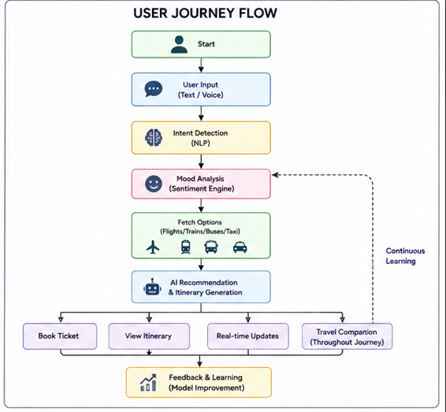
In_Scope: AI Generation, Chat Widget, Collaborative Voting/Expenses, Live Dashboard, Mood Detection, Auth, Mock Mode.
Out_Scopes: Direct Booking/Payments, Real-time Flight Tracking, Visa Processing, Native Mobile Apps, Support Ticketing.
Future Enhancements: Live booking APIs (Expedia/Skyscanner), Push notifications, Offline mode, Multi-language/Currency support.
Conclusion: Successfully built a responsive, AI-driven travel planner with functional, state-based UI and mock fallback architectures.
projectType: AI-powered SaaS web application

