**Structure of Web Browser:**

The primary components of a browser are shown in the below image:

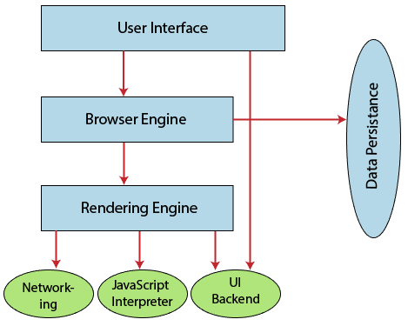

1. **User Interface:** The user interface is an area where the user can use several options like address bar, back and forward button, menu, bookmarking, and many other options to interact with the browser.
2. **Browser Engine:** It connects the UI (User Interface) and the rendering engine as a bridge. It queries and manipulates the rendering engine based on inputs from several user interfaces.
3. **Rendering Engine:** It is responsible for displaying the requested content on the browser screen. It translates the HTML, XML files, and images, which are formatted by using the CSS. It generates the layout of the content and displays it on the browser screen. Although it can also display the other types of content by using different types of plugins or extensions. such as:
   * Internet Explorer uses **Trident**
   * Chrome & Opera 15+ use **Blink**
   * Chrome (iPhone) & Safari use **Webkit**
   * Firefox & other Mozilla browsers use **Gecko**
4. **Networking:** It retrieves the URLs by using internet protocols like HTTP or FTP. It is responsible for maintaining all aspects of Internet communication and security. Furthermore, it may be used to cache a retrieved document to reduce network traffic.
5. **JavaScript Interpreter:** As the name suggests, JavaScript Interpreter translates and executes the JavaScript code, which is included in a website. The translated results are sent to the rendering engine to display results on the device screen.
6. **UI Backend:** It is used to draw basic combo boxes and Windows (widgets). It specifies a generic interface, which is not platform-specific.
7. **Data Storage:** The data storage is a persistence layer that is used by the browser to store all sorts of information locally, like cookies. A browser also supports different storage mechanisms such as IndexedDB, WebSQL, localStorage, and FileSystem. It is a database stored on the local drive of your computer where the browser is installed. It handles user data like cache, bookmarks, cookies, and preferences.

**How does a browser work?**

When a user enters a web address or URL in the search bar like javatpoint.com, the request is passed to a **domain name servers** (DNS). All of these requests are routed via several routers and switches.

The domain name servers hold a list of system names and their corresponding IP addresses. Thus, when you type something in the browser search bar, it gets converted into a number that determines the computers to which the search results are to be displayed.

The browser acts as a part of the client-server model. A browser is a client program that sends the request to the server in response to the user search queries by using Hypertext Transfer Protocol or [HTTP](https://www.javatpoint.com/http-tutorial). When the server receives the request, it collects information about the requested document and forwards the information back to the browser. Thereafter, the browser translates and displays the information on the user device.

**In Brief:**

* When a user enters something (like javatpoint.com) in the browser. This request goes to a domain name server.
* The browser sends the user request to the server using an IP address, which is described by the domain name server.
* The domain name server sends an IP address to the web server that hosts the website.
* The server sends the information back to the IP address, which is defined by the browser at the time of the request. The requested page may include links to other files on the same server, like images, for which the browser also requests the server.
* The browser gathers all the information requested by the user, and displays on your device screen in the form of web pages.